Charleston
Police Department
Junior Police & Leadership Academy
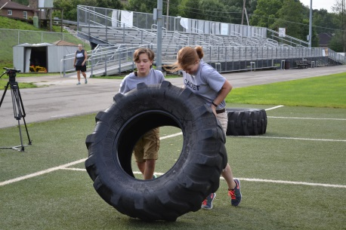

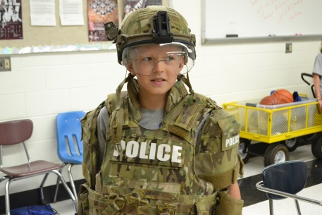
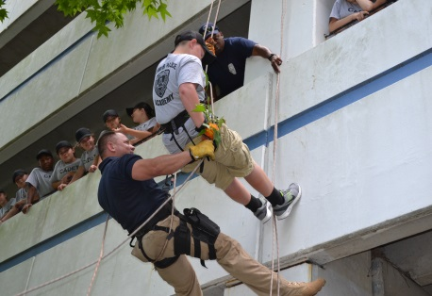

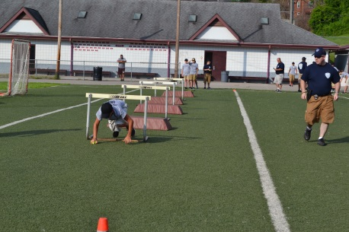

Do you have what it takes?

Applicant’s Name:___________________________________________
Last First Middle

Due By: May 8, 2018

Who can participate?
- Any Middle School student in the 6th- (going to) 8th grade.
- Student must have a minimum GPA of 2.0 and be in good standing at their school.
- The student must possess good moral character.
- The student must have an acceptable legal history.

The application must be returned to the Charleston Police Department Community Policing Bureau by the due date on the cover of the application. If you have any questions, please call Lt. P. A. Perdue (Academy Commander) (304) 348-6470 Monday through Friday 8am to 4pm.

Applicants are required to submit copes of:
- Student Identification (Photograph)
- Letter of Recommendation from a Teacher or Principal

Mail completed materials to:
Charleston Police Department
Community Policing Bureau
Attention: Lt. P.A. Perdue
501 Virginia Street East
Charleston WV 25301
(304) 348-6470

Or deliver the materials to the following Prevention Resource Officers:
- Cpl. Gary Daniels (SRO) George Washington High School
- Cpl. Stacey Loftis (PRO) Stonewall Middle School
- Cpl. Travis Hill (PRO) Capital High School

The Charleston Police Department reserves the right to suspend or terminate the participation of any participant who engages in unsafe, insubordinate or illegal behavior at any time before or during the academy.

Attendance is MANDATORY each day of the academy.

The Academy will be from July 16, 2018 to July 20, 2018 at Capitol High School. The Cadet Trainee that is accepted will receive an acceptance letter confirming dates, times, and location of the Academy.

Completing the application does not guarantee attendance to the program. A letter of acceptance to the CPD Junior Police & Leadership Academy will be mailed to the student that is approved.

Instructions

- Read every question carefully. Answer every question even if redundant. If the question does not pertain to you write “N.A” within the appropriate space.
- All answers shall be printed clearly in your own handwriting and in BLUE INK. Do Not Type.
- Answer every question completely. If space allotted for the question is insufficient use the additional space provided at the end of the questionnaire. Be sure to include the number of the question and maintain the same question/answer format.
- Applicants and their Parents/Guardians are required to sign the Release and Hold Harmless Agreement (included in the application packet)
- Applicants are required to have the Emergency Contact Information Form filled out completely.
- Applicants are required to have the Emergency Medical Treatment Form filled out completely.
- Send a picture with the application.

- Applicants will be evaluated on penmanship, grammar, spelling and completeness of this questionnaire.

Applicant Information

- Last Name_________________ First__________________ Middle_______________

- Address_________________________ City_______________ State_________ Zip____
- Home Telephone_____________________
- Parent’s Cell Phone__________________________
- Adult T-Shirt Size_________________

- Date of Birth: Month____________ Day________ Year_________

- Explain, in your own words, why you have applied for the Youth Police Academy Trainee with the Charleston Police Department:

________________________________________________________________________________________________________________________________________________________________________________________________________________________________________________________________________________________________________________________________________________________________________________________________________________________________________________________________________________________________________________________________________________________________________________________________

Autobiography

INSTRUCTIONS: Tell us about yourself. Follow the instructions carefully. No exception:
- Print in your own handwriting.
- Use a BLUE ink pen, NO pencil.
- Sign your autobiography by using your normal signature.

________________________________________________________________________________________________________________________________________________________________________________________________________________________________________________________________________________________________________________________________________________________________________________________________________________________________________________________________________________________________________________________________________________________________________________________________________________________________________________________________________________________________________________________________________________________________________________________________________________________________________________________________________________________________________________________________________________________________________________________________________________________________________________________________________________________________________________________________________________________________________________________________________________________________________________________________________________________________________________________________________________________________________________________________________________________________________________________________________________________________________________________________________________________________________________________________________________________________________________________________________________________________________________________________________________________________________________________________________________________________________________________________________________________________________________________________________________________________________________________________________________________________________________________________________________________________________________________________________________________________________________________________________________________________________________________________________________________________________________________________________________________________________________________________________________________________________________________________________________________________________________________________________________________________________________________________________________________________________________________________________________________________________________________________________________________________________________________________________________________________________________________________________________________________________________________
______________________________
Signature
Education History

List the Middle School you currently attend:
School____________________________ Location__________________________
From Month/Year___________________ To Month/Year_____________________
G.P.A._______________
School References (Principal or Teacher)___________________________________

List below any other Middle Schools you have attended:
School___________________________ Location___________________________
From Month/Year__________________ To Month/Year______________________
G.P.A.______________________

List below any honors or awards you have received:
________________________________________________________________________________________________________________________________________________________________________________________________________________________________________________________________________________________________________________________

Were you ever expelled or suspended from a Middle School that you have attended?

___ No ___ Yes If yes, specify when, where, and reason:
__________________________________________________________________________________________________________________________________________________________________________________________________________________________________________

List all school-related disciplinary action, including academic probation that has occurred since the sixth grade.
__________________________________________________________________________________________________________________________________________________________________________________________________________________________________________

Emergency Medical Treatment Form

To: Emergency Room Medical Staff

My son/daughter _________________________________ has my permission to participate in the Charleston Police Department Youth Police Academy. In the event of an illness or injury while participating in this activity, I consent to medical diagnostic treatment or procedures that are considered necessary in the best judgment of the attending physician and performed by or under the supervision of a member of the medical staff of the hospital furnishing medical services. I also give my consent for the attending physician to prescribe and administer any necessary medication needed in the event of a medical emergency.

It is understood that in the event of a serious illness or injury, reasonable efforts to reach me will be attempted.

Our family physician is
______________________________________________
Adress______________________________________ Phone_________________
Medical Coverage Company
__________________________________________________________________
Exp. Date_________________ Policy Number_________________________
Telephone number that I can be reached at_____________________________
Alternate number that I can be reached at ______________________________

Signature of Parent/Guardian
_______________________________________
Name______________________________
Address _______________________ City___________________ State________ Zip______

Special Medical Problems, Allergies and/or Prescribed Medications, Please list any physical activity your child may not participate in.
____________________________________________________________________________________________________________________________________________________________

Emergency Contact Information

The following designated individuals may act on behalf of the parent/guardian in case of emergency where the parent/guardian cannot be reached. This information must be filled out before your child can participate in the Youth Police Academy. Thank You for your cooperation. We will NOT release a Youth Police Officer Traninee to anyone except who is listed on this form.

Alternate Contact 1
Name _________________________________
Address_______________________________
City________________________ State______________________ Zip_____________
Phone Number _________________________________
Cell Phone _______________________________

Alternate Contact 2
Name _________________________________
Address_______________________________
City________________________ State______________________ Zip_____________
Phone Number _________________________________
Cell Phone _______________________________

Alternate Contact 3
Name _________________________________
Address_______________________________
City________________________ State______________________ Zip_____________
Phone Number _________________________________
Cell Phone _______________________________

Alternate Contact 4
Name _________________________________
Address_______________________________
City________________________ State______________________ Zip_____________
Phone Number _________________________________
Cell Phone _______________________________

Charleston
Police Department
Junior Police & Leadership Academy

Photo/Videotape Release Form

Throughout the Junior Police & Leadership Academy, there may be times when the Academy staff, the media, or other organizations, with the approval of the Academy Commander, may take photographs of students, audio/videotape students, or interview students for school related stories in a way that would individually identify a specific student. Those photographs and/or videotaped images or interviews may appear in Charleston Police Department publications, website, and authorized social networking sites such as Charleston Police Department Community Policing Bureau Facebook page. To authorize your child’s photograph and/or videotaped image or interview to be used for these purposes, please complete this form and mail it with the application.

□ I hereby grant unto the Charleston Police Department Junior Police & Leadership Academy permission to use my child’s, photograph and/or videotaped image or interview for the purposes mentioned above. I understand and agree that the Charleston Police Department Junior Police & Leadership Academy may use these photos and/or videotaped images or interviews in subsequent Academy classes unless I revoke this authorization by notifying the Academy Commander in writing. I further grant unto the Charleston Police Department Junior Police & Leadership Academy permission to permit my child to be photographed, audio/videotaped, or interviewed by the news media or other organizations for Academy related stories or articles.

Student’s Name: __________________________________________________________
Parent/Guardian Name: ___________________________________________________
Address: __________________________________________________________
City/State: _____________________________ Zip Code: _____________
Telephone Number: __________________________________________________________
Parent/Guardian Signature*: _______________________________________Date: ______

Charleston Police Department
Permission to Participate in the
Junior Police & Leadership Academy

I, as the parent or legal guardian, give permission for the student named herein to participate in the Charleston Police Department’s Junior Police & Leadership Academy program.

I understand that my child must follow the policies on coduct for the participating school and the Kanawha County Board of Education at all times. If she/he does not follow the rules and the direction of the Charleston Police Officers while participating in the program, she/he may, in the discretion of the Charleston Police Department or the participating school, be excluded from further participation in the program.

A school employee will notify me, the parent or guardian, in advance of the program events with the details of the activities.

The Charleston Police Department and the Kanawha County Board of Education acknowledge that you are not waiving your child’s or your personal rights, however, the Charleston Police Department and the Kanawha County Board of Education reserve all rights, immunities, and qualified defenses available to them under the law in connection with the permitted activities related to this program.

Parent Signature:__________________________
Child’s Name:____________________________
Date:___________________________________

Student Agreement:

While particpating in the Charleston Police Department’s Junior Police & Leadership Academy, I will accept responsibility for maintaining good conduct and behavior. I will follow school rules and directions from supervising adults at all times.

Student Signature:_________________________

