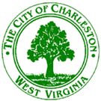

Planning Committee
August 28, 2017
7:00 p.m.
City Service Center – 915 Quarrier Street – Conference Room

Agenda

Right of Way Closing
Bill No. 7755 closing, abandoning, and discontinuing a portion of an 19th Street SE between Frontage Road and Kanawha Avenue SE and 88’ of Kanawha Ave SE, situate in Kanawha City District, Kanawha County, West Virginia.

Miscellaneous
Minutes of the August 7, 2017 meeting

