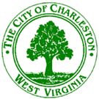

Municipal Planning Commission
August 8, 2018
3:00 p.m.
City Service Center – 915 Quarrier Street – Conference Room

Agenda

- Call to Order

- Unfinished Business

- New Business

Right of Way Closing: Bill No. 7786 closing, abandoning, and discontinuing a portion of a public alley between Washington Street, East and Jackson Street accessed by Thompson Street, Charleston Corporation East District, Kanawha County, West Virginia.

- Miscellaneous Business

- Minutes of the June 6, 2018 MPC meeting

- Announcements

- Adjournment

