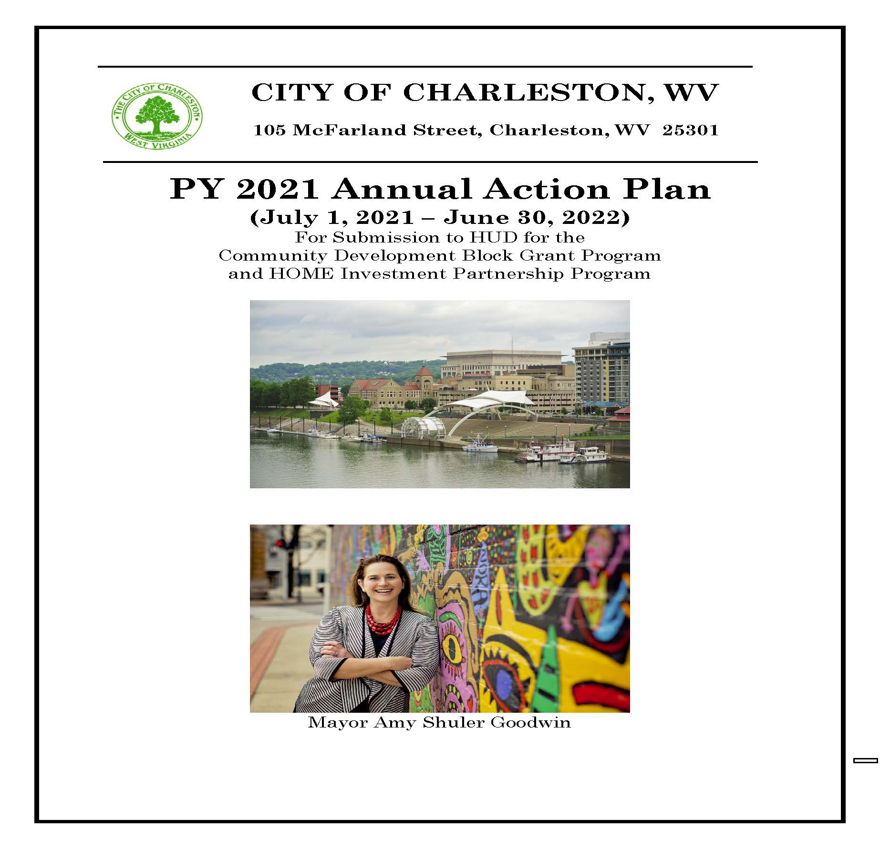

Executive Summary

AP-05 Executive Summary - 91.200(c), 91.220(b)
1. Introduction
The 2021 PY Annual Action Plan (2nd year of 2020-2024 Consolidated Plan) for the City of Charleston includes the City's Community Development Block Grant (CDBG) Program, outlining which activities the City will undertake during the program year beginning July 1, 2021 and ending June 30, 2022. In addition, the Plan includes the HOME funds that the City of Charleston/Kanawha County HOME Consortium will receive in PY 2021. The City of Charleston is the lead entity and administrator for the Consortium's HOME funds.
2. Summarize the objectives and outcomes identified in the Plan
This could be a restatement of items or a table listed elsewhere in the plan or a reference to another location. It may also contain any essential items from the housing and homeless needs assessment, the housing market analysis or the strategic plan.
The CDBG Programs and activities outlined in this Annual Action Plan will principally benefit low- and moderate-income persons. Funding has been targeted to neighborhoods where there is the highest percentage of low- and moderate-income residents. CDBG funds also are directed to where Charleston has high concentrations of distressed or abandoned houses. The HOME funds will be distributed based on the preference of the qualified client or approval of a development project in the HOME Consortium area. This includes ten (10) member jurisdictions of the City of Charleston/Kanawha County HOME Consortium.

3. Evaluation of past performance
This is an evaluation of past performance that helped lead the grantee to choose its goals or projects.
The City’s previous performance under the CDBG and HOME Programs were discussed during the public meetings. The City follows HUD regulations on timeliness of expenditures and there is no outstanding monitoring or audit findings against the City of Charleston or the City of Charleston/Kanawha County HOME Consortium.
4. Summary of Citizen Participation Process and consultation process
Summary from citizen participation section of plan.
The Annual Action Plan was developed in accordance with the City’s Citizen Participation Plan. Stakeholders including social service agencies, hosing providers and community and economic development agencies were notified on December 29, 2020 of the availability of funds. Applications were made available on January 14, 2021. Request for proposals for CDBG funding were due by February 12, 2021. On January 14, 2021, the City held a public meeting via Zoom to discuss the needs of the City with input from the residents of Charleston. Housing programs are retained or adjusted based on public input. The “Draft PY 2021 Annual Action Plan” was on display for a 30-day period beginning March 10, 2021 and was presented to the Charleston City Council prior to submitting to HUD. The availability for review of the “Draft Plan” was advertised in the local newspaper and the plan was on display at the City of Charleston’s website www.Charlestonwv.gov.
MOECD offered technical assistance to private non-profit organizations on how to fill out the CDBG applications to apply for CDBG funds for the PY 2021 year which begins on July 1, 2021. Applications as well as the Citizen’s Participation Plan were also available on the city’s website. The second public meeting was held on January 19, 2021 and the final public meeting held on March 25, 2021, to discuss eligible activities and solicit citizen participation and comments. Citizen comments and concerns were addressed in the Plan.
MOECD staff reaches out to the past stakeholders and continues to include any new contacts made throughout the year. Besides putting information out via newspaper and website, staff members network at public and neighborhood meetings to garner interest in the development of the action plan. Additionally, the City of Charleston has a page on social media and posted information regarding the development of the action plan.
5. Summary of public comments
This could be a brief narrative summary or reference an attached document from the Citizen Participation section of the Con Plan.
The City of Charleston did not receive any written comments regarding the 2021 Annual Action Plan. The PY 2021 Annual Action Plan was approved by city council, with no changes to the proposed activities at the May 3, 2021 council meeting.

6. Summary of comments or views not accepted and the reasons for not accepting them
No comments were received.
7. Summary
Ensuring an availability of safe, affordable housing in Charleston continues to be a problem for low-income families and individuals. Therefore, maintaining and developing affordable housing remains a key priority. Demolition of abandoned or unsafe houses continues to be another priority. To help in this the City will continue to offer owner-occupied rehabilitation and first-time home buyers assistance to eligible candidates. The City of Charleston also supports programs that target homelessness and work collaboratively with the Kanawha Valley Collective, the local Continuum of Care. Additionally, the MOECD staff works with a variety of social service non-profits and stakeholders to keep them informed of other potential funding programs and collaborations.

PR-05 Lead & Responsible Agencies - 91.200(b)
1. Agency/entity responsible for preparing/administering the Consolidated Plan
The following are the agencies/entities responsible for preparing the Consolidated Plan and those responsible for administration of each grant program and funding source.
Agency Role | Name | Department/Agency
Lead Agency | CHARLESTON

CDBG Administrator | CHARLESTON | Mayor's Office of Economic and Community Dev.
HOPWA Administrator
HOME Administrator | CHARLESTON | Mayor's Office of Economic and Community Dev.
HOPWA-C Administrator
Table 1 – Responsible Agencies

Narrative
The Mayor's Office of Economic and Community Development will be responsible for the administration of the CDBG, CDBG-CV and HOME programs and for the preparation of the Consolidated Plan and Annual Action Plan.
Consolidated Plan Public Contact Information
Andrew Backus, the Director of the Mayor's Office of Economic and Community Development, is the primary contact and receives all inquiries and comments from the public or any stakeholders regarding the plan. Written comments may be sent to Andrew.Backus@cityofcharleston.org, or mailed to Andrew Backus, Director c/o The Mayor's Office of Economic and Community Development at 105 McFarland Street, Charleston, WV 25301.

AP-10 Consultation - 91.100, 91.200(b), 91.215(l)
1. Introduction
The administering lead agency is the City of Charleston's Mayor's Office of Economic & Community Development (MOECD) for the Community Development Block Grant (CDBG) and the HOME Investment Partnership (HOME). The City consults with many types of agencies/organizations through public meetings and participation in community groups.
Provide a concise summary of the jurisdiction’s activities to enhance coordination between public and assisted housing providers and private and governmental health, mental health and service agencies (91.215(l)).
The City of Charleston Mayor’s Office of Economic and Community Development (MOECD) interacts regularly with the Charleston-Kanawha Housing Authority, non-profits, local housing providers, social service agencies, health care entities and community and economic development organizations. Specifically, MOECD works collaboratively to expand awareness of, coordination and utilization among a variety of local, state and national programs, including ones focused on health care (physical and mental), substance abuse, workforce development, education, youth programs, nutrition, recreation, childcare, etc. MOECD uses its CDBG public service funds to supplement many of these programs and seeks to develop linkages and resource-sharing where applicable. The city also is a member of the local Continuum of Care, the Kanawha Valley Collective (KVC), that includes many public and assisted housing providers and private and governmental health, mental health and service agencies. This continues to be an effective coordination tool. The city also works closely with the Kanawha-Charleston Health Department on key matters, particularly infectious disease management/response and substance abuse/addiction. While MOECD has not consulted with the local health department on monitoring lead-based poisoning incidents, the department does interact with state agencies to ensure its housing rehab contractors have the appropriate training and certifications in lead-based paint controls and procedures.
Describe coordination with the Continuum of Care and efforts to address the needs of homeless persons (particularly chronically homeless individuals and families, families with children, veterans, and unaccompanied youth) and persons at risk of homelessness.
The City of Charleston, as a member of the Kanawha Valley Collective (KVC), continually reaches out to individuals or organizations who have an interest in or knowledge of ending and preventing homelessness. The consortium does this at its membership meetings, on social media and with information on its web site. The KVC spotlights different agencies at these meetings giving them an opportunity to share the services they provide. The KVC also sponsors events (Vendor Fair, Veltri Thanksgiving Dinner) that bring public awareness to the plight of the homeless and those at risk. The KVC has an HMIS specialist to track statistics and trends that enable the KVC to better serve the homeless or those at risk. KVC also has a Project Resource Committee (formerly the ESG committee) made up of a variety of agencies and staff to get their input and opinions regarding ending and prevention of homelessness. Through the CDBG, and CoC programs, the City of Charleston historically funds many of the homeless shelters and non-profit homeless service providers with funding for activities that assist the homeless and at risk of becoming homeless.
Describe consultation with the Continuum(s) of Care that serves the jurisdiction’s area in determining how to allocate ESG funds, develop performance standards for and evaluate outcomes of projects and activities assisted by ESG funds, and develop funding, policies and procedures for the operation and administration of HMIS
The City of Charleston Mayor’s Office of Economic and Community Development (MOECD) has a long history of collaboration with the local Continuum of Care (CoC), the Kanawha Valley Collective (KVC). MOECD has represented the City of Charleston as a member of the KVC since its inception. Currently a staff member of MOECD serves on the board of directors of the KVC and several other committees, including the Project Resource Committee (formerly the ESG committee) and the Homeless Management Information System (HMIS). The city of Charleston staff works with the KVC Project Resource committee, made up of board members, ESG sub-recipients and HUD grant recipients, to determine how to allocate ESG funds for eligible activities. Numerous consultation meetings have taken place with the Homeless Management Information Systems (HMIS) specialist, and the Continuum of Care’s Project Resource Committee.
2. Agencies, groups, organizations and others who participated in the process and consultations

Table 2 – Agencies, groups, organizations who participated
1 | Agency/Group/Organization | Kanawha Valley Collective, Inc.
 | Agency/Group/Organization Type | Services-homeless  Regional organization  Planning organization
 | What section of the Plan was addressed by Consultation? | Homeless Needs - Chronically homeless  Homeless Needs - Families with children  Homelessness Needs - Veterans  Homelessness Needs - Unaccompanied youth  Homelessness Strategy  Non-Homeless Special Needs  Anti-poverty Strategy  Community Development Strategy
 | Briefly describe how the Agency/Group/Organization was consulted. What are the anticipated outcomes of the consultation or areas for improved coordination? | Was consulted for their input on the needs and goals for the City of Charleston
2 | Agency/Group/Organization | Charleston Urban Renewal Authority
 | Agency/Group/Organization Type | Housing  Services - Housing  Other government - Local  Planning organization  Business and Civic Leaders  Redevelopment Authority
 | What section of the Plan was addressed by Consultation? | Housing Need Assessment  Market Analysis  Economic Development  Anti-poverty Strategy  Community Development Strategy
 | Briefly describe how the Agency/Group/Organization was consulted. What are the anticipated outcomes of the consultation or areas for improved coordination? | Consultation on downtown issues, housing opportunity in the Homeownership Zone and Charleston's Westside for improved collaboration
3 | Agency/Group/Organization | Manna Meal, Inc.
 | Agency/Group/Organization Type | Services-homeless
 | What section of the Plan was addressed by Consultation? | Homeless Needs - Chronically homeless  Homeless Needs - Families with children  Homelessness Needs - Veterans  Homelessness Needs - Unaccompanied youth  Homelessness Strategy  Anti-poverty Strategy  Community Development Strategy
 | Briefly describe how the Agency/Group/Organization was consulted. What are the anticipated outcomes of the consultation or areas for improved coordination? | Manna Meal was consulted for their input on the needs and goals for the City of Charleston
4 | Agency/Group/Organization | REA OF HOPE, INC.
 | Agency/Group/Organization Type | Services-Persons with Disabilities
 | What section of the Plan was addressed by Consultation? | Homelessness Strategy  Anti-poverty Strategy  Community Development Strategy
 | Briefly describe how the Agency/Group/Organization was consulted. What are the anticipated outcomes of the consultation or areas for improved coordination? | Rea of Hope was consulted for their input on the needs and goals for the City of Charleston
5 | Agency/Group/Organization | Covenant House, Inc.
 | Agency/Group/Organization Type | Services-homeless
 | What section of the Plan was addressed by Consultation? | Homeless Needs - Chronically homeless  Homeless Needs - Families with children  Homelessness Needs - Veterans  Homelessness Needs - Unaccompanied youth  Homelessness Strategy  Non-Homeless Special Needs  Anti-poverty Strategy  Community Development Strategy
 | Briefly describe how the Agency/Group/Organization was consulted. What are the anticipated outcomes of the consultation or areas for improved coordination? | Covenant House was consulted for their input on the needs and goals for the City of Charleston. The City of Charleston and Covenant House are both active members of the CoC which provides opportunity for continued and improved coordination with issues surrounding homelessness.
6 | Agency/Group/Organization | YWCA Charleston
 | Agency/Group/Organization Type | Services-Children  Services-Elderly Persons  Services-Persons with Disabilities  Services-Victims of Domestic Violence  Services-homeless  Services-Health  Services - Victims  Regional organization  Planning organization
 | What section of the Plan was addressed by Consultation? | Homeless Needs - Chronically homeless  Homeless Needs - Families with children  Homelessness Needs - Veterans  Homelessness Needs - Unaccompanied youth  Homelessness Strategy  Non-Homeless Special Needs  Anti-poverty Strategy  Community Development Strategy
 | Briefly describe how the Agency/Group/Organization was consulted. What are the anticipated outcomes of the consultation or areas for improved coordination? | Was consulted for their input on the needs and goals for the City of Charleston
7 | Agency/Group/Organization | BOB BURDETTE CENTER, INC.
 | Agency/Group/Organization Type | Services-Children  Services-Education
 | What section of the Plan was addressed by Consultation? | Homelessness Strategy  Non-Homeless Special Needs  Anti-poverty Strategy  Community Development Strategy
 | Briefly describe how the Agency/Group/Organization was consulted. What are the anticipated outcomes of the consultation or areas for improved coordination? | Was consulted for their input on the needs and goals for the City of Charleston.
8 | Agency/Group/Organization | WEST VIRGINIA WOMEN WORK
 | Agency/Group/Organization Type | Services-Education  Services-Employment  Regional organization  Business Leaders
 | What section of the Plan was addressed by Consultation? | Economic Development  Anti-poverty Strategy  Community Development Strategy
 | Briefly describe how the Agency/Group/Organization was consulted. What are the anticipated outcomes of the consultation or areas for improved coordination? | WV Women Work was consulted for their input on the needs and goals for the City of Charleston.
9 | Agency/Group/Organization | ROARK SULLIVAN LIFEWAY CENTER
 | Agency/Group/Organization Type | Services-homeless
 | What section of the Plan was addressed by Consultation? | Homeless Needs - Chronically homeless  Homelessness Needs - Veterans  Homelessness Strategy  Anti-poverty Strategy  Community Development Strategy
 | Briefly describe how the Agency/Group/Organization was consulted. What are the anticipated outcomes of the consultation or areas for improved coordination? | Roark Sullivan Lifeway Center was consulted for their input on the needs and goals for the City of Charleston. The City of Charleston is a member agency of the KVC which gives much opportunity for continued and improved coordination with other member agencies.
10 | Agency/Group/Organization | Step By Step, Inc.
 | Agency/Group/Organization Type | Services-Children  Services-Education
 | What section of the Plan was addressed by Consultation? | Anti-poverty Strategy  Community Development Strategy
 | Briefly describe how the Agency/Group/Organization was consulted. What are the anticipated outcomes of the consultation or areas for improved coordination? | Was consulted for their input on the needs and goals for the City of Charleston.
11 | Agency/Group/Organization | WEST VIRGINIA HEALTH RIGHT
 | Agency/Group/Organization Type | Health Agency
 | What section of the Plan was addressed by Consultation? | Homelessness Strategy  Anti-poverty Strategy  Community Development Strategy
 | Briefly describe how the Agency/Group/Organization was consulted. What are the anticipated outcomes of the consultation or areas for improved coordination? | WV Health Right was consulted for their input on the needs and goals for the City of Charleston.
12 | Agency/Group/Organization | CHARLESTON
 | Agency/Group/Organization Type | Services - Housing  Services-Education  Service-Fair Housing  Agency - Managing Flood Prone Areas  Agency - Management of Public Land or Water Resources  Agency - Emergency Management  Other government - Local  Planning organization  Grantee Department
 | What section of the Plan was addressed by Consultation? | Housing Need Assessment  Public Housing Needs  Homeless Needs - Chronically homeless  Homeless Needs - Families with children  Homelessness Needs - Veterans  Homelessness Needs - Unaccompanied youth  Homelessness Strategy  Non-Homeless Special Needs  Market Analysis  Anti-poverty Strategy  Lead-based Paint Strategy  Community Development Strategy
 | Briefly describe how the Agency/Group/Organization was consulted. What are the anticipated outcomes of the consultation or areas for improved coordination? | Was consulted for their input on the needs and goals for the City of Charleston.
13 | Agency/Group/Organization | CHARLESTON KANAWHA HOUSING AUTHORITY
 | Agency/Group/Organization Type | Housing  PHA  Services - Housing  Service-Fair Housing  Other government - Local
 | What section of the Plan was addressed by Consultation? | Housing Need Assessment  Public Housing Needs  Market Analysis  Anti-poverty Strategy  Fair Housing
 | Briefly describe how the Agency/Group/Organization was consulted. What are the anticipated outcomes of the consultation or areas for improved coordination? | Was consulted for their input on the needs and goals for the City of Charleston.
14 | Agency/Group/Organization | DAYMARK, INC.
 | Agency/Group/Organization Type | Services-Children  Services-homeless
 | What section of the Plan was addressed by Consultation? | Homelessness Needs - Unaccompanied youth
 | Briefly describe how the Agency/Group/Organization was consulted. What are the anticipated outcomes of the consultation or areas for improved coordination? | Daymark was consulted through public meetings, KVC meetings, and monitoring visits. The City of Charleston and Daymark are both active members of the CoC which provides opportunity for continued and improved coordination with issues surrounding homelessness.
15 | Agency/Group/Organization | PRO KIDS INC
 | Agency/Group/Organization Type | Services-Children
 | What section of the Plan was addressed by Consultation? | Anti-poverty Strategy
 | Briefly describe how the Agency/Group/Organization was consulted. What are the anticipated outcomes of the consultation or areas for improved coordination? | Pro-Kids was consulted through public meetings, quarterly reports and monitoring calls.
16 | Agency/Group/Organization | RELIGIOUS COALITION FOR COMMUNITY RENEWAL
 | Agency/Group/Organization Type | Housing  Services-homeless
 | What section of the Plan was addressed by Consultation? | Homelessness Strategy
 | Briefly describe how the Agency/Group/Organization was consulted. What are the anticipated outcomes of the consultation or areas for improved coordination? | RCCR was consulted through public meetings, KVC meetings, and quarterly reports. The City of Charleston and RCCR are both active members of the CoC which provides opportunity for continued and improved coordination with issues surrounding homelessness.
17 | Agency/Group/Organization | WOMEN'S HEALTH CENTER
 | Agency/Group/Organization Type | Services-Health  Health Agency
 | What section of the Plan was addressed by Consultation? | Homelessness Strategy
 | Briefly describe how the Agency/Group/Organization was consulted. What are the anticipated outcomes of the consultation or areas for improved coordination? | Women's Health Center was consulted through public meetings, and quarterly reporting.
18 | Agency/Group/Organization | KANAWHA VALLEY FELLOWSHIP HOME
 | Agency/Group/Organization Type | Services-Persons with Disabilities  Services-homeless
 | What section of the Plan was addressed by Consultation? | Homelessness Strategy  Anti-poverty Strategy
 | Briefly describe how the Agency/Group/Organization was consulted. What are the anticipated outcomes of the consultation or areas for improved coordination? | KVFH was consulted through public meetings, KVC meetings, and quarterly reporting. The City of Charleston and KVFH are both active members of the CoC which provides opportunity for continued and improved coordination with issues surrounding homelessness.
19 | Agency/Group/Organization | City Engineering Department Charleston WV
 | Agency/Group/Organization Type | Other government - Local
 | What section of the Plan was addressed by Consultation? | Community Development Strategy
 | Briefly describe how the Agency/Group/Organization was consulted. What are the anticipated outcomes of the consultation or areas for improved coordination? | MOECD meets weekly to consult with other city departments on such issues regarding barriers to affordable housing, abandoned and vacant housing and infrastructure improvement.
20 | Agency/Group/Organization | MOECD/Rehab
 | Agency/Group/Organization Type | Housing  Services - Housing  Other government - Local  Grantee Department
 | What section of the Plan was addressed by Consultation? | Housing Need Assessment  Market Analysis  Lead-based Paint Strategy
 | Briefly describe how the Agency/Group/Organization was consulted. What are the anticipated outcomes of the consultation or areas for improved coordination? | MOECD housing staff meet regularly to consult on housing issues including lead-based paint strategies.
21 | Agency/Group/Organization | City Planning Department of Charleston WV
 | Agency/Group/Organization Type | Other government - Local  Grantee Department
 | What section of the Plan was addressed by Consultation? | Housing Need Assessment  Economic Development  Community Development Strategy
 | Briefly describe how the Agency/Group/Organization was consulted. What are the anticipated outcomes of the consultation or areas for improved coordination? | MOECD meets weekly with the planning department on such issues regarding barriers to affordable housing, abandoned and vacant housing and infrastructure improvement.
22 | Agency/Group/Organization | Prestera Center for Mental Health Services
 | Agency/Group/Organization Type | Services-homeless
 | What section of the Plan was addressed by Consultation? | Homelessness Strategy
 | Briefly describe how the Agency/Group/Organization was consulted. What are the anticipated outcomes of the consultation or areas for improved coordination? | The City of Charleston and MOECD regularly consults with the Prestera Center on homeless/mental health issues. Consultation is on-going through the Kanawha Valley Collective.
23 | Agency/Group/Organization | Huntington Bank, Inc
 | Agency/Group/Organization Type | Business Leaders  Private Sector Banking / Financing
 | What section of the Plan was addressed by Consultation? | Lender
 | Briefly describe how the Agency/Group/Organization was consulted. What are the anticipated outcomes of the consultation or areas for improved coordination? | MOECD consults regularly with this institution to address the financial needs and documentation requirements for loan qualification processes.
24 | Agency/Group/Organization | Wesbanco, Inc
 | Agency/Group/Organization Type | Business Leaders  Private Sector Banking / Financing
 | What section of the Plan was addressed by Consultation? | Lender
 | Briefly describe how the Agency/Group/Organization was consulted. What are the anticipated outcomes of the consultation or areas for improved coordination? | MOECD consults regularly with this institution to address the financial needs and documentation requirements for loan qualification processes.
Identify any Agency Types not consulted and provide rationale for not consulting
All agency types were given the opportunity for consultation through public meetings.
The city as a member of the CoC coordinates with local correctional facilities to ensure persons who are homeless are not released directly to the streets. The city also works with WV Re-Entry Initiative and the Roark Sullivan Lifeway Center that offers an offender re-entry program.
The Mayor's Office of Economic and Community Development has contacted the Maternal, Child and Family Health Department to learn more about their assessments of lead based paint poisoning incidents in children. They are the agency that make referrals to the State Health Department. MOECD will follow up with both departments to discuss the process. Additionally, pamphlets regarding lead-based paint poisoning are provided to every rehab client and first-time homebuyer.

Other local/regional/state/federal planning efforts considered when preparing the Plan
Name of Plan | Lead Organization | How do the goals of your Strategic Plan overlap with the goals of each plan?
Continuum of Care | Kanawha Valley Collective (KVC) | They are incorporated in the Five-Year Consolidated Plan and the Annual Action Plans.
Table 3 – Other local / regional / federal planning efforts
Narrative
An MOECD staff member serves on the board of the Kanawha Valley Collective, the local CoC, and consults with other members, including state and local HUD representatives on a regular basis. The Kanawha Valley Collective is a consortium of individuals and organizations working collaboratively to enrich the quality of life for individuals and families in the Kanawha Valley and surrounding areas. The Kanawha Valley Collective provides a seamless service delivery system through direct services, advocacy, education and prevention which address homelessness, the impact of poverty, and other social problems. In addition, HOME partners directly with local lenders, credit counselors, public housing, and other housing service providers to ensure the inclusion of all eligible clients or developers.

AP-12 Participation - 91.401, 91.105, 91.200(c)
1. Summary of citizen participation process/Efforts made to broaden citizen participation
Summarize citizen participation process and how it impacted goal-setting

The City advertised and conducted three public meetings on the needs of the City of Charleston and provided residents with the opportunity to comment on the City's CDBG and HOME programs, as well as the City's previous performance under these programs. Through consultation with its citizens, agencies, neighborhood organizations, institutions, and staff, the City developed its 2021 Action Plan to improve the quality of life for all residents of the City of Charleston.

Citizen Participation Outreach
Sort Order | Mode of Outreach | Target of Outreach | Summary of  response/attendance | Summary of  comments received | Summary of comments not accepted and reasons | URL (If applicable)
1 | Public Meeting | Non-targeted/broad community | See Zoom notes | N/A | N/A
2 | Newspaper Ad | Non-targeted/broad community | N/A | N/A | N/A
3 | Internet Outreach | Non-targeted/broad community | N/A | N/A | N/A | www.charlestonwv.gov
Table 4 – Citizen Participation Outreach

Expected Resources

AP-15 Expected Resources - 91.420(b), 91.220(c)(1,2)
Introduction
Charleston, like many jurisdictions, is faced with the challenging task of meeting increasing needs with fluctuating and/or decreasing federal and state resources. The figures shown in the table below reflect HUD's current allocations. The figure for “Expected Amount Available Remainder of ConPlan” projects those amounts over the next three years covered by the Consolidated Plan. If there are further funding cuts to CDBG over the coming years, the City will adjust accordingly and craft Annual Action Plans reflective of funding realities.
Anticipated Resources
Program | Source of Funds | Uses of Funds | Expected Amount Available Year 1 |  |  |  | Expected Amount Available Remainder of ConPlan  $ | Narrative Description
 |  |  | Annual Allocation: $ | Program Income: $ | Prior Year Resources: $ | Total:  $
CDBG | public - federal | Acquisition  Admin and Planning  Economic Development  Housing  Public Improvements  Public Services | 1,529,228 | 27,415 | 151,412 | 1,708,055 | 4,587,684 | Full CDBG award will be allocated for eligible activities. Prior Year resources will be used on several new projects through an future amendment.
HOME | public - federal | Acquisition  Homebuyer assistance  Homeowner rehab  Multifamily rental new construction  Multifamily rental rehab  New construction for ownership  TBRA | 704,942 | 33,000 | 0 | 737,942 | 2,114,826 | HOME funds will be used primarily for First-Time Homebuyers
Table 1 - Expected Resources – Priority Table

Explain how federal funds will leverage those additional resources (private, state and local funds), including a description of how matching requirements will be satisfied
The City of Charleston/Kanawha County Consortium is obligated to seek out non-federal contributions for projects it anticipates completing. The match obligation of the City is 25% of the HOME funds expended. Sources of match may be met with documentation from several sources. Currently, the primary source of match is based on the donated value of land that is sold to existing clients for less than market value. The city continues to expand and leverage funds with local lender’s and non-profit agencies. This allows for ongoing discovery and opportunities for additional match sources.
CDBG funds will also be leveraged against other state grants to provide funding other opportunities. As CDBG funds have decreased the City has needed to seek other funding sources to continue developing and redeveloping the City.

If appropriate, describe publically owned land or property located within the jurisdiction that may be used to address the needs identified in the plan
The City will continue to utilize federal, state and private resources currently available to develop and expand affordable rental opportunities, homeownership options for low- and moderate-income households, and to promote other critical community sustainability initiatives. Currently there are no publicly owned land or property that will be used to address needs.
Discussion
The City established its Priorities, Strategies and Goals based on its limited amount of HUD Federal CDBG and HOME Grant Funds.

Annual Goals and Objectives
AP-20 Annual Goals and Objectives - 91.420, 91.220(c)(3)&(e)
Goals Summary Information
Sort Order | Goal Name | Start Year | End Year | Category | Geographic Area | Needs Addressed | Funding | Goal Outcome Indicator
1 | HSS-1 Homeownership | 2020 | 2024 | Affordable Housing | Low/mod areas  Citywide  Charleston-Kanawha County Consortium | Housing Strategy | HOME: $634,448 | Direct Financial Assistance to Homebuyers: 18 Households Assisted
2 | HSS-2 Owner-Occupied Housing Rehabilitation | 2020 | 2024 | Affordable Housing | Low/mod areas  Citywide  Charleston-Kanawha County Consortium | Housing Strategy | CDBG: $340,000 | Homeowner Housing Rehabilitated: 12 Household Housing Unit
3 | SNS-1 Addiction Services | 2020 | 2024 | Non-Homeless Special Needs | Low/mod areas  Citywide | Other Special Needs Strategy | CDBG: $28,500 | Public service activities other than Low/Moderate Income Housing Benefit: 537 Persons Assisted
4 | SNS-2 Support for Social Services | 2020 | 2024 | Non-Homeless Special Needs | Low/mod areas | Other Special Needs Strategy | CDBG: $10,000 | Public Facility or Infrastructure Activities other than Low/Moderate Income Housing Benefit: 1000 Persons Assisted
5 | CDS-1 Infrastructure | 2020 | 2024 | Non-Housing Community Development | Low/mod areas  Citywide | Community Development Strategy | CDBG: $300,000 | Other: 44 Other
6 | CDS-2 Community Facilities | 2020 | 2024 | Non-Housing Community Development | Low/mod areas  Citywide | Community Development Strategy | CDBG: $339,116 | Public Facility or Infrastructure Activities other than Low/Moderate Income Housing Benefit: 14115 Persons Assisted
7 | CDS-3 Public Services | 2020 | 2024 | Non-Housing Community Development | Low/mod areas  Citywide | Community Development Strategy | CDBG: $158,800 | Public service activities other than Low/Moderate Income Housing Benefit: 14254 Persons Assisted
8 | CDS-4 Nutritional Services | 2020 | 2024 | Non-Housing Community Development | Low/mod areas  Citywide | Community Development Strategy | CDBG: $37,000 | Public service activities other than Low/Moderate Income Housing Benefit: 12450 Persons Assisted
9 | AMS-1 Overall Coordination | 2020 | 2024 | Administration, Planning, and Management | Low/mod areas  Citywide  Charleston-Kanawha County Consortium | Administration, Planning, and Management Strategy | CDBG: $305,846  HOME: $70,494 | Other: 2 Other
10 | AMS-2 Fair Housing | 2020 | 2024 | Administration, Planning, and Management | Low/mod areas  Citywide  Charleston-Kanawha County Consortium | Administration, Planning, and Management Strategy | CDBG: $0 | Other: 0 Other
Table 2 – Goals Summary

Goal Descriptions

1 | Goal Name | HSS-1 Homeownership
 | Goal Description | Assist low and moderate income households who wish to become homeowners for providing down payment assistance, closing costs assistance & providing housing counseling.
2 | Goal Name | HSS-2 Owner-Occupied Housing Rehabilitation
 | Goal Description | Provide financial assistance to low- and moderate-income homeowners to rehabilitate their existing owner-occupied housing.
3 | Goal Name | SNS-1 Addiction Services
 | Goal Description | Support programs to aid those directly and indirectly affected addiction and substance abuse
4 | Goal Name | SNS-2 Support for Social Services
 | Goal Description | Support social service programs and facilities for the elderly, frail elderly, persons with disabilities, victims of domestic violence, the developmentally delayed, persons with alcohol/drug dependency, and persons with other special needs.
5 | Goal Name | CDS-1 Infrastructure
 | Goal Description | Improve the public infrastructure through rehabilitation, reconstruction, and new construction of streets, sidewalks, ADA curb cuts, waterlines, sewer lines, storm drainage, sanitary sewers, addressing hill slips, broadband, etc.
6 | Goal Name | CDS-2 Community Facilities
 | Goal Description | Improve the parks, recreational facilities, trails, bikeways, and all public and community facilities through rehabilitation, new construction, and ADA accessibility improvements.
7 | Goal Name | CDS-3 Public Services
 | Goal Description | Improve and enhance public services including programs for youth, the elderly, disabled, and other public service programs for low- and moderate-income persons.
8 | Goal Name | CDS-4 Nutritional Services
 | Goal Description | Promote and support programs that provide more access to food and nutritional programs for low income residents.
9 | Goal Name | AMS-1 Overall Coordination
 | Goal Description | Provide program management and oversight for the successful administration of Federal, State, and local funded programs, including planning services for special studies, annual action plans, five year consolidated plans, substantial amendments, consolidated annual performance and evaluation reports, environmental review and clearance, fair housing, and compliance with all Federal, State, and local laws and regulations.
10 | Goal Name | AMS-2 Fair Housing
 | Goal Description | Provide funds for training, education, outreach, and monitoring to affirmatively further fair housing in the City of Charleston.

AP-35 Projects - 91.420, 91.220(d)
Introduction
The City of Charleston is proposing the following projects for its FY 2021 Annual Action Plan
# | Project Name
1 | CDBG ADMINISTRATION
2 | CORP ADMIN - REHAB PROGRAM DELIVERY
3 | CORP REHAB
4 | ADA ACCESSIBLE RAMP & SIDEWALKS
5 | COB - MAJOR RENOVATIONS - RCCR
6 | COB - MAJOR RENOVATIONS - RSLC
7 | COB - MAJOR RENOVATIONS - YWCA MEL WOLF
8 | COB - MAJOR RENOVATIONS - YWCA SOJOURNER'S
9 | KANAWHA VALLEY SENIOR SERVICES
10 | ZION CHILD DEVELOPMENT CENTER
11 | KANAWHA CITY COMMUNITY CENTER - ADA BATHROOMS
12 | MLK COMMUNITY CENTER - SECURITY SYSTEM
13 | NORTH CHARLESTON COMMUNITY CENTER - SECURITY SYSTEM
14 | NORTH CHARLESTON COMMUNITY CENTER - PAVING
15 | BOB BURDETTE CENTER
16 | COVENANT HOUSE, INC.
17 | DAYMARK, INC.
18 | KANAWHA VALLEY FELLOWSHIP HOME
19 | MANNA MEAL, INC.
20 | MIDIAN LEADERSHIP PROJECT
21 | REA OF HOPE, INC.
22 | RCCR - SMITH ST STATION
23 | STEP BY STEP
24 | UNDERPRIVILEGED CHILDREN FOUNDATION - FOOD SHACK
25 | WEST VIRGINIA HEALTH RIGHT
26 | WEST VIRGINIA WOMEN WORK
27 | WOMEN'S HEALTH CENTER
28 | YWCA - SOJOURNER'S
29 | UNPROGRAMMED FUNDS
30 | HOME ADMINISTRATION
31 | HOME PROJECT
32 | HOME CHDO
Table 3 – Project Information

Describe the reasons for allocation priorities and any obstacles to addressing underserved needs
The City allocated its CDBG and HOME funds to those geographic areas where the population exceeds 51% low- and moderate-income households or the beneficiaries are LMI. At least 70% of the City's CDBG funds are budgeted to activities that principally benefit low- and moderate-income persons. The following guidelines for allocating CDBG funds will be used for the FY 2021 Annual Action Plan:
- The Housing activities will directly benefit LMI household.
- The Community Facilities and Public Service activities will assist organizations which are directly providing benefit to LMI persons.
The allocation priorities were established through consultations with stakeholders, a resident survey, and public meetings.
A significant obstacle in the City to meet underserved needs is access to financial resources to develop additional or enhanced housing and community development activities.

AP-38 Project Summary
Project Summary Information

1 | Project Name | CDBG ADMINISTRATION
 | Target Area | Citywide
 | Goals Supported | AMS-1 Overall Coordination
 | Needs Addressed | Administration, Planning, and Management Strategy
 | Funding | CDBG: $305,845
 | Description | These funds will be used for the administration of the Community Development Block Grant Program.
 | Target Date | 6/30/2022
 | Estimate the number and type of families that will benefit from the proposed activities | 1 ORGANIZATION
 | Location Description | 105 MCFARLAND STREET, CHARLESTON, WV 25301
 | Planned Activities | MATRIX CODE IS 21 A - GENERAL PROGRAM ADMINISTRATION
2 | Project Name | CORP ADMIN - REHAB PROGRAM DELIVERY
 | Target Area | Citywide
 | Goals Supported | HSS-2 Owner-Occupied Housing Rehabilitation
 | Needs Addressed | Housing Strategy
 | Funding | CDBG: $100,000
 | Description | These funds will be used for the services and delivery costs of the CORP.
 | Target Date | 6/30/2022
 | Estimate the number and type of families that will benefit from the proposed activities | 1 ORGANIZATION
 | Location Description | CITYWIDE, LMH
 | Planned Activities | MATRIX CODE IS 14H - REHABILITATION ADMINISTRATION
3 | Project Name | CORP REHAB
 | Target Area | Low/mod areas  Citywide
 | Goals Supported | HSS-2 Owner-Occupied Housing Rehabilitation
 | Needs Addressed | Housing Strategy
 | Funding | CDBG: $240,000
 | Description | Funding for rehabilitation projects for low-to-moderate income families living in the city of Charleston to include Emergency Rehab up to $5,000 each
 | Target Date | 6/30/2022
 | Estimate the number and type of families that will benefit from the proposed activities | 12 LMI HOUSEHOLDS
 | Location Description | CITYWIDE, LMG
 | Planned Activities | MATRIX CODE IS 14A - REHAB SINGLE RESIDENTIAL
4 | Project Name | ADA ACCESSIBLE RAMP & SIDEWALKS
 | Target Area | Citywide
 | Goals Supported | CDS-1 Infrastructure
 | Needs Addressed | Community Development Strategy
 | Funding | CDBG: $300,000
 | Description | This activity will provide for the repair and/or replacement of ADA accessible ramps and sidewalks in low income areas of Charleston.
 | Target Date | 6/30/2022
 | Estimate the number and type of families that will benefit from the proposed activities | 90 CURB CUTS
 | Location Description | CITYWIDE
 | Planned Activities | MATRIX CODE IS 03L - SIDEWALKS
5 | Project Name | COB - MAJOR RENOVATIONS - RCCR
 | Target Area | Low/mod areas  Citywide
 | Goals Supported | CDS-2 Community Facilities
 | Needs Addressed | Economic Development Strategy
 | Funding | CDBG: $10,000
 | Description | Major renovations to RCCR Smith Street Station
 | Target Date | 6/30/2022
 | Estimate the number and type of families that will benefit from the proposed activities | 29 PEOPLE - LMC
 | Location Description | 801 SMITH STREET, CHARLESTON, WV 25301
 | Planned Activities | MATRIX CODE IS 14B - REHAB - MULTI UNIT RESIDENTIAL
6 | Project Name | COB - MAJOR RENOVATIONS - RSLC
 | Target Area | Low/mod areas  Citywide
 | Goals Supported | CDS-2 Community Facilities
 | Needs Addressed | Community Development Strategy
 | Funding | CDBG: $10,000
 | Description | Major renovations to RSLC Giltinan Center
 | Target Date | 6/30/2022
 | Estimate the number and type of families that will benefit from the proposed activities | 50 LMC
 | Location Description | 505 LEON SULLIVAN WAY, CHARLESTON WV, 25301
 | Planned Activities | MATRIX CODE IS O3C - HOMELESS FACILITIES
7 | Project Name | COB - MAJOR RENOVATIONS - YWCA MEL WOLF
 | Target Area | Low/mod areas  Citywide
 | Goals Supported | CDS-2 Community Facilities
 | Needs Addressed | Community Development Strategy
 | Funding | CDBG: $10,000
 | Description | Major renovations to YWCA Mel Wolf daycare facility
 | Target Date
 | Estimate the number and type of families that will benefit from the proposed activities | 344 LMC
 | Location Description | 201 DONNALLY STREET
 | Planned Activities | MATRIX CODE IS 03M - CHILD CARE CENTERS
8 | Project Name | COB - MAJOR RENOVATIONS - YWCA SOJOURNER'S
 | Target Area | Low/mod areas  Citywide
 | Goals Supported | CDS-2 Community Facilities
 | Needs Addressed | Community Development Strategy
 | Funding | CDBG: $10,000
 | Description | Major renovations to the YWCA Sojourner's shelter
 | Target Date | 6/30/2022
 | Estimate the number and type of families that will benefit from the proposed activities | 75 LMC
 | Location Description | 1418 WASHINGTON STREET, EAST, CHARLESTON, WV
 | Planned Activities | MATRIX CODE IS O3C - HOMELESS FACILITIES
9 | Project Name | KANAWHA VALLEY SENIOR SERVICES
 | Target Area | Low/mod areas  Citywide
 | Goals Supported | CDS-2 Community Facilities
 | Needs Addressed | Community Development Strategy
 | Funding | CDBG: $10,000
 | Description | This senior center designed to help seniors age successfully, located at 1710 Pennsylvania Avenue will assist with replacing concrete steps, ramp, awnings and add crosswalk
 | Target Date | 6/30/2022
 | Estimate the number and type of families that will benefit from the proposed activities | 725 LMC
 | Location Description | 1710 PENNSYLVANIA AVE, CHARLESTON, WV 25302
 | Planned Activities | MATRIX CODE IS 03A - SENIOR CENTER
10 | Project Name | ZION CHILD DEVELOPMENT CENTER
 | Target Area | Low/mod areas  Citywide
 | Goals Supported | CDS-2 Community Facilities
 | Needs Addressed | Community Development Strategy
 | Funding | CDBG: $24,116
 | Description | This child development center, located at 1720 5th Avenue, will assist with funding to Increase security for the building
 | Target Date | 6/30/2022
 | Estimate the number and type of families that will benefit from the proposed activities | 540 LMC
 | Location Description | 1720 5TH AVENUE - CHARLESTON, WV 25387
 | Planned Activities | MATRIX CODE IS 03M - CHILD CARE CENTERS
11 | Project Name | KANAWHA CITY COMMUNITY CENTER - ADA BATHROOMS
 | Target Area | Low/mod areas  Citywide
 | Goals Supported | CDS-2 Community Facilities
 | Needs Addressed | Community Development Strategy
 | Funding | CDBG: $20,000
 | Description | ADA COMPLIANT BATHROOMS
 | Target Date | 6/30/2022
 | Estimate the number and type of families that will benefit from the proposed activities | 450 LMC
 | Location Description | 3511 VENABLE AVENUE - CHARLESTON, WV 25302
 | Planned Activities | MATRIX CODE IS 03E - NEIGHBORHOOD FACILITIES
12 | Project Name | MLK COMMUNITY CENTER - SECURITY SYSTEM
 | Target Area | Low/mod areas  Citywide
 | Goals Supported | CDS-2 Community Facilities
 | Needs Addressed | Community Development Strategy
 | Funding | CDBG: $25,000
 | Description | INTERIOR & EXTERIOR SECURITY SYSTEM
 | Target Date | 6/30/2022
 | Estimate the number and type of families that will benefit from the proposed activities | 3000 LMC
 | Location Description | 314 DONALLY STREET - CHARLESTON, WV 25301
 | Planned Activities | MATRIX CODE IS 03E - NEIGHBORHOOD FACILITIES
13 | Project Name | NORTH CHARLESTON COMMUNITY CENTER - SECURITY SYSTEM
 | Target Area | Low/mod areas  Citywide
 | Goals Supported | CDS-2 Community Facilities
 | Needs Addressed | Community Development Strategy
 | Funding | CDBG: $35,000
 | Description | INTERIOR & EXTERIOR SECURITY SYSTEM
 | Target Date | 6/30/2022
 | Estimate the number and type of families that will benefit from the proposed activities | 3000 LMC
 | Location Description | 2009 7TH AVENUE - CHARLESTON, WV 25312
 | Planned Activities | MATRIX CODE IS 03E NEIGHBORHOOD FACILITIES
14 | Project Name | NORTH CHARLESTON COMMUNITY CENTER - PAVING
 | Target Area | Low/mod areas  Citywide
 | Goals Supported | CDS-2 Community Facilities
 | Needs Addressed | Community Development Strategy
 | Funding | CDBG: $185,000
 | Description | ROADWAY & PARKING LOT PAVING
 | Target Date | 6/30/2022
 | Estimate the number and type of families that will benefit from the proposed activities | 3000 LMC
 | Location Description | 2009 7TH AVENUE - CHARLESTON, WV 25312
 | Planned Activities | MATRIX CODE IS 03E NEIGHBORHOOD FACILITIES
15 | Project Name | BOB BURDETTE CENTER
 | Target Area | Low/mod areas  Citywide
 | Goals Supported | CDS-3 Public Services
 | Needs Addressed | Community Development Strategy
 | Funding | CDBG: $11,500
 | Description | Funding for this afterschool program will assist with Direct Provider salary, benefits, payroll taxes, utilities & background checks
 | Target Date | 6/30/2022
 | Estimate the number and type of families that will benefit from the proposed activities | 80 LMC
 | Location Description | 1401 Washington Street, W, 1009 Woodward Drive, 100 Florida St and 550 Hawks Ridge Rd
 | Planned Activities | MATRIX CODE IS 05L CHILD CARE SERVICES
16 | Project Name | COVENANT HOUSE, INC.
 | Target Area | Low/mod areas  Citywide
 | Goals Supported | CDS-3 Public Services
 | Needs Addressed | Community Development Strategy
 | Funding | CDBG: $9,000
 | Description | Funding for this project located at 600 Shrewsbury Street, Charleston, WV 25301 will assist with Service Center Coordinator direct provider salaries, benefits & payroll taxes
 | Target Date | 6/30/2022
 | Estimate the number and type of families that will benefit from the proposed activities | 841 LMC
 | Location Description | 600 SHREWSBURY STREET - CHARLESTON, WV 25301
 | Planned Activities | MATRIX CODE IS 03T HOMELESS/AIDS PATIENTS PROGRAMS
17 | Project Name | DAYMARK, INC.
 | Target Area | Low/mod areas  Citywide
 | Goals Supported | CDS-3 Public Services
 | Needs Addressed | Community Development Strategy
 | Funding | CDBG: $18,000
 | Description | Funding for this crisis intervention center and shelter for youth, located at 1583 Lee Street, Charleston, 25311, will assist with direct provider salaries, benefits & payroll taxes
 | Target Date | 6/30/2022
 | Estimate the number and type of families that will benefit from the proposed activities | 200 LMC
 | Location Description | 1583 LEE STREET, CHARLESTON, WV 25311
 | Planned Activities | MATRIX CODE IS 05D YOUTH SERVICES
18 | Project Name | KANAWHA VALLEY FELLOWSHIP HOME
 | Target Area | Low/mod areas  Citywide
 | Goals Supported | SNS-1 Addiction Services
 | Needs Addressed | Other Special Needs Strategy
 | Funding | CDBG: $12,000
 | Description | Funding for this halfway house for men recovering from substance abuse will assist with utility expenses at the facility located at 1121 Virginia Street & 1327 Quarrier Street, Charleston 25301.
 | Target Date | 6/30/2022
 | Estimate the number and type of families that will benefit from the proposed activities | 80 LMC
 | Location Description | 1121 VIRGINIA STREET, EAST; 1327 QUARRIER STREET; 1429 QUARRIER STREET
 | Planned Activities | MARTRIX CODE IS 05F SUBSTANCE ABUSE SERVICES
19 | Project Name | MANNA MEAL, INC.
 | Target Area | Low/mod areas  Citywide
 | Goals Supported | CDS-4 Nutritional Services
 | Needs Addressed | Economic Development Strategy
 | Funding | CDBG: $17,000
 | Description | Funding for this soup kitchen, located at 1105 Quarrier Street, Charleston, WV 25301, that serves the homeless and low income persons will assist with direct provider salaries
 | Target Date | 6/30/2022
 | Estimate the number and type of families that will benefit from the proposed activities | 450 LMC
 | Location Description | 1105 QUARRIER STREET, CHARLESTON, WV 25301
 | Planned Activities | MATRIX CODE IS 05W FOOD BANKS
20 | Project Name | MIDIAN LEADERSHIP PROJECT
 | Target Area | Low/mod areas  Citywide
 | Goals Supported | CDS-3 Public Services
 | Needs Addressed | Community Development Strategy
 | Funding | CDBG: $14,000
 | Description | Funding for this community center located at 711 Park Ave that serves students and young adults will assist with utiltiies
 | Target Date | 6/30/2022
 | Estimate the number and type of families that will benefit from the proposed activities | 175 LMC
 | Location Description | 711 PARK AVENUE
 | Planned Activities | MATRIX CODE IS 05D YOUTH SERVICES
21 | Project Name | REA OF HOPE, INC.
 | Target Area | Low/mod areas  Citywide
 | Goals Supported | SNS-1 Addiction Services
 | Needs Addressed | Other Special Needs Strategy
 | Funding | CDBG: $7,500
 | Description | Funding for this halfway house for recovering alcoholic women, located at 1429 Lee Street, Charleston 25301, will assist with utility expenses.
 | Target Date | 6/30/2022
 | Estimate the number and type of families that will benefit from the proposed activities | 57 LMC
 | Location Description | 1429 LEE STREET, CHARLESTON, WV 25301
 | Planned Activities | MATRIX CODE IS 05F SUBSTANCE ABUSE SERVICES
22 | Project Name | RCCR - SMITH ST STATION
 | Target Area | Low/mod areas  Citywide
 | Goals Supported | CDS-3 Public Services
 | Needs Addressed | Community Development Strategy
 | Funding | CDBG: $23,000
 | Description | Funding for this 29 unit low income apartment building, located at 801 Smith Street, Charleston, 25301, will assist with utility expenses.
 | Target Date | 6/30/2022
 | Estimate the number and type of families that will benefit from the proposed activities | 29 LMC
 | Location Description | 801 SMITH STREET, CHARLESTON, WV 25301
 | Planned Activities | MATRIX CODE IS 05Z OTHER PUBLIC SERVICES
23 | Project Name | STEP BY STEP
 | Target Area | Low/mod areas  Citywide
 | Goals Supported | CDS-3 Public Services
 | Needs Addressed | Community Development Strategy
 | Funding | CDBG: $17,000
 | Description | Funding for this afterschool/summer internship program located at 415 Dickinson Street will assist with direct provider salaries, benefits, payroll taxes & youth intern stipends
 | Target Date | 6/30/2022
 | Estimate the number and type of families that will benefit from the proposed activities | 299 LMC
 | Location Description | 415 DICKINSON STREET
 | Planned Activities | MATRIX CODE IS 05L CHILD CARE SERVICES
24 | Project Name | UNDERPRIVILEGED CHILDREN FOUNDATION - FOOD SHACK
 | Target Area | Low/mod areas  Citywide
 | Goals Supported | CDS-4 Nutritional Services
 | Needs Addressed | Community Development Strategy
 | Funding | CDBG: $20,000
 | Description | Funding for this Food SHACK project, that provides no-cost meals to low to moderate children and families, will assist with food expenses
 | Target Date | 6/30/2022
 | Estimate the number and type of families that will benefit from the proposed activities | 12000 LMC
 | Location Description | 1548 WASHINGTON STREET, EAST - CHARLESTON, WV 25301
 | Planned Activities | MATRIX CODE IS 05W FOOD BANKS
25 | Project Name | WEST VIRGINIA HEALTH RIGHT
 | Target Area | Low/mod areas  Citywide
 | Goals Supported | CDS-3 Public Services
 | Needs Addressed | Community Development Strategy
 | Funding | CDBG: $45,000
 | Description | This facility which offers health care and medications and to the homeless and needy citizens in Charleston and surrounding areas is located at 1520 Washington Street, East, Charleston, 25311. Funding will assist with the purchase of medications and medical supplies/dental supplies & consumables.
 | Target Date | 6/30/2022
 | Estimate the number and type of families that will benefit from the proposed activities | 12500 LMC
 | Location Description | 1520 WASHINGTON STREET, EAST, CHARLESTON, WV 25311
 | Planned Activities | MATRIX CODE IS 05M HEALTH SERVICES
26 | Project Name | WEST VIRGINIA WOMEN WORK
 | Target Area | Low/mod areas  Citywide
 | Goals Supported | CDS-3 Public Services
 | Needs Addressed | Community Development Strategy
 | Funding | CDBG: $6,300
 | Description | This program, Step Up for Women, offers a skilled trade training class for women. Funds will assist with salaries, benefits & payroll taxes & rent.
 | Target Date | 6/30/2022
 | Estimate the number and type of families that will benefit from the proposed activities | 30 LMC
 | Location Description | 3601 JAMES AVENUE, CHARLESTON, WV 25312
 | Planned Activities | MATRIX CODE IS 05H EMPLOYMENT TRAINING
27 | Project Name | WOMEN'S HEALTH CENTER
 | Target Area | Low/mod areas  Citywide
 | Goals Supported | CDS-3 Public Services
 | Needs Addressed | Community Development Strategy
 | Funding | CDBG: $15,000
 | Description | Funding for the Women's Health Center, parent program, located at 510 Washington Street, West, Charleston, WV 25302, will assist with salary, benefits & payroll taxes for the licensed social workers and transportation expenses for the clients
 | Target Date | 6/30/2022
 | Estimate the number and type of families that will benefit from the proposed activities | 100 LMC
 | Location Description | 510 WASHINGTON STREET, WEST - CHARLESTON, WV 25302
 | Planned Activities | MATRIX CODE IS 05M HEALTH SERVICES
28 | Project Name | YWCA - SOJOURNER'S
 | Target Area | Low/mod areas  Citywide
 | Goals Supported | SNS-1 Addiction Services
 | Needs Addressed | Other Special Needs Strategy
 | Funding | CDBG: $9,000
 | Description | Emergency shelter for homeless women and families. Funding provided will assist salary, benefits & payroll expenses of the substance abuse counselor.
 | Target Date | 6/30/2022
 | Estimate the number and type of families that will benefit from the proposed activities | 400 LMC
 | Location Description | 1418 WASHINGTON STREET, EAST - CHARLESTON, WV 25301
 | Planned Activities | MATRIX CODE IS O5F SUBSTANCE ABUSE SERVICES
29 | Project Name | UNPROGRAMMED FUNDS
 | Target Area | Low/mod areas  Citywide
 | Goals Supported | HSS-1 Homeownership  HSS-2 Owner-Occupied Housing Rehabilitation  SNS-1 Addiction Services  SNS-2 Support for Social Services  CDS-1 Infrastructure  CDS-2 Community Facilities  CDS-3 Public Services  CDS-4 Nutritional Services  AMS-1 Overall Coordination  AMS-2 Fair Housing
 | Needs Addressed | Housing Strategy  Homeless Strategy  Other Special Needs Strategy  Community Development Strategy  Economic Development Strategy  Administration, Planning, and Management Strategy
 | Funding | CDBG: $19,966
 | Description | Funds for emergency projects and overruns during the program year.
 | Target Date | 6/30/2022
 | Estimate the number and type of families that will benefit from the proposed activities
 | Location Description
 | Planned Activities | Funds are to be used for overruns and emergencies
30 | Project Name | HOME ADMINISTRATION
 | Target Area | Charleston-Kanawha County Consortium
 | Goals Supported | HSS-1 Homeownership
 | Needs Addressed | Administration, Planning, and Management Strategy
 | Funding | HOME: $70,494
 | Description | Administrative funds for the Home program
 | Target Date | 6/30/2022
 | Estimate the number and type of families that will benefit from the proposed activities | 1
 | Location Description | 105 MCFARLAND STREET - CHARLESTON, WV 25301
 | Planned Activities | MATRIX CODE IS AD/CO/CC ONLY
31 | Project Name | HOME PROJECT
 | Target Area | Charleston-Kanawha County Consortium
 | Goals Supported | HSS-1 Homeownership
 | Needs Addressed | Housing Strategy
 | Funding | HOME: $528,706
 | Description | Funds allocated to qualified persons/families in the city of Charleston and Kanawha County to assist first-time homebuyers with downpayment, closing costs and mortgage subsidies.
 | Target Date | 6/30/2022
 | Estimate the number and type of families that will benefit from the proposed activities | 18 LOW TO MODERATE INCOME
 | Location Description | CHARLESTON-KANAWHA COUNTY CONSORTIUM
 | Planned Activities | MATRIX CODE IS 13B HOMEOWNERSHIP ASSISTANCE
32 | Project Name | HOME CHDO
 | Target Area | Charleston-Kanawha County Consortium
 | Goals Supported | HSS-1 Homeownership
 | Needs Addressed | Housing Strategy
 | Funding | HOME: $105,741
 | Description | Funds allocated to qualified Community Housing Development Organizations (CHDO's) in the city of Charleston and Kanawha County.
 | Target Date | 6/30/2022
 | Estimate the number and type of families that will benefit from the proposed activities | 1
 | Location Description | CHARLESTON-KANAWHA COUNTY CONSORTIUM
 | Planned Activities | FUNDS FOR THE CHARLESTON/KANAWHA COUNTY CONSORTIUM CHDO. PROJECTS TO BE DETERMINED

AP-50 Geographic Distribution - 91.420, 91.220(f)
Description of the geographic areas of the entitlement (including areas of low-income and minority concentration) where assistance will be directed
The City of Charleston will distribute CDBG funds on a City-wide basis and HOME on a Consortium-wide basis to eligible beneficiaries. An eligible beneficiary may be a LMI individual person or family, and activity that primarily benefits a LMI household, or an activity located in a LMI Census Tract or Block Group.
Geographic Distribution
Target Area | Percentage of Funds
Low/mod areas | 13
Citywide | 55
Charleston-Kanawha County Consortium | 32
Table 5 - Geographic Distribution

Rationale for the priorities for allocating investments geographically
CDBG funds are intended to provide lower and moderate-income households with viable communities, including decent housing, a suitable living environment, and expanded economic opportunities. Eligible activities include community facilitates and improvements, housing rehabilitation and preservation, affordable housing development activities, public services, economic development, planning, and administration.
The system for establishing the priority for the selection of these projects is predicated upon the following criteria:
- Meeting the statutory requirements of the CDBG program
- Meeting the needs of very-low, low-, and moderate-income residents
- Focus on low- and moderate-income areas or neighborhoods
- Coordination and leveraging of resources
- Response to expressed needs
- Sustainability and/or long-term impact
- The ability to measure or demonstrate progress and success
Discussion
The geographic locations for the FY 2021 CDBG and HOME Activities will be citywide or at the location of service provider sub-recipients. Public benefit will be for low- and moderate- income residents of the City either through direct benefit such as homeownership, housing rehabilitation or individual services such as homeless assistance. Community facilities improvements will be area benefit activities such as street reconstruction or recreation improvements in areas where at least 51% of the residents are LMI.

Affordable Housing

AP-55 Affordable Housing - 91.420, 91.220(g)
Introduction
The City has long recognized the need for housing that is decent, safe, sanitary, affordable and accessible. To that end the CDBG funds will be allocated to income eligible households to assist owners with the maintenance and preservation of their properties. All funds will principally benefit low- and moderate-income persons 100%. The HOME funds will be budgeted for homebuyer assistance for low-income households.
One Year Goals for the Number of Households to be Supported
Homeless | 0
Non-Homeless | 29
Special-Needs | 0
Total | 29
Table 5 - One Year Goals for Affordable Housing by Support Requirement

One Year Goals for the Number of Households Supported Through
Rental Assistance | 0
The Production of New Units | 2
Rehab of Existing Units | 12
Acquisition of Existing Units | 18
Total | 32
Table 7 - One Year Goals for Affordable Housing by Support Type

Discussion
The proposed affordable housing projects in the City for FY 2021 CDBG and HOME are:
- Housing Rehabilitation – residential rehabilitation for income eligible owner-occupied units in need of health, safety or code violations. (12 households)
- Homeownership – Down Payment Closing Cost Assistance Loans. Available consortium-wide for income eligible low- to moderate-income first-time homebuyers. (18 households)

AP-60 Public Housing - 91.420, 91.220(h)
Introduction
The Charleston Kanawha Housing Authority is the public housing agency that serves the City of Charleston and Kanawha County. The overall mission of the Housing Authority is to provide decent, safe, and sanitary housing to the residents receiving assistance through the Public Housing and Section 8 Housing Choice Voucher Programs in an efficient and professional manner
Actions planned during the next year to address the needs to public housing
CKHA is in the process of developing a strategic asset management plan for the next five years which will give recommendations for the best use of existing properties, need for new developments or the acquisition of additional affordable housing.
Actions to encourage public housing residents to become more involved in management and participate in homeownership
The Charleston Kanawha Authority continues to seek ways to improve the living environment of residents by working with the Resident Councils.
If the PHA is designated as troubled, describe the manner in which financial assistance will be provided or other assistance
The Housing Authority is not designated as “troubled” per HUD guidelines.
Discussion
There continues to be a need in the City for housing that are affected by housing problems including: severe housing problems and housing cost burden. The Housing Authority plays a key role in addressing these needs by providing of housing for extremely low - income, very low income, and lower income residents of the City by means of Public Housing or the Section 8 Housing Choice Voucher Program.

AP-65 Homeless and Other Special Needs Activities - 91.420, 91.220(i)
Introduction
The City of Charleston Mayor's Office of Economic and Community Development has a long history of collaboration with the Kanawha Valley Collective (KVC), the local Continuum of Care. The City of Charleston continues to have representation on the KVC Board of Directors. The City participates in the strategic planning with the KVC, and its member agencies, to promote permanent housing for those experiencing homelessness.
The City will fund activities with FY 2021 CDBG funds that will provide case management services for homeless and lower income persons. The City has funded special needs activities in the FY 2021 grant year related to substance abuse and the elderly.
The following goals (per the FY 2020 through FY 2024 Consolidated Plan) for the City of Charleston’s Homeless and Special Needs Strategies are:
Homeless Strategy
Priority Need: There is a need for housing and supportive services for homeless persons and persons who are at-risk of becoming homeless.
Goals: The following homeless goals are:
- HMS-1 Operation/Support - Assist homeless providers in the operation of housing and supportive services for the homeless and persons who are at-risk of becoming homeless.
- HMS-2 Housing - Support efforts of local agencies to provide emergency shelters and permanent housing for the homeless.
- HMS-3 Prevention and Re-Housing - Support the prevention of homelessness through anti-eviction activities and programs for rapid re-housing.
Other Special Needs Strategy
Priority Needs: There is a need for affordable housing, services, and facilities for the elderly, frail elderly, persons with disabilities, victims of domestic violence, persons with alcohol/drug dependency, and persons with other special needs.
Goals: The following special needs goals are:
- SNS-1 Addiction Services – Support programs to aid those directly and indirectly affected addiction and substance abuse.
- SNS-2 Support for Social Services - Support social service programs and facilities for the elderly, frail elderly, persons with disabilities, victims of domestic violence, the developmentally delayed, persons with alcohol/drug dependency, and persons with other special needs.
- SNS-3 Housing - Increase the supply of affordable, accessible, decent, safe, sound, and sanitary housing for the elderly, frail elderly, persons with disabilities, victims of domestic violence, the developmentally delayed, persons with alcohol/drug dependency, and persons with other special needs through rehabilitation of existing buildings and new construction.
Describe the jurisdictions one-year goals and actions for reducing and ending homelessness including
Reaching out to homeless persons (especially unsheltered persons) and assessing their individual needs
The Kanawha Valley Collective is comprised of individuals, government agencies, faith-based organizations, nonprofit and community-based organizations that share a common concern for the needs of Charleston and Kanawha County’s residents who are homeless or at risk of homelessness. The KVC will continue to evaluate the needs of residents who are homeless, continue to advocate for resources, and coordinate services to meet these needs. The members of the KVC use street outreach programs to meet the needs of the most vulnerable homeless individuals and identify and engage individuals residing in places that are considered unfit for habitation. Case workers distribute food, clothing and conduct basic needs assessments. The case workers become liaisons between homeless individuals, other KVC homeless providers and other appropriate providers.
Addressing the emergency shelter and transitional housing needs of homeless persons
Charleston is home to several homeless shelters. The shelters range from family shelters to shelter for domestic violence. The KVC uses the Housing First model to address the needs of homeless persons by placing them in housing first then providing the needed services. to work toward self-sufficiency. The goal of the KVC is to get people off the street and some type of housing be it emergency shelter or transitional housing with the final goal of permanent housing.
Additionally, the city funds two outreach workers and sponsors and administers a Continuum of Care grant for a centralized assessment team that provides a single point of access and appropriate assessment for homeless persons needing shelter and/or services.
Helping homeless persons (especially chronically homeless individuals and families, families with children, veterans and their families, and unaccompanied youth) make the transition to permanent housing and independent living, including shortening the period of time that individuals and families experience homelessness, facilitating access for homeless individuals and families to affordable housing units, and preventing individuals and families who were recently homeless from becoming homeless again
The KVC continues to use the Housing First Model to provide housing for homeless individuals. This model houses persons quickly and ties them to supportive services necessary to maintain that housing. The Rapid Re-Housing program promotes self-sufficiency and reduces time as homeless. Case Manager’s provide long-term monitoring of clients to prevent further episodes of homelessness.
The KVC can track its recidivism through its HMIS as well as the coming together of COC Case Managers during their weekly By Name List meetings which identify and discuss recidivists.
Helping low-income individuals and families avoid becoming homeless, especially extremely low-income individuals and families and those who are: being discharged from publicly funded institutions and systems of care (such as health care facilities, mental health facilities, foster care and other youth facilities, and corrections programs and institutions); or, receiving assistance from public or private agencies that address housing, health, social services, employment, education, or youth needs.
KVC partners use Homeless Assistance Prevention (HAP) funds to assist the most at-risk families to avoid homelessness. These funds provide rental assistance (when available) and case management services which include – budget counseling, goal setting, home maintenance training, life skills and employment referrals in an effort to assist these families with achieving self-sufficiency and maintaining stable housing. KVC partners also use CDBG-CV funds to assist low-to-moderate income families that have been negatively impacted by COVID from becoming homeless. CDBG-CV funds provide food security, utility and rental assistance. The KVC also assesses discharge policies of the foster care system, physical/mental health and correctional facilities within the jurisdiction. The purpose is to work with institutions to ensure the institutions are knowledgeable of resources and services. This subcommittee works collaboratively to ensure that no one in these publicly funded programs is discharged into homelessness.
Discussion
The Kanawha Valley Collective is comprised of individuals, government agencies, faith-based organizations, nonprofit and community-based organizations that share a common concern for the needs of the homeless in Charleston and Kanawha County. The KVC evaluates the needs of those who are homeless, advocates for resources, and coordinates services to meet these needs

AP-75 Barriers to affordable housing -91.420, 91.220(j)
Introduction
The City of Charleston, as many communities are now seeing, affordable housing needs have expanded beyond the affordability factor. Housing today should be encompassing of decent, safe, sanitary, accessible and affordable. The City has also identified the following barriers and obstacles to meet the housing needs of the residents:
- Lack of a supply of decent, safe, sanitary, affordable, and accessible housing
- Cost of land acquisition for new housing development
- High cost of construction of new housing
- Economic factors that limit a low- or moderate-income person’s or family’s opportunity to improve their income and wealth status (for example job opportunities, transportation accessibility, etc.)
- Limited access via public transportation to community social services and facilities (for example health care facilities, day care, etc.)
Actions it planned to remove or ameliorate the negative effects of public policies that serve as barriers to affordable housing such as land use controls, tax policies affecting land, zoning ordinances, building codes, fees and charges, growth limitations, and policies affecting the return on residential investment
The City anticipates updating its AI including identifying issues people encounter when seeking decent, safe, sanitary accessible and affordable housing. Public policies have a role in that negative effect related to affordable housing and residential investment in a community. The following have been previously identified as needing attention and further consideration to remove barriers including: the ability of lower-income households to become homeowners and funding for owner-occupied housing rehabilitation and rehabilitation of rental housing units; prevention of predatory lending; and investigating lower homeownership rates experienced by African Americans and Hispanics.
Barriers to homeownership include:
- Sufficient funds for down payments and closing costs while contending with other obligations such as monthly rent and utilities.
- Affordable units which require repairs to make them habitable and must be completed by closing of the sale.
- Poor credit, inconsistent employment, lack of budgeting skills.
Barriers to housing rehabilitation include:
- Demand for funds exceeds what is available
- Cost of lead-based paint abatement
- Real estate taxes, which in Charleston are high
The City will continue to use CDBG and HOME funds to support homeownership, owner occupied housing rehabilitation and rental housing development. The city will also provide Certification of Consistency with the Consolidated Plan for projects that meet local codes and land use requirements.
The current Analysis of Impediments to Fair Housing Choice had several suggestions and recommendations to modify sections to include various definitions and changes to zoning districts and special use requirements.
Discussion
Specific to the FY 2021 Annual Action Plan, the City of Charleston will use the following activities to assist in removing barriers to affordable housing as well as implement the updates of the Analysis of impediments to Fair Housing Choice as outlined above:
- HSS-1 Homeownership - Assist low- and moderate-income households who wish to become homeowners by providing down payment assistance, closing cost assistance, and providing housing counseling training.
- HSS-2 Owner-occupied Housing Rehabilitation - Provide financial assistance to low- and moderate-income homeowners to rehabilitate their existing owner-occupied housing.
- HSS-3 Renter-occupied Housing Rehabilitation - Provide financial assistance to landlords to rehabilitate housing units for rent to low- and moderate-income tenants.
- HSS-4 Neighborhood Revitalization - Promote and strengthen the housing stock in residential neighborhoods throughout the City and particularly in the City’s West Side and other neighborhoods with high concentrations of blight.
- HSS-5 Housing Education - Provide more access, for low-and-moderate residents, to financial counseling, credit counseling, life skills and homeownership training.

AP-85 Other Actions - 91.420, 91.220(k)
Introduction
Despite efforts made by the City and social service providers, a number of obstacles to meeting underserved needs remain. With funding resources being scarce, funding becomes the greatest obstacle for the City to meet its underserved needs. With insufficient funding it leads to issues with maintaining funding levels and also limits the availability of funding to the many worthy public service programs, activities and agencies.
Actions planned to address obstacles to meeting underserved needs
The City and social service providers have made efforts to reduce obstacles to meet underserved needs however obstacles remain. Funding resources are scarce, making funding one of the largest obstacles for the City to meet its underserved needs. Insufficient funding lessens the ability to fund many worthwhile public service programs, activities, and agencies. The City through its planning efforts will use its limited resources to address the greatest needs and improve the quality of life for its residents. The following obstacles need to be overcome in order to meet underserved needs:
- Lack of decent, safe, sound, accessible and affordable homeowner and rental housing
- High cost of rehabilitation work
- Amount of abandoned or vacant housing that affects the vitality of residential neighborhoods
- Aging in place population who need accessibility improvements
- Low wages in the service and retail sector job market
- Increasing costs to complete projects
- Decrease in the amount of federal financial assistance each year
- Difficulty in obtaining mortgages for low-income homebuyers
Actions planned to foster and maintain affordable housing
In order to provide affordable housing items such as lack of funding, lack of affordable housing, and escalating costs to provide housing are obstacles in providing affordable housing. The City will continue to fund housing activities and expand those activities this year. The City continually seeks additional resources to assist property owners in the rehabilitation of both owner occupied and rental housing and works with the Continuum of Care to provide funds for homeless programs . The Housing Authority provides vouchers for rental housing opportunities in the City. The members of the Kanawha Valley Collective have programs to provide assistance for homelessness persons and strive to end chronic homelessness.
The City will continue to provide Certificate of Consistency with the Consolidated Plan to agencies and organizations applying for other federal funding to meet the goals in the Consolidated Plan.
In order to foster and maintain affordable housing, (per the FY 2020-2024 Consolidated Plan) the City proposes the following Goals and Strategies:
- HSS-1 Homeownership - Assist low- and moderate-income households who wish to become homeowners by providing down payment assistance, closing cost assistance, and providing housing counseling training.
- HSS-2 Owner-occupied Housing Rehabilitation - Provide financial assistance to low- and moderate-income homeowners to rehabilitate their existing owner-occupied housing.
- HSS-3 Renter-occupied Housing Rehabilitation - Provide financial assistance to landlords to rehabilitate housing units for rent to low- and moderate-income tenants.
- HSS-4 Neighborhood Revitalization - Promote and strengthen the housing stock in residential neighborhoods throughout the City and particularly in the City’s West Side and other neighborhoods with high concentrations of blight.
- HSS-5 Housing Education - Provide more access, for low-and-moderate residents, to financial counseling, credit counseling, life skills and homeownership training.
Actions planned to reduce lead-based paint hazards
Charleston is proactive in identifying and controlling lead hazards to ensure lead problems are addressed. Contractors must be trained and registered with EPA to work in older homes and follow the latest rule of Title 24, Part 35: Lead-Based Paint Poisoning Prevention in Certain Residential Structures. The City ensures the following:
Rehabilitation Programs:
- Applicants for rehabilitation funding receive the required lead-based paint information and understand their responsibilities.
- Staff properly determines whether proposed projects are exempt from some or all lead-based paint requirements.
- The level of federal rehabilitation assistance is properly calculated and the applicable lead-based paint requirements determined.
- Properly qualified personnel perform risk management, paint testing, lead hazard reduction, and clearance services when required.
- Required lead hazard reduction work and protective measures are incorporated into project rehabilitation specifications.
- Risk assessment, paint testing, lead hazard reduction, and clearance work are performed in accordance with the applicable standards established in 24 CFR Part 35.
- Required notices regarding lead-based paint evaluation, presumption, and hazard reduction are provided to occupants and documented.
- Program documents establish the rental property owner’s responsibility to perform and document ongoing lead-based paint maintenance activities, when applicable.
- Program staff monitors owner compliance with ongoing lead-based paint maintenance activities, when applicable.
Homeownership Programs:
- Applicants for homeownership assistance receive adequate information about lead-based paint requirements.
- Staff properly determines whether proposed projects are exempt from some or all lead based paint requirements.
- A proper visual assessment is performed to identify deteriorated paint in the dwelling unit, any common areas servicing the unit, and exterior surfaces of the building or soil.
- Prior to occupancy, properly qualified personnel perform paint stabilization and the dwelling passes a clearance exam in accordance with the standards established in 24 CFR Part 35.
- The home purchaser receives the required lead-based paint pamphlet and notices.
Actions planned to reduce the number of poverty-level families
The City assists other agencies and organizations to reduce poverty. The City typically funds programs to provide services to the homeless and other low- and moderate-income individuals and families out of poverty. This grant year homeless services are being funded to provide case management which may include childcare assistance, job training, employment opportunities and financial management programs.
Actions planned to develop institutional structure
The Mayor’s Office of Economic and Community Development (MOECD) works with public and private agencies and organizations in the City to ensure that the goals and objectives of the Five-Year Consolidated Plan are addressed by more than one agency. The MOECD will facilitate and coordinate the linkages between these public-private partnerships and develop new partnership opportunities.
Effective implementation of the Annual Action Plan involves a variety of agencies both in the community and in the region. Coordination and collaboration between agencies is important to ensure that the needs in the community are addressed.
Actions planned to enhance coordination between public and private housing and social service agencies
The primary responsibility for the administration of the Annual Action Plan is assigned to the MOECD. The department coordinates activities among the public and private organizations, in their efforts to implement different elements of the Annual Action Plan to realize the prioritized goals of the Annual Action Plan. The City is committed to continuing its participation and coordination with public, housing, and social service organizations. The City has solicited funding requests for CDBG and HOME funds. These requests have been reviewed by staff for recommendations for funding.
MOECD works with the Charleston Urban Renewal Authority (CURA) which oversees five urban renewal areas. This oversight of economic redevelopment efforts includes – infrastructure improvements, land use regulations and renovation or removal of blighted structures. MOECD also works with the Charleston Kanawha Housing Authority which administers public housing and the Housing Choice Voucher Program.
The Charleston-Kanawha Housing Authority continues to modernize units as well as develop and disburse units into mixed-income neighborhoods throughout the City. The Kanawha Valley Collective (KVC) is the lead organization for the Continuum of Care. The CoC addresses the needs of the homeless in the City as well as Kanawha, Putnam, Boone and Clay Counties.
There are a number of non-profit agencies that serve targeted income households in the City. Many of these agencies are funded through the CDBG and Home programs. The City will continue to collaborate with and support essential service providers. Non-profit developers assist in the implementation of the Five Year Consolidated and Annual Action Plans and are funded through MOECD, the West Virginia Housing Development Fund (WVHDF), and other financial institutions. Typically, the developers are providing housing through new construction and rehabilitation. There are six service providers supported by the City that provide shelter and/or drop-in services for the homeless.
The City also continues to collaborate with the private sector in the implementation of the Five- Year Consolidated Plan and Annual Action Plans. The private sector brings additional resources and expertise that is used to supplement existing services or fill gaps in the system. Several lending institutions provide first-time homebuyer mortgage financing and financing for rehabilitation. Lenders, affordable housing developers, business and economic development organizations and private service providers offer a variety of assistance to residents such as health care, small business assistance, home loan programs and assisted housing.
The City continues participating and coordinating with federal, state, county, and local agencies, as well as with the private and non-profit partners, to serve the needs of target income individuals and families in the community.
Discussion
The Mayor’s Office of Economic and Community Development has the primary responsibility for monitoring the Annual Action Plan and maintain records on the progress toward meeting the goals and the statutory and regulatory compliance of each activity. Timeliness of expenditures is achieved through scheduling activities, drawdown of funds, and budgets which track of expenditures. Program modifications are considered if project activities are not able to be completed within the allowable time limits of the grant. The MOECD is also responsible for the on-going monitoring of any sub-recipients for similar compliance

Program Specific Requirements
AP-90 Program Specific Requirements - 91.420, 91.220(l)(1,2,4)
Introduction
The City of Charleston receives an annual allocation of CDBG and HOME funds. Since the City receives these Federal allocations the questions below have been completed, as they are applicable.
The city has specified a consecutive period of three years: 2020, 2021 & 2022, will be used to determine that a minimum overall benefit of 70% of CDBG funds will be used to benefit persons of low and moderate income.
Community Development Block Grant Program (CDBG)
Reference 24 CFR 91.220(l)(1)
Projects planned with all CDBG funds expected to be available during the year are identified in the Projects Table. The following identifies program income that is available for use that is included in projects to be carried out.

1. The total amount of program income that will have been received before the start of the next program year and that has not yet been reprogrammed | 27,415
2. The amount of proceeds from section 108 loan guarantees that will be used during the year to address the priority needs and specific objectives identified in the grantee's strategic plan. | 0
3. The amount of surplus funds from urban renewal settlements | 0
4. The amount of any grant funds returned to the line of credit for which the planned use has not been included in a prior statement or plan | 0
5. The amount of income from float-funded activities | 0
Total Program Income: | 27,415

Other CDBG Requirements
1. The amount of urgent need activities | 0

2. The estimated percentage of CDBG funds that will be used for activities that benefit persons of low and moderate income.Overall Benefit - A consecutive period of one, two or three years may be used to determine that a minimum overall benefit of 70% of CDBG funds is used to benefit persons of low and moderate income. Specify the years covered that include this Annual Action Plan. | 80.00%

HOME Investment Partnership Program (HOME)
Reference 24 CFR 91.220(l)(2)
- A description of other forms of investment being used beyond those identified in Section 92.205 is as follows:
The City of Charleston receives an annual allocation of CDBG and HOME funds. Since the City receives these Federal allocations the questions below have been completed, as they are applicable.

- A description of the guidelines that will be used for resale or recapture of HOME funds when used for homebuyer activities as required in 92.254, is as follows:
The City of Charleston/Kanawha County Consortium has adopted the HOME Program Recapture Policy for homeownership activities. It is the policy of the City, whenever possible to recapture the appropriate amount of the HOME investments rather than restricting the sale to a qualified low-income family. The HOME subsidy to be recaptured includes only direct homebuyer assistance.

- A description of the guidelines for resale or recapture that ensures the affordability of units acquired with HOME funds? See 24 CFR 92.254(a)(4) are as follows:
Eligibility:
Each qualifying applicant will be issued a Letter of Eligibility after the completion of all the above steps. This letter will inform the applicants of their successful completion of the City of Charleston/Kanawha County Consortium process and provide a limited time frame to search for a home. Applicants are required to negotiate a sales contract for the appropriate sales price prior to expiration. Time frames may be extended at the discretion of MOECD.
Lender Loan:
Applicant is responsible for contacting and scheduling loan application with a participating lender. Upon approval of the loan application, the lender will contact the MOECD to coordinate the closing process. Funds will only be requested after loan approval and/or the determination has been made that closing is possible within 15 days after funding has been received. The first mortgage obtained by the borrower must be a fixed rate loan. The loan term is optional as long as the client can meet the debt to income ratio guidelines. It is preferable the loan term remain between 20 to 30 years. The loans require an of escrow of taxes, insurance and additional homeowner fees. Loans with a balloon term are not acceptable.
Affordability/Recapture/Resale Requirements:
HOME units require a minimum affordability period. The City of Charleston/Kanawha County Consortium has elected the minimum set forth by the HOME regulations . The current regulations set a 5-year term for loans less than $15,000.00, a term of 10 years for loans between 15,000.00 and 40,000.00, and a term of 15 years for any loan over the amount of 40,000.00. The affordability period will begin on the 1st of the second month after the loan closing. In order to maintain this affordability a recapture requirement as described by 92.254 will apply to assisted property. The loan represents the HOME subsidy to be recaptured and only includes direct homebuyer assistance. Upon sale of the home by the borrower, MOECD will recapture a portion of the HOME investment from the net proceeds of the sale. The HOME investment amount is reduced based on the time the homeowner has owned and occupied the unit measured against the required affordability period. The loan will be reduced on monthly bases by amortizing the total loan amount by the appropriate affordability period. The net proceeds will be determined by subtracting the loan repayments and senior liens from the gross sale price of the home. The homeowner will recover the amounts over and above the funds needed to recapture any outstanding HOME investment. If the net proceeds are not sufficient to recapture any outstanding HOME, the HOME investment amount may be reduced based on actual proceeds received from the sale. This requirement will be enforced by a deed of trust lien that is carried with the loan. Lender will use HOME funds that are recaptured to assist other income eligible clients.

- Plans for using HOME funds to refinance existing debt secured by multifamily housing that is rehabilitated with HOME funds along with a description of the refinancing guidelines required that will be used under 24 CFR 92.206(b), are as follows:
The City of Charleston/Kanawha County Consortium does not intend to refinance any existing debt for multi-family housing that will be rehabilitated with HOME funds.

Attachments

Citizen Participation Comments
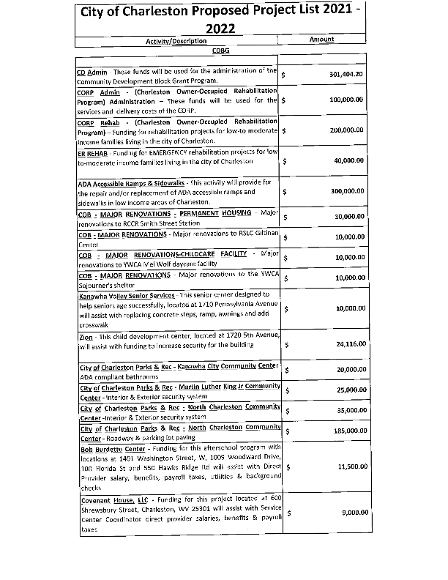
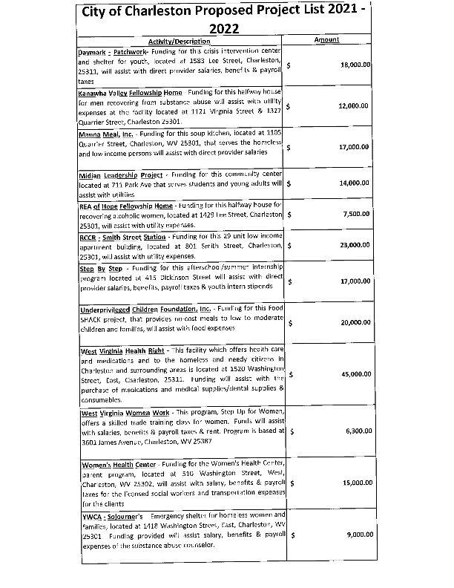
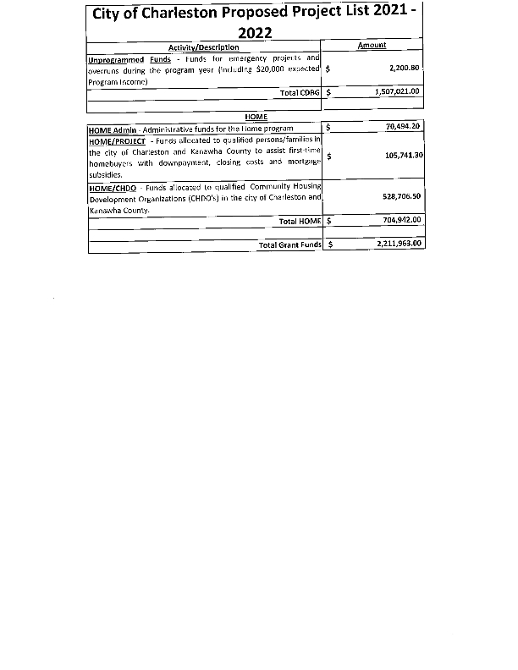
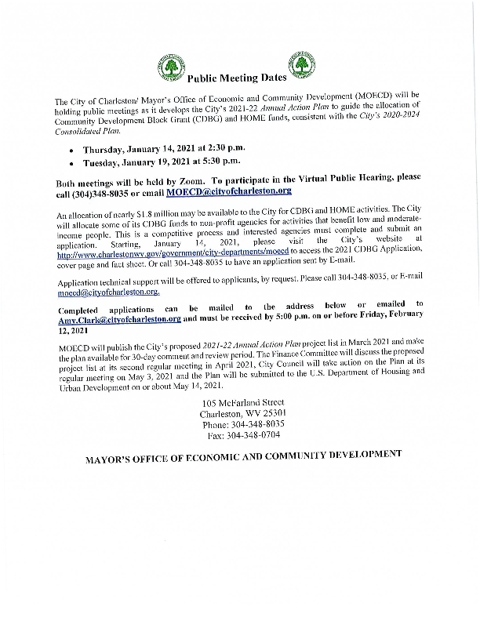
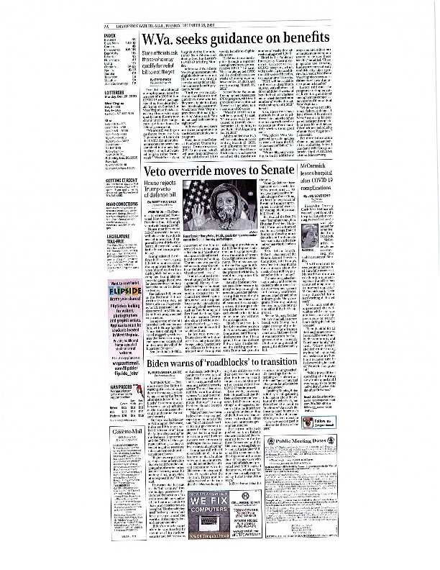
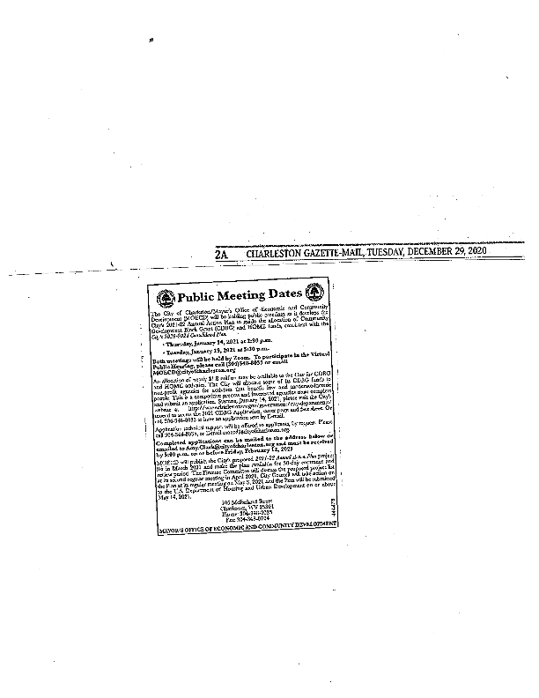
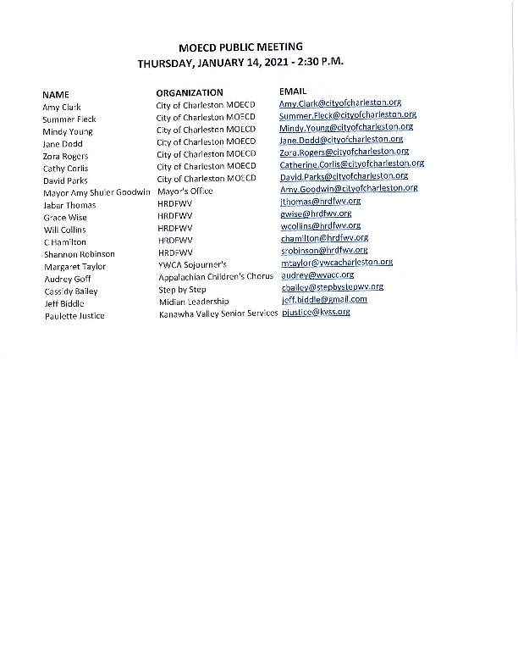
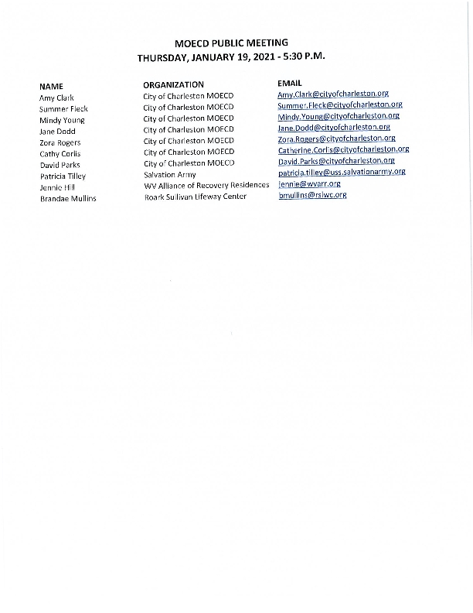
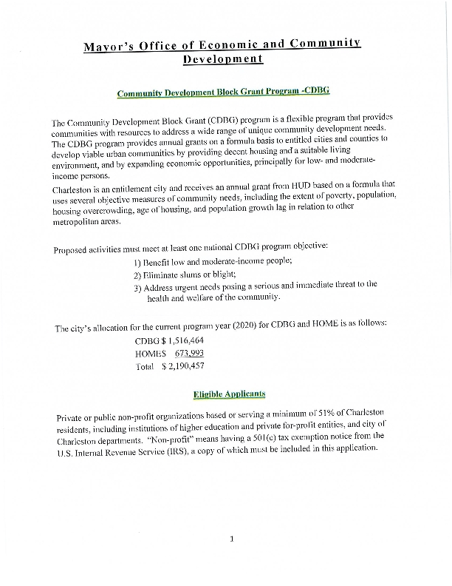
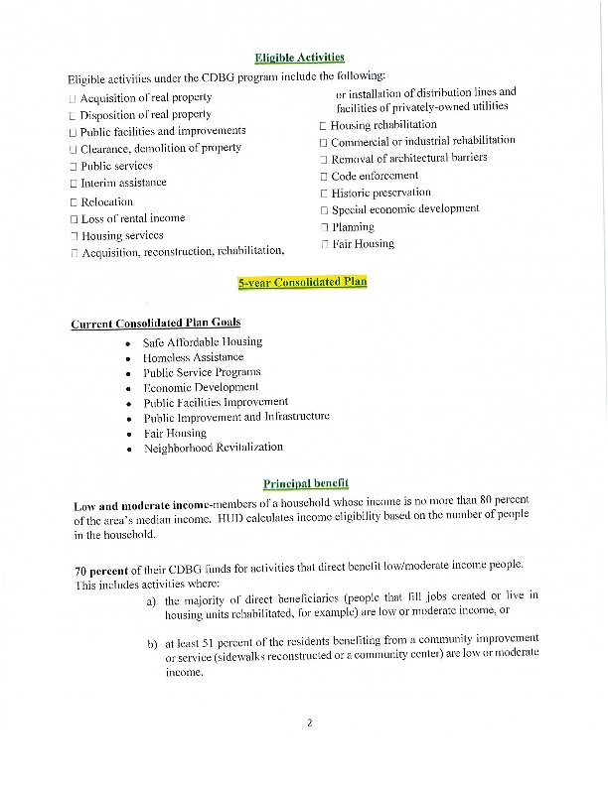
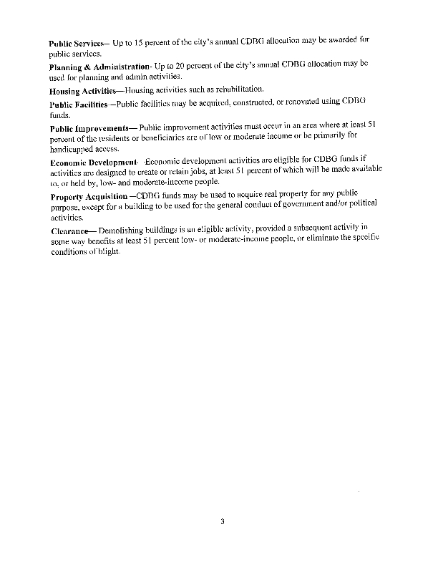
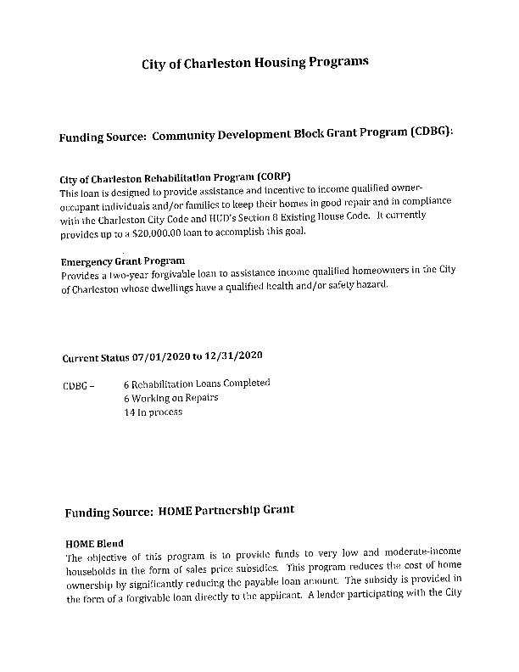
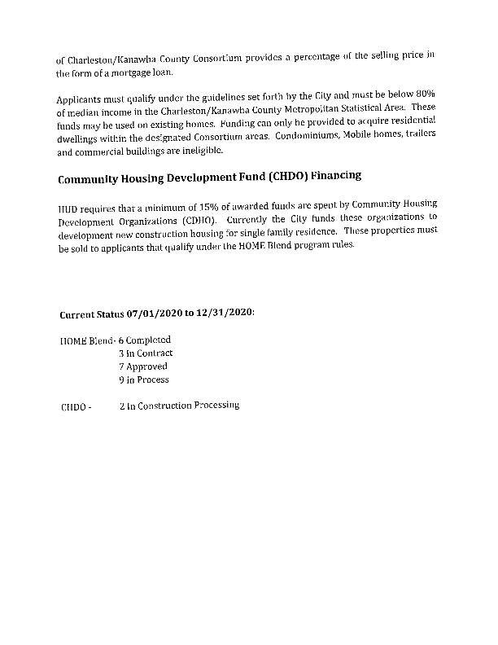
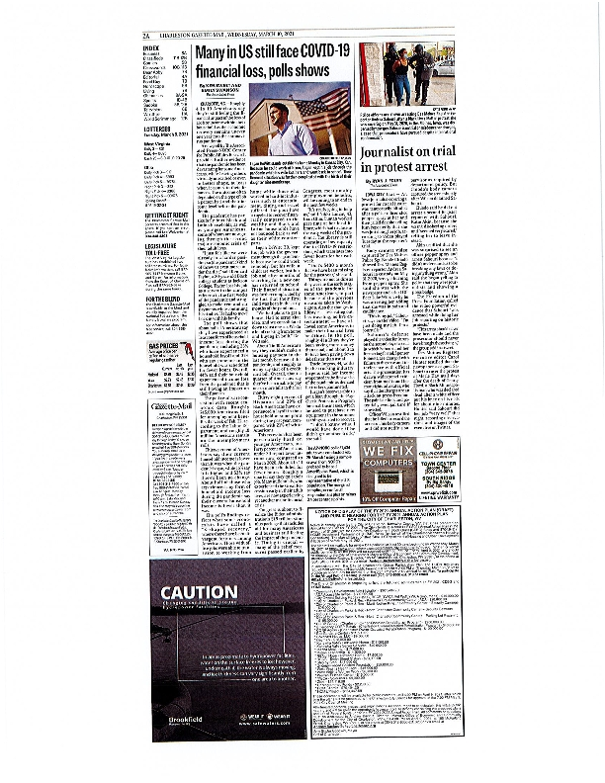
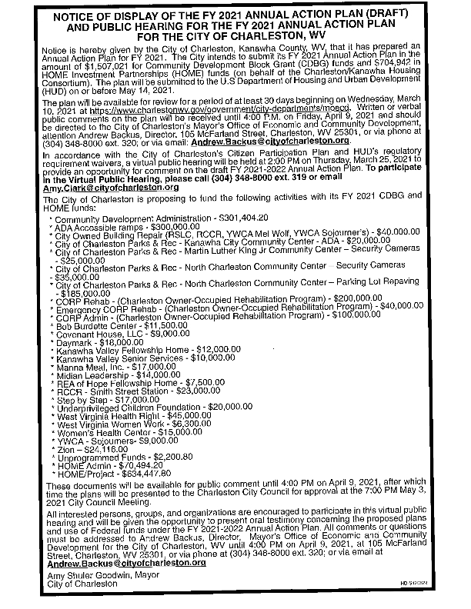
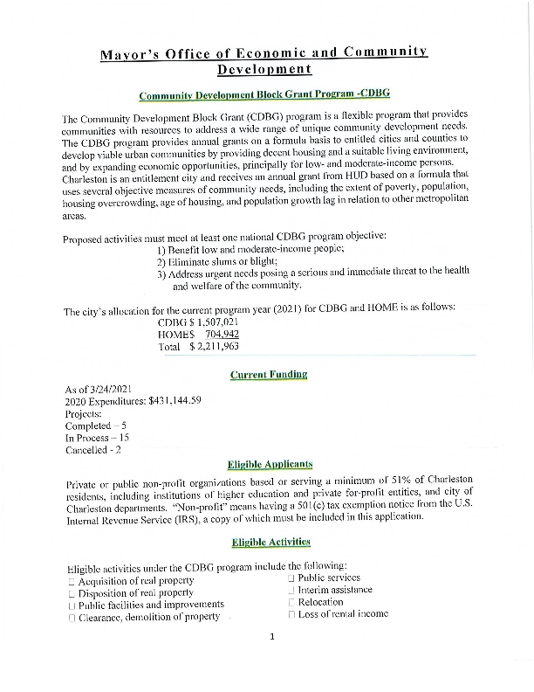
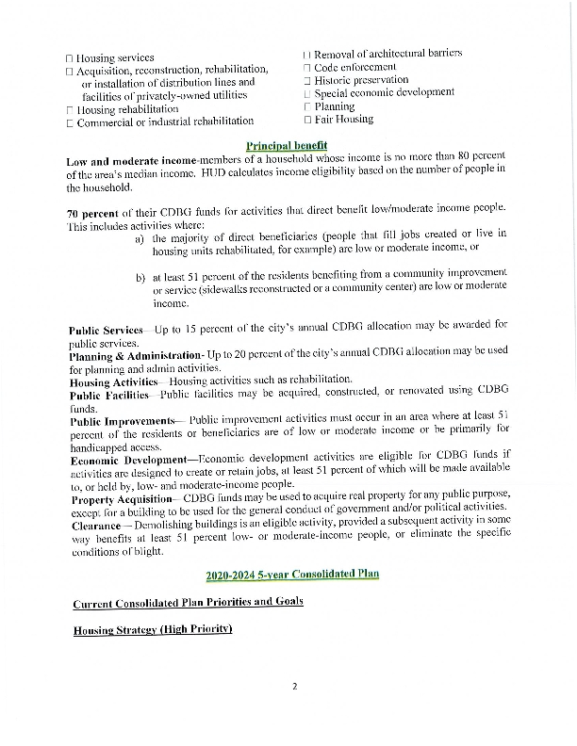
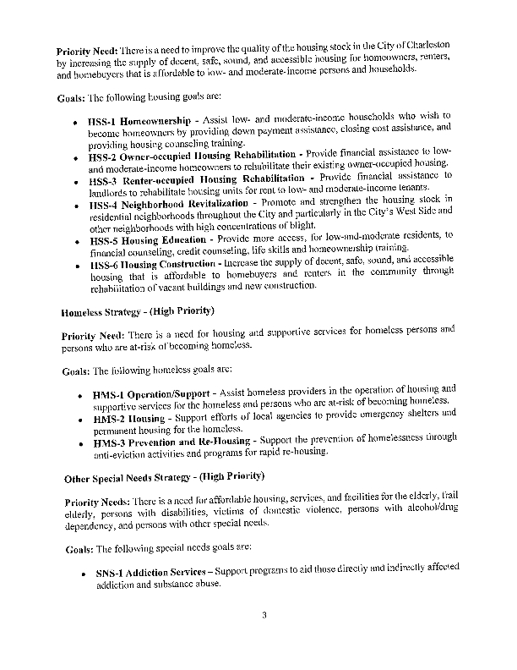
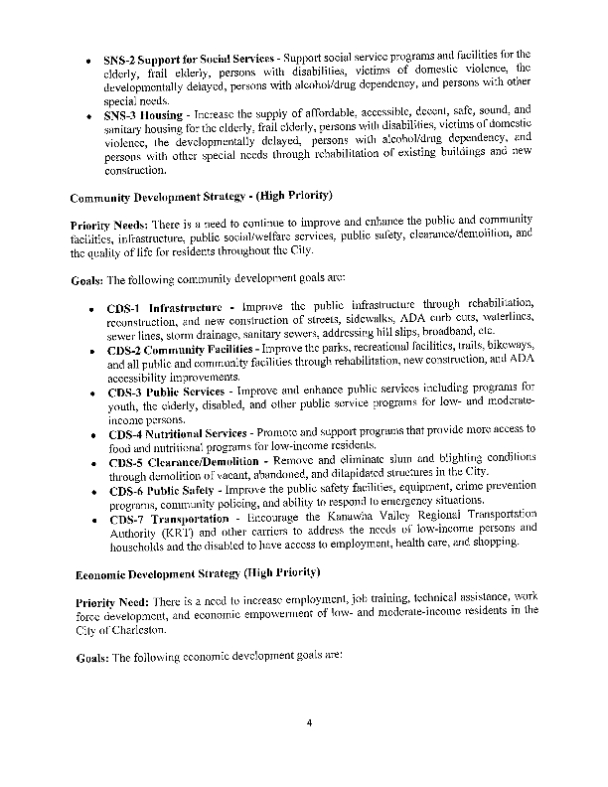
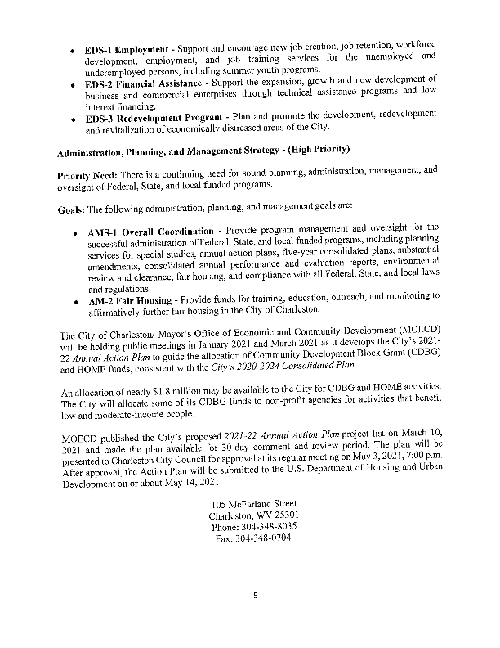
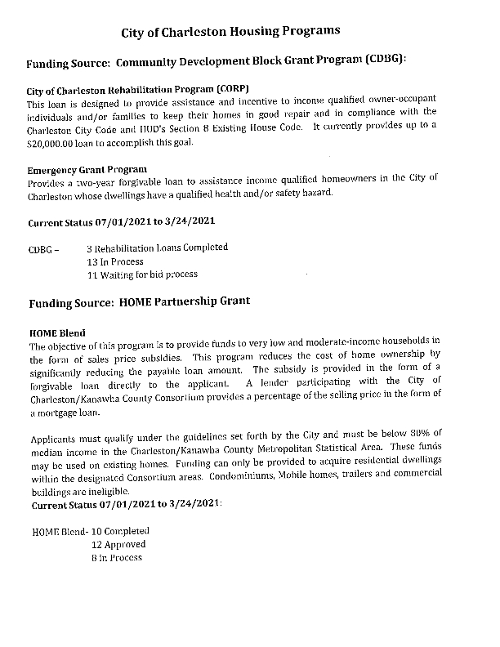
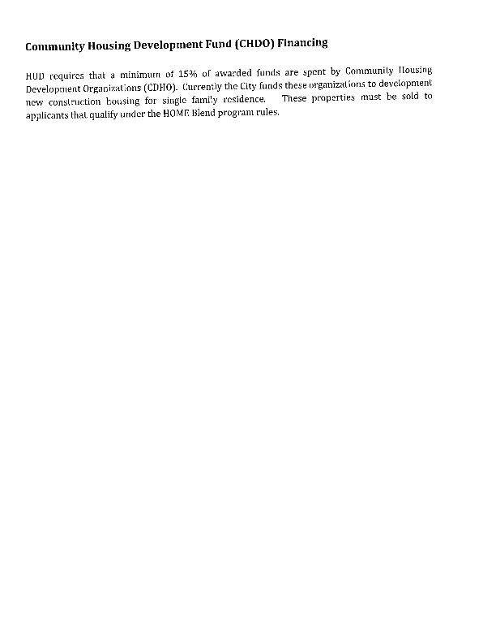
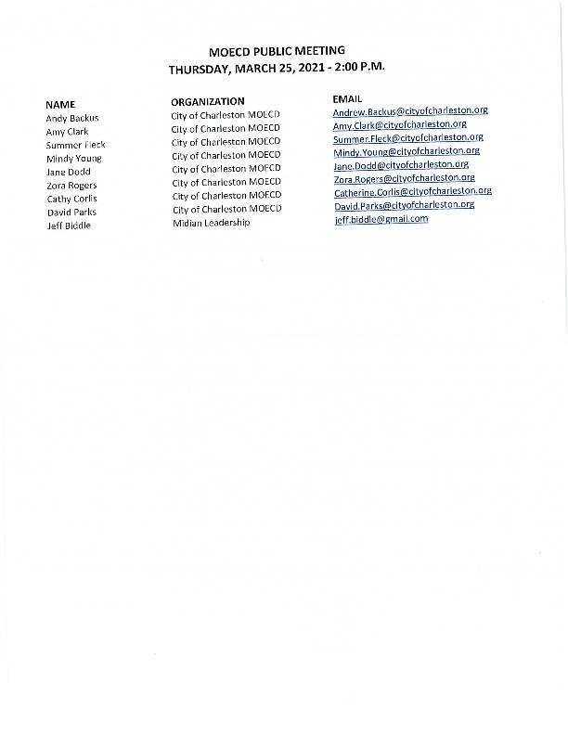

Grantee SF-424's and Certification(s)
