Executive Summary

ES-05 Executive Summary - 24 CFR 91.200(c), 91.220(b)
1. Introduction
The Consolidated Plan for the City of Charleston, West Virginia, has been prepared in response to a consolidated process developed by the U.S. Department of Housing and Urban Development (HUD) for the Community Development Block Grant (CDBG) and Home Investment Partnerships Act (HOME) programs.
This Consolidated Plan outlines housing, community and economic development needs, priorities, strategies, and projects that will be undertaken by the City of Charleston with the funds that the City receives from the U.S. Department of Housing and Urban Development (HUD). As an entitlement jurisdiction, the City receives an annual share of federal CDBG and HOME funds. In order to receive its CDBG entitlement, the City must submit this Consolidated Plan and First Year Annual Action Plan to HUD. The funds are intended to provide lower and moderate-income households with viable communities, including decent housing, a suitable living environment, and expanded economic opportunities. Eligible activities include community facilities and improvements, housing rehabilitation and preservation, development activities, public services, economic development, planning, and program administration.
The Consolidated Plan serves the following functions: 1) A planning document for the City, which builds upon a citizen participation process; 2) An application for federal funds under HUD’s formula grant programs; 3) A strategy to be followed in carrying out HUD programs; and, 4) An action plan that provides a basis for assessing performance.

2. Summary of the objectives and outcomes identified in the Plan Needs Assessment Overview
The needs in these low/mod areas are numerous and varied. The principal needs are: 1) housing rehabilitation for owner occupied units, 2) assistance for extremely low-income households threatened with homelessness, 3) public improvements to improve/revitalize neighborhoods), 4) public services, and 5) assisting the homeless.
The City believes that rehabilitation of both rental and owner housing units is a High priority, as these efforts keep people in affordable housing and, especially for extremely low-income and elderly homeowners may serve to prevent homelessness. Similarly, Homeless activities, ranging from providing emergency shelter to preventing homelessness receive a High priority.
While the City supports programs for affordable homeownership, the opportunities for homeownership among the City’s low-income residents are limited by the poor economy, job uncertainty, strict lending criteria and significant down payment requirements. Homeowner loan programs are still given a High priority ranking, however, and efforts will be made to assist those seeking to purchase a home.
Because of the difficult economic situation in the City’s low/mod Census Tracts the provision of Public Service Programs receives a High priority rank. The need for a wide range of services, including programs for seniors and youth, feeding programs, and child care, is present in each of these areas.
Public Facilities, Public Improvements, and Infrastructure are very important to the City and receive a High rating.
Fair Housing is a concern in the City and also receives a High ranking.

3. Evaluation of past performance
Past performance and activities were a part of formulating the strategies for this Plan. The City’s needs are many and significant, and the success of previous programs and the need to complete some already under way did influence both public and staff perceptions of needs and priorities. The Self-Evaluation sections of our recent CAPERs describe our progress in providing decent, safe, and affordable housing, in the demolition of dilapidated structures, the improvement of the housing stock through our code enforcement program and the provision of important public services.

4. Summary of citizen participation process and consultation process
The City considers the involvement of its low- and moderate-income residents to be essential to the development and implementation of its Five-Year Consolidated Plan and Annual Action Plans.
The City of Charleston has an approved Citizen Participation Plan, as required by HUD. The City has abided by its Citizen Participation Plan in the preparation and development of the FY 2015-2019 Consolidated Plan and the FY 2015 Annual Action Plan.
Well publicized public hearings were held on two occasions – January 20, 2015 at Schoenbaum Center at 6:00 PM and on March 19 a second Public Hearing was held at The Kanawha City Community Center, 3511 Venable Avenue, Charleston WV. These sessions were part of a concerted effort to obtain as much public input as possible in the course of Plan preparation.
The City also conducted two focus group meetings, held on January 20 and 21, 2015 at City Service Center. Representatives from community service organizations attended one session, and members of the housing development and real estate community attended another. Active participation by attendees at both meetings provided insight into community and neighborhood needs. The Consolidated Plan was also discussed at the City staff meeting held on the morning of January 20. This staff meeting was attended by the Mayor and all City Department heads, and comments and community needs were solicited from the attendees.
The City also prepared a Web-based community survey to obtain additional public input. The survey was available on the City Website from December 15, 2014, until February 14, 2014, and hard copies were made available at the first public hearings, and at the focus group meetings. The City received 172 responses.
The Consolidated Plan and first-year Annual Action Plan were presented at two City Council meetings, the first reading taking place on April 20, 2015, and the plans approved at the May 4th meeting. The public was permitted to comment at both meetings.
The City ensures that all Public Hearings are held at times and locations convenient to potential and actual beneficiaries and with accommodations for persons with disabilities. Upon request, in advance of the meeting, the City will attempt to make accommodations for those individuals in need of special assistance. The City also provides technical assistance workshops for all interested in the programs.

5. Summary of public comments
The City received program and priority ideas from the public during the focus group meetings. However, no comments were received during the 30-day public review period. All comments are included in the participation appendix to this Plan.

6. Summary of comments or views not accepted and the reasons for not accepting them
The City accepted all comments that were offered.

7. Summary
The primary objective of the City’s CDBG and HOME activities is the provision of safe, affordable housing, the provision of a suitable living environment and the expansion of economic opportunity for low and moderate-income persons. This definition includes a wide range of programs and activities as described in the following sections of the Consolidated Plan and first-year Annul Action Plan.

The Process

PR-05 Lead & Responsible Agencies 24 CFR 91.200(b)
1. Describe agency/entity responsible for preparing the Consolidated Plan and those responsible for administration of each grant program and funding source
The following are the agencies/entities responsible for preparing the Consolidated Plan and those responsible for administration of each grant program and funding source.
Agency Role | Name | Department/Agency
Lead Agency | CHARLESTON

CDBG Administrator | CHARLESTON | City of Charleston Mayor's Office of Economic & Co
HOPWA Administrator
HOME Administrator | CHARLESTON | City of Charleston Mayor's Office of Economic & Co
HOPWA-C Administrator
Table 1 – Responsible Agencies

Narrative
The City of Charleston’s Mayor's Office of Economic & Community Development (MOECD) is the lead agency for the completion of the Consolidated Plan and the implementation of the Annual Action Plan, as well as the responsible party for the processing and distribution of federal funds under the Community Development Block Grant (CDBG) and HOME Investment Partnership (HOME) programs, once allocated by the federal government and approved by the City Council.
Other offices and agencies responsible for executing and administering programs covered by the Consolidated Plan include the City Engineer, the Building Commission, the Human Rights Commission, the Planning Department, the Fire Department, Public Works, Parks and Recreation, the Mayor’s Office, the Police Department, and the City Manager.

Consolidated Plan Public Contact Information
Mr. Brian King, Director
Mayor’s Office of Economic and Community Development
105 McFarland Street
Charleston, West Virginia 25301

Tel: (304) 348-8035
Fax: (304) 348-0704
E-mail: moecd@cityofcharleston.org

PR-10 Consultation - 91.100, 91.200(b), 91.215(l)
1. Introduction
The development of this Consolidated Plan included public hearings as well as consultation with public and private agencies that provide assisted housing, health services, mental health services, and social services. Community and economic development entities were also consulted.

Provide a concise summary of the jurisdiction’s activities to enhance coordination between public and assisted housing providers and private and governmental health, mental health and service agencies (91.215(I)).
The City of Charleston Mayor's Office of Economic and Community Development (MOECD) typically holds a series of meetings with non-profits, local housing providers, social service agencies, and community and economic development organizations to address these issues. MOECD holds two public hearings annually and agencies/organizations submit applications for specific activities. The city is also a member of the local Continuum of Care, the Kanawha Valley Collective (KVC). The KVC includes many public and assisted housing providers and private and governmental health, mental health and service agencies, and thus provides an effective coordination of resources.

Describe coordination with the Continuum of Care and efforts to address the needs of homeless persons (particularly chronically homeless individuals and families, families with children, veterans, and unaccompanied youth) and persons at risk of homelessness
The City of Charleston, as a member of the KVC, continually reaches out to any individual or organization with an interest or knowledge of ending and preventing homelessness at every membership meeting, social media and its web site. The KVC formed a panel that traveled through the service area to explain the various services and to hear concerns. The KVC also sponsors events that bring public awareness to the plight of the homeless and those at risk.
The KVC has an HMIS specialist to track statistics and trends that enable the KVC to better serve the homeless or those at risk. KVC also created an ESG committee made up of a variety of agencies and staff to get their input and opinions regarding ending and prevention of homelessness. Through the CDBG, Supportive Housing Program (SHP), and Emergency Solutions Grant (ESG) programs, the City of Charleston historically funds many of the homeless shelters and nonprofit homeless service providers for activities that assist the homeless and those at risk of becoming homeless
Describe consultation with the Continuum(s) of Care that serves the jurisdiction's area in determining how to allocate ESG funds, develop performance standards and evaluate outcomes, and develop funding, policies and procedures for the administration of HMIS
The City of Charleston Mayor's Office of Economic and Community Development (MOECD) has a long history of collaboration with the local Continuum of Care (CoC), the Kanawha Valley Collective (KVC), and the West Virginia Governor's Office of Economic Opportunity (GOEO). MOECD has represented the City of Charleston as a member of the KVC since its inception in 1997. Currently a staff member of the MOECD serves on the board of directors of the KVC and several other committees, including the Emergency Solutions Grant (ESG) and the Homeless Management Information System (HMIS).

Discussions involving the Hearth Act of 2009, HMIS requirements, and the new Emergency Solutions Grant are on-going. The city of Charleston staff consulted with a KVC designated ESG working committee, made up of board members, ESG sub-recipients, HPRP sub-recipients and staff to get their input on determining how to allocate ESG funds for eligible activities, developing the performance standards for activities funded under ESG and developing funding, policies, and procedures for the operation and administration of the HMIS. Numerous consultation meetings have taken place with the Homeless Management Information Systems (HMIS) specialist, and the Continuum of Care's Project Resource Committee.

2. Describe Agencies, groups, organizations and others who participated in the process and describe the jurisdictions consultations with housing, social service agencies and other entities

Table 2 – Agencies, groups, organizations who participated
1 | Agency/Group/Organization | ROARK SULLIVAN LIFEWAY CENTER
 | Agency/Group/Organization Type | Services-homeless
 | What section of the Plan was addressed by Consultation? | Homelessness Strategy  Homeless Needs - Chronically homeless  Homelessness Needs - Veterans
 | How was the Agency/Group/Organization consulted and what are the anticipated outcomes of the consultation or areas for improved coordination? | Roark Sullivan Lifeway Center was consulted through CoC meetings, public meetings, and workshops. The City of Charleston is a member agency of the KVC which gives much opportunity for continued and improved coordination with other member agencies.
2 | Agency/Group/Organization | Charleston West Side Main Street
 | Agency/Group/Organization Type | Planning organization
 | What section of the Plan was addressed by Consultation? | Economic Development
 | How was the Agency/Group/Organization consulted and what are the anticipated outcomes of the consultation or areas for improved coordination? | The organization was consulted through meetings and discussions about economic development needs. These discussions led to a better understanding of needs and priorities.
3 | Agency/Group/Organization | DAYMARK
 | Agency/Group/Organization Type | Services-homeless
 | What section of the Plan was addressed by Consultation? | Homeless Needs - Chronically homeless  Homelessness Needs - Unaccompanied youth
 | How was the Agency/Group/Organization consulted and what are the anticipated outcomes of the consultation or areas for improved coordination? | Daymark was consulted through public meetings and workshops. The City of Charleston is a member agency of the KVC which gives much opportunity for continued and improved coordination with other member agencies.
4 | Agency/Group/Organization | COMMUNITY ACCESS
 | Agency/Group/Organization Type | Services-Persons with Disabilities  Services-homeless
 | What section of the Plan was addressed by Consultation? | Public Housing Needs
 | How was the Agency/Group/Organization consulted and what are the anticipated outcomes of the consultation or areas for improved coordination? | Community Access was consulted through CoC meetings, public meetings, and workshops. The City of Charleston is a member agency of the KVC which gives much opportunity for continued and improved coordination with other member agencies.
5 | Agency/Group/Organization | RELIGIOUS COALITION FOR COMMUNITY RENEWAL
 | Agency/Group/Organization Type | Services - Housing  Services-homeless
 | What section of the Plan was addressed by Consultation? | Homelessness Strategy
 | How was the Agency/Group/Organization consulted and what are the anticipated outcomes of the consultation or areas for improved coordination? | RCCR was consulted through public meetings, application workshops, and monitoring visits. The City of Charleston and RCCR are both active members of the CoC which provides opportunity for continued and improved coordination with issues surrounding homelessness.RCCR is also a CHDO and consults with MOECD regularly on issues regarding housing RCCR is also a CHDO and consults with MOECD regularly on issues regarding housing.ing.
6 | Agency/Group/Organization | COVENANT HOUSE
 | Agency/Group/Organization Type | Services-homeless
 | What section of the Plan was addressed by Consultation? | Homelessness Strategy
 | How was the Agency/Group/Organization consulted and what are the anticipated outcomes of the consultation or areas for improved coordination? | Covenant House was consulted through public meetings, application workshops, and monitoring visits. The City of Charleston and Covenant House are both active members of the CoC which provides opportunity for continued and improved coordination with issues surrounding homelessness.
7 | Agency/Group/Organization | PRO KIDS
 | Agency/Group/Organization Type | Services-Children
 | What section of the Plan was addressed by Consultation? | Anti-poverty Strategy
 | How was the Agency/Group/Organization consulted and what are the anticipated outcomes of the consultation or areas for improved coordination? | Pro-Kids was consulted through public meetings, application workshops and monitoring visits. The City of Charleston/MOECD has an open door policy and provides technical assistance to agencies as needed. This open communication provides opportunity for continued and improved coordination with issues surrounding anti-poverty as is relates to child care and education.
8 | Agency/Group/Organization | MANNA MEAL
 | Agency/Group/Organization Type | Services-homeless
 | What section of the Plan was addressed by Consultation? | Homelessness Strategy
 | How was the Agency/Group/Organization consulted and what are the anticipated outcomes of the consultation or areas for improved coordination? | Manna Meals was consulted through public meetings, application workshops and monitoring visits. The City of Charleston/MOECD has an open door policy and provides technical assistance to agencies as needed. This open communication provides opportunity for continued and improved coordination with issues surrounding anti-poverty as is relates to child care and education.
9 | Agency/Group/Organization | REA OF HOPE
 | Agency/Group/Organization Type | Services-Persons with Disabilities
 | What section of the Plan was addressed by Consultation? | Homelessness Strategy
 | How was the Agency/Group/Organization consulted and what are the anticipated outcomes of the consultation or areas for improved coordination? | Rea of Hope was consulted through public meetings, application workshops and monitoring visits. The City of Charleston and Rea of Hope are both active members of the CoC which provides opportunity for continued and improved coordination with issues surrounding homelessness
10 | Agency/Group/Organization | WOMEN'S HEALTH CENTER
 | Agency/Group/Organization Type | Health Agency
 | What section of the Plan was addressed by Consultation? | Homelessness Strategy  Anti-poverty Strategy
 | How was the Agency/Group/Organization consulted and what are the anticipated outcomes of the consultation or areas for improved coordination? | Women's Health Center was consulted through public meetings, application workshops and monitoring visits. The City of Charleston and Women's Health Center are both active members of the CoC which provides opportunity for continued and improved coordination with issues surrounding homelessness and health care, specifically for pregnant women and infants.
11 | Agency/Group/Organization | KANAWHA VALLEY FELLOWSHIP HOME
 | Agency/Group/Organization Type | Services-Persons with Disabilities
 | What section of the Plan was addressed by Consultation? | Homelessness Strategy
 | How was the Agency/Group/Organization consulted and what are the anticipated outcomes of the consultation or areas for improved coordination? | KVFH was consulted through public meetings, application workshops and monitoring visits. The City of Charleston and KVFH are both active members of the CoC which provides opportunity for continued and improved coordination with issues surrounding homelessness and substance abuse.
12 | Agency/Group/Organization | WV HEALTH RIGHT
 | Agency/Group/Organization Type | Health Agency
 | What section of the Plan was addressed by Consultation? | Homelessness Strategy  Anti-poverty Strategy
 | How was the Agency/Group/Organization consulted and what are the anticipated outcomes of the consultation or areas for improved coordination? | WV Health Right was consulted through public meetings, application workshops and monitoring visits. The City of Charleston/MOECD has an open door policy and provides technical assistance to agencies as needed. This open communication provides opportunity for continued and improved coordination with issues surrounding anti-poverty as is relates to health care.
13 | Agency/Group/Organization | WV WOMEN WORK
 | Agency/Group/Organization Type | Services-Education  Services-Employment
 | What section of the Plan was addressed by Consultation? | Anti-poverty Strategy
 | How was the Agency/Group/Organization consulted and what are the anticipated outcomes of the consultation or areas for improved coordination? | WV Women Work was consulted through public meetings, application workshops and monitoring visits. The City of Charleston/MOECD has an open door policy and provides technical assistance to agencies as needed. This open communication provides opportunity for continued and improved coordination with issues surrounding anti-poverty as is relates to jobs.
14 | Agency/Group/Organization | KISRA
 | Agency/Group/Organization Type | Housing
 | What section of the Plan was addressed by Consultation? | Housing Need Assessment
 | How was the Agency/Group/Organization consulted and what are the anticipated outcomes of the consultation or areas for improved coordination?
15 | Agency/Group/Organization | HOPE COMMUNITY DEVELOPMENT CORP
 | Agency/Group/Organization Type | Housing
 | What section of the Plan was addressed by Consultation? | Housing Need Assessment
 | How was the Agency/Group/Organization consulted and what are the anticipated outcomes of the consultation or areas for improved coordination? | Consultation with Hope CDC, a local nonprofit operating in Charleston, regarding assessment and housing rehabilitation in the local Homeownership Zone, for improved coordination.
16 | Agency/Group/Organization | WEST VIRGINIA HOUSING DEVELOPMENT FUND
 | Agency/Group/Organization Type | Other government - State
 | What section of the Plan was addressed by Consultation? | Housing Provider
 | How was the Agency/Group/Organization consulted and what are the anticipated outcomes of the consultation or areas for improved coordination? | Consultations about requirements for the first-time homebuyer.
17 | Agency/Group/Organization | YMCA of Charleston WV
 | Agency/Group/Organization Type | Services-Children  Services-homeless
 | What section of the Plan was addressed by Consultation? | Homelessness Strategy
 | How was the Agency/Group/Organization consulted and what are the anticipated outcomes of the consultation or areas for improved coordination? | The YWCA was consulted through public meetings, application workshops and monitoring visits. The City of Charleston and the YWCA are both active members of the CoC which provides opportunity for continued and improved coordination with issues surrounding homelessness.
18 | Agency/Group/Organization | City Building Department Charleston WV
 | Agency/Group/Organization Type | Other government - Local
 | What section of the Plan was addressed by Consultation? | Housing Need Assessment
 | How was the Agency/Group/Organization consulted and what are the anticipated outcomes of the consultation or areas for improved coordination? | MOECD meets twice weekly to consult with other city departments on such issues regarding barriers to affordable housing, abandoned and vacant housing and infrastructure improvement.
19 | Agency/Group/Organization | City Engineering Department Charleston WV
 | Agency/Group/Organization Type | Other government - Local
 | What section of the Plan was addressed by Consultation? | Community Development Stragey
 | How was the Agency/Group/Organization consulted and what are the anticipated outcomes of the consultation or areas for improved coordination? | MOECD meets twice weekly to consult with other city departments on such issues regarding barriers to affordable housing, abandoned and vacant housing and infrastructure improvement.
20 | Agency/Group/Organization | MOECD/Rehab
 | Agency/Group/Organization Type | Other government - Local
 | What section of the Plan was addressed by Consultation? | Lead-based Paint Strategy
 | How was the Agency/Group/Organization consulted and what are the anticipated outcomes of the consultation or areas for improved coordination? | MOECD housing staff meet regularly to consult on housing issues including lead based paint strategies.
21 | Agency/Group/Organization | The Greater Kanawha Valley Foundation
 | Agency/Group/Organization Type | Regional organization
 | What section of the Plan was addressed by Consultation? | Market Analysis
 | How was the Agency/Group/Organization consulted and what are the anticipated outcomes of the consultation or areas for improved coordination? | MOECD has consulted with this agency, a local funder, on housing issues as well as leadership issues.
22 | Agency/Group/Organization | CURA
 | Agency/Group/Organization Type | Other government - Local
 | What section of the Plan was addressed by Consultation? | Economic Development
 | How was the Agency/Group/Organization consulted and what are the anticipated outcomes of the consultation or areas for improved coordination? | Consultation on downtown issues, housing opportunity in the Homeownership Zone and Charleston's Westside for improved collaboration.
23 | Agency/Group/Organization | City Planning Department of Charleston WV
 | Agency/Group/Organization Type | Other government - Local
 | What section of the Plan was addressed by Consultation? | Community Development
 | How was the Agency/Group/Organization consulted and what are the anticipated outcomes of the consultation or areas for improved coordination? | MOECD meets twice weekly to consult with other city departments on such issues regarding barriers to affordable housing, abandoned and vacant housing and infrastructure improvement.
24 | Agency/Group/Organization | WV Human Rights Commission
 | Agency/Group/Organization Type | Other government - State
 | What section of the Plan was addressed by Consultation? | Non-Homeless Special Needs  Public Services
 | How was the Agency/Group/Organization consulted and what are the anticipated outcomes of the consultation or areas for improved coordination? | Fair Housing issues
25 | Agency/Group/Organization | Huntington Bank, Inc
 | Agency/Group/Organization Type | Business Leaders  Private Sector Banking / Financing
 | What section of the Plan was addressed by Consultation? | Lender
 | How was the Agency/Group/Organization consulted and what are the anticipated outcomes of the consultation or areas for improved coordination? | MOECD consults regularly with this institution to address the financial needs and documentation requirements for loan qualification processes
26 | Agency/Group/Organization | Wesbanco, Inc
 | Agency/Group/Organization Type | Business Leaders  Private Sector Banking / Financing
 | What section of the Plan was addressed by Consultation? | Lender
 | How was the Agency/Group/Organization consulted and what are the anticipated outcomes of the consultation or areas for improved coordination? | MOECD consults regularly with this institution to address the financial needs and documentation requirements for loan qualification processes

Identify any Agency Types not consulted and provide rationale for not consulting
To the best of its ability, the City has been in contact with all known agencies and organizations involved in activities that are relevant to CDBG, HOME, and ESG activities and programs.

Other local/regional/state/federal planning efforts considered when preparing the Plan
Name of Plan | Lead Organization | How do the goals of your Strategic Plan overlap with the goals of each plan?
Continuum of Care | Kanawha Valley Collective, Inc. | The City of Charleston and the KVC work in coordination with the development of homeless strategies, ESG and HMIS implementation.
Table 3 – Other local / regional / federal planning efforts
Describe cooperation and coordination with other public entities, including the State and any adjacent units of general local government, in the implementation of the Consolidated Plan (91.215(l))
An MOECD staff member serves on the board of the Kanawha Valley Collective, the local CoC, and consults with other members, including state and local HUD representatives on a regular basis. The Kanawha Valley Collective is a consortium of individuals and organizations working collaboratively to enrich the quality of life for individuals and families in the Kanawha Valley and surrounding areas. The Kanawha Valley Collective provides a seamless service delivery system through direct services, advocacy, education and prevention which address homelessness, the impact of poverty, and other social problems.

Narrative (optional):

PR-15 Citizen Participation
1. Summary of citizen participation process/Efforts made to broaden citizen participation
Summarize citizen participation process and how it impacted goal-setting

The City considers the involvement of its low- and moderate-income residents to be essential to the development and implementation of its Five-Year Consolidated Plan and Annual Action Plans.

The City of Charleston has an approved Citizen Participation Plan, as required by HUD. The City has abided by its Citizen Participation Plan in the preparation and development of the FY 2015-2019 Consolidated Plan and the FY 2015 Annual Action Plan.

Well publicized public hearings were held on two occasions – January 20, 2015 at Schoenbaum Center at 6:00 PM and on March 19 a second Public Hearing was held at The Kanawha City Community Center, 3511 Venable Avenue, Charleston WV. These sessions were part of a concerted effort to obtain as much public input as possible in the course of Plan preparation.

The City also conducted two focus group meetings, held on January 20 and 21, 2015 at City Service Center. Representatives from community service organizations attended one session, and members of the housing development and real estate community attended another. Active participation by attendees at both meetings provided insight into community and neighborhood needs. The Consolidated Plan was also discussed at the City staff meeting held on the morning of January 20. This staff meeting was attended by the Mayor and all City Department heads, and comments and community needs were solicited from the attendees.

The City also prepared a Web-based community survey to obtain additional public input. The survey was available on the City Website from December 15, 2014, until February 14, 2014, and hard copies were made available at the first public hearings, and at the focus group meetings. The City received 172 responses.

The Consolidated Plan and first-year Annual Action Plan were presented at two City Council meetings, the first reading taking place on April 20, 2015, and the plans approved at the May 4th meeting. The public was permitted to comment at both meetings.

The City ensures that all Public Hearings are held at times and locations convenient to potential and actual beneficiaries and with accommodations for persons with disabilities. Upon request, in advance of the meeting, the City will attempt to make accommodations for those individuals in need of special assistance. The City also provides technical assistance workshops for all interested in the programs.

Citizen Participation Outreach
Sort Order | Mode of Outreach | Target of Outreach | Summary of  response/attendance | Summary of  comments received | Summary of comments not accepted and reasons | URL (If applicable)
1 | City Staff Meeting | City staff | Mayor, 19 Department Heads, ad key staff | Discussion of needs and priorities | All comments accepted
2 | City Staff Meeting | Housing developers, lenders and realtors | 7 attendees | Identified key needs and priorities; discussion of other community needs | All comments accepted
3 | Public Hearing | Non-targeted/broad community | 6 attendees | Wide ranging discussion | All comments accepted
4 | City Staff Meeting | Non-targeted/broad community  Public Service Providers | 7 attendees | Excellent discussion of needs and priorities | All comments accepted
5 | City Staff Meeting | Non-targeted/broad community | 172 responses | Identification of needs and priorities | All comments accepted
6 | Public Hearing | Non-targeted/broad community | No attendees | N/A | N/A
7 | City Staff Meeting | Non-targeted/broad community | No comments received | N/A | N/A
8 | City Staff Meeting | Non-targeted/broad community | Members of the public present | No comments on the Consolidated Plan | N/A
9 | City Staff Meeting | Non-targeted/broad community | Members of the public present | No comments on the Consolidated Plan | N/A
10 | Newspaper Ad | Non-targeted/broad community | Notice to the Public about Hearings and availability of documents for review | N/A | N/A
Table 4 – Citizen Participation Outreach

Needs Assessment

NA-05 Overview
Needs Assessment Overview
Poverty is a concern in Charleston as 18.4 percent of the population had an income in the preceding twelve months that was below the established poverty level of $23,850. The Median Household income in Charleston is $48,527, as shown in the table below, which, though higher than that of the state is 91.5 percent of the national figure. The poverty percentage for the City is higher than that of the state or the nation. Further, in Charleston, 29.2 percent of persons under 18 are living in poverty.

The City does have a higher percentage of households with retirement income than the nation (21.7% vs. 17.6%) and a higher percentage of households with Social Security income (34.5% vs. 28.3%). At the same time, the percentage of persons with Supplemental Security Income is 6.1 percent compared to the national figure of 4.6 percent. The percentage of persons receiving Food Stamp/SNAP benefits is 14.9 percent, which is three and one-half percent higher than the national percentage, 11.4.
The City has a substantial number of households with an income of less than $15,000; indeed, 10.3 percent of families, some 1,232 households, are below this figure. The percentage of persons with incomes over $100,000 is only slightly below the US percentage because of the high percentage of families with an income greater than $200,000.

HUD has provided detailed data as part of its Comprehensive Housing Affordability Strategy materials to assist in preparing the Consolidated Plan and implementing HUD programs. HUD established five income categories for its analysis of incomes. The five income ranges are:

Extremely Low (0-30% of the median income),
Very Low-income (31-50% of the median income),
Low-income (51-80% of the median),
Moderate-income (81-100% of the median), and
Upper-income (100% and above of the median).
The 2014 Median Income figure for a family of four in Charleston, calculated by HUD, is $55,800, so by HUD definitions, 3,962 (38.3 %) of Charleston families are in the low-income categories.

NA-10 Housing Needs Assessment - 24 CFR 91.205 (a,b,c)
Summary of Housing Needs

Demographics | Base Year: 2000 | Most Recent Year: 2011 | % Change
Population | 53,421 | 51,360 | -4%
Households | 24,522 | 23,907 | -3%
Median Income | $34,009.00 | $46,004.00 | 35%
Table 5 - Housing Needs Assessment Demographics

Data Source: | 2000 Census (Base Year), 2007-2011 ACS (Most Recent Year)

Number of Households Table
 | 0-30% HAMFI | >30-50% HAMFI | >50-80% HAMFI | >80-100% HAMFI | >100% HAMFI
Total Households * | 3,095 | 2,750 | 3,230 | 1,940 | 12,885
Small Family Households * | 770 | 710 | 875 | 675 | 5,070
Large Family Households * | 70 | 79 | 165 | 54 | 700
Household contains at least one person 62-74 years of age | 405 | 450 | 330 | 380 | 2,685
Household contains at least one person age 75 or older | 330 | 640 | 995 | 290 | 1,385
Households with one or more children 6 years old or younger * | 509 | 297 | 225 | 249 | 545

* the highest income category for these family types is >80% HAMFI
Table 6 - Total Households Table
Data Source: | 2007-2011 CHAS

Housing Needs Summary Tables
1. Housing Problems (Households with one of the listed needs)
 | Renter |  |  |  |  | Owner
 | 0-30% AMI | >30-50% AMI | >50-80% AMI | >80-100% AMI | Total | 0-30% AMI | >30-50% AMI | >50-80% AMI | >80-100% AMI | Total
NUMBER OF HOUSEHOLDS
Substandard Housing - Lacking complete plumbing or kitchen facilities | 25 | 4 | 80 | 15 | 124 | 4 | 10 | 25 | 4 | 43
Severely Overcrowded - With >1.51 people per room (and complete kitchen and plumbing) | 45 | 0 | 15 | 0 | 60 | 0 | 0 | 0 | 0 | 0
Overcrowded - With 1.01-1.5 people per room (and none of the above problems) | 15 | 8 | 20 | 0 | 43 | 0 | 0 | 15 | 0 | 15
Housing cost burden greater than 50% of income (and none of the above problems) | 1,380 | 275 | 35 | 50 | 1,740 | 325 | 255 | 120 | 20 | 720
Housing cost burden greater than 30% of income (and none of the above problems) | 310 | 785 | 365 | 119 | 1,579 | 53 | 265 | 275 | 260 | 853
Zero/negative Income (and none of the above problems) | 110 | 0 | 0 | 0 | 110 | 75 | 0 | 0 | 0 | 75
Table 7 – Housing Problems Table
Data Source: | 2007-2011 CHAS

2. Housing Problems 2 (Households with one or more Severe Housing Problems: Lacks kitchen or complete plumbing, severe overcrowding, severe cost burden)
 | Renter |  |  |  |  | Owner
 | 0-30% AMI | >30-50% AMI | >50-80% AMI | >80-100% AMI | Total | 0-30% AMI | >30-50% AMI | >50-80% AMI | >80-100% AMI | Total
NUMBER OF HOUSEHOLDS
Having 1 or more of four housing problems | 1,465 | 290 | 145 | 65 | 1,965 | 330 | 265 | 155 | 24 | 774
Having none of four housing problems | 960 | 1,395 | 1,310 | 800 | 4,465 | 160 | 810 | 1,625 | 1,055 | 3,650
Household has negative income, but none of the other housing problems | 110 | 0 | 0 | 0 | 110 | 75 | 0 | 0 | 0 | 75
Table 8 – Housing Problems 2
Data Source: | 2007-2011 CHAS

3. Cost Burden > 30%
 | Renter |  |  |  | Owner
 | 0-30% AMI | >30-50% AMI | >50-80% AMI | Total | 0-30% AMI | >30-50% AMI | >50-80% AMI | Total
NUMBER OF HOUSEHOLDS
Small Related | 510 | 378 | 124 | 1,012 | 75 | 105 | 120 | 300
Large Related | 45 | 40 | 0 | 85 | 0 | 14 | 15 | 29
Elderly | 285 | 109 | 114 | 508 | 167 | 283 | 205 | 655
Other | 895 | 535 | 195 | 1,625 | 145 | 140 | 75 | 360
Total need by income | 1,735 | 1,062 | 433 | 3,230 | 387 | 542 | 415 | 1,344
Table 9 – Cost Burden > 30%
Data Source: | 2007-2011 CHAS

4. Cost Burden > 50%
 | Renter |  |  |  | Owner
 | 0-30% AMI | >30-50% AMI | >50-80% AMI | Total | 0-30% AMI | >30-50% AMI | >50-80% AMI | Total
NUMBER OF HOUSEHOLDS
Small Related | 485 | 119 | 15 | 619 | 65 | 35 | 20 | 120
Large Related | 35 | 0 | 0 | 35 | 0 | 4 | 15 | 19
Elderly | 215 | 39 | 20 | 274 | 129 | 123 | 60 | 312
Other | 680 | 120 | 0 | 800 | 135 | 105 | 50 | 290
Total need by income | 1,415 | 278 | 35 | 1,728 | 329 | 267 | 145 | 741
Table 10 – Cost Burden > 50%
Data Source: | 2007-2011 CHAS

5. Crowding (More than one person per room)
 | Renter |  |  |  |  | Owner
 | 0-30% AMI | >30-50% AMI | >50-80% AMI | >80-100% AMI | Total | 0-30% AMI | >30-50% AMI | >50-80% AMI | >80-100% AMI | Total
NUMBER OF HOUSEHOLDS
Single family households | 25 | 8 | 25 | 0 | 58 | 0 | 0 | 15 | 0 | 15
Multiple, unrelated family households | 0 | 0 | 10 | 0 | 10 | 0 | 0 | 0 | 0 | 0
Other, non-family households | 35 | 0 | 0 | 0 | 35 | 0 | 0 | 0 | 0 | 0
Total need by income | 60 | 8 | 35 | 0 | 103 | 0 | 0 | 15 | 0 | 15
Table 11 – Crowding Information – 1/2
Data Source: | 2007-2011 CHAS

 | Renter |  |  |  | Owner
 | 0-30% AMI | >30-50% AMI | >50-80% AMI | Total | 0-30% AMI | >30-50% AMI | >50-80% AMI | Total
Households with Children Present | 0 | 0 | 0 | 0 | 0 | 0 | 0 | 0
Table 12 – Crowding Information – 2/2

Data Source Comments:

Describe the number and type of single person households in need of housing assistance.
According to the 2013 ACS figures the percentage of householders living alone in Charleston (42.7%) is higher than the US percentage (27.5%) and the average household size in Charleston is 2.11, lower than the US figure of 2.63. This would indicate a need for smaller units
Figures from table 6 above show that there are 890 small family households in the extremely low-income range and another 690 small households in the very low-income range. Assuming that forty percent of these households are persons living alone, it can be assumed that there are 632 single person households who could need housing assistance.

Estimate the number and type of families in need of housing assistance who are disabled or victims of domestic violence, dating violence, sexual assault and stalking.
The City does not maintain comprehensive statistics on domestic violence and instances of homelessness. However, the West Virginia State Police Uniform Crime Statistics Report for 2012 notes that there were 765 domestic violence investigations in Charleston that year.
ACS figures indicate that there are 9,106 persons with a disability in Charleston, which is 18.1 percent of the population, a figure 6.0 percent higher than the national percentage. Figures broken down by age category show that the percentages of persons with a disability are significantly higher than US figures in each of the age groupings except the elderly. As income levels in Charleston are low, and many of the elderly in particular are living on retirement, Social Security income, or SSI, there is very likely a high degree of need for housing assistance among persons with a disability. The percent of persons living in poverty in Charleston is 18.4 percent, and percent of elderly persons living in poverty is 6.9 percent.
Thus, there appears to be a strong need for housing assistance for the disabled, especially the elderly disabled, within the City, as well as a significant number of victims of domestic violence.
The ESG rapid rehousing and homeless prevention fund administered by the City served 31 victims of domestic violence and 168 disabled persons in the last program year.

What are the most common housing problems?
HUD has identified four housing problems, which are (1) overcrowding, (2) lack of complete kitchen, (3) lack of complete plumbing, and (4) cost burden. Overcrowding means that more than one person per room lives in a housing unit. The lack of complete kitchen or lack of plumbing is straightforward.
By HUD’s definition, when households spend over 30 percent of their income on shelter they are “cost burdened,” and when they spend over 50 percent of their income for shelter they are “severely cost burdened.” Expenditures for shelter include rent or mortgage payments and utility costs.
The most common housing problem per Tables 7, 9 and 10 is cost burden, especially cost burden over 50% for renter households. Sub-standard housing and overcrowding are experienced by relatively few Charleston low-income households.

Are any populations/household types more affected than others by these problems?
Table 10 shows that 1,524 extremely low and 295 very low income renter households report paying rent in excess of 50 percent of income and another 1,873 extremely low and 1,025 very low income renter households report paying over 30 percent of income for rent. These represent 94.7 percent and 84.1 percent respectively of households with these problems. Though low income Owner households report problems, they are not on the scale of the number of Renter households reporting problems.
Tables 9 and 10 show that within the extremely low income range, “Other” households and “Small related” households experience the greatest number of problems with cost burden.
The greatest number of households reporting overcrowding problems are the low-income Renter households (74 households). No low-income owner households report overcrowding.

Describe the characteristics and needs of Low-income individuals and families with children (especially extremely low-income) who are currently housed but are at imminent risk of either residing in shelters or becoming unsheltered 91.205(c)/91.305(c)). Also discuss the needs of formerly homeless families and individuals who are receiving rapid re-housing assistance and are nearing the termination of that assistance
Low-income households at imminent risk of homelessness often have recently lost a job, seen their hours cut if still working, or have encountered a medical emergency, the effect of which is to cause them to spend any savings they might have and reduce or eliminate income. Such households may not have any support from friends or family, who may be in the same economic situation. Lacking education or skills, or facing medical situations or lack of transportation, these persons cannot readily obtain new, better paying positions.
Households facing the termination of re-housing assistance are in a similar situation. In order to obtain a stable housing situation, they need full-time employment, affordable child care, affordable housing, and transportation. Access to healthcare, life skills training, and additional education and/or training, including GED programs, and English as a Second Language, are valuable, if not necessary, in most situations.

If a jurisdiction provides estimates of the at-risk population(s), it should also include a description of the operational definition of the at-risk group and the methodology used to generate the estimates:
Persons at risk of homelessness are defined as individuals or families facing immediate eviction and who cannot relocate to another residence. Statistics on this population cannot be provided directly, but an examination of the data on overcrowding and upon cost burdened households provides some insight into the extent of the problem in Charleston. Particular attention is accorded to households in the extremely low-income range as these represent the most stressed and vulnerable group.
Overcrowding (more than 1.01 persons per room) and severe overcrowding (> 1.51 persons per room) are possible factors in creating an at-risk household. The figures in Table 11 indicate that there are 74 Renter households in the lowest income categories (45.9% of whom are single family households and 40.5% of whom are “Other” households. As noted above, no low-income owner households report overcrowding.
However, as shown in Table 10, there are a total of 1,919 Renter households with a cost burden greater than 50 percent and another 3,442 Renter households with a cost burden greater than 30 percent (Table 9). Also there are 843 Owner households with a cost burden greater than 50 percent and another 1,527 Owner households with a cost burden greater than 30 percent.
The average household in Charleston numbers 2.11 persons, so that, using the figures for severely cost burdened households in Table 10, there could be over 4,049 extremely low-income Renters and over 1,778 extremely low-income Owners on the edge of homelessness.

Specify particular housing characteristics that have been linked with instability and an increased risk of homelessness
Lack of affordable and habitable housing, especially among extremely low- and very low-income renters, is the principal risk linked to housing instability in Charleston. However, poor housing maintenance can result in housing violations or findings of uninhabitable living conditions among rental properties can force renters into homelessness. The issue of code violations and habitability standards can affect homeowners as well, especially the elderly who do not have the resources to maintain their homes. Lack of accessibility features can force both homeowners and renters with disabilities out of their living situations.

Discussion
Please see the preceding responses.

NA-15 Disproportionately Greater Need: Housing Problems – 91.205 (b)(2)
Assess the need of any racial or ethnic group that has disproportionately greater need in comparison to the needs of that category of need as a whole.
Introduction
HUD has identified four housing problems, which are (1) overcrowding, (2) lack of complete kitchen, (3) lack of complete plumbing, and (4) cost burden. Overcrowding means that more than one person per room lives in a housing unit.
HUD defines disproportionate need as the “(housing) need for an income and racial category that is 10 percentage points higher than the income group as a whole”. This need is based upon the calculated proportion of a population group with the need, rather than the number of households.

0%-30% of Area Median Income
Housing Problems | Has one or more of four housing problems | Has none of the four housing problems | Household has no/negative income, but none of the other housing problems
Jurisdiction as a whole | 2,160 | 755 | 180
White | 1,540 | 515 | 95
Black / African American | 440 | 185 | 75
Asian | 0 | 0 | 0
American Indian, Alaska Native | 10 | 0 | 0
Pacific Islander | 0 | 0 | 0
Hispanic | 0 | 25 | 0
Table 13 - Disproportionally Greater Need 0 - 30% AMI
Data Source: | 2007-2011 CHAS

*The four housing problems are:
1. Lacks complete kitchen facilities, 2. Lacks complete plumbing facilities, 3. More than one person per room, 4.Cost Burden greater than 30%

30%-50% of Area Median Income
Housing Problems | Has one or more of four housing problems | Has none of the four housing problems | Household has no/negative income, but none of the other housing problems
Jurisdiction as a whole | 1,600 | 1,155 | 0
White | 1,230 | 835 | 0
Black / African American | 260 | 185 | 0
Asian | 0 | 35 | 0
American Indian, Alaska Native | 10 | 0 | 0
Pacific Islander | 0 | 0 | 0
Hispanic | 20 | 0 | 0
Table 14 - Disproportionally Greater Need 30 - 50% AMI
Data Source: | 2007-2011 CHAS

*The four housing problems are:
1. Lacks complete kitchen facilities, 2. Lacks complete plumbing facilities, 3. More than one person per room, 4.Cost Burden greater than 30%

50%-80% of Area Median Income
Housing Problems | Has one or more of four housing problems | Has none of the four housing problems | Household has no/negative income, but none of the other housing problems
Jurisdiction as a whole | 935 | 2,290 | 0
White | 765 | 1,905 | 0
Black / African American | 120 | 195 | 0
Asian | 15 | 0 | 0
American Indian, Alaska Native | 0 | 4 | 0
Pacific Islander | 0 | 0 | 0
Hispanic | 0 | 85 | 0
Table 15 - Disproportionally Greater Need 50 - 80% AMI
Data Source: | 2007-2011 CHAS

*The four housing problems are:
1. Lacks complete kitchen facilities, 2. Lacks complete plumbing facilities, 3. More than one person per room, 4.Cost Burden greater than 30%
80%-100% of Area Median Income
Housing Problems | Has one or more of four housing problems | Has none of the four housing problems | Household has no/negative income, but none of the other housing problems
Jurisdiction as a whole | 460 | 1,480 | 0
White | 390 | 1,100 | 0
Black / African American | 29 | 140 | 0
Asian | 0 | 4 | 0
American Indian, Alaska Native | 0 | 0 | 0
Pacific Islander | 0 | 0 | 0
Hispanic | 45 | 70 | 0
Table 16 - Disproportionally Greater Need 80 - 100% AMI
Data Source: | 2007-2011 CHAS

*The four housing problems are:
1. Lacks complete kitchen facilities, 2. Lacks complete plumbing facilities, 3. More than one person per room, 4.Cost Burden greater than 30%
Discussion
The following groups have a disproportionate percentage of Housing Problems according to the HUD figures:
0 to 30% AMI – 15 Native American households
30 to 50% AMI – 15 Native American households
50 to 80% AMI – 180 African-American households

NA-20 Disproportionately Greater Need: Severe Housing Problems – 91.205 (b)(2)
Assess the need of any racial or ethnic group that has disproportionately greater need in comparison to the needs of that category of need as a whole.
Introduction

0%-30% of Area Median Income
Severe Housing Problems* | Has one or more of four housing problems | Has none of the four housing problems | Household has no/negative income, but none of the other housing problems
Jurisdiction as a whole | 1,790 | 1,130 | 180
White | 1,230 | 825 | 95
Black / African American | 395 | 230 | 75
Asian | 0 | 0 | 0
American Indian, Alaska Native | 10 | 0 | 0
Pacific Islander | 0 | 0 | 0
Hispanic | 0 | 25 | 0
Table 17 – Severe Housing Problems 0 - 30% AMI
Data Source: | 2007-2011 CHAS

*The four severe housing problems are:
1. Lacks complete kitchen facilities, 2. Lacks complete plumbing facilities, 3. More than 1.5 persons per room, 4.Cost Burden over 50%

30%-50% of Area Median Income
Severe Housing Problems* | Has one or more of four housing problems | Has none of the four housing problems | Household has no/negative income, but none of the other housing problems
Jurisdiction as a whole | 545 | 2,205 | 0
White | 420 | 1,645 | 0
Black / African American | 105 | 350 | 0
Asian | 0 | 35 | 0
American Indian, Alaska Native | 10 | 0 | 0
Pacific Islander | 0 | 0 | 0
Hispanic | 4 | 20 | 0
Table 18 – Severe Housing Problems 30 - 50% AMI
Data Source: | 2007-2011 CHAS

*The four severe housing problems are:
1. Lacks complete kitchen facilities, 2. Lacks complete plumbing facilities, 3. More than 1.5 persons per room, 4.Cost Burden over 50%

50%-80% of Area Median Income
Severe Housing Problems* | Has one or more of four housing problems | Has none of the four housing problems | Household has no/negative income, but none of the other housing problems
Jurisdiction as a whole | 295 | 2,930 | 0
White | 220 | 2,440 | 0
Black / African American | 39 | 275 | 0
Asian | 15 | 0 | 0
American Indian, Alaska Native | 0 | 4 | 0
Pacific Islander | 0 | 0 | 0
Hispanic | 0 | 85 | 0
Table 19 – Severe Housing Problems 50 - 80% AMI
Data Source: | 2007-2011 CHAS

*The four severe housing problems are:
1. Lacks complete kitchen facilities, 2. Lacks complete plumbing facilities, 3. More than 1.5 persons per room, 4.Cost Burden over 50%

80%-100% of Area Median Income
Severe Housing Problems* | Has one or more of four housing problems | Has none of the four housing problems | Household has no/negative income, but none of the other housing problems
Jurisdiction as a whole | 85 | 1,860 | 0
White | 74 | 1,415 | 0
Black / African American | 15 | 155 | 0
Asian | 0 | 4 | 0
American Indian, Alaska Native | 0 | 0 | 0
Pacific Islander | 0 | 0 | 0
Hispanic | 0 | 115 | 0
Table 20 – Severe Housing Problems 80 - 100% AMI
Data Source: | 2007-2011 CHAS

*The four severe housing problems are:
1. Lacks complete kitchen facilities, 2. Lacks complete plumbing facilities, 3. More than 1.5 persons per room, 4.Cost Burden over 50%

Discussion
The following groups have a disproportionate percentage of Severe Housing Problems according to the HUD figures:

0 to 30% AMI – 15 Native American households

30 to 50% AMI – 190 African-American households
- 15 Native American households

50 to 80% AMI – 20 Asian households

NA-25 Disproportionately Greater Need: Housing Cost Burdens – 91.205 (b)(2)
Assess the need of any racial or ethnic group that has disproportionately greater need in comparison to the needs of that category of need as a whole.
Introduction:

Housing Cost Burden
Housing Cost Burden | <=30% | 30-50% | >50% | No / negative income (not computed)
Jurisdiction as a whole | 5,820 | 2,490 | 2,530 | 180
White | 15,455 | 2,410 | 1,965 | 90
Black / African American | 1,275 | 320 | 540 | 75
Asian | 370 | 10 | 0 | 0
American Indian, Alaska Native | 4 | 8 | 20 | 0
Pacific Islander | 0 | 0 | 0 | 0
Hispanic | 265 | 65 | 0 | 0
Table 21 – Greater Need: Housing Cost Burdens AMI
Data Source: | 2007-2011 CHAS

Discussion:
The following groups have a disproportionate Cost Burden:

0 to 30% AMI – 525 Asian households
- 425 Hispanic households

30 to 50% AMI – 19 Native American households
- 45 Pacific Islander households

50 to 80% AMI – 820 African-American households
- 20 Native American households

NA-30 Disproportionately Greater Need: Discussion – 91.205(b)(2)
Are there any Income categories in which a racial or ethnic group has disproportionately greater need than the needs of that income category as a whole?
In summary:
The following groups have a disproportionate percentage of Housing Problems according to the HUD figures:
0 to 30% AMI – 15 Native American households
30 to 50% AMI – 15 Native American households
50 to 80% AMI – 180 African-American households

The following groups have a disproportionate percentage of Severe Housing Problems according to the HUD figures:
0 to 30% AMI – 15 Native American households
30 to 50% AMI – 190 African-American households
- 15 Native American households
50 to 80% AMI – 20 Asian households

The following groups have a disproportionate Cost Burden:
0 to 30% AMI – 525 Asian households
- 425 Hispanic households
30 to 50% AMI – 19 Native American households
- 45 Pacific Islander households
50 to 80% AMI – 820 African-American households
Overall, extremely low-income and very low-income Native American Households appear most frequently, though the number of affected households is small compared to the numbers of African-American households with Housing Problems, Severe Housing Problems and Cost Burden. The number of extremely low-income Asian and Hispanic households with Cost Burden is the largest number of households, and Cost Burden is the greatest issue in terms of numbers of affected households.

If they have needs not identified above, what are those needs?
The identified needs are the principal housing needs of these groups. The need for good paying jobs, training and educational opportunities, as well as a range of social support programs are imperative in order to improve neighborhood conditions.

Are any of those racial or ethnic groups located in specific areas or neighborhoods in your community?

NA-35 Public Housing – 91.205(b)
Introduction
The Charleston-Kanawha Housing Authority (CKHA) provides public housing for its low-income residents in the City of Charleston and throughout Kanawha and Putnam Counties. The Charleston-Kanawha Housing Authority offers family and senior communities, as well as private scattered site housing options.
The Authority’s mission is to provide every resident with a decent, safe, affordable place to live, while linking or providing programs that will assist them on their journey to self-sufficiency.
The City of Charleston and Kanawha County appoint the Charleston- Kanawha Housing Authority Board. The Charleston-Kanawha Housing Authority is responsible for its own hiring, contracting and procurement. The Housing Authority provides the City with a copy of its Annual Plan for review. Should the Housing Authority propose any demolition or disposition of public housing units, it will consult with the local neighborhood where the development is located, as well as with the City staff.
The Charleston-Kanawha Housing Authority currently owns and operates the following housing communities:
Housing Development Units Type
Carroll Terrace - 199 Senior
Oakhurst Village - 50 Family
Hillcrest Village - 54 Family
Orchard Manor - 150 Family
Jarrett Terrace - 99 Senior
South Park Village - 80 Family
Lee Terrace - 80 Senior
Washington Manor - 181 Family
Lippert Terrace - 112 Senior
Littlepage Terrace - 124 Family
Scattered Sites - 31 Family
J. Douglas Anderson (Scattered Sites) - 49 Family
Albert Harris (Scattered Sites) - 44 Family
In addition, the Authority administers 3,000 Housing Choice Vouchers according to the Authority’s latest Five Year Plan.

Totals in Use
Program Type
 | Certificate | Mod-Rehab | Public Housing | Vouchers
 |  |  |  | Total | Project -based | Tenant -based | Special Purpose Voucher
 |  |  |  |  |  |  | Veterans Affairs Supportive Housing | Family Unification Program | Disabled  *
# of units vouchers in use | 0 | 24 | 1,165 | 2,835 | 66 | 2,736 | 27 | 0 | 0

Table 22 - Public Housing by Program Type
*includes Non-Elderly Disabled, Mainstream One-Year, Mainstream Five-year, and Nursing Home Transition

Data Source: | PIC (PIH Information Center)

Characteristics of Residents

Program Type
 | Certificate | Mod-Rehab | Public Housing | Vouchers
 |  |  |  | Total | Project -based | Tenant -based | Special Purpose Voucher
 |  |  |  |  |  |  | Veterans Affairs Supportive Housing | Family Unification Program
Average Annual Income | 0 | 7,279 | 11,405 | 9,932 | 10,149 | 9,964 | 6,236 | 0
Average length of stay | 0 | 4 | 5 | 4 | 0 | 4 | 0 | 0
Average Household size | 0 | 1 | 1 | 2 | 2 | 2 | 1 | 0
# Homeless at admission | 0 | 0 | 1 | 0 | 0 | 0 | 0 | 0
# of Elderly Program Participants (>62) | 0 | 3 | 276 | 304 | 4 | 297 | 2 | 0
# of Disabled Families | 0 | 5 | 348 | 977 | 14 | 952 | 8 | 0
# of Families requesting accessibility features | 0 | 24 | 1,165 | 2,835 | 66 | 2,736 | 27 | 0
# of HIV/AIDS program participants | 0 | 0 | 0 | 0 | 0 | 0 | 0 | 0
# of DV victims | 0 | 0 | 0 | 0 | 0 | 0 | 0 | 0
Table 24 – Characteristics of Public Housing Residents by Program Type

Data Source: | PIC (PIH Information Center)

Race of Residents
Program Type
Race | Certificate | Mod-Rehab | Public Housing | Vouchers
 |  |  |  | Total | Project -based | Tenant -based | Special Purpose Voucher
 |  |  |  |  |  |  | Veterans Affairs Supportive Housing | Family Unification Program | Disabled  *
White | 0 | 21 | 559 | 2,161 | 19 | 2,121 | 15 | 0 | 0
Black/African American | 0 | 3 | 602 | 649 | 47 | 591 | 11 | 0 | 0
Asian | 0 | 0 | 1 | 7 | 0 | 7 | 0 | 0 | 0
American Indian/Alaska Native | 0 | 0 | 3 | 13 | 0 | 13 | 0 | 0 | 0
Pacific Islander | 0 | 0 | 0 | 5 | 0 | 4 | 1 | 0 | 0
Other | 0 | 0 | 0 | 0 | 0 | 0 | 0 | 0 | 0

*includes Non-Elderly Disabled, Mainstream One-Year, Mainstream Five-year, and Nursing Home Transition
Table 25 – Race of Public Housing Residents by Program Type
Data Source: | PIC (PIH Information Center)

Ethnicity of Residents
Program Type
Ethnicity | Certificate | Mod-Rehab | Public Housing | Vouchers
 |  |  |  | Total | Project -based | Tenant -based | Special Purpose Voucher
 |  |  |  |  |  |  | Veterans Affairs Supportive Housing | Family Unification Program | Disabled  *
Hispanic | 0 | 0 | 11 | 23 | 0 | 22 | 1 | 0 | 0
Not Hispanic | 0 | 24 | 1,154 | 2,812 | 66 | 2,714 | 26 | 0 | 0

*includes Non-Elderly Disabled, Mainstream One-Year, Mainstream Five-year, and Nursing Home Transition
Table 26 – Ethnicity of Public Housing Residents by Program Type
Data Source: | PIC (PIH Information Center)

Section 504 Needs Assessment: Describe the needs of public housing tenants and applicants on the waiting list for accessible units:
The figures from Table 23 indicate that there are 348 families with disabilities in public housing units and 977 Section 8 voucher holder families with disabilities. However, there are 1,165 families requesting housing with accessibility features and 2,835 families seeking Section 8 housing that are requesting housing with accessibility features.
These figures differ from the data in the Authority’s latest Five Year Plan, which indicates that there are 22 families with disabilities on the public housing wait list (7% of those on the list) and 180 families with disabilities on the Section 8 wait list.

Most immediate needs of residents of Public Housing and Housing Choice voucher holders
The most immediate housing needs of Public Housing and Housing Choice Voucher Holders with respect to accessibility issues appears to be for additional accessible units. The increasing number of elderly and younger disabled persons creates additional need for accessible units.
In broader terms, these households often need jobs or improved job skills as well as support services, such as access to day care, health care, and transportation to improve their employment situation and prospects.

How do these needs compare to the housing needs of the population at large
These needs are similar to those faced by most low-income households in the City. However, these needs are often exacerbated by having fewer resources and lower income levels than the population at large.

Discussion
Please see the preceding responses.

NA-40 Homeless Needs Assessment – 91.205(c)
Introduction:
The City of Charleston is part of the Continuum of Care set forth by the Kanawha Valley Collective (KVC), which is the lead organization for the Continuum of Care. The Continuum of Care addresses the needs of the City of Charleston, Kanawha County, Putnam County, Boone County and Clay County. The City of Charleston Mayor's Office of Economic and Community Development has a long history of collaboration with the Kanawha Valley Collective. The City of Charleston currently has representation on the KVC Board of Directors. The City participates in all of the strategic planning with the KVC, and its member agencies, to promote permanent housing for those experiencing homelessness.
According to a January 4, 2015 article in the Charleston Gazette, a “point-in-time” count in Charleston last January found 360 homeless people in the city. Most, 244, were in emergency shelters. More than 100 were in temporary housing, and just 13 people were counted as unsheltered. The greatest number of total homeless people was in 2013, when more than 415 were counted with fifty-six of them were unsheltered, meaning they were living on the streets.
Data taken from the Kanawha Valley Collective website shows that the number of homeless persons between 2009 and 2013 was fairly consistent (around 400 persons each year) with a marked decline to 360 in 2014.

Homeless Needs Assessment
Population | Estimate the # of persons experiencing homelessness on a given night |  | Estimate the # experiencing homelessness each year | Estimate the # becoming homeless each year | Estimate the # exiting homelessness each year | Estimate the # of days persons experience homelessness
 | Sheltered | Unsheltered
Persons in Households with Adult(s) and Child(ren) | 0 | 71 | 250 | 220 | 218 | 50
Persons in Households with Only Children | 0 | 13 | 35 | 25 | 25 | 50
Persons in Households with Only Adults | 44 | 273 | 1,000 | 770 | 830 | 50
Chronically Homeless Individuals | 18 | 45 | 0 | 0 | 0 | 0
Chronically Homeless Families | 0 | 1 | 0 | 0 | 0 | 0
Veterans | 5 | 29 | 0 | 0 | 0 | 0
Unaccompanied Child | 0 | 0 | 0 | 0 | 0 | 0
Persons with HIV | 0 | 0 | 0 | 0 | 0 | 0
Table 27 - Homeless Needs Assessment

Data Source Comments:

Indicate if the homeless population is: | Has No Rural Homeless

If data is not available for the categories "number of persons becoming and exiting homelessness each year," and "number of days that persons experience homelessness," describe these categories for each homeless population type (including chronically homeless individuals and families, families with children, veterans and their families, and unaccompanied youth):
The 2015 “Point In Time Survey” has not been finalized but estimates were derived from preliminary PIT data.
Homelessness is a concern in Charleston and the City works to address the needs of the homeless, and those at risk of becoming homeless. Most of these people are working poor and those that have been unemployed who are in dire need of low cost housing. Most of the families and homeless individuals are the City’s poorest and typically cannot turn to family members for assistance or housing. The current homeless population includes women with children, persons with mental illness, substance abusers, persons with HIV/AIDS, victims of domestic violence, as well as youth, and veterans who are unable to find work and a decent and affordable place to live. The main factor that contributes to homelessness is the lack of a decent living wage and employment opportunities.

Nature and Extent of Homelessness: (Optional)
Race: | Sheltered: | Unsheltered (optional)
White | 0 | 0
Black or African American | 0 | 0
Asian | 0 | 0
American Indian or Alaska Native | 0 | 0
Pacific Islander | 0 | 0
Ethnicity: | Sheltered: | Unsheltered (optional)
Hispanic | 0 | 0
Not Hispanic | 0 | 0

Data Source Comments:

Estimate the number and type of families in need of housing assistance for families with children and the families of veterans.
The City estimates 34 homeless veterans or families of veterans.
Describe the Nature and Extent of Homelessness by Racial and Ethnic Group.
The City has no figures or estimates on the extent of homelessness by racial or ethnic group.

Describe the Nature and Extent of Unsheltered and Sheltered Homelessness.
Please see the Introduction for the most recent and complete figures.

Discussion:
Please see the preceding responses.

NA-45 Non-Homeless Special Needs Assessment - 91.205 (b,d)
Introduction:
Certain population groups require supportive services and/or supportive housing, either on a permanent basis, or on a temporary basis. Many special needs populations are very low-income households (below 50% of Median Family Income) because they are not able to work or can only work on a part-time basis. Special population groups include the elderly and frail elderly, the physically and developmentally disabled, severely mentally ill persons, and those with substance abuse issues.
Many disabled individuals rely on Supplemental Security Income (SSI) for financial support. SSI provides income support to persons 65 years and over, the blind, and also the disabled. Since many disabled persons have limited incomes, finding affordable and accessible housing is often a serious challenge. Even when new affordable rental housing is developed, the rental rates for the housing units are often too high for many disabled persons.
In addition, these persons often require various types of special assistance, program activities to enhance their quality of life, and respite care for their caregivers. Support for municipal programs as well as assistance to not-for-profit organizations is necessary for the implementation of these types of activities.
HUD has identified a number of special needs populations. However, detailed information on some special needs populations is often not available from census or HUD data sources. The City has used information from reliable sources or calculations from entities such as ARC (for the developmentally disabled), the National Institutes of Mental Health, or the National Institute of Alcohol and Alcohol Abuse to estimate the numbers of persons in those categories. Where possible, figures from reliable local sources are used to support these analyses.
While the City’s resources are not sufficient to address the needs of all these groups, the City is committed to supporting other entities in their efforts to provide needed resources. The Charleston Community Development staff members work closely with organizations that serve the needs of these populations through on-going participation in a wide range of committees and community-based efforts.

Describe the characteristics of special needs populations in your community:
The Elderly and Frail Elderly
The elderly, 65 and over, number 8,940 and constitute 17.5 percent of the total population in City of Charleston in the 2013 ACS. There are 4,519 frail elderly (75 and older) in Charleston, and they are 50.5 percent of the elderly population.
The elderly, especially in very low-income households, face housing difficulties based upon their particular housing needs (size of units, and types of fixtures and amenities), and on the basis of the cost burden they bear for housing and the fact that most are limited by fixed incomes. The Frail Elderly may need additional assistance to live independently and have additional requirements for their housing, such as elevators, grab bars in the bathroom, and special types of kitchen and bathroom fixtures.
Persons with Disabilities
The 2013 figures for disability indicate that 18.1 percent of the City’s population has some disability. This represents 8,106 persons. This percentage is above the national figure of 12.1 percent. Information about specific types of disability is not available from the Census data.
The Developmentally Disabled
The Association for Retarded Citizens (ARC) indicates that the base definition of developmentally disabled is an IQ score less than 70. ARC indicates that the nationally accepted percentage of the population that can be categorized as developmentally disabled is two and one-half to three percent of the population. By this calculation, there are an estimated 1,278 developmentally disabled persons in Charleston.
The preferred housing options for the developmentally disabled are those that present a choice and integrate them into the community. This includes supervised apartments, supported living, skilled development homes, and family care homes.

What are the housing and supportive service needs of these populations and how are these needs determined?
The Physically Disabled
The number of persons under the age of 18 with disabilities is 687, while the number of persons aged 18 to 64 with disabilities is 4,777, or 15.2 percent of the persons in that age group. The number of persons 65 and over with disabilities is 3,642 or 41.8 percent of that age group. These figures, based upon the Census Bureau definition of disability, include a wide range of disabilities and a precise figure for persons with physical disabilities is difficult to determine.
However, deducting the number of developmentally disabled persons from the census figure for disabled persons gives an approximate figure of 7,828 persons who may be physically disabled.
Persons with physical disabilities may require assistance with daily living, and additional requirements for their housing including, for example, special types of kitchen and bathroom fixtures and special fire alarms.
Persons with Alcohol and Drug Dependencies
The City has no direct data upon which to reliably estimate the number of persons with alcohol/other drug addiction problems. However, various organizations and bodies have supplied figures on this topic from a national perspective.
The National Institute of Alcohol Abuse and Alcoholism estimates that 16 to 17 percent of the male population over the age of 18 have a drinking problem and that six percent of women over the age of 18 have this problem. These estimates mean that in Charleston an estimated 3,108 males and 1,292 women are in need of supportive services for alcohol alone.
According to the 2012 National Survey on Drug Use and Health (NSDUH), conducted by the Substance Abuse and Mental Health Services Administration (SAMHSA), an estimated 23.9 million Americans in 2012 had substance dependence or abuse (9.2 percent of the total population aged 12 or older). Applying these statistics to Charleston’s population, approximately 4,204 persons aged 12 and older had substance dependence or abuse in 2012.

Discuss the size and characteristics of the population with HIV/AIDS and their families within the Eligible Metropolitan Statistical Area:
The West Virginia HIV/AIDS Surveillance Report, May 2014 Update, reports that Public Health District 3, which includes Kanawha, Clay, Boone and Putnam Counties, had 437 persons living with HIV/AIDS as of December 2013. Recent data for Charleston or Kanawha County specifically are not available.

Discussion:
Please see the preceding responses.

NA-50 Non-Housing Community Development Needs – 91.215 (f)
Describe the jurisdiction’s need for Public Facilities:
The City is aware of the need for and importance of maintaining, repairing and upgrading the City’s public facilities and infrastructure to preserve the community’s general well-being. Further, these facilities and this infrastructure are critical in order to maintain and preserve commercial and residential areas and attract development. The City will strive to meet the needs of the community through the upkeep of its roads, sidewalks, sewers, bridges, parks and public buildings. Priority funding will be given to City-owned facilities and structures. The City will consider funding improvements to such facilities to eliminate code violations or to address emergency conditions based on funding availability.

How were these needs determined?
Non-housing Community Development needs and priorities were identified in the course of preparing this Consolidated Plan through the input of community leaders, citizen participation, and requests and ideas from a wide range of service providers and public agencies. These inputs were provided in a series of meetings and public hearings described in the public participation section of this Plan. Representatives from City Departments, public service providers, and housing developers and lenders were invited to a focus group meeting that focused on ranking City facility and infrastructure needs and developing ideas to coordinate City infrastructure efforts with those of private sector entities such as the utility companies.
The City is also in touch with agency officials and organization heads, forwarding program information to them prior to meetings and hearings. The Mayor’s Office of Economic and Community Development is in contact with County and State departments and agencies that often raise issues and concerns or make requests about improvements or conditions in the low/mod neighborhoods. The City has considered the many and varied needs, and the funding and project selection process reflect the input and weighing of needs and requests in light of the overall objective and availability of funds.

Describe the jurisdiction’s need for Public Improvements:
The City of Charleston is faced with the physical problems of older public improvements including streets, water and sewer systems, and public buildings. Thus, the need to repair and replace aging infrastructure is on-going. As many of the CDBG target areas coincide with the oldest areas of the City, repair of roads, sidewalks and public spaces are necessary to support neighborhood livability objectives. These activities provide visual evidence of neighborhood improvements and directly reinforce the efforts being made in upgrading the housing stock.
Thus, there is a need for Public Improvements in the City. Attention will be paid to the maintenance and improvement of neighborhood facilities, park and recreation facilities and sidewalks, and road repair.

How were these needs determined?
Non-housing Community Development needs and priorities were identified in the course of preparing this Consolidated Plan through the input of community leaders, citizen participation, and requests and ideas from a wide range of service providers and public agencies. These inputs were provided in a series of meetings and public hearings described in the public participation section of this Plan. Representatives from City Departments, public service providers, and housing developers and lenders were invited to a focus group meeting that focused on ranking City facility and infrastructure needs and developing ideas to coordinate City infrastructure efforts with those of private sector entities such as the utility companies.
The City is also in touch with agency officials and organization heads, forwarding program information to them prior to meetings and hearings. The Mayor’s Office of Economic and Community Development is in contact with County and State departments and agencies that often raise issues and concerns or make requests about improvements or conditions in the low/mod neighborhoods. The City has considered the many and varied needs, and the funding and project selection process reflect the input and weighing of needs and requests in light of the overall objective and availability of funds.

Describe the jurisdiction’s need for Public Services:
The City wishes to do all that it can to improve the quality of life for its most vulnerable low- and moderate-income populations, including the elderly, the disabled, and the homeless. Many of the non-profit agencies serving the neediest in Charleston’s low-income neighborhoods rely on CDBG funds to serve the greatest number of citizens possible. Public Services play a vital role in providing for some of the most vulnerable Charleston residents. Given the City's poverty rate and population, Public Services are increasingly in demand.
According to HUD, 38.3 percent of Charleston's population falls within the low and moderate-income categories, and approximately 1,500 families live below the poverty level. A high percentage of this population utilizes the various social service programs that exist in the city. Despite the fact that the City has lost population, the needs of the public services agencies have grown.
Thus, the need is significant and diverse, and decision making is especially difficult in light of the fifteen percent cap on Public Service spending and recent cuts in the grant itself.

How were these needs determined?
Non-housing Community Development needs and priorities were identified in the course of preparing this Consolidated Plan through the input of community leaders, citizen participation, and requests and ideas from a wide range of service providers and public agencies. These inputs were provided in a series of meetings and public hearings described in the public participation section of this Plan. Representatives from City Departments, public service providers, and housing developers and lenders were invited to a focus group meeting that focused on ranking City facility and infrastructure needs and developing ideas to coordinate City infrastructure efforts with those of private sector entities such as the utility companies.
The City is also in touch with agency officials and organization heads, forwarding program information to them prior to meetings and hearings. The Mayor’s Office of Economic and Community Development is in contact with County and State departments and agencies that often raise issues and concerns or make requests about improvements or conditions in the low/mod neighborhoods. The City has considered the many and varied needs, and the funding and project selection process reflect the input and weighing of needs and requests in light of the overall objective and availability of funds.

Housing Market Analysis

MA-05 Overview
Housing Market Analysis Overview:
Population growth follows job growth and the demand for housing will be influenced by the location, type, and wage levels of the City. The affordability component of housing demand, however, is based upon local wages and salaries that are translated into household incomes. The availability of an existing supply of various housing types and price levels must be maintained to meet the housing demand of the variety of occupations that comprise the local economic base.
The City’s population has declined by 4.2 percent since the 2000 Census, going from 53,421 in 2000 to 51,135 in 2013. The size of the City’s labor force has declined since 2010, according to Bureau of Labor Statistics (BLS) figures. The workforce was 24,911 in 2010, 24,736 in 2011, 24,449 in 2012, and was 24,070 in 2013 and is 23,212 as of November of 2014. The average number of unemployed persons also declined over the period, going from 6.7 percent in 2013 to 4.4 percent in November 2014. This 4.4 percent figure means that approximately 1,013 persons were seeking employment.
The implication for the housing market is that the combination of population decline and employment decline create a stagnant demand for housing. This in turn serves to drive housing costs downward and increase disinvestment in housing in general. The City has many low-income homeowners struggling to keep up with the cost of maintaining their houses, many bank owned properties that are not managed or maintained, and a number of absentee landlords who have left properties vacant and let them deteriorate. Many of the City’s low-income renters pay more for the limited supply of rental units, a substantial portion of which are older and sometimes in deteriorated condition.
The following market analysis will also demonstrate that low incomes and limited job opportunities for “living wage” jobs keep household incomes low in the face of increasing rents. As noted in the Needs Assessment, Charleston, like the rest of the nation, has seen stagnant income levels over the past decade, so that even those working in ”good” jobs are losing ground financially. The rent figures continue to increase as the population declines and the supply of units remains stable. At the same time, demands for increased down payment and stricter lending criteria keep many households from purchasing homes, which also increases the pressure on the rental market.

MA-10 Number of Housing Units – 91.210(a)&(b)(2)
Introduction
A basic premise of all housing markets is that there should be a spectrum of housing choices and opportunities for residents. This concept recognizes that housing choice and needs differ in most communities because of factors such as employment mix, household income, the age of the population, proximity to employment, and personal preference. Local housing markets and labor markets are linked to one another, and local housing markets provide choices and opportunities for current and future workers.

All residential properties by number of units
Property Type | Number | %
1-unit detached structure | 18,307 | 67%
1-unit, attached structure | 903 | 3%
2-4 units | 3,537 | 13%
5-19 units | 1,929 | 7%
20 or more units | 2,631 | 10%
Mobile Home, boat, RV, van, etc | 118 | 0%
Total | 27,425 | 100%
Table 31 – Residential Properties by Unit Number
Data Source: | 2007-2011 ACS

Unit Size by Tenure
 | Owners |  | Renters
 | Number | % | Number | %
No bedroom | 12 | 0% | 699 | 8%
1 bedroom | 451 | 3% | 2,844 | 31%
2 bedrooms | 2,997 | 20% | 3,478 | 37%
3 or more bedrooms | 11,167 | 76% | 2,259 | 24%
Total | 14,627 | 99% | 9,280 | 100%
Table 32 – Unit Size by Tenure
Data Source: | 2007-2011 ACS

Describe the number and targeting (income level/type of family served) of units assisted with federal, state, and local programs.
The objectives of the housing programs in the City are to 1) provide property rehabilitation assistance,
2) provide opportunities for additional ownership, 3) to demolish abandoned, unsafe, and deteriorated structures and 4) expand the supply of affordable housing in good condition that meets the needs of the City’s diverse households, family structures, and income levels. This includes 1,408 extremely low-income and 1,036 very low-income households in the City that are part of the City’s 3,000 HCV and the City’s 1,241 public housing households.

Provide an assessment of units expected to be lost from the affordable housing inventory for any reason, such as expiration of Section 8 contracts.
The Housing Authority does not expect to lose any units in the foreseeable future. Approval has been received for the demolition of 108 units all of which have either been replaced prior to demolition, or will be replaced on the demotion site.

Does the availability of housing units meet the needs of the population?
Based upon the above data and data from the 2013 American Community Survey, there is some mismatch between the housing supply and the housing need. Housing in Charleston differs somewhat from the national norm in terms of the types of structures. Nationally, over 60.0 percent of structures are one-unit structures and the percentage of multi-unit structures is around 40.0 percent. In Charleston over two-thirds of structures are one-unit detached, the percentage of two- to four-unit structures is almost twice the national percentage, and only 15.4 percent are multi-unit (5 or more units) structures, compared to the national figure of 17.8 percent.
However, there appears to be a balance between the supply and demand for owner and rental units, if one assumes that there are approximately 3,000 one-unit rentals in the City. ACS data shows 14,395 owner-occupied units, compared to 17,725 one unit detached structures. It also appears that there are many small (two to four unit) rental units.
A review of the ACS numbers of units by room size shows that there are 4,607 small units (no bedroom or one bedroom) – 17.5 percent of housing units, which compares to 13.3 percent for the US. There are 35.5 percent of units are 3 bedrooms, and 18.0 percent of units have four or more bedrooms for large households (compared to 20.2 percent nationally).
Since the household size in Charleston is small (2.11 persons) and 37.5 percent of householders are living alone, the supply of small units for small households does not appear to be in line with the need. At the same time, the supply of larger units for larger families is slightly below the national percentage, indicating a potential modest shortage of larger units. However, ACS figures show the percentage of overcrowded households in Charleston at 0.9 percent, lower than the national figure of 3.2 percent.

Describe the need for specific types of housing:
It appears that there may be a need for additional small units to meet the need of the City’s smaller households. Though there appears to be a modest shortage of larger units, the statistics on overcrowding contradict this.

Discussion
Please see the preceding responses.

MA-15 Housing Market Analysis: Cost of Housing - 91.210(a)
Introduction
As noted earlier, a basic premise of housing markets is that there should be a spectrum of housing choice and opportunity for residents. This housing choice and resident needs will vary because of employment mix, household incomes, age of the population, and personal preference. However, housing markets and labor markets are inextricably linked and the level of affordable housing demand is largely a function of job growth and retention. Employment growth will occur through the retention and expansion of existing firms, and new economic growth will result from start-ups, spin-offs, and relocations. Population growth follows job growth and the demand for housing will be influenced by the location, type, and wage levels of the City.
The affordability component of housing demand, however, is based upon local wages and salaries that are translated into household incomes. Therefore, the availability of an existing supply of various housing types and price levels must be maintained to meet the housing demand of the variety of occupations that comprise the local economic base.
According to data from Trulia, a respected source of real estate data, the average closing price for a home in the Charleston area in the period November 2014 to February 2015 (the most recent data) was $140,000. Using the rule of thumb that a house should cost no more than two and one-half times one’s income, a family would need an income of $56,000 to afford an average priced home. The HUD median income in Charleston $55,800, indicating that it is possible for a median income household to acquire the average-priced home. However, an analysis of the income ranges reveals that approximately 38.3 percent of households in Charleston have incomes below the $55,800 figure.
According to the National Low Income Housing Coalition’s 2014 “Out of Reach” report, the Fair Market Rent (FMR) for a two-bedroom apartment in West Virginia is $665. However, the FMR for a two-bedroom unit in Charleston is higher, $721, and a renter household must earn $13.87 an hour to rent this apartment without spending more than 30% of household income. At the minimum wage, a worker would need to work 1.9 full time jobs to afford the apartment. The result of relatively high rental housing costs and a large number of low-income households is housing instability, cost burden, “doubling up” and a need for individuals and families to work more than one job just to “afford” the rent.
These income figures mean that it is more difficult for many households to meet monthly expenses, especially when housing costs more than 30% of their income, more difficult to save for a down payment for a home, and more difficult to qualify for a mortgage to purchase home, especially in light the current tight lending market.

Cost of Housing
 | Base Year: 2000 | Most Recent Year: 2011 | % Change
Median Home Value | 100,800 | 136,600 | 36%
Median Contract Rent | 355 | 466 | 31%
Table 33 – Cost of Housing

Data Source: | 2000 Census (Base Year), 2007-2011 ACS (Most Recent Year)

Rent Paid | Number | %
Less than $500 | 5,606 | 60.4%
$500-999 | 3,435 | 37.0%
$1,000-1,499 | 156 | 1.7%
$1,500-1,999 | 12 | 0.1%
$2,000 or more | 71 | 0.8%
Total | 9,280 | 100.0%
Table 34 - Rent Paid
Data Source: | 2007-2011 ACS

Housing Affordability
% Units affordable to Households earning | Renter | Owner
30% HAMFI | 1,350 | No Data
50% HAMFI | 3,310 | 1,064
80% HAMFI | 6,090 | 2,908
100% HAMFI | No Data | 4,221
Total | 10,750 | 8,193
Table 35 – Housing Affordability
Data Source: | 2007-2011 CHAS

Monthly Rent
Monthly Rent ($) | Efficiency (no bedroom) | 1 Bedroom | 2 Bedroom | 3 Bedroom | 4 Bedroom
Fair Market Rent | 0 | 0 | 0 | 0 | 0
High HOME Rent | 0 | 0 | 0 | 0 | 0
Low HOME Rent | 0 | 0 | 0 | 0 | 0
Table 36 – Monthly Rent

Data Source Comments:

Is there sufficient housing for households at all income levels?
In terms of affordability, there appears to be a sufficient supply of rental housing in Charleston. According to the HUD provided data, almost two-thirds of renters pay less than $500 per month, a sum well below the National Low Income Housing Coalition figure of $721. The figures in Table 30 also indicate that over 12,000 rental units are affordable to low-income households.
However, the 2013 ACS data show that only 26.4 percent of units rent for less than $500 and that 44.4 percent of renters are cost burdened, the majority with a cost burden greater than 35 percent.
Affordability gaps for ownership units within the “extremely low” household income categories are fairly normal as ownership opportunities within these lower income levels is cost prohibitive, and thus renting becomes the means to obtain housing.
However, for households at or above the median household income homeownership opportunities are good, and Trulia figures indicate that housing prices have been fairly steady in the range of $140,000 over the past five years.

How is affordability of housing likely to change considering changes to home values and/or rents?
Housing prices will likely remain steady or increase slightly in the near future, but this means that cost burden will continue to be a significant concern, especially for the extremely-low income households in the City.

How do HOME rents / Fair Market Rent compare to Area Median Rent? How might this impact your strategy to produce or preserve affordable housing?
The need for affordable units remains critical, and the City must do all that it can to preserve affordable units and produce additional units to meet demand.
The HUD Low Rent Limits are well below the Fair Market Rents and this property owners would have little reason to consider providing affordable housing at those levels. The High Rent Limits are close to FMR level.
The City faces a number of problems in providing a sufficient supply of affordable housing. As noted, low incomes and limited job opportunities for “living wage” jobs keep household incomes low in the face of increasing rents. It should also be noted that Charleston, like the rest of the nation, has seen stagnant income levels over the past decade, so that even those working in ”good” jobs are losing ground financially. The rent figures continue to increase as the supply of units remains stable in light of limited new construction. At the same time, demands for increased down payment and stricter lending criteria keep many households from purchasing homes, which also increases the pressure on the rental market.

Discussion
Please see the preceding responses.

MA-20 Housing Market Analysis: Condition of Housing – 91.210(a)
Introduction
A vast majority (83.2%) of the City’s housing stock is more than thirty-five years old. This threshold is important because at that point the need for major housing repairs becomes evident. Utility and maintenance costs are typically higher with older homes and major rehabilitation projects are more common. Recent construction in Charleston, both owner and rental, has been modest.
Based on information gathered through observation and consultation with local officials, a large portion of the troubled housing stock is in substandard condition but suitable for rehabilitation.

Definitions
For the purposes of this plan, units are considered to be in “standard condition” when the unit is in compliance with the local building code, which is based on the International Property Maintenance Code. Units are considered to be in “substandard condition but suitable for rehabilitation” when the unit is out of compliance with one or more code violations and it is both financially and structurally feasible to rehabilitate the unit. This definition does not include units that require only minor cosmetic work or maintenance work.
HUD has identified four housing problems, which are 1) overcrowding, 2) lacks complete kitchen, 3) lacks complete plumbing, or 4) cost burden. Overcrowding means that there is more than one person per room living in a housing unit. The lack of complete kitchen or lack of plumbing is self-apparent.
The U.S. Census estimates the total number of substandard units in a geographic area by calculating both owner- and renter-occupied units 1) lacking complete plumbing facilities, 2) lacking complete kitchen facilities, and 3) 1.01 or more persons per room (extent of housing overcrowding). The U.S. Census defines “complete plumbing facilities” to include: (1) hot and cold piped water; (2) a flush toilet; and (3) a bathtub or shower. All three facilities must be located in the housing unit.
Overcrowding is defined by HUD as 1.01 to 1.50 persons per room, while severe overcrowding is 1.51 or more persons per room. HUD data on the numbers of persons residing in housing units provides some insight into the potential for homelessness.

Condition of Units
Condition of Units | Owner-Occupied |  | Renter-Occupied
 | Number | % | Number | %
With one selected Condition | 2,175 | 15% | 3,591 | 39%
With two selected Conditions | 34 | 0% | 100 | 1%
With three selected Conditions | 11 | 0% | 8 | 0%
With four selected Conditions | 0 | 0% | 0 | 0%
No selected Conditions | 12,407 | 85% | 5,581 | 60%
Total | 14,627 | 100% | 9,280 | 100%
Table 37 - Condition of Units
Data Source: | 2007-2011 ACS

Year Unit Built
Year Unit Built | Owner-Occupied |  | Renter-Occupied
 | Number | % | Number | %
2000 or later | 646 | 4% | 288 | 3%
1980-1999 | 1,911 | 13% | 1,304 | 14%
1950-1979 | 6,927 | 47% | 4,260 | 46%
Before 1950 | 5,143 | 35% | 3,428 | 37%
Total | 14,627 | 99% | 9,280 | 100%
Table 38 – Year Unit Built
Data Source: | 2007-2011 CHAS

Risk of Lead-Based Paint Hazard
Risk of Lead-Based Paint Hazard | Owner-Occupied |  | Renter-Occupied
 | Number | % | Number | %
Total Number of Units Built Before 1980 | 12,070 | 83% | 7,688 | 83%

Housing Units build before 1980 with children present | 202 | 1% | 190 | 2%
Table 39 – Risk of Lead-Based Paint
Data Source: | 2007-2011 ACS (Total Units) 2007-2011 CHAS (Units with Children present)

Vacant Units
 | Suitable for Rehabilitation | Not Suitable for Rehabilitation | Total
Vacant Units | 0 | 0 | 0
Abandoned Vacant Units | 0 | 0 | 0
REO Properties | 0 | 0 | 0
Abandoned REO Properties | 0 | 0 | 0
Table 40 - Vacant Units
Data Source: | 2005-2009 CHAS

Need for Owner and Rental Rehabilitation
The City's aging housing stock requires significant maintenance and often upgrades and renovation for outdated plumbing and electrical work to accommodate modern equipment, fixtures, and living needs. Unfortunately, many buildings comprising the housing stock have experienced a lack of maintenance and disinvestment, resulting in substandard living conditions or outright blight. The ACS figure of 3,087 vacant and deteriorating structures creates a negative impression, depresses property values, and reduces the quality of life in many neighborhoods, especially low- and moderate-income neighborhoods. Earlier figures estimated that 15 - 20% of the vacant deteriorated housing units in the City of Charleston are not economically feasible to rehabilitate, meaning that the cost of rehabilitation exceeds the expected market value of the rehabilitated property.

Table 32 shows that 16.0 percent of owner occupied and 39.0 percent of renter occupied units have one or more of the four housing problems identified in the Census. As noted in the Needs Assessment, many of these units are cost burdened or severely cost burdened. As noted in public meetings and the focus groups sessions, upkeep and maintenance are key issues especially for elderly homeowners living on a fixed income, and for many renters living in older buildings with absentee landlords.
There is a need for both owner and rental housing rehabilitation in the City of Charleston, as evidenced by participants in past rehabilitation programs and feedback received during discussions during the consultation/participation phase of preparing this document.

Estimated Number of Housing Units Occupied by Low or Moderate Income Families with LBP Hazards
As shown above, 83.0 percent of the City’s owner housing stock and 84.0 percent of rental units were constructed before 1980, and thus most likely to contain lead-based paint. The City’s population is 38.2% extremely low-, very low-, and low-income households, who have the difficult task of locating safe and affordable rental housing. Poverty and parental supervision are risk factors in determining the prevalence of lead poisoning.
However, the number of pre-1980 units with children present according to Table 34 indicates that there are 170 owner-occupied units but 7,685 renter-occupied units that were constructed before 1980 and have children present. Thus, there is clear need to address lead-based paint hazard among renters.

Discussion
Please see the preceding responses.

MA-25 Public and Assisted Housing – 91.210(b)
Introduction

Totals Number of Units
Program Type
 | Certificate | Mod-Rehab | Public Housing | Vouchers
 |  |  |  | Total | Project -based | Tenant -based | Special Purpose Voucher
 |  |  |  |  |  |  | Veterans Affairs Supportive Housing | Family Unification Program | Disabled  *
# of units vouchers available | 0 | 24 | 1,459 | 2,952 | 0 | 2,952 | 0 | 0 | 0
# of accessible units |  |  | 49

*includes Non-Elderly Disabled, Mainstream One-Year, Mainstream Five-year, and Nursing Home Transition
Table 41 – Total Number of Units by Program Type
Data Source: | PIC (PIH Information Center)

Describe the supply of public housing developments:
Describe the number and physical condition of public housing units in the jurisdiction, including those that are participating in an approved Public Housing Agency Plan:
The Charleston-Kanawha Housing Authority maintains its existing public housing in good condition. The annual capital improvements promote the modernization and upgrades to the housing projects. A more complete description is presented in the Charleston-Kanawha Housing Authority’s Five Year Plan for FY 2015-2019 and its Annual Plan for FY 2015, as well as information posted on the Authority’s website
Some of the Authority’s units are among the oldest public housing facilities in the nation, constructed in the late 1930s. Built over the course of six decades many of these units require renovation or rehabilitation, as well as the maintenance of streets, parking lots, grounds and sidewalks, in order to maintain livability. Older units are monitored closely and the Authority has completed phase one of a major redevelopment plan that will be implemented in five phases and will lead to the overall construction of more than 300 new homes and the total revitalization of two of the oldest public housing communities in the state of West Virginia, Littlepage Terrace and Washington Manor.

Public Housing Condition
Public Housing Development | Average Inspection Score
Table 42 - Public Housing Condition

Describe the restoration and revitalization needs of public housing units in the jurisdiction:
Please see the preceding response.

Describe the public housing agency's strategy for improving the living environment of low- and moderate-income families residing in public housing:
In Phase One, forty-four new homes were constructed on three separate sites; Jarrett Terrace, Orchard Manor & Patrick Street. There are eight (8) one-bedroom units, fourteen (14) two-bedroom units, sixteen (16) three-bedroom units and six (6) four-bedroom units. These communities are owned by Charleston Replacement Housing Limited Partnership # 1, and are public housing and tax credit units.
Phase II is complete and fully occupied. Forty-four new homes were constructed in three separate locations, on Hutchinson Street in Orchard Manor, beside Washington Manor and in Littlepage Terrace. There are eight (8) one-bedroom, eighteen (18) two-bedroom, sixteen (16) three-bedroom and two (2) four-bedroom units. Nine of these units are reserved for people with disabilities. Twenty two (22) of the units are designated public housing and 22 are project-based section 8.
Twelve units were constructed on Copenhaver Drive in Orchard Manor in 2009 and are designated elderly. These are all one-bedroom public housing units and are fully occupied.
Charleston Replacement Housing #3 is nearing completion in Washington Manor. Seven buildings were demolished consisting of 120 units and 3 buildings were demolished in Littlepage Terrace consisting of 46 units. Ninety seven affordable rental units, which includes a 36-unit building for elderly/disabled, are currently being constructed in Washington Manor. The replacement bedroom distribution will be 36 one-bedrooms, 24 two– bedrooms and 20 three-bedrooms for a total of 80 units.
Twenty-four affordable rental units contained in 6 buildings will be constructed on the Littlepage Terrace site. The replacement bedroom distribution will be 8 one-bedroom, 4 two-bedroom and 4 three-bedroom units for a total of 16 units.
All of these new homes are furnished with energy star appliances, dishwashers, central heat and air, carpeted bedrooms and are wheelchair accessible on the first level. The two-bedroom units have 1.5 baths; three-bedroom units have 2 baths; and the four-bedroom units have 2.5 baths. Each of these communities is located on the city bus line.

Discussion:
Please see the preceding responses.

MA-30 Homeless Facilities and Services – 91.210(c)
Introduction
The City in coordination with KVC provides a range of housing assistance for the homeless.

Facilities and Housing Targeted to Homeless Households
 | Emergency Shelter Beds |  | Transitional Housing Beds | Permanent Supportive Housing Beds
 | Year Round Beds (Current & New) | Voucher / Seasonal / Overflow Beds | Current & New | Current & New | Under Development
Households with Adult(s) and Child(ren) | 31 | 0 | 95 | 0 | 0
Households with Only Adults | 136 | 0 | 40 | 82 | 0
Chronically Homeless Households | 0 | 0 | 0 | 0 | 0
Veterans | 0 | 0 | 12 | 0 | 0
Unaccompanied Youth | 10 | 0 | 5 | 0 | 0
Table 43 - Facilities and Housing Targeted to Homeless Households

Data Source Comments:

Describe mainstream services, such as health, mental health, and employment services to the extent those services are use to complement services targeted to homeless persons
The Kanawha Valley Collective collaborates with the following agencies to provide mainstream services to homeless persons:
Mildred-Bateman Hospital
Children’s Home Society of West Virginia
Community Access
Covenant House
Daymark, Inc.
West Virginia Health Right
Jericho House
Kanawha Valley Fellowship Home
Legal Aid of West Virginia
Prestera Center
Roark-Sullivan Lifeway Center, Inc.
United Way of Central West Virginia
YWCA of Charleston
Religious Coalition for Community Renewal
Salvation Army
Mental Health Association of Greater Kanawha Valley
Charleston Area Medical Center
Highland Hospital
Kanawha County Schools
US Department of Veteran Affairs
Rea of Hope Fellowship
List and describe services and facilities that meet the needs of homeless persons, particularly chronically homeless individuals and families, families with children, veterans and their families, and unaccompanied youth. If the services and facilities are listed on screen SP-40 Institutional Delivery Structure or screen MA-35 Special Needs Facilities and Services, describe how these facilities and services specifically address the needs of these populations.
The following roster lists the existing facilities for the homeless in the City of Charleston and Kanawha County. Each of these homeless facilities is under contract with the West Virginia Department of Health and Human Resources. The West Virginia Department of Health and Human Resources contracts providers to serve residents throughout the City of Charleston and Kanawha County. The Kanawha Valley Collective administers the Continuum of Care for the City and County.
Charleston has four homeless shelters: the YWCA’s Sojourner’s Shelter for women and families; the Roark Sullivan Lifeway Center’s Giltinan Center; the Union Mission’s Crossroads Shelter, Daymark and Brookside Family Life Center. The Giltinan Center and Crossroads serve homeless adult men. Brookside serves single women with children and single mothers-to-be.

MA-35 Special Needs Facilities and Services – 91.210(d)
Introduction
The Non-Homeless Special Needs Population receives support from a number of agencies that target these populations. Charleston will continue to collaborate with these agencies, to the extent possible with limited funding, to meet the needs established within the Consolidated Plan for these sub-populations.
The special need priorities described below will be addressed to some extent by affordable housing strategies such as homeowner rehabilitation and new housing development. Each of these affordable housing strategies will provide additional consideration when serving persons with special needs.
Supportive housing refers to housing and supportive service needs of persons who are not homeless but who may require supportive housing. These populations include elderly, frail elderly, persons with disabilities (including mental, physical and developmental), persons with alcohol or other drug addiction, and persons with HIV/AIDS and their families. Persons with mental illness, disabilities, and substance abuse problems need an array of services to keep them adequately housed and prevent bouts of homelessness. Indeed, mental illness and substance abuse are two of the largest contributing factors to homelessness.

Including the elderly, frail elderly, persons with disabilities (mental, physical, developmental), persons with alcohol or other drug addictions, persons with HIV/AIDS and their families, public housing residents and any other categories the jurisdiction may specify, and describe their supportive housing needs
The numbers of and supportive needs of these groups was described above in Section NA-45. The City will support and encourage social and public service providers to seek funding assistance from Federal, State and private sector resource to fund individual programs.

Describe programs for ensuring that persons returning from mental and physical health institutions receive appropriate supportive housing
Foster Care: The WV Department of Health & Human Resources has had a foster care discharge plan in place for many years. It addresses children aging out of foster care, but lacks specificity on avoiding the negative outcome of discharging youth into homelessness. This oversight is being worked on in the WV Interagency Council on Homelessness (ICH) at this time by DHHR and the other members of the ICH. At present, the policy requires DHHR case managers to work on a plan for eventual independence. This process begins when a child reaches the age of 14, and until the youth ages out, there are continuous reviews and modifications to enable the youth to access services both before and after discharge. Youths who have graduated high school may further their education through college/vocation school (up to age 21) and youths with good grades are encouraged in this direction in order to become independent. Follow up services are available to youth aging out of the system. According to the code DHHR is responsible to help youth develop into self-sufficient adults. Most youth aging out of foster care in WV enter the work force; some continue education after high school. Health Care: Charleston Area Medical Center (CAMC), which is the largest hospital in the state, serves the vast majority of people in the KVC service area. There are several smaller hospitals, but most people go to CAMC. CAMC, and the other hospitals, have policies directing staff to discharge patients into the community with appropriate resources identified prior to discharge. Hospital social workers/case coordinators work with patients prior to discharge and look first at returning patients to prior living situations. If those are no longer in place, community resources are located through the DHHR's county affiliates (local health departments) and nonprofit agencies offering placements in some type of group living or care facility. Patients who were already in shelter or temporary housing return to those placements. Patients coming to mental hospitals from the street, and who are to be discharged, are referred for services to local emergency shelters if other placements absolutely cannot be found. The WV Interagency Council has a Discharge Planning Committee which is attempting to develop uniform protocols, but since hospitals are not part of state government, state agencies do not have jurisdiction. Mental Health: The WV Department of Health has a Clinical Policy (#3185)(8210.1)(R) that deals with discharge planning. This document has been in effect since 1987. It states that clients in public behavioral health hospitals and long-term care facilities shall be discharged as part of an organized process of evaluation; planning and treatment carried out by an interdisciplinary team and based on the unique needs of each individual. This written plan addresses the client's behavioral, health, medical, psychosocial, housing, financial, vocational, educational and recreational needs and links the client to the appropriate aftercare and support services to meet those needs (Policy #3180). The institution's case management staff is responsible for coordinating with family members and regional/local behavioral health centers to access services, including housing. Many community resources/agencies are funded by this agency for community-based permanent housing for the seriously mentally ill, including the WV Mental Health Consumers Association. Corrections:

Specify the activities that the jurisdiction plans to undertake during the next year to address the housing and supportive services needs identified in accordance with 91.215(e) with respect to persons who are not homeless but have other special needs. Link to one-year goals. 91.315(e)
The City of Charleston has developed the following activities for the non-homeless housing needs and supportive services. These activities are based on the information obtained from housing providers and supportive service organizations, public input, as well as statistical information provided in the Housing and Homeless Needs Section of this Five Year Consolidated Plan.
The City will seek to assist the elderly and frail elderly by promoting housing opportunities and by providing assistance to the elderly and frail elderly supportive service programs.
The City will seek to assist persons with disabilities by promoting housing opportunities and by providing assistance to supportive services for persons with disabilities.
The City will seek to assist persons with alcohol/drug addictions & persons with AIDS/HIV by promoting housing opportunities and supportive service needs for these persons.
The City will seek to assist public housing residents by promoting accessibility improvements to units
And by providing supportive services to meet their needs.

For entitlement/consortia grantees: Specify the activities that the jurisdiction plans to undertake during the next year to address the housing and supportive services needs identified in accordance with 91.215(e) with respect to persons who are not homeless but have other special needs. Link to one-year goals. (91.220(2))
NOT APPLICABLE

MA-40 Barriers to Affordable Housing – 91.210(e)
Negative Effects of Public Policies on Affordable Housing and Residential Investment
Through vehicles such as zoning ordinances, subdivision controls, permit systems, and housing codes and standards, the City has attempted to ensure the health, safety, and quality of life of its residents while minimizing the barriers that may impede the development of affordable housing. None of these measures is intended to restrict the affordability of housing, though these regulations may on occasion affect the pricing of housing. There are no known public policies in the City of Charleston that are a barrier to affordable housing.
The most important impediment to affordable housing revolves around the lack of income of the City residents. In addition, the cost of maintenance, renovation, or redevelopment is also very high. Many structures, as noted earlier, are very old and contain both lead-based paint and asbestos, which must be remediated in order to bring the structure up to code. These facts make housing redevelopment expensive and many times put quality affordable housing out of the reach of low-income households.
Other barriers include:
- • a limited supply of sites physically suitable and appropriately zoned for new housing;
- • the expense of available sites;
- • a lengthy and sometimes complex regulatory process for residential development;
- • high property tax to fund local government makes residential homeownership expensive; and
- • public attitudes opposing the construction of affordable housing.
The Housing Needs Assessment also identified stringent criteria in the mortgage origination process due to the foreclosure crisis, which also is outside the scope and control of City policy. In some instances, issues revolving around personal finances (lack of down payment, credit history, employment history) affect the availability of affordable housing for residents.
However, the City of Charleston is committed to removing or reducing barriers to the development of affordable housing whenever possible. A variety of actions to reduce the cost of housing to make it affordable include provide developers with incentives for construction of affordable housing, assisting in acquiring sites for affordable housing, and promoting Federal and State financial assistance for affordable housing.

MA-45 Non-Housing Community Development Assets – 91.215 (f)
Introduction
The City has a number of needs in order to support economic development, which is critical to growth and revitalization. As noted in the Housing Needs Assessment and the Housing Market Analysis, good, well-paying jobs are the means to secure economic stability, improve neighborhoods and obtain decent housing. The City's economic development needs center upon obtaining new jobs and providing the workforce to take those jobs. The City also recognizes the need to support small business growth and development and the revitalization of the downtown.

Economic Development Market Analysis
Business Activity
Business by Sector | Number of Workers | Number of Jobs | Share of Workers  % | Share of Jobs  % | Jobs less workers  %
Agriculture, Mining, Oil & Gas Extraction | 430 | 403 | 2 | 1 | -1
Arts, Entertainment, Accommodations | 2,498 | 5,243 | 14 | 12 | -2
Construction | 633 | 1,213 | 4 | 3 | -1
Education and Health Care Services | 4,830 | 13,831 | 28 | 31 | 3
Finance, Insurance, and Real Estate | 1,507 | 5,106 | 9 | 11 | 2
Information | 597 | 1,994 | 3 | 4 | 1
Manufacturing | 669 | 1,160 | 4 | 3 | -1
Other Services | 826 | 2,016 | 5 | 5 | 0
Professional, Scientific, Management Services | 1,624 | 5,206 | 9 | 12 | 3
Public Administration | 0 | 0 | 0 | 0 | 0
Retail Trade | 2,637 | 6,313 | 15 | 14 | -1
Transportation and Warehousing | 496 | 814 | 3 | 2 | -1
Wholesale Trade | 765 | 1,494 | 4 | 3 | -1
Total | 17,512 | 44,793 | -- | -- | --
Table 45 - Business Activity
Data Source: | 2007-2011 ACS (Workers), 2011 Longitudinal Employer-Household Dynamics (Jobs)

Labor Force
Total Population in the Civilian Labor Force | 26,481
Civilian Employed Population 16 years and over | 24,508
Unemployment Rate | 7.45
Unemployment Rate for Ages 16-24 | 26.66
Unemployment Rate for Ages 25-65 | 4.44
Table 46 - Labor Force
Data Source: | 2007-2011 ACS

Occupations by Sector | Number of People
Management, business and financial | 7,932
Farming, fisheries and forestry occupations | 782
Service | 2,201
Sales and office | 5,674
Construction, extraction, maintenance and repair | 921
Production, transportation and material moving | 529
Table 47 – Occupations by Sector
Data Source: | 2007-2011 ACS

Travel Time
Travel Time | Number | Percentage
< 30 Minutes | 20,055 | 87%
30-59 Minutes | 2,122 | 9%
60 or More Minutes | 912 | 4%
Total | 23,089 | 100%
Table 48 - Travel Time
Data Source: | 2007-2011 ACS

Education:
Educational Attainment by Employment Status (Population 16 and Older)
Educational Attainment | In Labor Force
 | Civilian Employed | Unemployed | Not in Labor Force
Less than high school graduate | 727 | 185 | 1,213
High school graduate (includes equivalency) | 4,805 | 357 | 2,337
Some college or Associate's degree | 5,074 | 502 | 1,656
Bachelor's degree or higher | 10,130 | 225 | 1,373
Table 49 - Educational Attainment by Employment Status
Data Source: | 2007-2011 ACS

Educational Attainment by Age
 | Age
 | 18–24 yrs | 25–34 yrs | 35–44 yrs | 45–65 yrs | 65+ yrs
Less than 9th grade | 72 | 126 | 46 | 325 | 615
9th to 12th grade, no diploma | 724 | 503 | 377 | 748 | 995
High school graduate, GED, or alternative | 1,290 | 1,989 | 1,575 | 3,935 | 2,844
Some college, no degree | 1,377 | 1,260 | 1,302 | 2,823 | 1,783
Associate's degree | 208 | 437 | 406 | 1,004 | 258
Bachelor's degree | 350 | 1,555 | 1,497 | 3,092 | 1,237
Graduate or professional degree | 16 | 980 | 1,359 | 3,263 | 1,237
Table 50 - Educational Attainment by Age
Data Source: | 2007-2011 ACS

Educational Attainment – Median Earnings in the Past 12 Months
Educational Attainment | Median Earnings in the Past 12 Months
Less than high school graduate | 10,750
High school graduate (includes equivalency) | 21,954
Some college or Associate's degree | 26,760
Bachelor's degree | 44,974
Graduate or professional degree | 64,564
Table 51 – Median Earnings in the Past 12 Months
Data Source: | 2007-2011 ACS

Based on the Business Activity table above, what are the major employment sectors within your jurisdiction?
The figures in Table 39 indicate that the major employment sectors are 1) Education and Health Care, 2) Retail Trade, 3) Arts, Entertainment and Accommodations, 4) Professional, Scientific and Management Services and 5) Finance, Insurance and Real Estate.
These figures differ from the Census Bureau data which show the Retail, the Finance, Insurance and Real Estate, and the Arts and Entertainment sectors with lower rankings in terms of number of employees. Further, the HUD provided figures significantly discount the Public Administration sector which according to Census figures represent almost eleven percent of the City’s employment.

Describe the workforce and infrastructure needs of the business community:
The greatest need for the City in terms of economic development is the creation or attraction of new jobs for City residents that pay a living wage. However, these jobs can only be created if there is an adequate, trained workforce in place to fill them. To this end the City has, and will continue to, support education and job training programs. These efforts include job training for younger persons, retraining for older workers, the provision of a good basic education for the City's youth, and the assisting young persons in the development of life skills.
The earnings figures in Table 45 show what is commonly known - that the higher one's level of education, the greater one's earnings. Indeed, the Median Income figure for those with less than a high school diploma is below the current poverty level. Unfortunately, in Charleston the educational attainment level of many residents is very low as shown in Table 44 - over 3,000 persons in the working age cohorts (18 - 65) do not have a high school diploma. For these persons, the emphasis must be upon job and skills training, especially as almost half of this group are over the age of 45.
The City's infrastructure needs are many and varied, given the age and condition of the City's infrastructure. These infrastructure projects are often large scale, multi-year projects that require significant resources, which the City by itself does not possess. There is also a need for façade programs, streetscaping, street paving, and additional street improvements and maintenance.

Describe any major changes that may have an economic impact, such as planned local or regional public or private sector investments or initiatives that have affected or may affect job and business growth opportunities during the planning period. Describe any needs for workforce development, business support or infrastructure these changes may create.
The City has been working for over a decade to revitalize and develop the City, including efforts to develop the City’s riverfront as a Green Ribbon connecting the City east to west, and the recent Downtown Redevelopment Plan which addresses both the economic and residential aspects of creating a vital and attractive Downtown. The West Side Community Renewal Plan addresses economic, living, safety, and open space objectives to create a viable and active community in one of the City’s most distressed areas.
Work on these projects has proceeded, in some cases slowly because of funding issues, but the City is determined to move forward and is actively seeking the implementation of these plans.

How do the skills and education of the current workforce correspond to employment opportunities in the jurisdiction?
The City is working diligently to retain and, when possible, expand existing businesses and attract new ones, as noted. The City’s labor force has shrunk slightly in the past five years, but it is the educational and training level of that workforce, which currently does not match the needs of many of today's industries and businesses, that is the greater concern. The City's employment opportunities are limited at this time, and in some measure it is the quality of the labor force that limits those opportunities. The City also wishes to support small businesses and the development of new enterprises, and there is a need for trained and workforce ready persons for these undertakings.

Describe any current workforce training initiatives, including those supported by Workforce Investment Boards, community colleges and other organizations. Describe how these efforts will support the jurisdiction's Consolidated Plan.
Job Corp. Charleston Area Alliance, West Virginia Women Work, all offer job skills classes and workforce opportunities.

Does your jurisdiction participate in a Comprehensive Economic Development Strategy (CEDS)?
Yes
If so, what economic development initiatives are you undertaking that may be coordinated with the Consolidated Plan? If not, describe other local/regional plans or initiatives that impact economic growth.

The Council supports the City’s economic development efforts and in the latest (2014) Update, specifically notes support for the Civic Center Renovations, the Leon Sullivan Way Streetscaping, the West Washington Streetscaping project, the Transit Mall redevelopment and Edge Project.

Discussion
Please see the preceding responses.

MA-50 Needs and Market Analysis Discussion
Are there areas where households with multiple housing problems are concentrated? (include a definition of "concentration")
Cost burden and severe cost burden represent the most prevalent housing problem in Charleston. Over 38.0 percent of the City’s households are in the three lowest HUD income categories and face difficulties in obtaining affordable housing that is decent and safe. These populations are concentrated in the City’s low/mod Census Tracts.
Because of the amount of poverty spread throughout the majority of the City, it may be reasonably asserted that households with multiple housing problems are not concentrated in any particular area. The City's low/mod Census Tracts are all in need of reinvestment through owner and rental housing rehabilitation.

Are there any areas in the jurisdiction where racial or ethnic minorities or low-income families are concentrated? (include a definition of "concentration")
An ‘area of racial/ethnic minority concentration’ is defined as a census tract which has a minority population percentage exceeding the citywide percentage. An ‘area of low-income concentration’ is defined as a census tract that has a low and moderate-income population percentage exceeding 51%.
An examination of data provided through the CPD Mapping program indicates that Native American, African American, Hispanic, and Asian households are disproportionately burdened by cost of housing problems. The Native American population in the City does not exceed 1.5 percent of the population in any of the City’s Census Tracts. African Americans constitute 23.6 percent of the population in Census Tract 1200, 24.1 percent in Census Tract 900, 38.1 percent in Census Tract 700, and 25.6 percent in Census Tract 200, all of which are low/mod tracts.
There are seven low/mod Census Tracts as shown (outlined in green) on the following map. These low/mad Tracts are home to many of the minority concentrations described above.

What are the characteristics of the market in these areas/neighborhoods?
In general, these neighborhoods are characterized by older, sometimes dilapidated, structures. Single-family owner units are available at relatively low prices, but the market is weak because of the need for extensive and expensive renovation in many of the structures, as well as stricter loan standards and higher down payment requirements that limit the number of potential buyers. More affluent buyers will tend to favor newer construction in other more attractive neighborhoods.
The rental market in these neighborhoods is stronger in the face of increased demand, especially for more modern or better kept buildings. Rents tend to increase, even for poorer buildings, exacerbating the cost burden issue for low-income households.
Often, there are few businesses or amenities, and in particular, there are limited opportunities for food shopping.

Are there any community assets in these areas/neighborhoods?
The North Charleston Community Center, the Second Avenue Recreation Center, the Mary C. Snow Elementary School, and the senior housing at the rehabilitated school building at 810 Glenwood each represent an asset for their respective neighborhood, and are resources around which community programs and projects can be built.

Are there other strategic opportunities in any of these areas?
In a city that is only 9 miles east to west and 8 miles south to north opportunities are fairly accessible via transport or by foot. Census tract 1200 has the highest concentration of minority population in the city and is also a low/mod tract along with CT”s 900, 700, and 200 those tracts are located in what is locally known as the “Westside”. (Bound by Kanawha Blvd to the south, Flowers Lane to the north, Pennsylvania Ave to the east and Patrick St to the west) Strategic opportunities begin with overland transport on CDBG supported streets and sidewalk repairs. Safety and security need provides by funding of 2 housing inspectors from the City’s Building Commission. Further safety and sanitary issues are addressed with funds available through MOECD’s owner occupied rehabilitation program. For those houses that are beyond repair the City supported demolition program aide in the removal of blighted properties. With the removal of blighted property comes the opportunity for new in fill housing with available funds from the HOME program to support new construction.

The FamilyCare Health Center at 116 Hills Plaza Funded by Health Resources& Services Administration of the U.S. Department of Health and Human Services 42.I.S.C.254b)now provides a wide range of health care services for low and moderate income residents of the City.

Strategic Plan

SP-05 Overview
Strategic Plan Overview
The following is the City’s Strategic Plan for the investment of its CDBG funds from 2015-2019. The priorities in this section of Plan influence non-federal funds as state, local and private sources look to the priorities in the Plan when developing their plans and making funding decisions. The priorities are based on the needs assessment, market analysis and program eligibility requirements. The City tried to focus its priorities on the types of projects and programs that meet program eligibility requirements, have long term impacts on low and moderate income residents, and help address other federal, state and local priorities, such as fair housing choice and sustainability. The highest priority needs for these target areas and the City’s low/mod population are: -Stabilization and improvement of neighborhoods-Maintenance and improvement of existing housing stock-Continued support of programs for the homeless, especially in the areas of prevention and of transitioning to independent living-Continued support of provision of services to those individuals and groups with special needs, such as the disabled and the elderly-Continued support of key public service programs, the improvement of public facilities and infrastructure - Implementation of economic development Initiatives in support of and in coordination with the county and state programs and entities, and-Execution of anti-poverty efforts that support and build upon existing programs, relate to economic development efforts and integrate job training and placement, welfare to work initiatives and other programs aimed at improving opportunities for economic self-sufficiency. Market conditions, especially increasing rental costs, low incomes, stagnant wages, and a low vacancy rate create the needs for the rental programs, while high down payment requirements and stringent loan standards create a need for home buyer assistance programs. The City has identified a number of barriers to affordable housing, including the deteriorated condition of some housing units, environmental problems and the high cost of remediating them, and low income levels that make affordability a major concern. The City is attempting to address these issues through community and economic planning initiatives, as well as by providing financial assistance to developers and homebuyers. The City’s homelessness strategy is a multi-pronged approach that emphasizes homelessness prevention, immediate assistance and rapid re-housing; support for persons and families as they transition to economic and housing stability; and efforts to prevent those persons from returning to homelessness. Lead-based paint hazards are a serious problem in Charleston in light of the age and condition of many housing units and the presence of many children in the most vulnerable age group.

SP-10 Geographic Priorities – 91.215 (a)(1)
Geographic Area
Table 52 - Geographic Priority Areas
1 | Area Name: | Citywide
 | Area Type: | Citywide
 | Other Target Area Description: | Citywide
 | HUD Approval Date:
 | % of Low/ Mod:
 | Revital Type:
 | Other Revital Description:
 | Identify the neighborhood boundaries for this target area.
 | Include specific housing and commercial characteristics of this target area.
 | How did your consultation and citizen participation process help you to identify this neighborhood as a target area?
 | Identify the needs in this target area.
 | What are the opportunities for improvement in this target area?
 | Are there barriers to improvement in this target area?
2 | Area Name: | Low/mod areas
 | Area Type: | Low and Moderate Income areas
 | Other Target Area Description: | Low and Moderate Income areas
 | HUD Approval Date:
 | % of Low/ Mod:
 | Revital Type:
 | Other Revital Description:
 | Identify the neighborhood boundaries for this target area.
 | Include specific housing and commercial characteristics of this target area.
 | How did your consultation and citizen participation process help you to identify this neighborhood as a target area?
 | Identify the needs in this target area.
 | What are the opportunities for improvement in this target area?
 | Are there barriers to improvement in this target area?
3 | Area Name: | West Side
 | Area Type: | Local Target area
 | Other Target Area Description:
 | HUD Approval Date:
 | % of Low/ Mod:
 | Revital Type: | Comprehensive
 | Other Revital Description:
 | Identify the neighborhood boundaries for this target area.
 | Include specific housing and commercial characteristics of this target area.
 | How did your consultation and citizen participation process help you to identify this neighborhood as a target area?
 | Identify the needs in this target area.
 | What are the opportunities for improvement in this target area?
 | Are there barriers to improvement in this target area?

General Allocation Priorities
Describe the basis for allocating investments geographically within the jurisdiction (or within the EMSA for HOPWA)
Activities are spread throughout (5) five Census Tracts for 2015-16. Those CT’s being CT 5, running east to west from Edgewood Dr. to Garrison Avenue, and north to south from the bottom of Edgewood Dr. to the Elk River. In Census Tract 6 running east to west from Edgewood Dr. to 2 Mile Creek, and north to south from Chandler Dr. to Rt. 60. Census Tract 7 running east to west from Park Drive to Patrick St, and north to south from Rt. 60 to Kanawha Blvd.. Census Tract 9 running east to west from Brooks St. to the Elk River, and north to south from Piedmont S.t to Kanawha Blvd. Census Tract 13 running east to west from Greenbrier St. t Brooks, and north to south from Piedmont Rd to Kanawha Blvd..
The assisted activities offer assistance to low- and moderate-income residents located throughout the community. The programs are funded on a limited clientele basis where at least 51% of those served are of low and moderate income or services are provided to a low income population.
The proposed activities under the PY 2015 CDBG Program Year are located in areas with the highest percentages of low- and moderate-income persons and those block groups with a percentage of minority The goals, objectives, and activities are designed to assist those households with incomes less than 80% of the area median income (AMI). This group is referred to as the “target income” group. Areas in the City with 51% or more of households with incomes less than 80% AMI are designated as CDBG Target Areas.persons above the average for the City of Charleston.
As noted above, these areas emerged in the course of examining the data, but were also frequently mentioned in the course of focus group discussions. These discussions confirmed the already known needs of these areas, complementing or corroborating the data.

SP-25 Priority Needs - 91.215(a)(2)
Priority Needs
Table 53 – Priority Needs Summary
1 | Priority Need Name | Safe Affordable Housing
 | Priority Level | High
 | Population | Extremely Low  Low  Large Families  Families with Children  Elderly  Public Housing Residents
 | Geographic Areas Affected | West Side  Low and Moderate Income areas
 | Associated Goals | Affordable Housing  CDBG Administration  HOME Administration
 | Description | Homeowner Rehabilitation, Emergency Repairs, Increased Ownership Opportunities, Increased Supply of Single-family Housing,
 | Basis for Relative Priority | Significant Need based upon research, public input, and observations.
2 | Priority Need Name | Housing for Persons with Special Needs
 | Priority Level | High
 | Population | Extremely Low  Low  Large Families  Families with Children  Elderly  Public Housing Residents
 | Geographic Areas Affected | West Side  Low and Moderate Income areas
 | Associated Goals | Affordable Housing  CDBG Administration  HOME Administration
 | Description | Housing for Persons with Special Needs
 | Basis for Relative Priority | Significant Need based upon research, public input, and observations.
3 | Priority Need Name | Neighborhood Revitalization, especially Code Enfor
 | Priority Level | High
 | Population | Extremely Low  Low  Large Families  Families with Children  Elderly
 | Geographic Areas Affected | West Side  Low and Moderate Income areas
 | Associated Goals | Neighborhood Revitalization  CDBG Administration
 | Description | Neighborhood Revitalization, especially Code Enforcement
 | Basis for Relative Priority | Significant Need based upon research, public input, and observations.
4 | Priority Need Name | Homeless Assistance
 | Priority Level | High
 | Population | Extremely Low  Low  Moderate  Large Families  Families with Children  Elderly  Chronic Homelessness  Individuals  Families with Children  Mentally Ill  Chronic Substance Abuse  veterans  Persons with HIV/AIDS  Victims of Domestic Violence  Unaccompanied Youth
 | Geographic Areas Affected | West Side  Low and Moderate Income areas  Citywide
 | Associated Goals | Homeless Activities  CDBG Administration
 | Description | Homeless Prevention, Homeless Assistance
 | Basis for Relative Priority | Significant Need based upon research, public input, and observations.
5 | Priority Need Name | Public Service Programs
 | Priority Level | High
 | Population | Extremely Low  Low  Large Families  Families with Children  Elderly  Elderly  Frail Elderly  Persons with Mental Disabilities  Persons with Physical Disabilities  Persons with Developmental Disabilities  Persons with Alcohol or Other Addictions  Persons with HIV/AIDS and their Families  Victims of Domestic Violence  Non-housing Community Development
 | Geographic Areas Affected | West Side  Low and Moderate Income areas
 | Associated Goals | Public Services  CDBG Administration
 | Description | Range of Public Services
 | Basis for Relative Priority | Significant Need based upon research, public input, and observations.
6 | Priority Need Name | Public Improvements and Infrastructure
 | Priority Level | High
 | Population | Extremely Low  Low  Large Families  Families with Children  Elderly  Public Housing Residents  Elderly  Frail Elderly  Persons with Mental Disabilities  Persons with Physical Disabilities  Persons with Developmental Disabilities  Persons with Alcohol or Other Addictions  Persons with HIV/AIDS and their Families  Victims of Domestic Violence  Non-housing Community Development
 | Geographic Areas Affected | West Side  Low and Moderate Income areas
 | Associated Goals | Public Improvements and Infrastructure  CDBG Administration
 | Description | Public Improvements and Infrastructure
 | Basis for Relative Priority | Significant Need based upon research, public input, and observations.
7 | Priority Need Name | Public Facilities
 | Priority Level | High
 | Population | Extremely Low  Low  Large Families  Families with Children  Elderly  Public Housing Residents  Elderly  Frail Elderly  Persons with Mental Disabilities  Persons with Physical Disabilities  Persons with Developmental Disabilities  Persons with Alcohol or Other Addictions  Persons with HIV/AIDS and their Families  Victims of Domestic Violence  Non-housing Community Development
 | Geographic Areas Affected | West Side  Low and Moderate Income areas
 | Associated Goals | Public Facilities Improvements  CDBG Administration
 | Description | Significant Need based upon research, public input, and observations.
 | Basis for Relative Priority | Significant Need based upon research, public input, and observations.
8 | Priority Need Name | Economic Development
 | Priority Level | High
 | Population | Extremely Low  Low
 | Geographic Areas Affected | West Side  Low and Moderate Income areas
 | Associated Goals | Economic Development
 | Description | Significant Need based upon research, public input, and observations.
 | Basis for Relative Priority | Significant Need based upon research, public input, and observations.
9 | Priority Need Name | Fair Housing
 | Priority Level | High
 | Population | Extremely Low  Low  Moderate  Middle
 | Geographic Areas Affected | West Side  Low and Moderate Income areas  Citywide
 | Associated Goals | Fair Housing  CDBG Administration
 | Description | Fair Housing programs
 | Basis for Relative Priority | Significant Need based upon research, public input, and observations.

Narrative (Optional)
The needs in the target neighborhoods are numerous and varied. The principal needs are: 1) housing rehabilitation for owner occupied units, 2) assistance for extremely low-income households threatened with homelessness, 3) public improvements to improve/revitalize neighborhoods), 4) public services, and5) assisting the homeless.
The City believes that rehabilitation of both rental and owner housing units is a High priority, as these efforts keep people in affordable housing and, especially for extremely low-income and elderly homeowners may serve to prevent homelessness. Similarly, Homeless activities, ranging from providing emergency shelter to preventing homelessness receive a High priority.
While the City supports programs for affordable homeownership, the opportunities for homeownership among the City’s low-income residents are limited by the poor economy, job uncertainty, strict lending criteria and significant down payment requirements. Homeowner loan programs are still given a High priority ranking, however, and efforts will be made to assist those seeking to purchase a home.
Because of the difficult economic situation in the City’s low/mod Census Tracts the provision of Public Service Programs receives a High priority rank. The need for a wide range of services, including programs for seniors and youth, feeding programs, and child care, is present in each of these areas.
Public Facilities, Public Improvements, and Infrastructure are very important to the City and receive a High rating.
Fair Housing is a concern in the City and also receives a High ranking.

SP-30 Influence of Market Conditions – 91.215 (b)
Influence of Market Conditions
Affordable Housing Type | Market Characteristics that will influence  the use of funds available for housing type
Tenant Based Rental Assistance (TBRA) | According to the Housing Needs Assessment and the Housing Market Study the greatest housing problem in Charleston is cost burden, and many of the households in the lowest income categories are severely cost burdened. Rental assistance thus ranks very high among program strategies. In the face of reduced rental construction and lower vacancy rates, rents are expected to continue to increase, causing the number of cost burdened households to grow. However, the City will not support a rental assistance program in light of limited resources and other pressing needs.
TBRA for Non-Homeless Special Needs | Rental assistance for the non-homeless special needs group should focus on the elderly and extremely low-income small households as these are the two groups that emerged as most vulnerable both from the analysis of data and from discussion in the public meetings. However, the City will not support a rental assistance program in light of limited resources and other pressing needs.
New Unit Production | Because of the weak housing market, the City will focus its new construction resources on the production of affordable residential units.
Rehabilitation | Rehabilitation of both owner units in the City’s low income areas is a High priority as part of the effort to keep households in affordable housing.
Acquisition, including preservation | Because of the limited funds available, the City will not emphasize the acquisition and rehabilitation of rental units.
Table 54 – Influence of Market Conditions

SP-35 Anticipated Resources - 91.215(a)(4), 91.220(c)(1,2)
Introduction
Charleston, like many jurisdictions, is faced with the challenging task of meeting increasing needs with fluctuating and/or decreasing federal and state resources
The figures shown in the table below reflect HUD's current allocations. The figure for “Expected Amount Available Remainder of ConPlan” projects those amounts over the four remaining years covered by the Consolidated Plan. If there are further funding cuts to CDBG over the coming years, the City will adjust accordingly and craft Annual Action Plans reflective of funding realities. The City of Charleston and the Charleston/Kanawha County Consortium do not anticipate the receipt of Program Income during the next five years.

Anticipated Resources
Program | Source of Funds | Uses of Funds | Expected Amount Available Year 1 |  |  |  | Expected Amount Available Reminder of ConPlan  $ | Narrative Description
 |  |  | Annual Allocation: $ | Program Income: $ | Prior Year Resources: $ | Total:  $
CDBG | public - federal | Acquisition  Admin and Planning  Economic Development  Housing  Public Improvements  Public Services | 1,371,511 | 0 | 0 | 1,371,511 | 0 | Full CDBG award will be allocated for eligible activities
HOME | public - federal | Acquisition  Homebuyer assistance  Homeowner rehab  Multifamily rental new construction  Multifamily rental rehab  New construction for ownership  TBRA | 476,560 | 0 | 0 | 476,560 | 0 | HOME funds will be used primarily for first time homebuyers
Table 55 - Anticipated Resources

Explain how federal funds will leverage those additional resources (private, state and local funds), including a description of how matching requirements will be satisfied
The City administration recognizes that the City's annual entitlement and formula allocations are not sufficient to meet all of its needs, and that leveraging resources is critical to achieving the City’s goals. The City continues to cultivate funding partners who can match the City's investment of CDBG and HOME funds. Additional funds need to be raised to ensure that more affordable housing is available for those in need.
To that end the City seeks funds from the State and grants from other entities, both public and private. These resources could include resources such as the West Virginia Housing Development Fund, HUD Section 202 Supportive Housing for the Elderly Program, HUD Section 811 Supportive Housing for Persons with Disabilities Program, Supportive Housing Program (SHP) funds, the HUD Section 108 Loan Program, and the use of Low Income Housing Tax Credits. Potential private sector sources of funding include the Federal Home Loan Bank – Affordable Housing Program, assistance from local financial institutions in the form of bank loans and SBA guaranteed loans, investment by private developers, and foundations/donations provided to non-profit agencies.
Matching requirements have been satisfied with other eligible financial resources and/or in-kind services, and the City will continue to seek this type of matching as well as financial matches.

If appropriate, describe publically owned land or property located within the jurisdiction that may be used to address the needs identified in the plan
There is no land banking at this time nor are there any publically owned lands or property to address the needs of this plan.

Discussion
Please see the preceding responses.

SP-40 Institutional Delivery Structure – 91.215(k)
Explain the institutional structure through which the jurisdiction will carry out its consolidated plan including private industry, non-profit organizations, and public institutions.
Responsible Entity | Responsible Entity Type | Role | Geographic Area Served
Charleston Urban Renewal Authority | Government | Economic Development | Other
WorkForce West Virginia Career Center | Government | public services | State
CHARLESTON AREA ALLIANCE | Non-profit organizations | public services | Other
COVENANT HOUSE | Non-profit organizations | public services | Other
DAYMARK | Non-profit organizations | Homelessness  public services | Other
HOPE COMMUNITY DEVELOPMENT CORP | Non-profit organizations | public services | Other
KANAWHA DENTAL HEALTH COUNCIL | Non-profit organizations | public services | Other
KANAWHA VALLEY FELLOWSHIP HOME | Non-profit organizations | public services | Other
MANNA MEAL | Non-profit organizations | public services | Other
Prestera Center for Mental Health Services | Non-profit organizations | public services | Other
PRO KIDS | Non-profit organizations | public services | Other
REA OF HOPE | Non-profit organizations | public services | Other
RELIGIOUS COALITION FOR COMMUNITY RENEWAL | Non-profit organizations | public services | Other
ROARK SULLIVAN LIFEWAY CENTER | Non-profit organizations | Homelessness  public services | Other
UNITED WAY | Non-profit organizations | public facilities | Other
WEST VIRGINIA HEALTH RIGHT | Non-profit organizations | public services | Other
WEST VIRGINIA WOMEN WORK | Non-profit organizations | public services | Other
MOECD/Rehab | Government | neighborhood improvements | Other
CURA | Government | Economic Development | Other
CHARLESTON KANAWHA HOUSING AUTHORITY | Government | Public Housing | Other
Kanawha Valley Collective (KVC) | Non-profit organizations | Homelessness | Other
Kanawha County Board of Education | Government | public services | Other
Charleston Civic Center | Non-profit organizations | public services | Other
City Shelters Charleston WV | Non-profit organizations | public services | Other
COMMUNITY ACCESS | Non-profit organizations | public services | Other
Direct Action Welfare Group | Non-profit organizations | public services | Other
EAST END FAMILY RESOURCE CENTER | Non-profit organizations | public services | Other
YMCA of Charleston WV | Non-profit organizations | public services | Other
WVSU | Non-profit organizations | public services | Other
Table 56 - Institutional Delivery Structure
Assess of Strengths and Gaps in the Institutional Delivery System
The City of Charleston’s strength is that it is committed to continuing its participation and coordination with federal, state, county, and local agencies, as well as with the private and non-profit sectors, to serve the needs of target income individuals and families in the City.
The amount of available funds to support community and economic development, affordable housing, and social services agencies for target income populations is the most significant gap in the delivery system.

Availability of services targeted to homeless persons and persons with HIV and mainstream services
Homelessness Prevention Services | Available in the Community | Targeted to Homeless | Targeted to People with HIV
Homelessness Prevention Services
Counseling/Advocacy | X | X | X
Legal Assistance | X | X | X
Mortgage Assistance | X | X | X
Rental Assistance | X | X | X
Utilities Assistance | X | X | X

Street Outreach Services
Law Enforcement | X | X | X
Mobile Clinics | X | X | X
Other Street Outreach Services | X | X | X

Supportive Services
Alcohol & Drug Abuse | X | X | X
Child Care | X | X | X
Education | X | X | X
Employment and Employment Training | X | X | X
Healthcare | X | X | X
HIV/AIDS | X | X | X
Life Skills | X | X | X
Mental Health Counseling | X | X | X
Transportation | X | X | X

Other
Table 57 - Homeless Prevention Services Summary
Describe how the service delivery system including, but not limited to, the services listed above meet the needs of homeless persons (particularly chronically homeless individuals and families, families with children, veterans and their families, and unaccompanied youth)
The City uses a variety of programs and partners to support homeless persons and families in obtaining safe, affordable and sustainable housing. These efforts include a continuum of programs ranging from emergency shelters to transitional housing to permanent supportive housing services. The agencies and organizations listed above work together to meet these needs.

Describe the strengths and gaps of the service delivery system for special needs population and persons experiencing homelessness, including, but not limited to, the services listed above
This delivery system includes a wide range of services for special needs populations and persons experiencing homelessness. The City attempts to coordinate these programs into a City-wide strategy to address needs, prevent homelessness and address it in a comprehensive manner. The primary strength of addressing homelessness through participation in the Kanawha Valley Collective is that it allows partners to focus resources on specific issues in order to avoid duplication of services. The KVC also allows for a wider array of voices to be heard on what is a wide ranging issue.
Still, the need exists to provide better and more information among housing providers, social service providers and case management agencies.

Provide a summary of the strategy for overcoming gaps in the institutional structure and service delivery system for carrying out a strategy to address priority needs
Overcoming gaps continues to be a matter of funding annual shortfalls. The City (MOECD) will continue funding owner occupied rehabilitation projects and when opportunity arises assist the local non- profit “Rebuilding Together “in sustaining its Christmas In April projects to help home owners make needed repairs. The City remains entrenched with local social service agencies, funding when and where appropriate. As part of the Kanawha Valley Collective, we will continue assisting with planning, organizing and developing activities related to addressing priority needs.

SP-45 Goals Summary – 91.215(a)(4)
Goals Summary Information
Sort Order | Goal Name | Start Year | End Year | Category | Geographic Area | Needs Addressed | Funding | Goal Outcome Indicator
1 | Affordable Housing | 2015 | 2019 | Affordable Housing | West Side  Low/mod areas | Safe Affordable Housing  Housing for Persons with Special Needs | CDBG: $449,500  HOME: $428,904 | Homeowner Housing Rehabilitated:  100 Household Housing Unit  Direct Financial Assistance to Homebuyers:  100 Households Assisted
2 | Homeless Activities | 2015 | 2019 | Homeless | West Side  Low/mod areas  Citywide | Homeless Assistance | CDBG: $24,000  HOME: $0 | Homeless Person Overnight Shelter:  15000 Persons Assisted
3 | Public Services | 2015 | 2019 | Non-Homeless Special Needs | West Side  Low/mod areas | Public Service Programs | CDBG: $153,500  HOME: $0 | Public service activities other than Low/Moderate Income Housing Benefit:  160000 Persons Assisted
4 | Economic Development | 2015 | 2019 | Non-Housing Community Development | West Side  Low/mod areas | Economic Development | CDBG: $5,000  HOME: $0 | Jobs created/retained:  50 Jobs
5 | Public Facilities Improvements | 2015 | 2019 | Non-Housing Community Development | West Side  Low/mod areas | Public Facilities | CDBG: $25,000  HOME: $0 | Public Facility or Infrastructure Activities other than Low/Moderate Income Housing Benefit:  5000 Persons Assisted
6 | Public Improvements and Infrastructure | 2015 | 2019 | Non-Housing Community Development | West Side  Low/mod areas | Public Improvements and Infrastructure | CDBG: $250,000  HOME: $0 | Public Facility or Infrastructure Activities other than Low/Moderate Income Housing Benefit:  5000 Persons Assisted
7 | Fair Housing | 2015 | 2019 | Fair Housing | West Side  Low/mod areas  Citywide | Fair Housing | CDBG: $0  HOME: $0 | Other:  100 Other
8 | Neighborhood Revitalization | 2015 | 2019 | Non-Housing Community Development | West Side  Low/mod areas | Neighborhood Revitalization, especially Code Enfor | CDBG: $190,000  HOME: $0 | Buildings Demolished:  20 Buildings  Housing Code Enforcement/Foreclosed Property Care:  2000 Household Housing Unit
9 | CDBG Administration | 2015 | 2019 | Affordable Housing  Public Housing  Homeless  Non-Homeless Special Needs  Non-Housing Community Development | Citywide | Safe Affordable Housing  Housing for Persons with Special Needs  Neighborhood Revitalization, especially Code Enfor  Homeless Assistance  Public Service Programs  Public Improvements and Infrastructure  Public Facilities  Fair Housing | CDBG: $274,511 | Other:  5 Other
10 | HOME Administration | 2015 | 2019 | Affordable Housing | West Side  Low/mod areas | Safe Affordable Housing  Housing for Persons with Special Needs | HOME: $47,656 | Other:  5 Other
Table 58 – Goals Summary

Goal Descriptions

1 | Goal Name | Affordable Housing
 | Goal Description | Emergency home repairs, home rehabilitation
2 | Goal Name | Homeless Activities
 | Goal Description | Homeless Prevention, sheleters, services, transitional housing
3 | Goal Name | Public Services
 | Goal Description | Child care, counseling services, after school prpograms, health care services,
4 | Goal Name | Economic Development
 | Goal Description | Job Training
5 | Goal Name | Public Facilities Improvements
 | Goal Description | Repairs and Improvements to public facilities
6 | Goal Name | Public Improvements and Infrastructure
 | Goal Description | Improvements for municipal infrastructure, including streets, water, sewer and lighting
7 | Goal Name | Fair Housing
 | Goal Description | Fair Housing programs and services; support for legal aid
8 | Goal Name | Neighborhood Revitalization
 | Goal Description | Code enforcement, demolition; neighborhood improvements
9 | Goal Name | CDBG Administration
 | Goal Description | CDBG Administration
10 | Goal Name | HOME Administration
 | Goal Description | HOME Administration
Estimate the number of extremely low-income, low-income, and moderate-income families to whom the jurisdiction will provide affordable housing as defined by HOME 91.315(b)(2)

SP-50 Public Housing Accessibility and Involvement – 91.215(c)
Need to Increase the Number of Accessible Units (if Required by a Section 504 Voluntary Compliance Agreement)
The City will endorse and encourage applications for public funds (federal, state, and local) and private funds to increase the supply of accessible units for persons with disabilities. In particular, the City will promote the availability of accessibility grants and loans through the City’s housing improvement and new housing programs and continue to work with agencies that serve persons with disabilities to identify and address this population’s housing needs.

Activities to Increase Resident Involvements
The City supports these programs, but this is a function of the Housing Authority and City CDBG funds are not planned to be used for this activity.

Is the public housing agency designated as troubled under 24 CFR part 902?
No
Plan to remove the ‘troubled’ designation
Not Applicable

SP-55 Barriers to affordable housing – 91.215(h)
Barriers to Affordable Housing
Through vehicles such as zoning ordinances, subdivision controls, permit systems, and housing codes and standards, the City has attempted to ensure the health, safety, and quality of life of its residents while minimizing the barriers that may impede the development of affordable housing. None of these measures is intended to restrict the affordability of housing, though these regulations may on occasion affect the pricing of housing. There are no known public policies in the City of Charleston that are a barrier to affordable housing.
The most important impediment to affordable housing revolves around the lack of income of the City residents. In addition, the cost of maintenance, renovation, or redevelopment is also very high. Many structures, as noted earlier, are very old and contain both lead-based paint and asbestos, which must be remediated in order to bring the structure up to code. These facts make housing redevelopment expensive and many times put quality affordable housing out of the reach of low-income households.
Other barriers include:
- • a limited supply of sites physically suitable and appropriately zoned for new housing;
- • the expense of available sites;
- • a lengthy and sometimes complex regulatory process for residential development;
- • high property tax to fund local government makes residential homeownership expensive; and
- • public attitudes opposing the construction of affordable housing.
The Housing Needs Assessment also identified stringent criteria in the mortgage origination process due to the foreclosure crisis, which also is outside the scope and control of City policy. In some instances, issues revolving around personal finances (lack of down payment, credit history, employment history) affect the availability of affordable housing for residents.
However, the City of Charleston is committed to removing or reducing barriers to the development of affordable housing whenever possible. A variety of actions to reduce the cost of housing to make it affordable include provide developers with incentives for construction of affordable housing, assisting in acquiring sites for affordable housing, and promoting Federal and State financial assistance for affordable housing.

Strategy to Remove or Ameliorate the Barriers to Affordable Housing
The most important impediment to affordable housing revolves around the lack of income and a poor credit history of the City residents. Exacerbating this factor is the lack of Federal and State resources for affordable housing initiatives. The lack of programs and resources to reduce excessive rent or mortgage burdens to qualified persons is a key factor. The City will do all that it can with the limited resources available to maintain and produce affordable housing, both owner and renter units. Home rehabilitation programs are in place and have been effective in keeping homeowners in habitable housing.
The most effective means to remove barriers to affordable housing is to have better paying jobs for City residents. The City and its economic development programs are working to retain, expand and attract businesses and to provide the qualified workforce necessary for those new jobs.
More directly, through the HOME funded first-time homebuyer program, financial support of two community housing development organizations, and two housing rehabilitation programs, the city is incrementally addressing the lack of affordable housing for a variety of households. Additionally, the city has committed Community Development Block Grant (CDBG) funds to the Housing Authority. CDBG funds will be used to continue the City’s owner-occupied housing rehabilitation programs and financial support of the Building Department’s successful code enforcement program.
MOECD will continue administering a “regular” (work is bid to licensed contractors) housing rehabilitation program. The office anticipates facilitating the rehabilitation of 20 owner-occupied homes during each program year.
Two property maintenance inspectors are dedicated to CDBG-eligible Census Tracts throughout the city and systematically inspect homes for building code compliance. If and when deficiencies are noted, information is provided to the resident on housing related programs, such as home owner rehabilitation and homeownership programs administered by MOECD.
Two other efforts are under way to assist in the maintenance of quality affordable housing. First, in order to address barriers affecting the return on residential investment, the City developed a policy. In order to affect change in this regard City Council enacted Code Section 18-117 requiring rental unit registration. With registration came the requirement for periodic inspection by the city building inspector. Units found to be unfit for habitation now require remediation in order to maintain a residential rental license. The thinking is that creating a better standard for rental property would make for a cleaner safer neighborhood.
Additionally Bill 7613, a vacant Structure Registry has been proposed. The purpose of this bill is to create a registry of vacant commercial and residential property and setting of procedures for administration and enforcement. The presence of uninhabited structures can discourage potential buyers from purchasing a home adjacent to or in neighborhoods with vacant property. The registry establishes fines for abandon property to encourage landowners to maintain their property. The City Building Department is compiling a list of vacant and/or abandoned buildings that may be suitable for rehabilitation and including this data in the City’s GIS system.

SP-60 Homelessness Strategy – 91.215(d)
Reaching out to homeless persons (especially unsheltered persons) and assessing their individual needs
The needs of homeless persons are complex and require a wide range of specialized services. Numerous agencies are often involved in the care of a homeless person, providing distinct services such as housing, mental health counseling, employment training, and case work services. A number of activities and services are funded to help the needs of the homeless and other special needs populations.
The City of Charleston Mayor's Office of Economic and Community Development has a long history of collaboration with the Kanawha Valley Collective (KVC), the local Continuum of Care. The City of Charleston currently has representation on the KVC Board of Directors. The City participates in all of the strategic planning with the KVC, and its member agencies, to promote permanent housing for those experiencing homelessness. In this manner, the housing needs and priorities for the homeless are analyzed and the integration and coordination of resources and programs ensures that housing and support services are broad based, comprehensive and organized.
The CoC's adoption of the VI-SPDAT as the coordinated assessment tool, as well as the larger coordinated assessment process will allow the CoC to prioritize the most vulnerable individuals and families in our area for housing. This will allow us to best utilize the beds dedicated to individuals defined as chronically homeless. The city administers and oversees an SHP grant for supportive services outreach and also funds case management positions through the CDBG program. The supportive services team, comprised of front line staff, is revising their outreach plan to better assist clients who are struggling. The CoC conducts four point in time counts annually, using trained data collectors who work in teams and target specific geographic regions, approaching individuals and/or families experiencing homelessness. Additionally, homeless awareness events are held throughout the year.
Charleston is participating in Zero: 2016, the HUD supported effort to end Veteran’s Homelessness by year’s end and to end Chronic Homelessness by the end of 2016. To this end, Mayor Jones has signed on to accept the Mayor’s Challenge to End Veteran’s homelessness. In order to help achieve this zero sum, priority status will be given to CDBG project applications that support efforts to end Homelessness
Addressing the emergency and transitional housing needs of homeless persons
The City of Charleston no longer receives ESG funding but works with the Governor's Office of Economic Opportunity to administer state ESG to city shelters. The funds used to alleviate homelessness include working with the KVC to ensure that funds provide stability to those that are transitioning from a shelter to their own apartment; energy assistance; meals; food staples; and counseling. Other actions to help homeless persons transition to permanent housing and independent living are:
- Supportive Housing Programs that provide housing units and congregate living units which include supportive services.
- Shelter Plus Care Program provides grants for rental assistance for homeless individuals and families with disabilities
- The Housing Opportunities for Persons with AIDS (HOPWA) provides individuals and families with permanent housing with supportive services that have been diagnosed with HIV/AIDS.

Helping homeless persons (especially chronically homeless individuals and families, families with children, veterans and their families, and unaccompanied youth) make the transition to permanent housing and independent living, including shortening the period of time that individuals and families experience homelessness, facilitating access for homeless individuals and families to affordable housing units, and preventing individuals and families who were recently homeless from becoming homeless again.
The City will work and support the KVC and assist through funding and administration of ESG state funds to help homeless persons make the transition to permanent housing and homeless prevention. The KVC has begun conversations with the Charleston Kanawha Housing Authority for a graduation plan for individuals who no longer need shelter plus care, but still need housing assistance. This involves finding a way to better utilize our current resources. Simply stated, the plan is two- fold: utilize 100% of our current units and develop a plan for budget modifications that will allow for permanent housing growth.

While the CoC has developed a Housing First concept, we will continue to work on our Housing First mindset. Service providers will work with clients to identify potential barriers to maintaining housing, and support services will be structured so they identify issues and bring in resources needed to address these issues and lead to maximum self-sufficiency. Flexibility and communication will guide our housing services. Supportive Services Committee will meet weekly to discuss issues surrounding permanently housed clients and brainstorm ideas for needed services. By learning more and understanding the Housing First philosophy, service providers will be more prepared to provide the understanding and flexibility clients need to maintain housing. Support will be provided to help clients accomplish the basics of rental agreements: pay rent, keep apartment clean and be a good neighbor. After the basics are mastered, additional services will be brought in to address clients' issues.

Help low-income individuals and families avoid becoming homeless, especially extremely low-income individuals and families who are likely to become homeless after being discharged from a publicly funded institution or system of care, or who are receiving assistance from public and private agencies that address housing, health, social services, employment, education or youth needs
The coordinated assessment tool VI-SPDAT and over the next year the full assessment SPDAT will assist case managers and service providers in identifying clients in need of benefits, while also insuring that those who do have income have it recorded in HMIS accurately. The assessment will also help plan the type of income best serves the individual. By evaluating a client’s work history as well as their medical history, the opportunities for long term employment can be evaluated. System changes to data recording will also insure that recording obtained income will occur so the data and outcomes will be measured. The CoC will examine the SOAR initiative which has been revitalized in the state of WV over the past year. While there are SOAR trained case managers in the KVC area, there has not been a coordinated effort to use SOAR.

SP-65 Lead based paint Hazards – 91.215(i)
Actions to address LBP hazards and increase access to housing without LBP hazards
Based on the data provided by HUD and from the U.S. Census data, the majority of the housing stock in
the City of Charleston was built prior to 1979, making it likely that the incidence and associated hazards of lead-based paint extremely high. Though the reported cases of childhood lead poisoning are low, state health department representatives emphasized that the number of unreported/undetected cases of childhood lead poisoning is unknown, and the low number of reported cases should not be misconstrued as evidence that lead poisoning is not more widespread.
The revised Federal lead-based paint regulations published on September 15, 1999 (24 CFR Part 35) have had a significant impact on many activities – rehabilitation, tenant based rental assistance, and property acquisition – supported by the CDBG program. The City of Charleston will comply with Title 24 Part 35: Lead-Based Paint Poisoning Prevention in Certain Residential Structures (Current Rule).

How are the actions listed above related to the extent of lead poisoning and hazards?
For rehabilitation projects, the City of Charleston will continue to ensure that: Applicants for rehabilitation funding receive the required lead-based paint information and understand their responsibilities; Staff properly determines whether proposed projects are exempt from some or all lead-based paint requirements; The level of federal rehabilitation assistance is properly calculated and the applicable lead-based paint requirements determined; Properly qualified personnel perform risk management, paint testing, lead hazard reduction and clearance services when required; Required lead hazard reduction work and protective measures are incorporated into project rehabilitation specifications; Risk assessment, paint testing, lead hazard reduction and clearance work are performed in accordance with the applicable standards established in 24 CFR Part 35; Required notices regarding lead-based paint evaluation, presumption and hazard reduction are provided to occupants and documented; Program documents establish the rental property owner's responsibility to perform and document ongoing lead-based paint maintenance activities, when applicable; Program staff monitors owner compliance with ongoing lead-based paint maintenance activities, when applicable.

How are the actions listed above integrated into housing policies and procedures?
For homeownership projects, the City of Charleston will continue to ensure that: Applicants for homeownership assistance receive adequate information about lead-based paint requirements; Staff properly determines whether proposed projects are exempt from some or all lead based paint requirements; A proper visual assessment is performed to identify deteriorated paint in the dwelling unit, any common areas servicing the unit and exterior surfaces of the building or soil; Prior to occupancy, properly qualified personnel perform paint stabilization and the dwelling passes a clearance exam in accordance with the standards established in 24 CFR Part 35; The home purchaser receives the required lead-based paint pamphlet and notices.

SP-70 Anti-Poverty Strategy – 91.215(j)
Jurisdiction Goals, Programs and Policies for reducing the number of Poverty-Level Families
As noted 18.4% of the City of Charleston’s residents live in poverty, compared to 17.9% of the State of West Virginia residents live in poverty and 15.4 percent nationally. Female-headed households with children are particularly affected by poverty at 54.0%.
The City’s anti-poverty strategy is based on attracting a range of businesses and supporting workforce development including job-training services for low income residents. The City’s first time home buyer program and other homeownership programs will prevent poverty by enabling wealth creation in the form of acquiring real assets. In addition, the City’s strategy is to provide supportive services for target income residents.

How are the Jurisdiction poverty reducing goals, programs, and policies coordinated with this affordable housing plan
City of Charleston’s goal over the next five (5) years of the Five Year Consolidated Plan is to reduce the poverty rate by 5%. As the national economy continues to improve the City will consider the following actions:
- Pursue new economic development opportunities to create jobs for the unemployed
and underemployed.
- Use the Section 108 Loan Guarantee Program to promote economic development.
- Use CDBG funds for public service programs for job training, education, health and
social services to raise the standard of living of families above the poverty level.
- Use different loan programs to attract new businesses or assist existing businesses to
expand in the City.
- The CURA will help to revitalize neighborhood business districts which will then assist
in the creation of new job opportunities in the City.

SP-80 Monitoring – 91.230
Describe the standards and procedures that the jurisdiction will use to monitor activities carried out in furtherance of the plan and will use to ensure long-term compliance with requirements of the programs involved, including minority business outreach and the comprehensive planning requirements
The City of Charleston Mayor’s Office of Economic and Community Development (MOECD) has the primary responsibility for monitoring the City’s Consolidated Plan. The MOECD will maintain records on the progress toward meeting the goals and statutory and regulatory compliance of each activity. MOECD will be responsible for the ongoing monitoring of sub-recipients.
It is the City’s responsibility for ensuring that Federal funds are used in accordance with all program requirements; determining the adequacy of performance under sub-recipient agreements; and taking appropriate action when performance problems arise. It is also the City’s responsibility to manage the day to day operation of grant and subrecipient activities. Monitoring is performed for each program, function, and activity.
The City of Charleston’s MOECD has developed a “monitoring checklist” that it utilizes when programs and activities are reviewed. This checklist, approved by the U.S. Department of Housing and Urban Development, was developed in accordance with Sub-part J of 24 CFR, Part 85 “Uniform Administrative Requirement for Grants and Cooperative Agreements of State and Local Governments” and the HUD Community Planning and Development Monitoring Handbook (HUD 6509.2)
MOECD staff conducts monitoring of Community Development Block Grant (CDBG) funds and other federal programs. For projects, other than CDBG funded activities, a similar reporting format is used to monitor the Consolidated Plan progress for HOME activities.
The monitoring process is not a “one-time” event. The process is an ongoing system of planning, implementation, communication and follow-up. In the planning stage, sub-recipients (non-profit agencies) are required to submit “proposals for funding.” These proposals are reviewed by MOECD staff for eligibility, and recommendations are then forwarded to the City’s administration and City Council for final funding approval. After a subrecipient is approved for funding, the MOECD staff conducts “orientation” meetings (either individually or a group meeting) to provide agencies information on their regulatory, financial and performance responsibilities. In addition, the monitoring process of the MOECD is outlined for the groups who are then guided into the “implementation” phase of the project. A scope of services and budget are finalized and the contract with each agency is executed.
During the time when the project or program is underway, MOECD’s staff may conduct an “on-site” monitoring visit where technical assistance is provided, files are reviewed and “corrective actions” are taken to resolve any potential deficiencies or problems. A written communiqué follows the site visit to ensure that the sub-recipient adheres to recommendations previously discussed that will help the group to avoid potential programmatic/financial difficulties. A follow-up site visit may occur with groups that were advised to take remedial or corrective actions to ensure that the actions were, in fact, taken and to prevent future recurrence of similar deficiencies.
The City monitors its performance with meeting its goals and objectives established in its Five Year Consolidated Plan. It reviews its goals on an annual basis in the preparation of its C.A.P.E.R. and makes adjustments to its goals as needed.

Expected Resources

AP-15 Expected Resources – 91.220(c)(1,2)
Introduction
Charleston, like many jurisdictions, is faced with the challenging task of meeting increasing needs with fluctuating and/or decreasing federal and state resources
The figures shown in the table below reflect HUD's current allocations. The figure for “Expected Amount Available Remainder of ConPlan” projects those amounts over the four remaining years covered by the Consolidated Plan. If there are further funding cuts to CDBG over the coming years, the City will adjust accordingly and craft Annual Action Plans reflective of funding realities. The City of Charleston and the Charleston/Kanawha County Consortium do not anticipate the receipt of Program Income during the next five years.

Anticipated Resources
Program | Source of Funds | Uses of Funds | Expected Amount Available Year 1 |  |  |  | Expected Amount Available Reminder of ConPlan  $ | Narrative Description
 |  |  | Annual Allocation: $ | Program Income: $ | Prior Year Resources: $ | Total:  $
CDBG | public - federal | Acquisition  Admin and Planning  Economic Development  Housing  Public Improvements  Public Services | 1,371,511 | 0 | 0 | 1,371,511 | 0 | Full CDBG award will be allocated for eligible activities
HOME | public - federal | Acquisition  Homebuyer assistance  Homeowner rehab  Multifamily rental new construction  Multifamily rental rehab  New construction for ownership  TBRA | 476,560 | 0 | 0 | 476,560 | 0 | HOME funds will be used primarily for first time homebuyers
Table 59 - Expected Resources – Priority Table

Explain how federal funds will leverage those additional resources (private, state and local funds), including a description of how matching requirements will be satisfied
The City administration recognizes that the City's annual entitlement and formula allocations are not sufficient to meet all of its needs, and that leveraging resources is critical to achieving the City’s goals. The City continues to cultivate funding partners who can match the City's investment of CDBG and HOME funds. Additional funds need to be raised to ensure that more affordable housing is available for those in need.
To that end the City seeks funds from the State and grants from other entities, both public and private. These resources could include resources such as the West Virginia Housing Development Fund, HUD Section 202 Supportive Housing for the Elderly Program, HUD Section 811 Supportive Housing for Persons with Disabilities Program, Supportive Housing Program (SHP) funds, the HUD Section 108 Loan Program, and the use of Low Income Housing Tax Credits. Potential private sector sources of funding include the Federal Home Loan Bank – Affordable Housing Program, assistance from local financial institutions in the form of bank loans and SBA guaranteed loans, investment by private developers, and foundations/donations provided to non-profit agencies.
Matching requirements have been satisfied with other eligible financial resources and/or in-kind services, and the City will continue to seek this type of matching as well as financial matches.

If appropriate, describe publically owned land or property located within the jurisdiction that may be used to address the needs identified in the plan
There is no land banking at this time nor are there any publically owned lands or property to address the needs of this plan.

Discussion
Please see the preceding responses.

Annual Goals and Objectives

AP-20 Annual Goals and Objectives
Goals Summary Information
Sort Order | Goal Name | Start Year | End Year | Category | Geographic Area | Needs Addressed | Funding | Goal Outcome Indicator
1 | Affordable Housing | 2015 | 2019 | Affordable Housing | West Side  Low/mod areas | Safe Affordable Housing | CDBG: $328,000  HOME: $428,904 | Homeowner Housing Rehabilitated: 20 Household Housing Unit  Direct Financial Assistance to Homebuyers: 20 Households Assisted
2 | Homeless Activities | 2015 | 2019 | Homeless | West Side  Low/mod areas | Homeless Assistance | CDBG: $90,500  HOME: $0 | Homeless Person Overnight Shelter: 300 Persons Assisted
3 | Public Services | 2015 | 2019 | Non-Homeless Special Needs | West Side  Low/mod areas | Public Service Programs | CDBG: $53,000  HOME: $0 | Public service activities other than Low/Moderate Income Housing Benefit: 15000 Persons Assisted
4 | Economic Development | 2015 | 2019 | Non-Housing Community Development | West Side  Low/mod areas | Public Service Programs | CDBG: $5,000  HOME: $0 | Jobs created/retained: 20 Jobs
5 | Public Facilities Improvements | 2015 | 2019 | Non-Housing Community Development | West Side  Low/mod areas | Public Facilities | CDBG: $25,000  HOME: $0 | Public Facility or Infrastructure Activities other than Low/Moderate Income Housing Benefit: 1000 Persons Assisted
6 | Public Improvements and Infrastructure | 2015 | 2019 | Non-Housing Community Development | West Side  Low/mod areas | Public Improvements and Infrastructure | CDBG: $250,000  HOME: $0 | Public Facility or Infrastructure Activities other than Low/Moderate Income Housing Benefit: 5000 Persons Assisted
7 | Fair Housing | 2015 | 2019 | Fair Housing | Citywide | Fair Housing | CDBG: $0  HOME: $0 | Other: 100 Other
8 | Neighborhood Revitalization | 2015 | 2019 | Non-Housing Community Development | West Side  Low/mod areas | Neighborhood Revitalization, especially Code Enfor | CDBG: $190,000  HOME: $0 | Buildings Demolished: 5 Buildings  Housing Code Enforcement/Foreclosed Property Care: 2000 Household Housing Unit
Table 60 – Goals Summary

Goal Descriptions

1 | Goal Name | Affordable Housing
 | Goal Description | Emergency home repairs, home rehabilitation
2 | Goal Name | Homeless Activities
 | Goal Description | homeless prevention, emergency shelters, transitional housing
3 | Goal Name | Public Services
 | Goal Description | Programs especially for the elderly, youth, and persons with disabilities
4 | Goal Name | Economic Development
 | Goal Description | façade programs, loan programs, training programs
5 | Goal Name | Public Facilities Improvements
 | Goal Description | Repairs and Improvements to public facilities
6 | Goal Name | Public Improvements and Infrastructure
 | Goal Description | Improvements for municipal infrastructure, including streets, water, sewer and lighting
7 | Goal Name | Fair Housing
 | Goal Description | Fair Housing programs and services; support for legal aid
8 | Goal Name | Neighborhood Revitalization
 | Goal Description | Code enforcement, demolition; neighborhood improvements

Projects

AP-35 Projects – 91.220(d)
Introduction
The development of the Annual Action Plan involved consultation with those agencies involved in delivering housing and housing services within the City of Charleston, as noted in section PR-10. In addition there were meetings conducted with appropriate housing and social service agencies regarding the housing needs of children, elderly persons, persons with disabilities, homeless persons. These agencies included Public Housing Authority.
The 2015 Annual Plan sets forth a description of activities for the use of funds that are expected to become available during the coming Federal fiscal year, determines goals for individuals and households to be served, and describes the implementation plan and geographic location of the activities to be undertaken. The City of Charleston will receive $1,371,511 in FY 2015 Community Development Block Grant (CDBG) Funds and $476,560 in HOME funding. Listed below are the proposed activities for FY 2015.

Projects
# | Project Name
1 | CDBG Administration
2 | City Owned Buildings- Major Renovations
3 | Covenant House
4 | Daymark
5 | KANAWHA VALLEY FELLOWSHIP HOME - BASIC NEEDS
6 | MANNA MEAL, INC.
7 | WV HEALTH RIGHT, INC.
8 | PRO KIDS, INC.
9 | Rea of Hope
10 | RELIGIOUS COALITION FOR COMMUNITY RENEWAL
11 | ROARK-SULLIVAN LIFEWAY CENTER
12 | WV WOMEN WORK - STEP UP FOR WOMEN
13 | WOMEN'S HEALTH CENTER
14 | Unprogrammed funds
15 | YWCA - MEL WOLF CHILD DEVELOPMENT CENTER
16 | YWCA - SOJOURNER'S SHELTER FOR HOMELESS WOMEN & FAMILIES
17 | COB - MINOR RENOVATIONS
18 | HOUSING REHAB - CORP REHAB
19 | Housing Rehab Delivery Admin.
20 | CITY ENGINEERING - PAVING
21 | BUILDING DEPARTMENT - DEMOLITION
22 | BUILDING DEPARTMENT - CODE ENFORCEMENT
23 | HOME ADMINISTRATION
24 | HOME PROJECT
25 | HOME CHDO
Table 61 – Project Information

Describe the reasons for allocation priorities and any obstacles to addressing underserved needs

AP-38 Project Summary
Project Summary Information

1 | Project Name | CDBG Administration
 | Target Area | West Side  Low/mod areas  Citywide
 | Goals Supported | Affordable Housing  Homeless Activities  Public Services  Economic Development  Public Facilities Improvements  Public Improvements and Infrastructure  Fair Housing  Neighborhood Revitalization
 | Needs Addressed | Safe Affordable Housing  Housing for Persons with Special Needs  Neighborhood Revitalization, especially Code Enfor  Homeless Assistance  Public Service Programs  Public Improvements and Infrastructure  Public Facilities  Economic Development
 | Funding | CDBG: $274,302
 | Description | CDBG Administration
 | Target Date | 6/30/2016
 | Estimate the number and type of families that will benefit from the proposed activities | N/A
 | Location Description
 | Planned Activities | CDBG Administration
2 | Project Name | City Owned Buildings- Major Renovations
 | Target Area | West Side  Low/mod areas
 | Goals Supported | Public Facilities Improvements
 | Needs Addressed | Public Facilities
 | Funding | CDBG: $25,000
 | Description | Funding assists with repairs to four City-Owned Buildings that house the following: Giltinan Center emergency homeless shelter located at 505 Leon Sullivan Way; YWCA Sojourners emergency shelter for women and families, located at 1418 Washington Street, East; YWCA Child Development Center located at 201 Donnally Street; and Smith Street Station, a 29 unit transitional housing apartment building. By contract the City of Charleston is responsible for all major mechanicals (heat, air, water pipes, electrical). The City repairs or replaces these systems on an as need basis in order maintain decent, safe and sanitary facilities.
 | Target Date | 6/30/2015
 | Estimate the number and type of families that will benefit from the proposed activities | 4
 | Location Description | The buildings considered for this activity include, but are not  YWCA Child Enrichment Center, 201 Donnally St., BG 1, CT 9  Smith Street Station, 801 Smith St., BG 1, CT 9  Sojourners, 1418 Washington St. E., BG2, CT6  Roark Sullivan lifeway Center, 505 Leon Sullivan Way, BG 1 CT 1  limitedc to:
 | Planned Activities | By contract the City of Charleston is responsible for all major mechanicals (heat, air, water pipes, electrical) including Alarm Systems, and gas fired emergency heat. The City removes, replaces and or replaces these systems on an as need basis in order maintain a descent, safe and sanitary facility.
3 | Project Name | Covenant House
 | Target Area | West Side  Low/mod areas
 | Goals Supported | Homeless Activities
 | Needs Addressed | Homeless Assistance
 | Funding | CDBG: $8,000
 | Description | SSI Outreach
 | Target Date | 6/30/2015
 | Estimate the number and type of families that will benefit from the proposed activities | 24-36
 | Location Description
 | Planned Activities | Outreach
4 | Project Name | Daymark
 | Target Area | West Side  Low/mod areas
 | Goals Supported | Homeless Activities
 | Needs Addressed | Homeless Assistance
 | Funding | CDBG: $18,500
 | Description | Provider Salaries
 | Target Date | 6/30/2015
 | Estimate the number and type of families that will benefit from the proposed activities | 147
 | Location Description
 | Planned Activities | Salaries
5 | Project Name | KANAWHA VALLEY FELLOWSHIP HOME - BASIC NEEDS
 | Target Area | West Side  Low/mod areas
 | Goals Supported | Homeless Activities
 | Needs Addressed | Homeless Assistance
 | Funding | CDBG: $14,000
 | Description | DIRECT PROVIDER SALARIES, UTILITIES
 | Target Date | 6/30/2015
 | Estimate the number and type of families that will benefit from the proposed activities | 41
 | Location Description
 | Planned Activities | DIRECT PROVIDER SALARIES, UTILITIES
6 | Project Name | MANNA MEAL, INC.
 | Target Area | West Side  Low/mod areas
 | Goals Supported | Public Services
 | Needs Addressed | Public Service Programs
 | Funding | CDBG: $25,000
 | Description | Funds to Purchase food
 | Target Date | 6/30/2015
 | Estimate the number and type of families that will benefit from the proposed activities | 7500
 | Location Description
 | Planned Activities | Funds to Purchase food
7 | Project Name | WV HEALTH RIGHT, INC.
 | Target Area | West Side
 | Goals Supported | Public Services
 | Needs Addressed | Public Service Programs
 | Funding | CDBG: $45,000
 | Description | MEDICAL AND DENTAL SUPPLIES
 | Target Date | 6/30/2015
 | Estimate the number and type of families that will benefit from the proposed activities | 22,000
 | Location Description
 | Planned Activities | MEDICAL AND DENTAL SUPPLIES
8 | Project Name | PRO KIDS, INC.
 | Target Area | West Side  Low/mod areas
 | Goals Supported | Public Services
 | Needs Addressed | Public Service Programs
 | Funding | CDBG: $13,000
 | Description | After School Program
 | Target Date | 6/30/2015
 | Estimate the number and type of families that will benefit from the proposed activities | 65
 | Location Description
 | Planned Activities | After School Program
9 | Project Name | Rea of Hope
 | Target Area | Low/mod areas
 | Goals Supported | Homeless Activities
 | Needs Addressed | Homeless Assistance
 | Funding | CDBG: $6,000
 | Description | Affordable housing for women
 | Target Date | 6/30/2015
 | Estimate the number and type of families that will benefit from the proposed activities | 31
 | Location Description
 | Planned Activities | Affordable housing for women
10 | Project Name | RELIGIOUS COALITION FOR COMMUNITY RENEWAL
 | Target Area | West Side  Low/mod areas
 | Goals Supported | Homeless Activities
 | Needs Addressed | Homeless Assistance
 | Funding | CDBG: $22,000
 | Description | UTILITY EXPENSES
 | Target Date | 6/30/2015
 | Estimate the number and type of families that will benefit from the proposed activities | 29
 | Location Description
 | Planned Activities | affordable housing
11 | Project Name | ROARK-SULLIVAN LIFEWAY CENTER
 | Target Area | Low/mod areas
 | Goals Supported | Homeless Activities
 | Needs Addressed | Homeless Assistance
 | Funding | CDBG: $15,000
 | Description | DIRECT PROVIDER SALARIES, BENEFITS & PAYROLL TAXES
 | Target Date | 6/30/2015
 | Estimate the number and type of families that will benefit from the proposed activities | 750
 | Location Description
 | Planned Activities | <table width="622" border="0" cellspacing="0" cellpadding="0"><colgroup><col width="55" /></colgroup><colgroup><col width="64" /></colgroup><colgroup><col width="13" /></colgroup><colgroup><col width="64" span="2" /></colgroup><colgroup><col width="48" /></colgroup><colgroup><col width="64" /></colgroup><colgroup><col width="18" /></colgroup><colgroup><col width="64" span="2" /></colgroup><colgroup><col width="40" /></colgroup><colgroup><col width="64" /></colgroup><tbody><tr height="21"><td width="622" height="42" rowspan="2" colspan="12"><font face="Calibri"><font size="3">DIRECT PROVIDER SALARIES, BENEFITS & PAYROLL TAXES</font><font size="3"> </font></font></td></tr><tr height="21"></tr></tbody></table>
12 | Project Name | WV WOMEN WORK - STEP UP FOR WOMEN
 | Target Area | West Side  Low/mod areas
 | Goals Supported | Economic Development
 | Needs Addressed | Economic Development
 | Funding | CDBG: $5,000
 | Description | DIRECT PROVIDER SALARIES, BENEFITS & PAYROLL TAXES, PROGRAM SUPPLIES, UTILITIES
 | Target Date | 6/30/2015
 | Estimate the number and type of families that will benefit from the proposed activities | 24
 | Location Description
 | Planned Activities | <table width="622" border="0" cellspacing="0" cellpadding="0"><colgroup><col width="55" /></colgroup><colgroup><col width="64" /></colgroup><colgroup><col width="13" /></colgroup><colgroup><col width="64" span="2" /></colgroup><colgroup><col width="48" /></colgroup><colgroup><col width="64" /></colgroup><colgroup><col width="18" /></colgroup><colgroup><col width="64" span="2" /></colgroup><colgroup><col width="40" /></colgroup><colgroup><col width="64" /></colgroup><tbody><tr height="21"><td width="622" height="42" rowspan="2" colspan="12"><font face="Calibri" size="3">DIRECT PROVIDER SALARIES, BENEFITS & PAYROLL TAXES, PROGRAM SUPPLIES, UTILITIES</font></td></tr><tr height="21"></tr></tbody></table>
13 | Project Name | WOMEN'S HEALTH CENTER
 | Target Area | West Side  Low/mod areas
 | Goals Supported | Public Services
 | Needs Addressed | Public Service Programs
 | Funding | CDBG: $17,000
 | Description | DIRECT PROVIDER SALARIES, BENEFITS & PAYROLL TAXES & BUS TICKETS
 | Target Date | 6/30/2015
 | Estimate the number and type of families that will benefit from the proposed activities | 275
 | Location Description
 | Planned Activities | <table width="622" border="0" cellspacing="0" cellpadding="0"><colgroup><col width="55" /></colgroup><colgroup><col width="64" /></colgroup><colgroup><col width="13" /></colgroup><colgroup><col width="64" span="2" /></colgroup><colgroup><col width="48" /></colgroup><colgroup><col width="64" /></colgroup><colgroup><col width="18" /></colgroup><colgroup><col width="64" span="2" /></colgroup><colgroup><col width="40" /></colgroup><colgroup><col width="64" /></colgroup><tbody><tr height="21"><td width="622" height="42" rowspan="2" colspan="12"><font face="Calibri" size="3">DIRECT PROVIDER SALARIES, BENEFITS & PAYROLL TAXES & BUS TICKETS</font></td></tr><tr height="21"></tr></tbody></table>
14 | Project Name | Unprogrammed funds
 | Target Area | Citywide
 | Goals Supported | Affordable Housing  Homeless Activities  Public Services  Economic Development  Public Facilities Improvements  Public Improvements and Infrastructure  Fair Housing  Neighborhood Revitalization
 | Needs Addressed | Safe Affordable Housing  Public Service Programs
 | Funding | CDBG: $5,209
 | Description | Funds for emergency projects or project overruns
 | Target Date | 6/30/2015
 | Estimate the number and type of families that will benefit from the proposed activities | 1
 | Location Description
 | Planned Activities | Emergency funds
15 | Project Name | YWCA - MEL WOLF CHILD DEVELOPMENT CENTER
 | Target Area | West Side  Low/mod areas
 | Goals Supported | Public Services
 | Needs Addressed | Public Service Programs
 | Funding | CDBG: $5,000
 | Description | UTILITY EXPENSES
 | Target Date | 6/30/2015
 | Estimate the number and type of families that will benefit from the proposed activities | 180
 | Location Description
 | Planned Activities | UTILITY EXPENSES
16 | Project Name | YWCA - SOJOURNER'S SHELTER FOR HOMELESS WOMEN & FAMILIES
 | Target Area | West Side  Low/mod areas
 | Goals Supported | Public Services
 | Needs Addressed | Public Service Programs
 | Funding | CDBG: $7,000
 | Description | DIRECT PROVIDER SALARIES, BENEFITS & PAYROLL TAXES
 | Target Date | 6/30/2015
 | Estimate the number and type of families that will benefit from the proposed activities | 50
 | Location Description
 | Planned Activities | DIRECT PROVIDER SALARIES, BENEFITS & PAYROLL TAXES
17 | Project Name | COB - MINOR RENOVATIONS
 | Target Area | West Side  Low/mod areas
 | Goals Supported | Public Facilities Improvements
 | Needs Addressed | Public Facilities
 | Funding | CDBG: $5,000
 | Description | Funding assists with maintenance to four City-Owned Buildings (COB) that house the following: Giltinan Center emergency homeless shelter located at 505 Leon Sullivan Way; YWCA Sojourners emergency shelter for women and families, located at 1418 Washington Street, East; YWCA Child Development Center located at 201 Donnally Street; and Smith Street Station, a 29 unit transitional housing apartment building. Minor maintenance is defined as cosmetic in nature but are related to basic functionality of to all mechanical systems. Simple items like faucet repair, cleaning and filtering of HVAC systems and minor structural repair issues related to ongoing usage of the facility.
 | Target Date | 6/30/2015
 | Estimate the number and type of families that will benefit from the proposed activities | 344
 | Location Description | The City-owned buildings for this activity include, but are not limited to:  YWCA Child Enrichment Center, 201 Donnally St., BG 1, CT 9  Smith Street Station, 801 Smith St., BG 1, CT 9  Sojourners, 1418 Washington St. E., BG2, CT6  Roark Sullivan lifeway Center, 505 Leon Sullivan Way, BG 1 CT 1
 | Planned Activities | MINOR RENOVATIONS which are defined as cosmetic in nature but are related to basic functionality of to all mechanical systems. Simple items like faucet repair, cleaning and filtering of HVAC systems and minor structural repair issues related to ongoing usage of the facility.
18 | Project Name | HOUSING REHAB - CORP REHAB
 | Target Area | West Side  Low/mod areas
 | Goals Supported | Affordable Housing
 | Needs Addressed | Safe Affordable Housing
 | Funding | CDBG: $300,000
 | Description | Charleston owner occupied rehab program
 | Target Date | 6/30/2015
 | Estimate the number and type of families that will benefit from the proposed activities | 13
 | Location Description
 | Planned Activities | Charleston owner occupied rehab program
19 | Project Name | Housing Rehab Delivery Admin.
 | Target Area | West Side  Low/mod areas
 | Goals Supported | Affordable Housing
 | Needs Addressed | Safe Affordable Housing
 | Funding | CDBG: $121,500
 | Description | Housing Rehab Delivery Admin.
 | Target Date | 6/30/2015
 | Estimate the number and type of families that will benefit from the proposed activities | 17
 | Location Description
 | Planned Activities | Housing Rehab Delivery Admin.
20 | Project Name | CITY ENGINEERING - PAVING
 | Target Area | West Side  Low/mod areas
 | Goals Supported | Public Improvements and Infrastructure
 | Needs Addressed | Public Improvements and Infrastructure
 | Funding | CDBG: $250,000
 | Description | Paving
 | Target Date | 6/30/2015
 | Estimate the number and type of families that will benefit from the proposed activities | 20000
 | Location Description
 | Planned Activities | Paving
21 | Project Name | BUILDING DEPARTMENT - DEMOLITION
 | Target Area | Low/mod areas
 | Goals Supported | Neighborhood Revitalization
 | Needs Addressed | Neighborhood Revitalization, especially Code Enfor
 | Funding | CDBG: $95,000
 | Description | Demolition
 | Target Date | 6/30/2015
 | Estimate the number and type of families that will benefit from the proposed activities | 12
 | Location Description
 | Planned Activities | FUNDING FOR DEMO AND ASBESTOS REMOVAL FROM DILAPIDATED AND ABANDONDED STRUCTURES IN THE CITY OF CHARLESTON
22 | Project Name | BUILDING DEPARTMENT - CODE ENFORCEMENT
 | Target Area | West Side  Low/mod areas
 | Goals Supported | Neighborhood Revitalization
 | Needs Addressed | Neighborhood Revitalization, especially Code Enfor
 | Funding | CDBG: $95,000
 | Description | ASSISTANCE WITH SALARY & BENEFITS FOR PROPERTY MAINTENANCE INSPECTORS
 | Target Date | 6/30/2015
 | Estimate the number and type of families that will benefit from the proposed activities | 300
 | Location Description
 | Planned Activities | ASSISTANCE WITH SALARY & BENEFITS FOR PROPERTY MAINTENANCE INSPECTORS
23 | Project Name | HOME ADMINISTRATION
 | Target Area | West Side  Low/mod areas  Citywide
 | Goals Supported | Affordable Housing  Homeless Activities  Public Services  Economic Development  Public Facilities Improvements  Public Improvements and Infrastructure  Fair Housing  Neighborhood Revitalization
 | Needs Addressed | Safe Affordable Housing  Housing for Persons with Special Needs  Neighborhood Revitalization, especially Code Enfor  Homeless Assistance  Public Service Programs  Public Improvements and Infrastructure  Public Facilities  Economic Development  Fair Housing
 | Funding | HOME: $47,656
 | Description | HOME ADMINISTRATION
 | Target Date | 6/30/2015
 | Estimate the number and type of families that will benefit from the proposed activities | 3
 | Location Description
 | Planned Activities | HOME Administration
24 | Project Name | HOME PROJECT
 | Target Area | West Side  Low/mod areas
 | Goals Supported | Affordable Housing
 | Needs Addressed | Safe Affordable Housing
 | Funding | HOME: $357,420
 | Description | HOME PROJECT
 | Target Date | 6/30/2015
 | Estimate the number and type of families that will benefit from the proposed activities | 14
 | Location Description
 | Planned Activities | Home Project - Homebuyers
25 | Project Name | HOME CHDO
 | Target Area | West Side  Low/mod areas
 | Goals Supported | Affordable Housing
 | Needs Addressed | Safe Affordable Housing
 | Funding | HOME: $71,484
 | Description | CHARLESTON KANAWHA COUNTY CONSORTIUM CHDO PROJECTS
 | Target Date | 6/30/2015
 | Estimate the number and type of families that will benefit from the proposed activities | 1
 | Location Description
 | Planned Activities | CHARLESTON KANAWHA COUNTY CONSORTIUM CHDO PROJECTS

AP-50 Geographic Distribution – 91.220(f)
Description of the geographic areas of the entitlement (including areas of low-income and minority concentration) where assistance will be directed

Geographic Distribution
Target Area | Percentage of Funds
West Side | 50
Low/mod areas | 40
Citywide | 10
Table 62 - Geographic Distribution

Rationale for the priorities for allocating investments geographically
The City target CDBG resources to low and moderate income areas as defined by HUD on the basis of census data. At this point the City is not targeting specific neighborhoods, though the West Side has a high percentage of low/mod residents and pressing needs.
Discussion
Please see the preceding responses.

Affordable Housing

AP-55 Affordable Housing – 91.220(g)
Introduction
The City of Charleston/Kanawha County HOME Consortium funds will be allocated to income eligible households to purchase an affordable house or to develop affordable housing. All of the funds will principally benefit low- and moderate-income persons 100%. The HOME Consortium funds will be budgeted to homebuyer assistance for low-income households.

One Year Goals for the Number of Households to be Supported
Homeless | 0
Non-Homeless | 32
Special-Needs | 0
Total | 32
Table 64 - One Year Goals for Affordable Housing by Support Requirement

One Year Goals for the Number of Households Supported Through
Rental Assistance | 0
The Production of New Units | 1
Rehab of Existing Units | 20
Acquisition of Existing Units | 14
Total | 35
Table 65 - One Year Goals for Affordable Housing by Support Type
Discussion

AP-60 Public Housing – 91.220(h)
Introduction
The Charleston-Kanawha Public Housing Authority provides public housing for the low-income residents of the City and the County. The Mayor and the County Commissioners appoint the members to the Housing Authority Board of Directors. The City of Charleston and the Charleston-Kanawha Housing Authority have an excellent working relationship in which they jointly promote new affordable housing opportunities in the City of Charleston and jointly plan for public housing improvements and new housing initiatives for public housing residents. The Charleston-Kanawha Housing Authority is responsible for its own hiring, contracts, and procurement.

Actions planned during the next year to address the needs to public housing
The City provides police and fire protection, as well as garbage collection, sewage service, street cleaning and snow removal. The Housing Authority provides the City with a copy of its Five Year CFP and Annual Plan for review. The City and the Housing Authority review and discuss the authority's capital improvements and new developments. Should the Housing Authority propose any demolition or disposition of public housing units, it will continue to consult with the City. The Charleston-Kanawha Housing Authority meets with the resident councils of each housing development to discuss the Annual Plans for the housing authority. They discussed the physical needs assessment for allocating and spending Capital Funds at the different developments. The Housing Authority puts copies of the plans at the housing developments for public comments.

Actions to encourage public housing residents to become more involved in management and participate in homeownership
The Charleston-Kanawha Housing Authority Board has a seat on the Board which is occupied by a resident to help with the decision and planning process of the Housing Authority. The Housing Authority refers and encourages tenants to participate in the HOME Consortium's Homebuyer Assistance Program to purchase homes using the down payment and closing costs available to low-income homebuyers.

If the PHA is designated as troubled, describe the manner in which financial assistance will be provided or other assistance
The Authority is a “High Performing” agency and will not require any assistance.

Discussion

AP-65 Homeless and Other Special Needs Activities – 91.220(i)
Introduction
The City of Charleston Mayor's Office of Economic and Community Development has a long history of collaboration with the Kanawha Valley Collective (KVC), the local Continuum of Care. The City of Charleston currently has representation on the KVC Board of Directors. The City participates in all of the strategic planning with the KVC, and its member agencies, to promote permanent housing for those experiencing homelessness.

Describe the jurisdictions one-year goals and actions for reducing and ending homelessness including
Reaching out to homeless persons (especially unsheltered persons) and assessing their individual needs
The CoC's adoption of the VI-SPDAT as the coordinated assessment tool, as well as the larger coordinated assessment process will allow the CoC to prioritize the most vulnerable individuals and families in our area for housing. This will allow us to best utilize the beds dedicated to individuals defined as chronically homeless. The city administers and oversees an SHP grant for supportive services outreach and also funds case management positions through the CDBG program. The supportive services team, comprised of front line staff, is revising their outreach plan to better assist clients who are struggling. The CoC conducts four point in time counts annually, using trained data collectors who work in teams and target specific geographic regions, approaching individuals and/or families experiencing homelessness. Additionally, homeless awareness events are held throughout the year.

Addressing the emergency shelter and transitional housing needs of homeless persons
The City of Charleston no longer receives ESG funding but works with the Governor's Office of Economic Opportunity to administer state ESG to city shelters. The city provides facilities for two of the largest homeless shelters and assists with funding for case management, utilities and maintenance. Additionally, the city sponsors and administers a Supportive Housing Program grant that assists with case management through outreach.

Helping homeless persons (especially chronically homeless individuals and families, families with children, veterans and their families, and unaccompanied youth) make the transition to permanent housing and independent living, including shortening the period of time that individuals and families experience homelessness, facilitating access for homeless individuals and families to affordable housing units, and preventing individuals and families who were recently homeless from becoming homeless again
The City will work and support the KVC and assist through funding and administration of ESG state funds to help homeless persons make the transition to permanent housing and homeless prevention. The KVC has begun conversations with the Charleston Kanawha Housing Authority for a graduation plan for individuals who no longer need shelter plus care, but still need housing assistance. This involves finding a way to better utilize our current resources. Simply stated, the plan is two- fold: utilize 100% of our current units and develop a plan for budget modifications that will allow for permanent housing growth.
While the CoC has developed a Housing First concept, we will continue to work on our Housing First mindset. Service providers will work with clients to identify potential barriers to maintaining housing, and support services will be structured so they identify issues and bring in resources needed to address these issues and lead to maximum self-sufficiency. Flexibility and communication will guide our housing services. Supportive Services Committee will meet weekly to discuss issues surrounding permanently housed clients and brainstorm ideas for needed services. By learning more and understanding the Housing First philosophy, service providers will be more prepared to provide the understanding and flexibility clients need to maintain housing. Support will be provided to help clients accomplish the basics of rental agreements: pay rent, keep apartment clean and be a good neighbor. After the basics are mastered, additional services will be brought in to address clients' issues.

Helping low-income individuals and families avoid becoming homeless, especially extremely low-income individuals and families and those who are: being discharged from publicly funded institutions and systems of care (such as health care facilities, mental health facilities, foster care and other youth facilities, and corrections programs and institutions); or, receiving assistance from public or private agencies that address housing, health, social services, employment, education, or youth needs
The coordinated assessment tool VI-SPDAT and over the next year the full assessment SPDAT will assist case managers and service providers in identifying clients in need of benefits, while also insuring that those who do have income have it recorded in HMIS accurately. The assessment will also help plan the type of income best serves the individual. By evaluating a client’s work history as well as their medical history, the opportunities for long term employment can be evaluated. System changes to data recording will also insure that recording obtained income will occur so the data and outcomes will be measured. The CoC will examine the SOAR initiative which has been revitalized in the state of WV over the past year. While there are SOAR trained case managers in the KVC area, there has not been a coordinated effort to use SOAR.

Discussion

AP-75 Barriers to affordable housing – 91.220(j)
Introduction:

Actions it planned to remove or ameliorate the negative effects of public policies that serve as barriers to affordable housing such as land use controls, tax policies affecting land, zoning ordinances, building codes, fees and charges, growth limitations, and policies affecting the return on residential investment
Please see discussion
Discussion:
The most important impediment to affordable housing revolves around the lack of income of the City residents. Exacerbating this factor is the lack of Federal and State resources for affordable housing initiatives. The lack of programs and resources to reduce excessive rent or mortgage burdens to qualified persons is a key factor. The City will do all that it can with the limited resources available to maintain and produce affordable housing, both owner and renter units. Home rehabilitation programs are in place and have been effective in keeping homeowners in habitable housing.
The most effective means to remove barriers to affordable housing is to have better paying jobs for City residents. The City and its economic development programs are working to retain, expand and attract businesses and to provide the qualified workforce necessary for those new jobs.
More directly, through the HOME funded first-time homebuyer program, financial support of two community housing development organizations, and three housing rehabilitation programs, the city is incrementally addressing the lack of affordable housing for a variety of households. Additionally, the city has committed Community Development Block Grant (CDBG) funds to the Housing Authority. CDBG funds will be used to continue the City’s owner-occupied housing rehabilitation programs and financial support of the Building Department’s successful code enforcement program.
MOECD will continue administering a “regular” (work is bid to licensed contractors) and volunteer-based housing rehabilitation programs. The office anticipates facilitating the rehabilitation of 20 owner-occupied homes during the program year.
Two property maintenance inspectors are dedicated to CDBG-eligible Census Tracts throughout the city and systematically inspect homes for building code compliance. If and when deficiencies are noted, information is provided to the resident on housing related programs, such as home owner rehabilitation and homeownership programs administered by MOECD.
Two other efforts are under way to assist in the maintenance of quality affordable housing. First, in order to address barriers affecting the return on residential investment, the City developed a policy. In order to affect change in this regard City Council enacted Code Section 18-117 requiring rental unit registration. With registration came the requirement for periodic inspection by the city building inspector. Units found to be unfit for habitation now require remediation in order to maintain a residential rental license. The thinking is that creating a better standard for rental property would make for a cleaner safer neighborhood.
Additionally Bill 7613, a vacant Structure Registry has been proposed. The purpose of this bill is to create a registry of vacant commercial and residential property and setting of procedures for administration and enforcement. The presence of uninhabited structures can discourage potential buyers from purchasing a home adjacent to or in neighborhoods with vacant property. The registry establishes fines for abandon property to encourage landowners to maintain their property. The MOECD is compiling a list of vacant and/or abandoned buildings that may be suitable for rehabilitation and including this data in the City’s GIS system.

AP-85 Other Actions – 91.220(k)
Introduction:
Despite efforts made by the City and social service providers, a number of significant obstacles to meeting underserved needs remain. With funding resources being scarce, funding becomes the greatest obstacle for the City of Charleston to meet its underserved needs. With insufficient funding it leads to issues with maintaining funding levels and also limits the availability of funding to the many worthy public service programs, activities and agencies.

Actions planned to address obstacles to meeting underserved needs
The following obstacles restrict the City of Charleston from meeting all the needs of its low-income residents: lack of decent, safe, sound, affordable and accessible owner and renter occupied housing for low-income families; the amount of abandoned or vacant housing that affects the vitality of residential neighborhoods; an aging in place population that requires accessibility improvements to the City's older housing stock; the need for major rehabilitation to the older housing stock in the low- and moderate-income areas of the City; high unemployment rate and loss of household income due to the economic decline nationally and loss of local industry; the decrease in the amount of federal financial assistance each year; and the difficulty in obtaining mortgages for low-income homebuyers. The city will continue to pursue and work with housing developers to provide safe and affordable owner-occupied and rental housing for low income families. Housing rehabilitation remains a priority. Through planning efforts the city will use its resources to assist programs that address the city of Charleston’s needs (i.e. housing, job training, health, mental health/ drug abuse and child care programs) and improve the quality of life for its residents.

Actions planned to foster and maintain affordable housing
The City of Charleston will continue to support and fund the Housing Rehabilitation, Emergency Rehabilitation, First Time Home Buyers and Home CHDO projects in effort to foster and maintain affordable housing.

Actions planned to reduce lead-based paint hazards
For rehabilitation projects, the City of Charleston will continue to ensure that: Applicants for rehabilitation funding receive the required lead-based paint information and understand their responsibilities; Staff properly determines whether proposed projects are exempt from some or all lead-based paint requirements; The level of federal rehabilitation assistance is properly calculated and the applicable lead-based paint requirements determined; Properly qualified personnel perform risk management, paint testing, lead hazard reduction and clearance services when required; Required lead hazard reduction work and protective measures are incorporated into project rehabilitation specifications; Risk assessment, paint testing, lead hazard reduction and clearance work are performed in accordance with the applicable standards established in 24 CFR Part 35; Required notices regarding lead-based paint evaluation, presumption and hazard reduction are provided to occupants and documented; Program documents establish the rental property owner's responsibility to perform and document ongoing lead-based paint maintenance activities, when applicable; Program staff monitors owner compliance with ongoing lead-based paint maintenance activities, when applicable.
For homeownership projects, the City of Charleston will continue to ensure that: Applicants for homeownership assistance receive adequate information about lead-based paint requirements; Staff properly determines whether proposed projects are exempt from some or all lead based paint requirements; A proper visual assessment is performed to identify deteriorated paint in the dwelling unit, any common areas servicing the unit and exterior surfaces of the building or soil; Prior to occupancy, properly qualified personnel perform paint stabilization and the dwelling passes a clearance exam in accordance with the standards established in 24 CFR Part 35; The home purchaser receives the required lead-based paint pamphlet and notices.

Actions planned to reduce the number of poverty-level families
The City's anti-poverty strategy is based on attracting a range of businesses and supporting workforce development including job-training services for low income residents. The City's first time home buyer program and other homeownership programs will prevent poverty by enabling wealth creation in the form of acquiring real assets. In addition, the City's strategy is to provide supportive services for target income residents.

Actions planned to develop institutional structure
Effective implementation of the Annual Action Plan involves a variety of agencies both in the City of Charleston and in Kanawha County. Coordination and collaboration between agencies is important to ensuring that the needs within the City are adequately addressed. The City of Charleston, through the Mayor's Office of Economic and Community Development (MOECD), is responsible for the administration for the City's Community Development Block Grant (CDBG) and HOME programs. The Department's responsibilities include managing and implementation of the City's affordable housing policies which include the following: the Five Year Consolidated and Annual Action Plans and other related documents. The Mayor's Office of Economic and Community Development submits annually for CDBG and HOME funding through the Annual Action plan.

Actions planned to enhance coordination between public and private housing and social service agencies

The Charleston Urban Renewal Authority (CURA) administers plans for five urban renewal areas. In these areas, the Authority oversees economic redevelopment efforts including: infrastructure improvements, land use regulations and renovation or removal of blighted structures. The Charleston Kanawha Housing Authority administers public housing and the Section 8 Rental Assistance Programs.
The Charleston-Kanawha Housing Authority will continue to modernize units, develop and disburse units into mixed-income neighborhoods through the City. The Kanawha Valley Collective (KVC) is the lead organization for the Continuum of Care. The Continuum of Care addresses the needs of the City of Charleston, Kanawha County, Putnam County, Boone County and Clay County. The KVC will continue to provide support and assistance as per their Continuum of Care Plan.
There are many non-profit agencies that serve target income households in the City of Charleston. In addition to the agencies funded through CDBG and Home programs, the City will collaborate with and support all essential service providers when possible. Non-profit developers play a role in the implementation of the Five Year Consolidated and Annual Action Plans. These developers access funding from the Mayor's Office of Economic and Community Development, West Virginia Housing Development Fund (WVHDF), and other financial institutions. These developers provide new construction and rehabilitation of existing housing units. Religious Coalition for Community Renewal (RCCR) and Kanawha Institute for Social Research and Action (KISRA) have both been recertified as CHDO's operating in the City of Charleston. There are six service providers supported by the City that provide shelter and/or drop in services for the homeless (Covenant House, Daymark, Inc., Religious Coalition for Community Renewal (RCCR), Roark-Sullivan Lifeway Center, YWCA of Charleston-Sojourner's, YWCA of Charleston- Resolve Family Abuse Program (RFAP)).
The private sector is an important collaborator in the services and programs associated with the Five Year Consolidated and Annual Action Plans. The private sector brings additional resources and expertise that can be used to supplement existing services or fill gaps in the system. Several lending institutions provide first-time homebuyer mortgage financing and financing for rehabilitation. Lenders, affordable housing developers, business and economic development organizations and private service providers offer a variety of assistance to residents such as health care, small business assistance, home loan programs and assisted housing, among others (Federal Home Loan Bank (FHLB), Private Housing Developers, Financial Institutions and the Board of Realtors for the City of Charleston).
The City is committed to continuing its participation and coordination with federal, state, county, and local agencies, as well as with the private and non-profit sectors, to serve the needs of target income individuals and families in the community.

Discussion:

Program Specific Requirements
AP-90 Program Specific Requirements – 91.220(l)(1,2,4)
Introduction:
Under the PY 2015 CDBG Program, the city of Charleston will receive a grant in the amount of $1,371,511. The city will budget $274,302 for general administration. The balance of funds ($1,097,209) will be allocated to activities that principally benefit low- and moderate-income persons in the amount of $907,209 (82.7%) and the $190,000 for the removal of slums and blight (17.3%)

Community Development Block Grant Program (CDBG)
Reference 24 CFR 91.220(l)(1)
Projects planned with all CDBG funds expected to be available during the year are identified in the Projects Table. The following identifies program income that is available for use that is included in projects to be carried out.

1. The total amount of program income that will have been received before the start of the next program year and that has not yet been reprogrammed | 0
2. The amount of proceeds from section 108 loan guarantees that will be used during the year to address the priority needs and specific objectives identified in the grantee's strategic plan. | 0
3. The amount of surplus funds from urban renewal settlements | 0
4. The amount of any grant funds returned to the line of credit for which the planned use has not been included in a prior statement or plan | 0
5. The amount of income from float-funded activities | 0
Total Program Income: | 0

Other CDBG Requirements
1. The amount of urgent need activities | 0

2. The estimated percentage of CDBG funds that will be used for activities that benefit persons of low and moderate income.Overall Benefit - A consecutive period of one, two or three years may be used to determine that a minimum overall benefit of 70% of CDBG funds is used to benefit persons of low and moderate income. Specify the years covered that include this Annual Action Plan. | 82.70%

HOME Investment Partnership Program (HOME)
Reference 24 CFR 91.220(l)(2)
- A description of other forms of investment being used beyond those identified in Section 92.205 is as follows:
The City of Charleston does not anticipate funds to be used beyond those identified in section 92.205.

- A description of the guidelines that will be used for resale or recapture of HOME funds when used for homebuyer activities as required in 92.254, is as follows:
The City of Charleston/Kanawha County Consortium has adopted the HOME Program Recapture Policy for homeownership activities. It is the policy of the City, whenever possible to recapture the appropriate amount of the HOME investments rather than restricting the sale to a qualified low income family. The HOME subsidy to be recaptured includes only direct homebuyer assistance.

- A description of the guidelines for resale or recapture that ensures the affordability of units acquired with HOME funds? See 24 CFR 92.254(a)(4) are as follows:
Please see the appendix for the response to this question.

- Plans for using HOME funds to refinance existing debt secured by multifamily housing that is rehabilitated with HOME funds along with a description of the refinancing guidelines required that will be used under 24 CFR 92.206(b), are as follows:
- The City of Charleston/Kanawha County Consortium does not intend to refinance any existing debt for multi-family housing that will be rehabilitated with HOME funds.

Discussion:

Attachments

Citizen Participation Comments
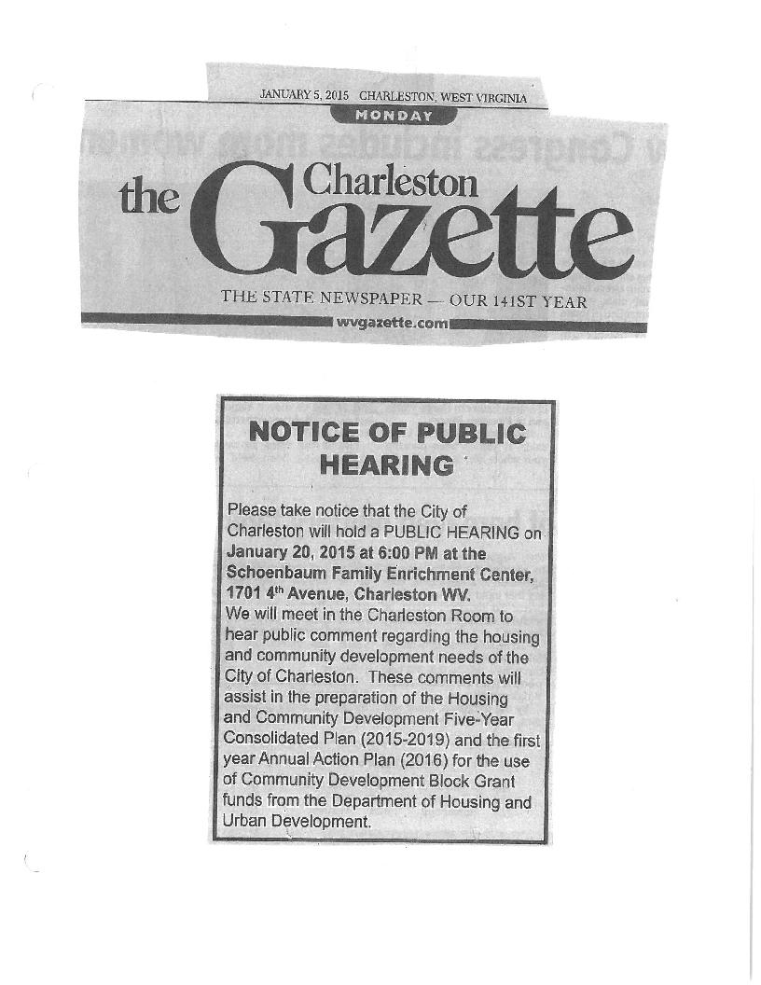
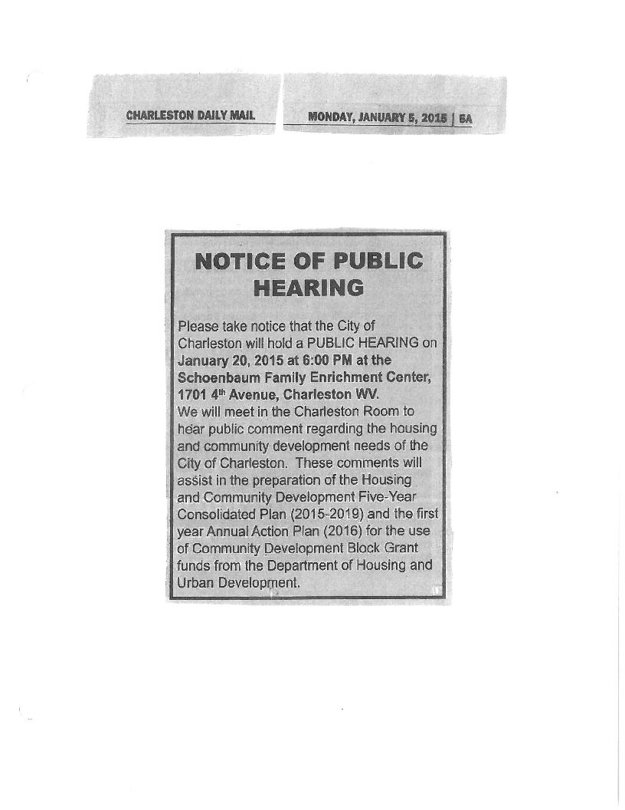
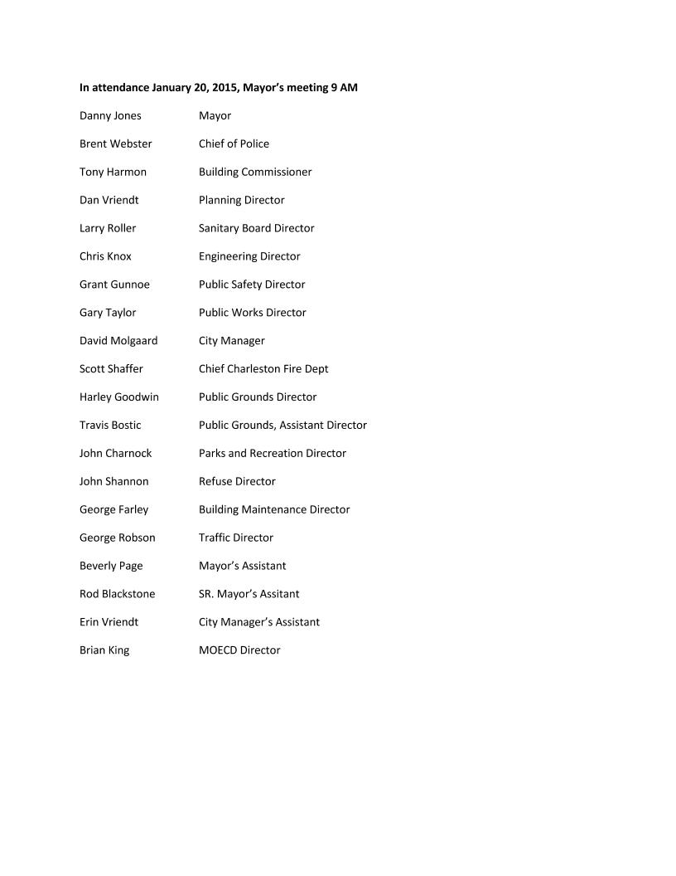
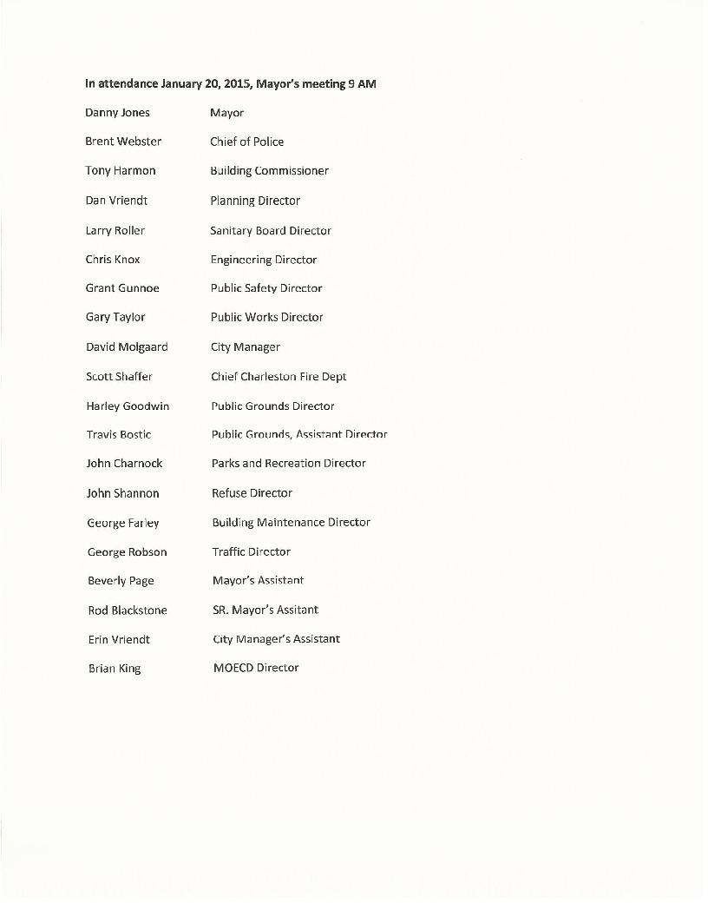
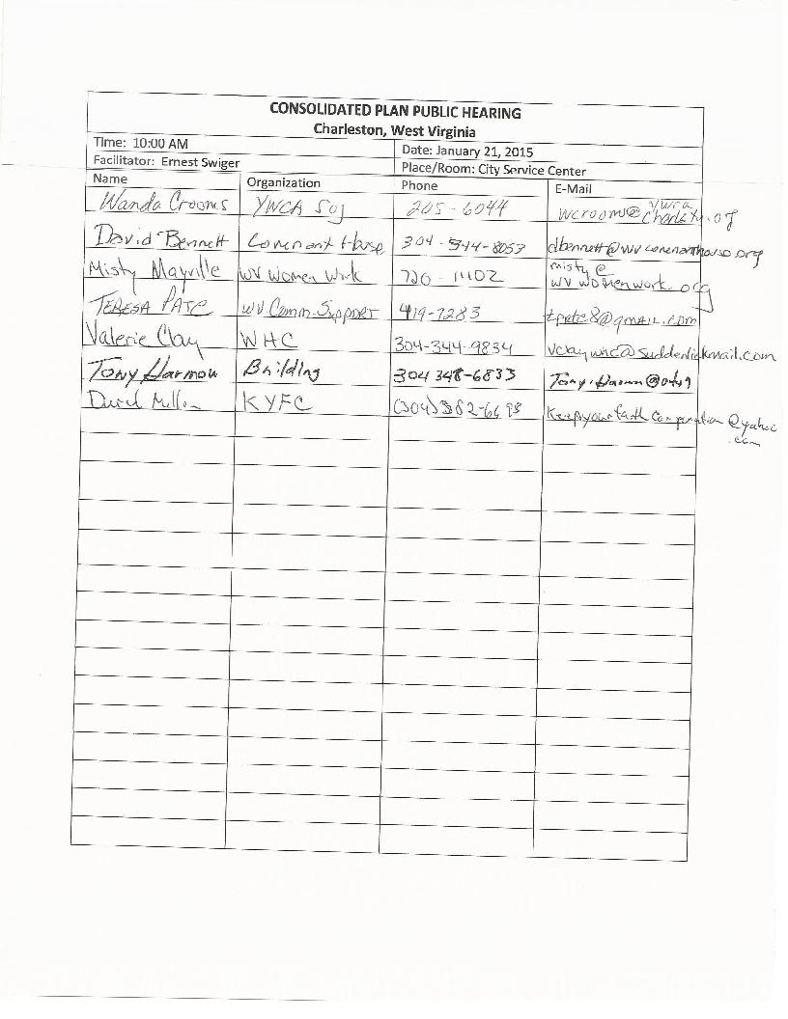
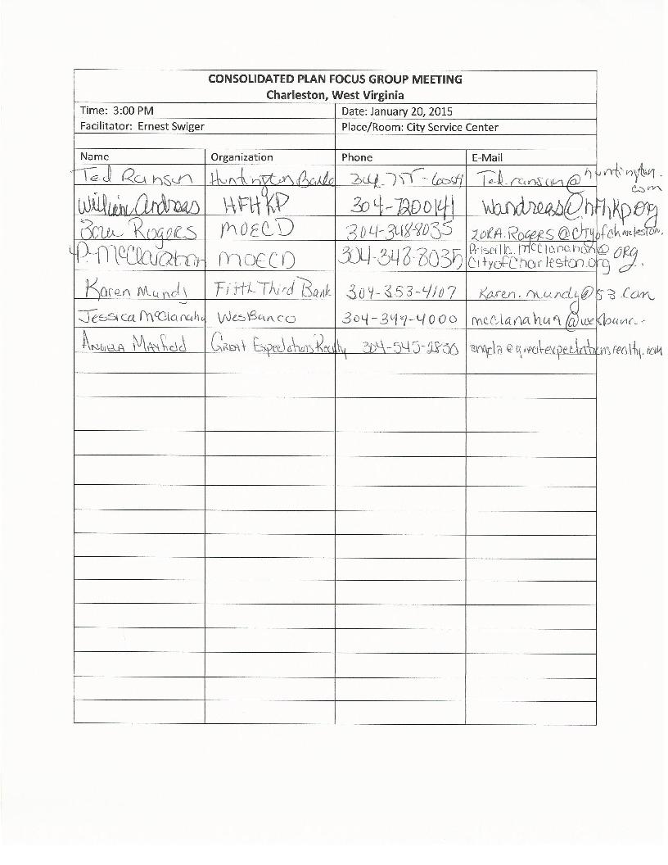
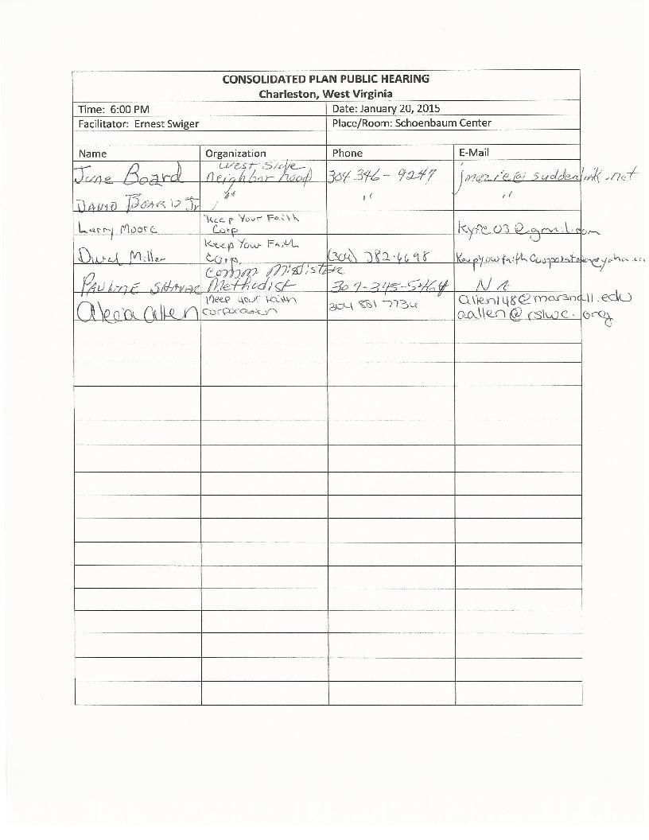
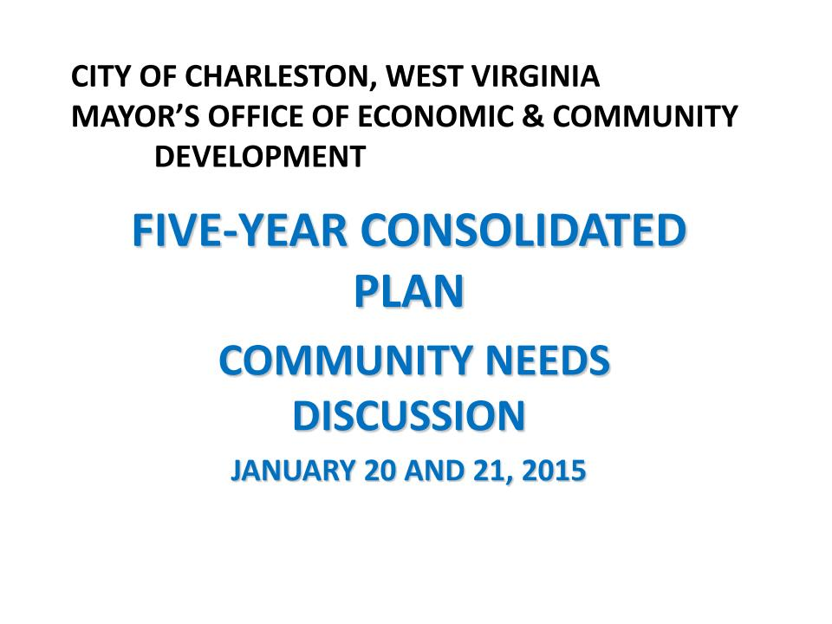
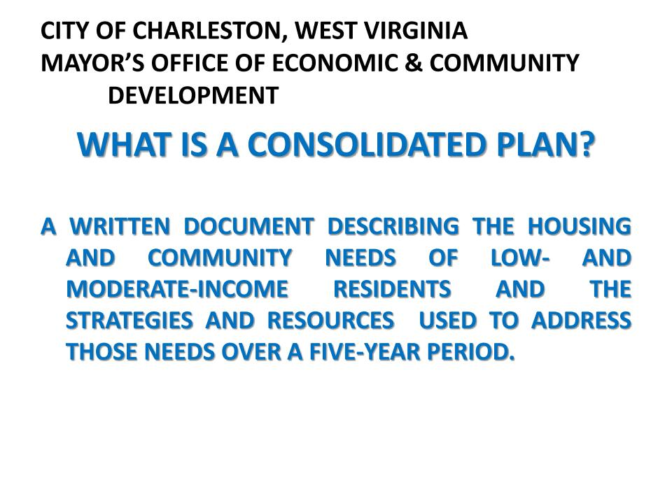
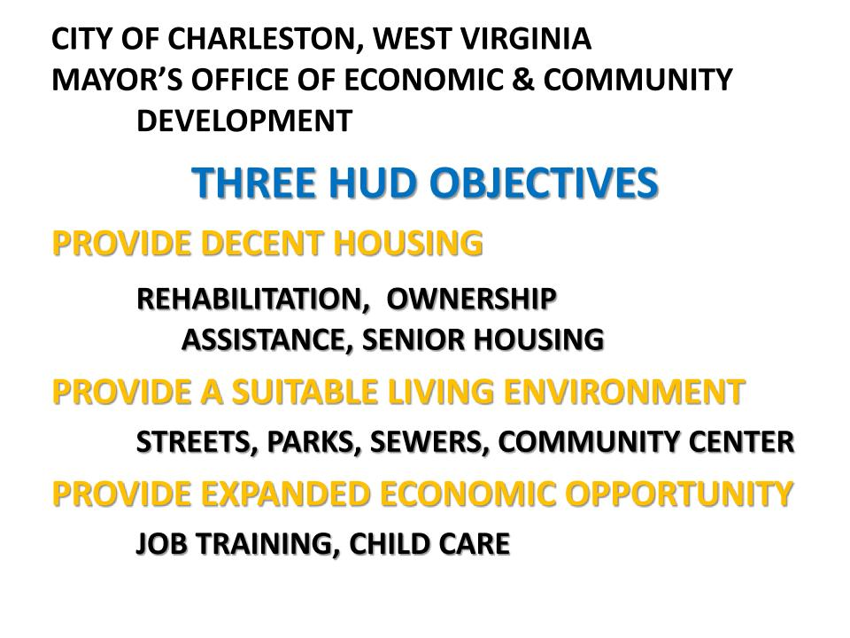
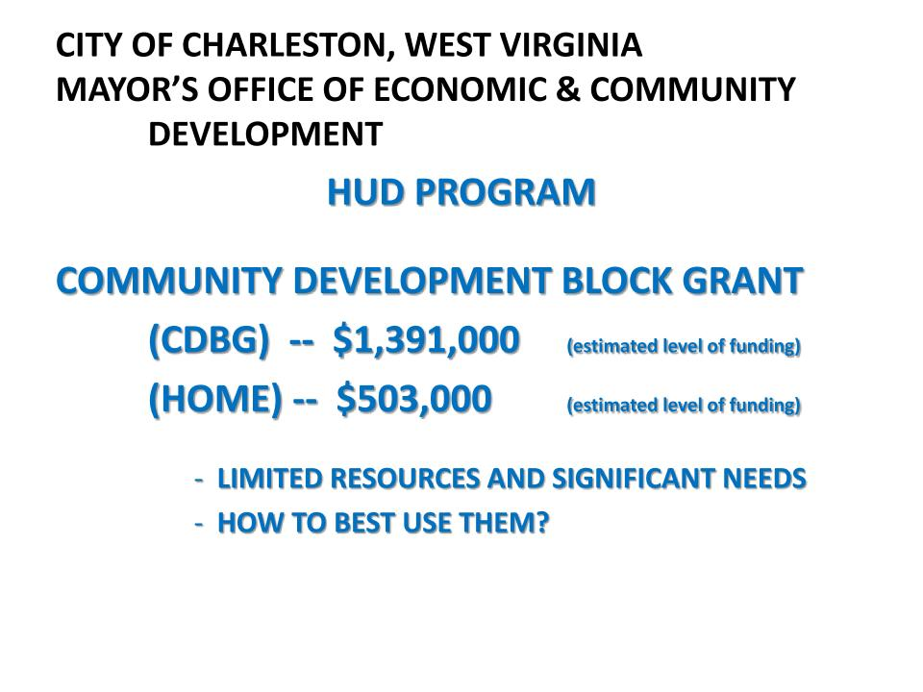
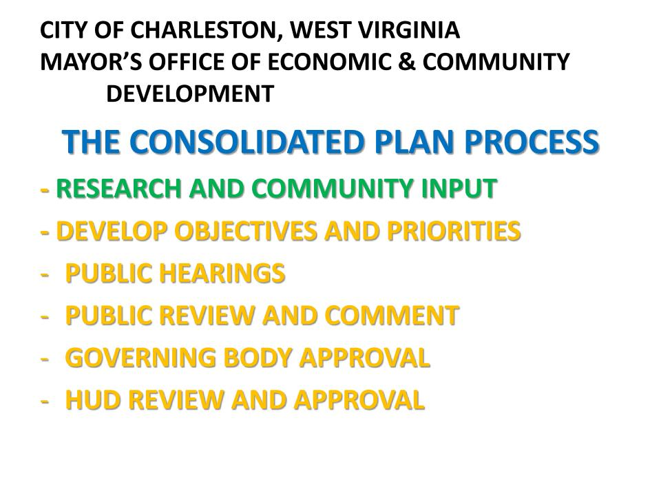
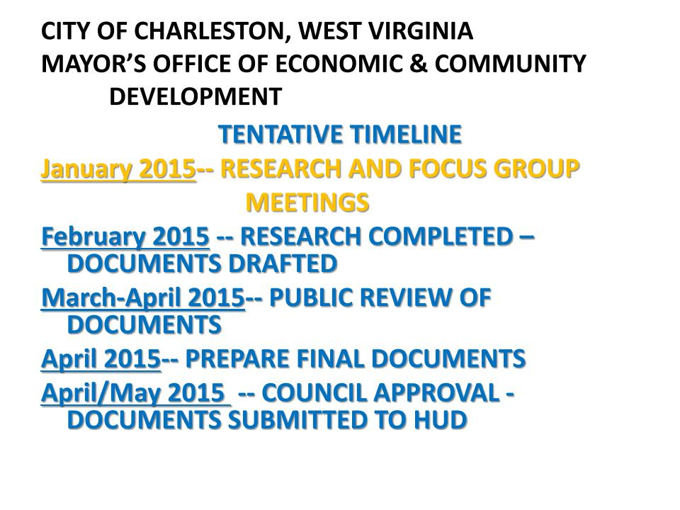
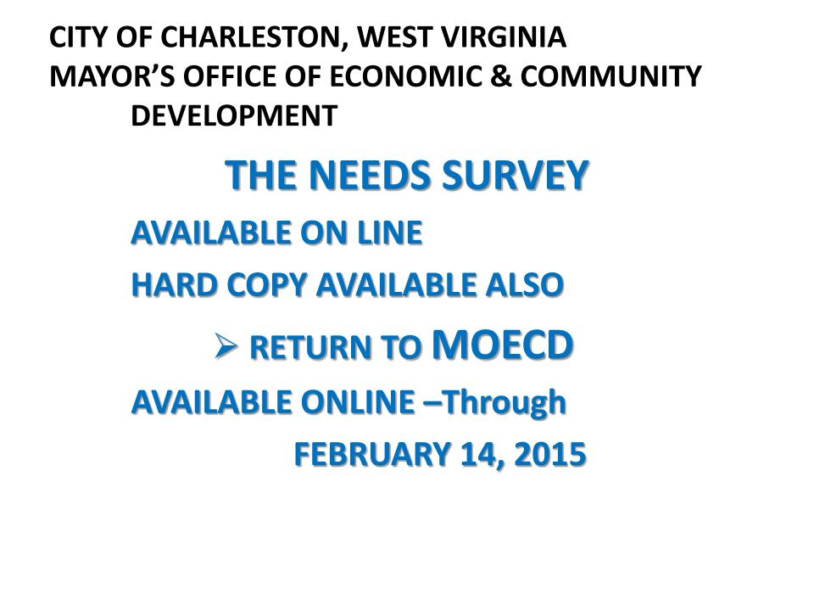
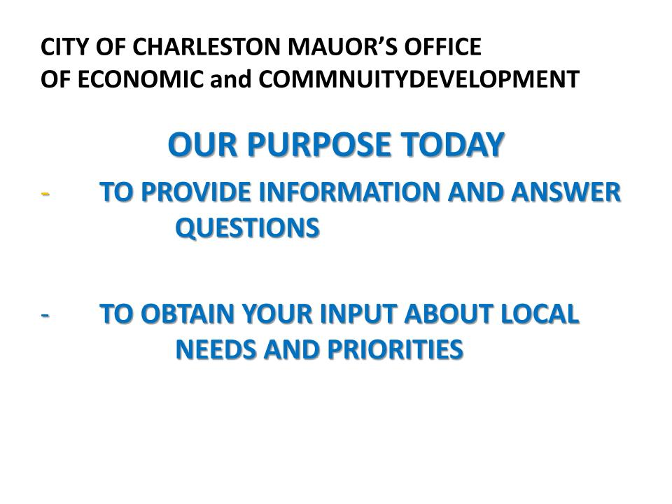
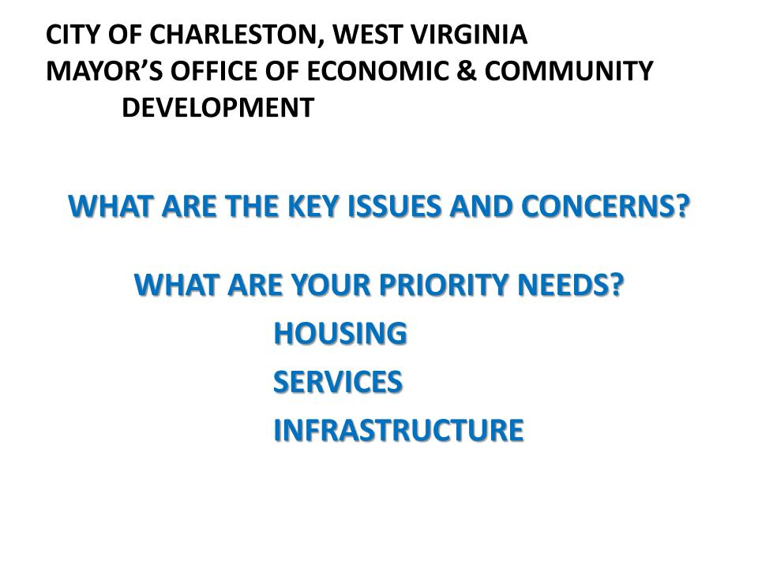
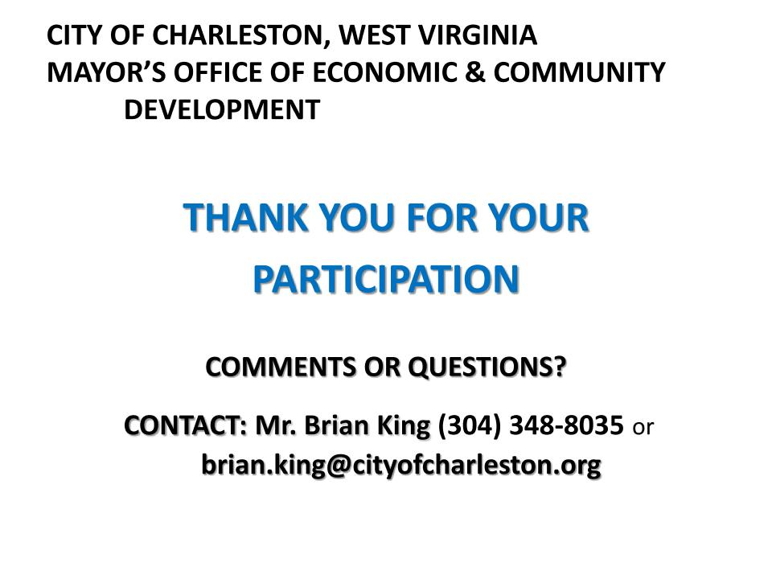
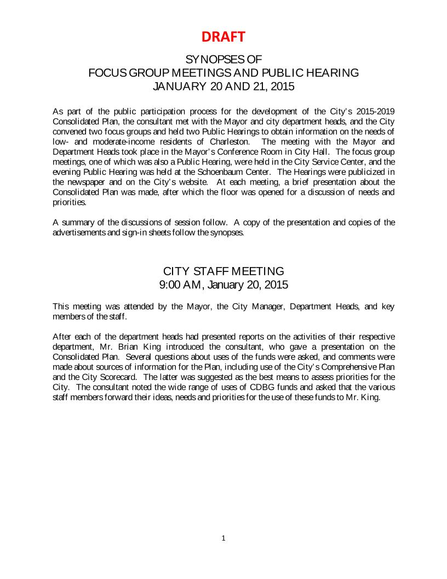
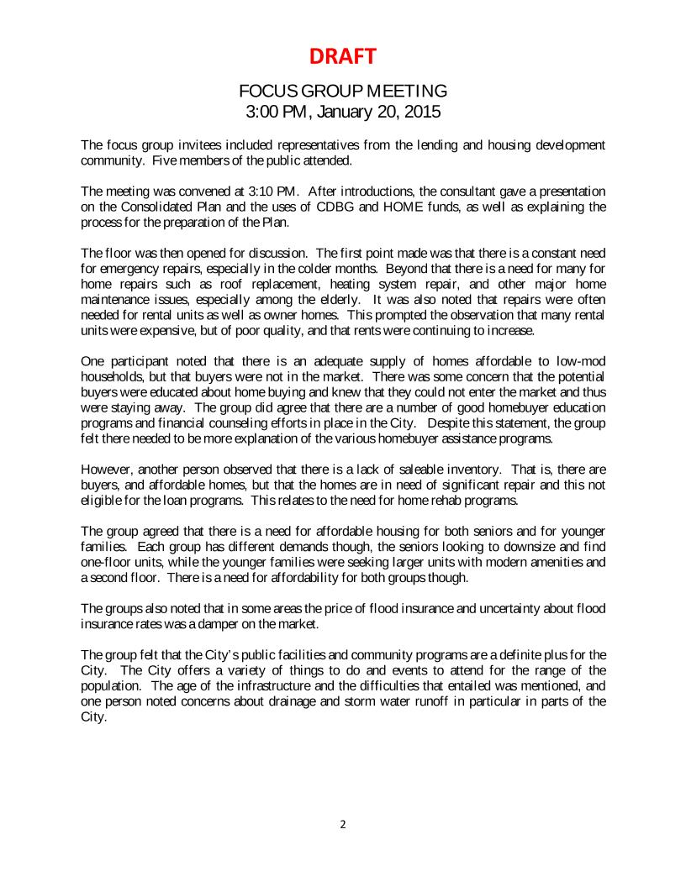
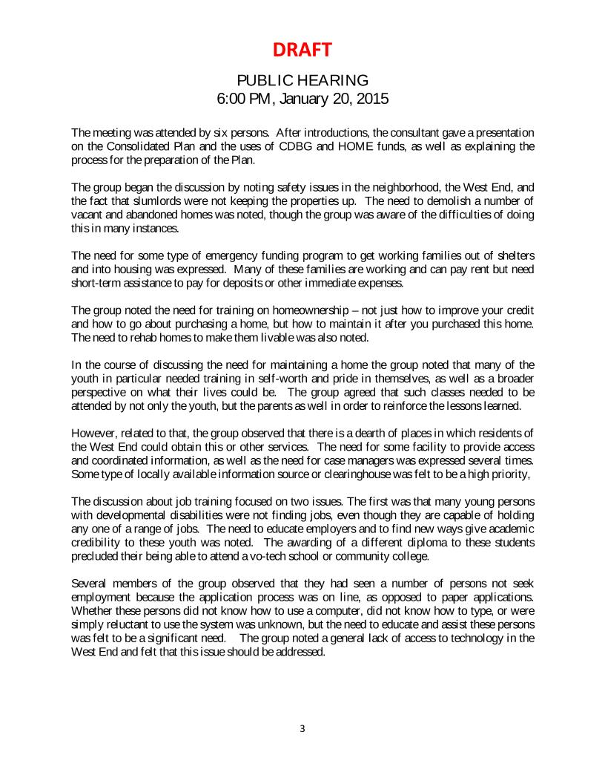
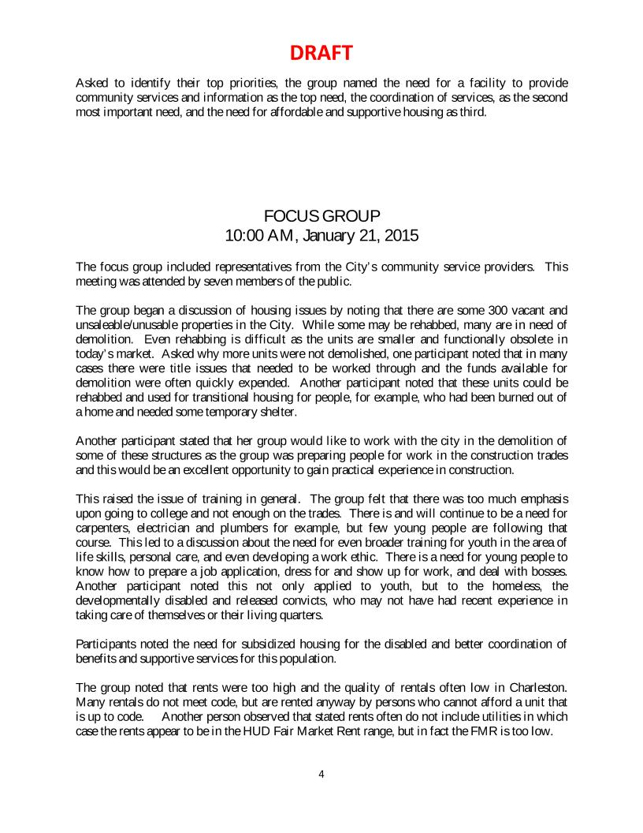
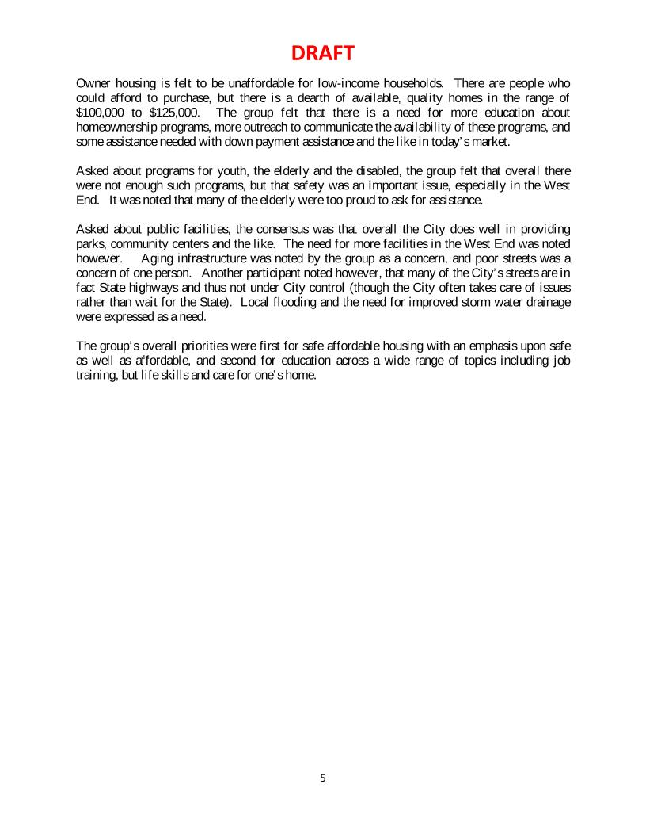
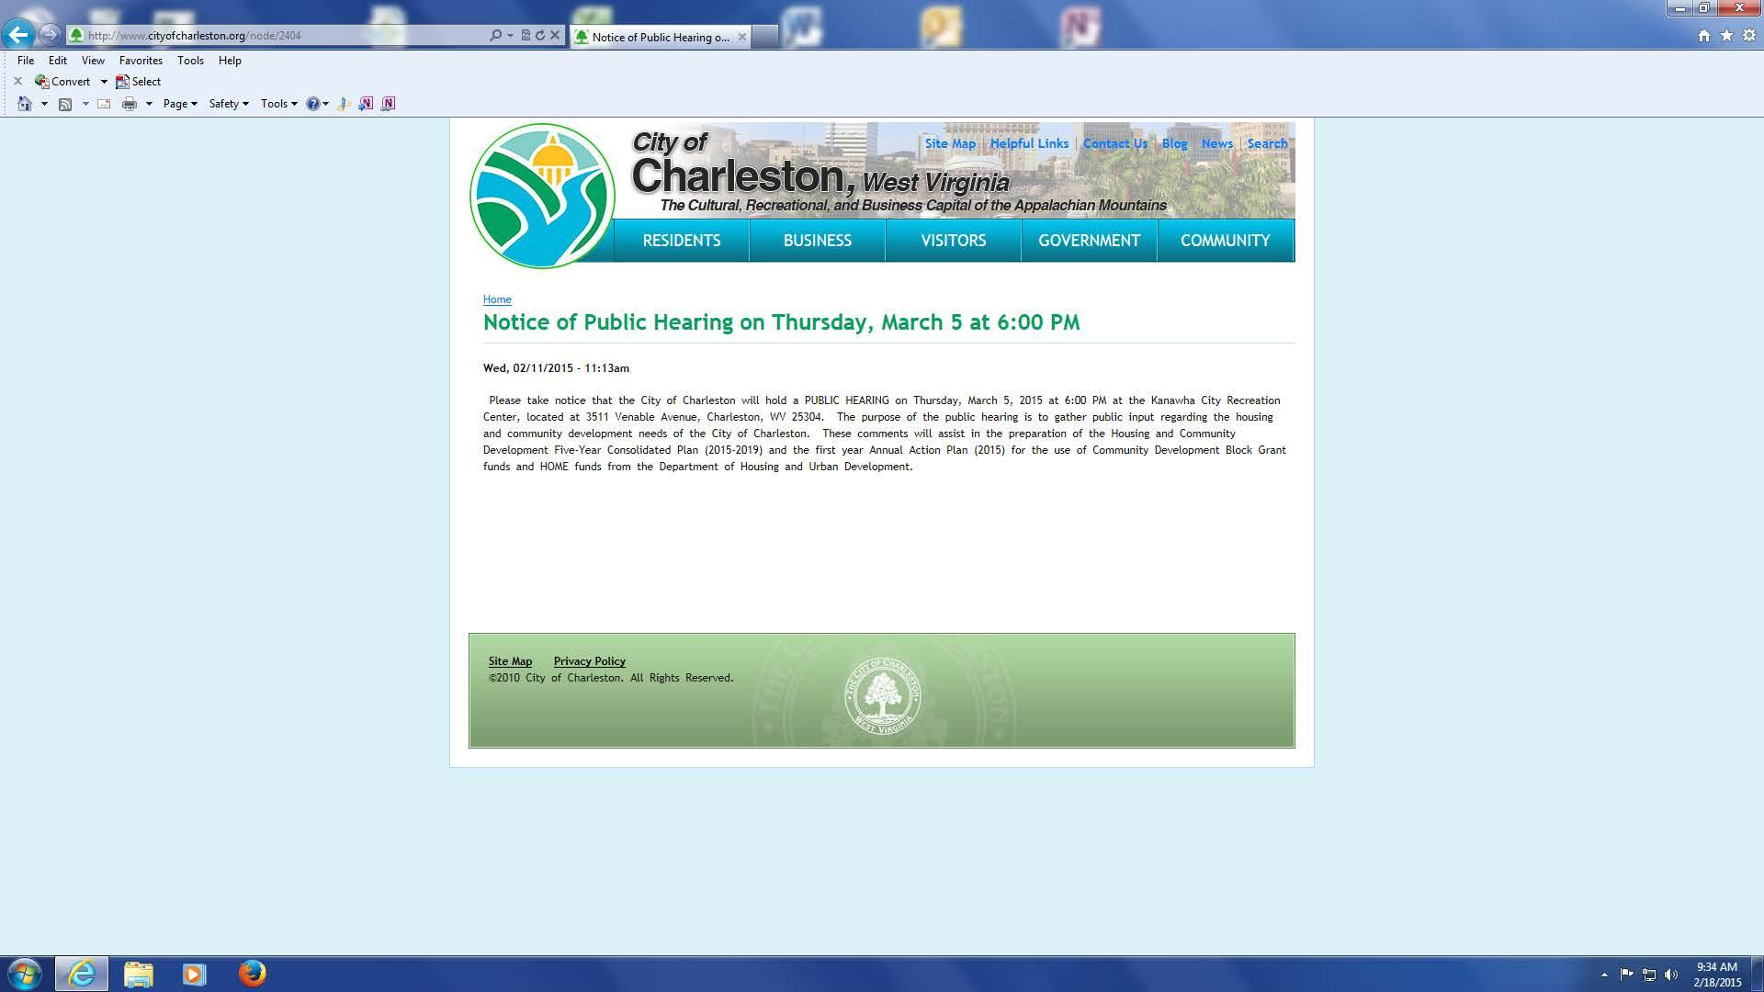
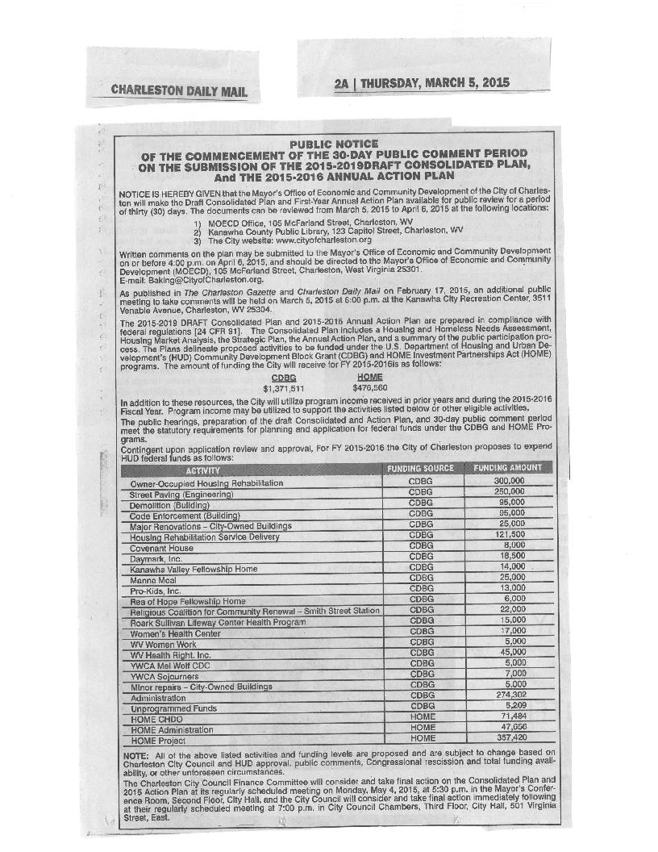
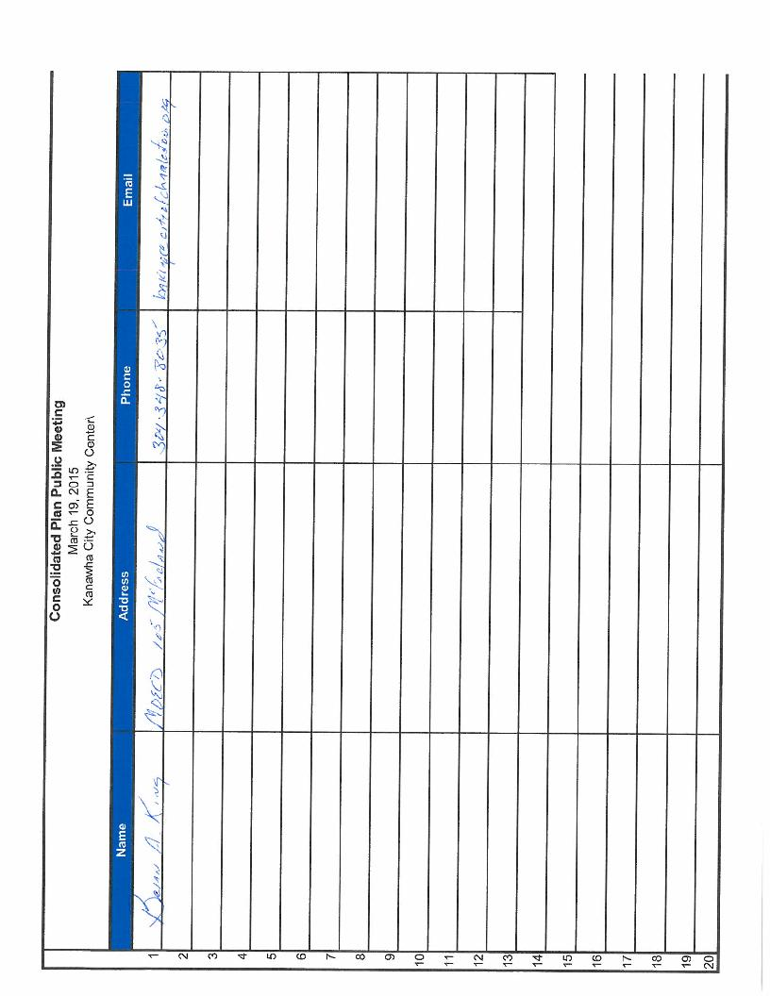
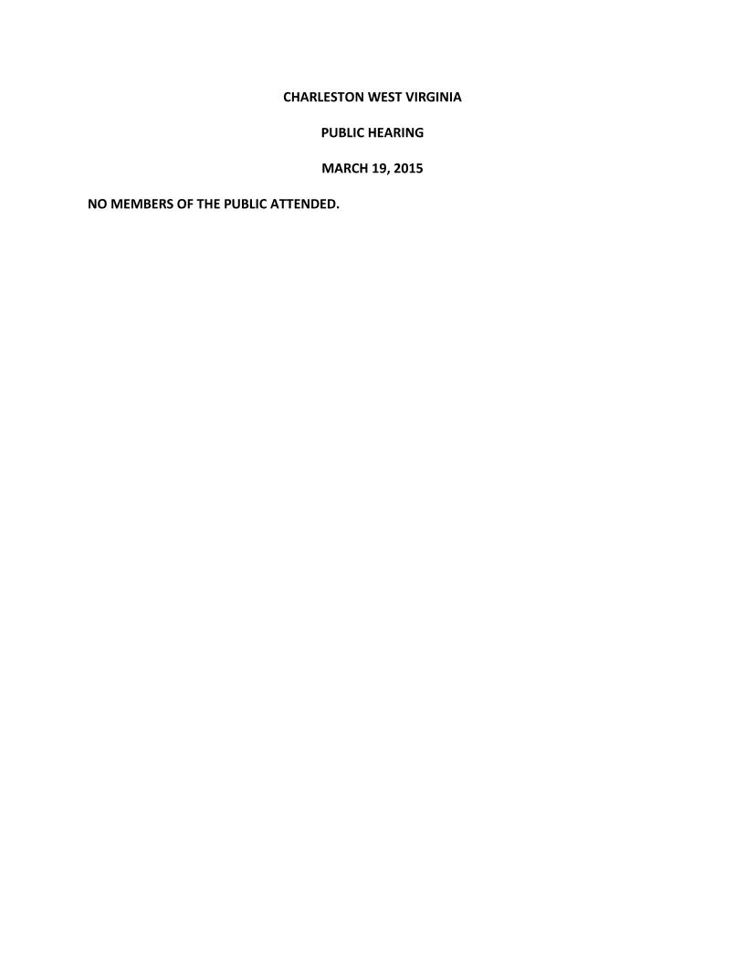
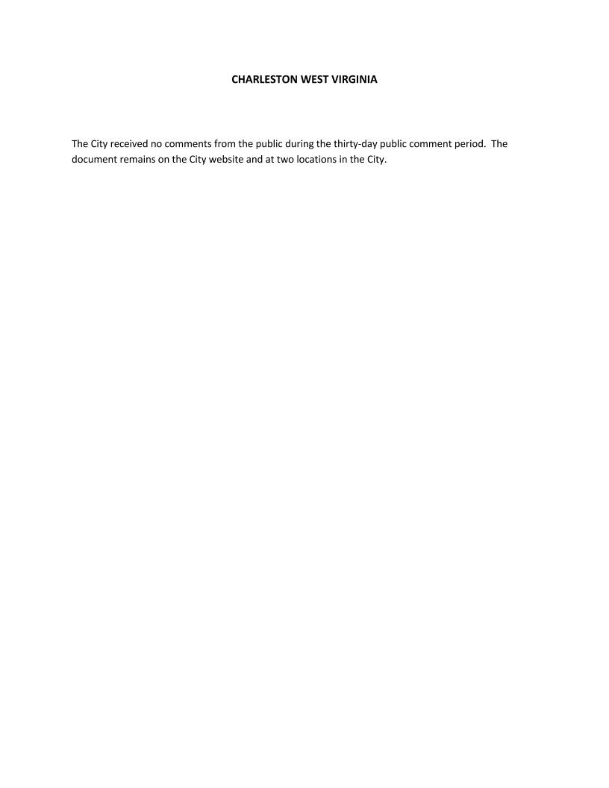

Grantee Unique Appendices
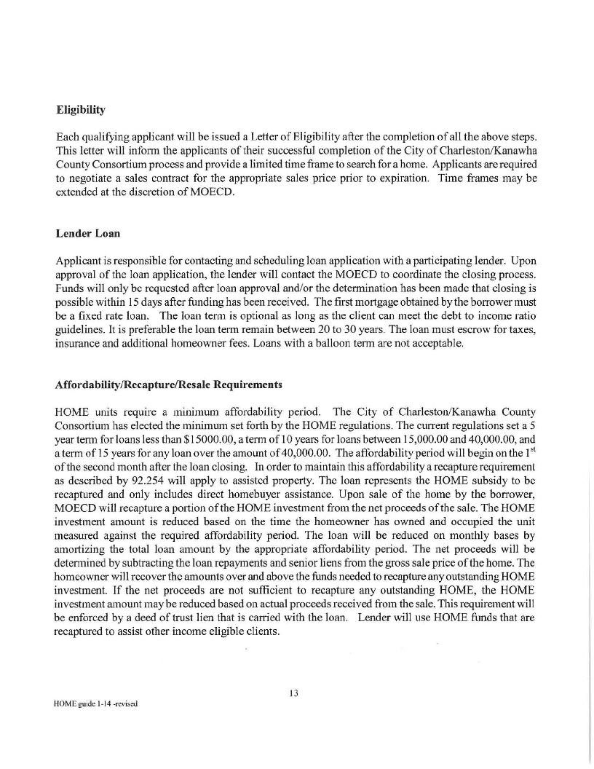

Grantee SF-424's and Certification(s)
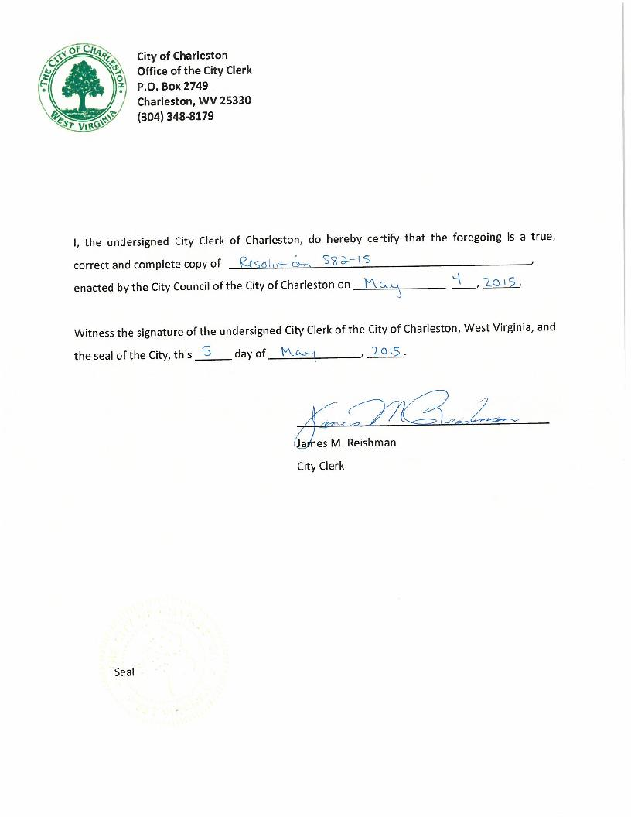
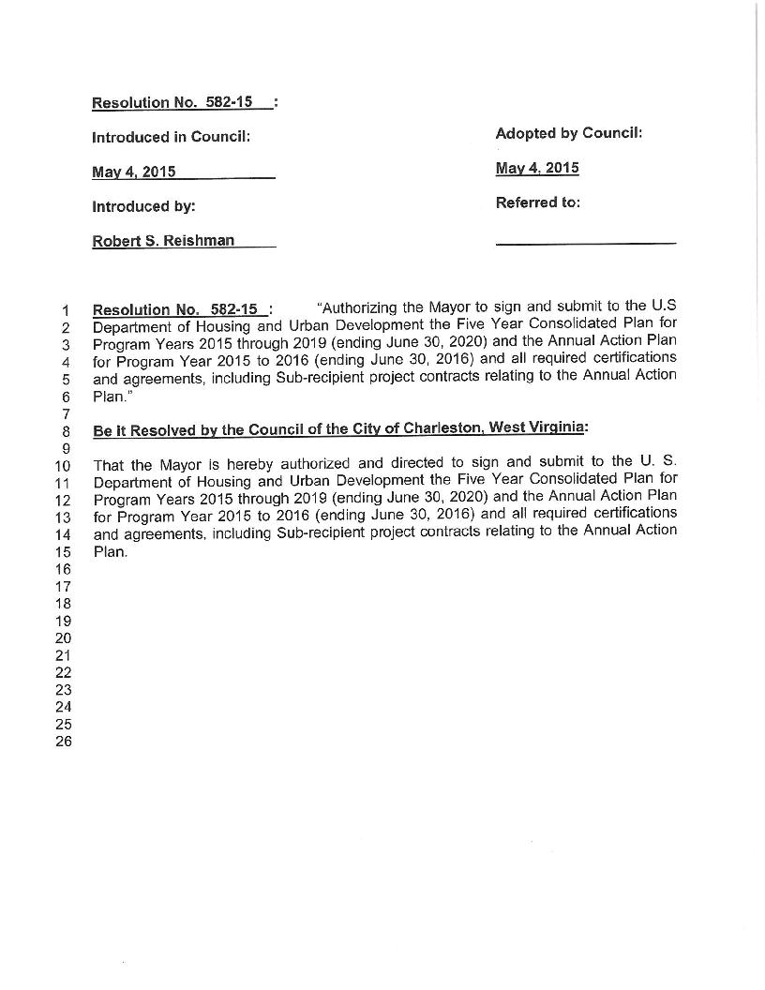
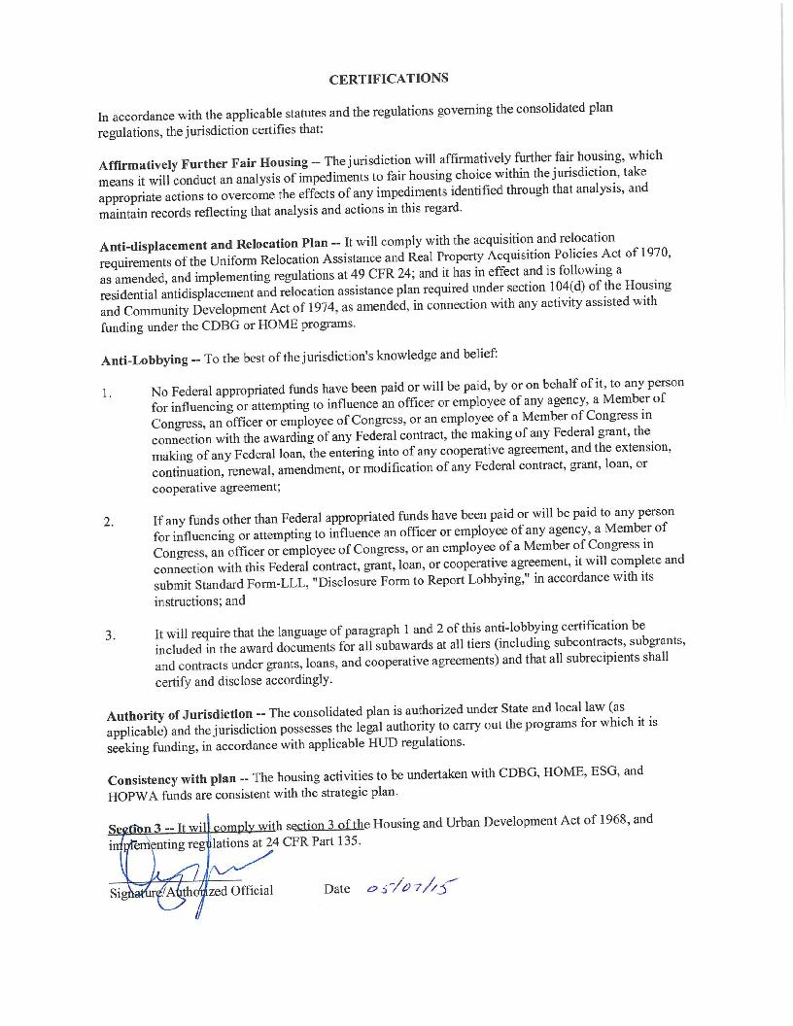
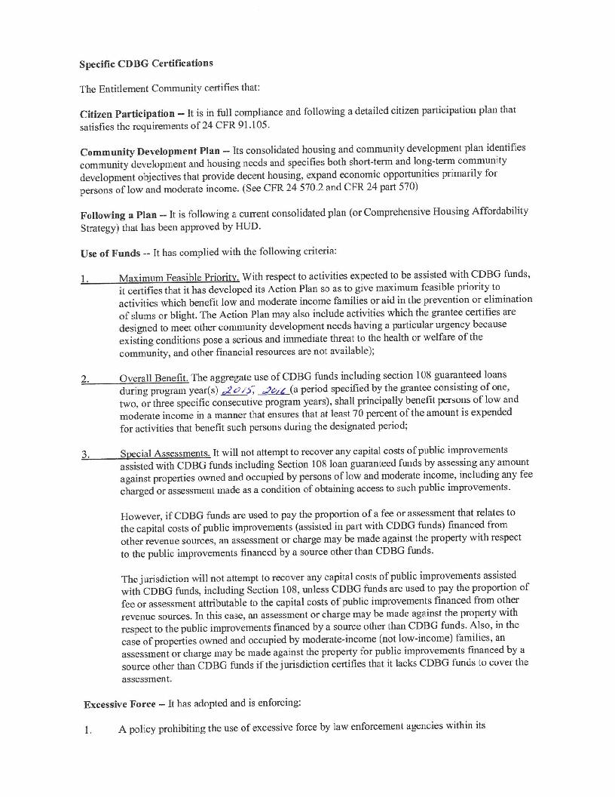
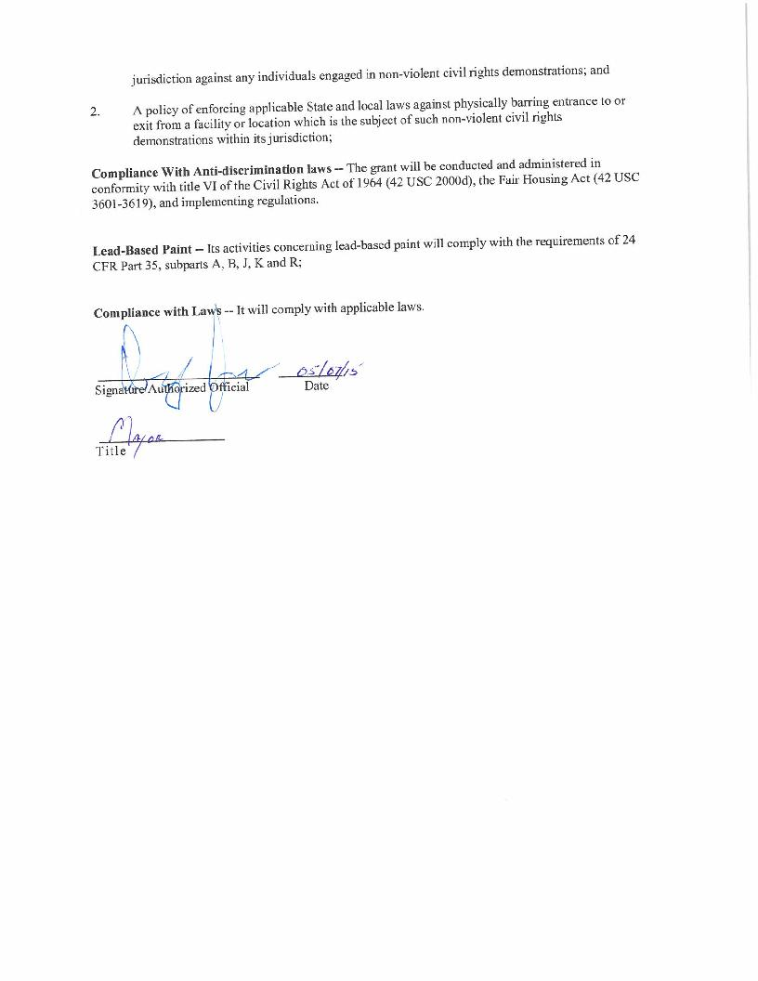
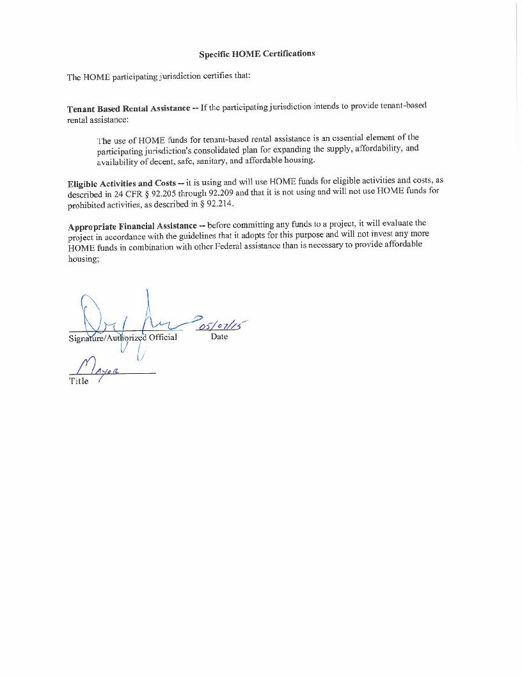
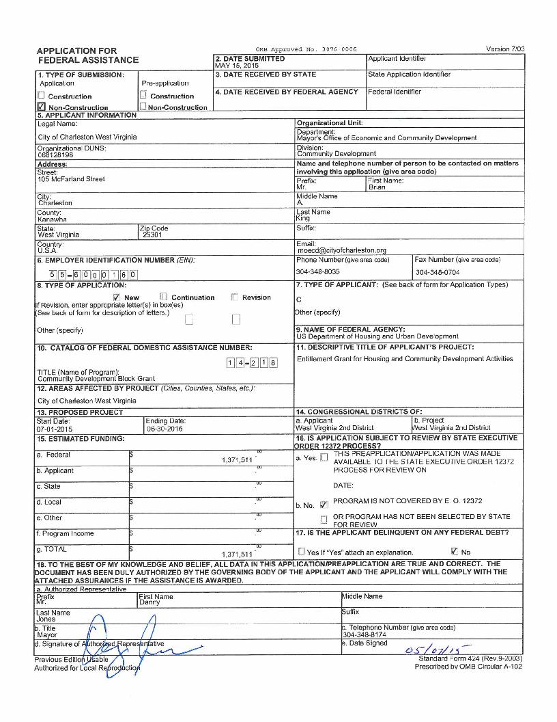
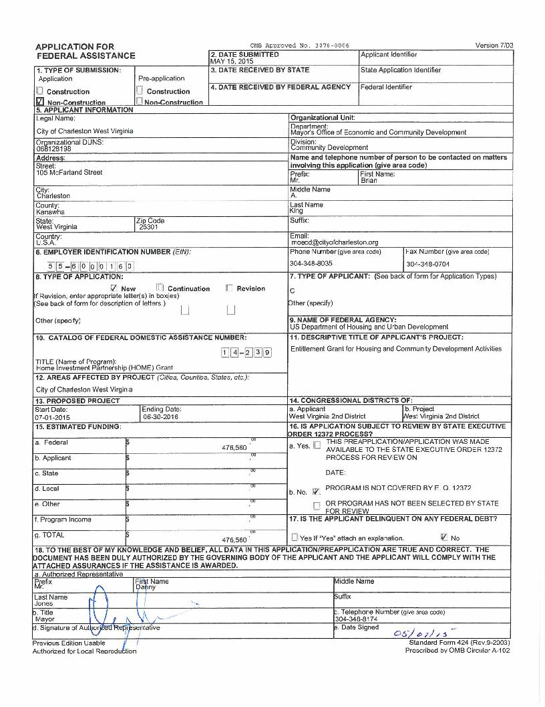

Appendix - Alternate/Local Data Sources

1 | Data Source Name  2015 ACS DATA CHARLESTON
List the name of the organization or individual who originated the data set.
US CEnsus Bureau
Provide a brief summary of the data set.
Complete demographic, social, housing and economic data about the City
What was the purpose for developing this data set?
Required by law
Provide the year (and optionally month, or month and day) for when the data was collected.
Data from 2008 to 2013
Briefly describe the methodology for the data collection.
Sampling and analysis
Describe the total population from which the sample was taken.
The City
Describe the demographics of the respondents or characteristics of the unit of measure, and the number of respondents or units surveyed.
Unknown
2 | Data Source Name  American Community Survey
List the name of the organization or individual who originated the data set.
US Census Bureau
Provide a brief summary of the data set.
Complete data on Charleston's emogrphics, economy, socila structure and housing
What was the purpose for developing this data set?
Required by law
How comprehensive is the coverage of this administrative data? Is data collection concentrated in one geographic area or among a certain population?
The data is complete and collected for the entire population
What time period (provide the year, and optionally month, or month and day) is covered by this data set?
Based on data 2008 to 2013
What is the status of the data set (complete, in progress, or planned)?
Complete

