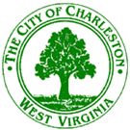

City of Charleston
Parks and Recreation Committee
Meeting Agenda
March 31, 2017 12:00 pm King Community Center

1. Tennis Court update – David Molgaard
2. Vandalia Center – David Molgaard
3. Summer swimming lessons – Monty Warner
4. Summer tennis lessons – Monty Warner
5. Community Center renovations – John Charnock
6. Spring and Summer highlights – John Charnock
7. Brainstorm outreach ideas
8. Unfinished Business
9. New Business

