JOURNAL

OF THE

COUNCIL

CITY OF CHARLESTON

WEST VIRGINIA

MARCH 5, 2012

THE COUNCIL MET IN CHAMBERS OF THE CITY BUILDING AT 7:00 P.M., FOR THE FIRST MEETING IN THE MONTH OF MARCH ON THE 5TH DAY, IN THE YEAR 2012, AND WAS CALLED TO ORDER BY THE HONORABLE MAYOR, DANNY JONES. THE INVOCATION WAS DELIVERED BY HARRISON AND THE PLEDGE OF ALLEGIANCE WAS LED BY TALKINGTON.

BURKA BURTON CLOWSER DAVIS DENEAULT DODRILL
EALY HAAS HARRISON
KIRK LANE MILLER
PERSINGER
REISHMAN RICHARDSON RUSSELL
SALISBURY SHEETS SMITH
SNODGRASS STAJDUHAR TALKINGTON
WARE WEINTRAUB WHITE
MAYOR JONES

WITH TWENTY- SIX MEMBERS BEING PRESENT, THE MAYOR DECLARED A QUORUM.

PENDING THE READING OF THE JOURNAL OF THE PREVIOUS MEETING, THE READING THEREOF WAS DISPENSED WITH AND THE SAME DULY APPROVED.

PUBLIC SPEAKERS
None

CLAIMS
1. A claim of Joseph Noronha,1704 Oak Knolls Rd., Charleston, WV; alleges damage to vehicle.
Refer to City Solicitor

2. A claim of Andrea Affolter, 4134 Coopers Fork Rd., Holden, WV; alleges damage to vehicle.
Refer to City Solicitor

MISCELLANEOUS RESOLUTION

Resolution No. 095-12
Introduced in Council
March 5, 2012
Susie Salisbury and Mary Jean Davis
WHEREAS: Downtown Charleston is the heart and soul of our cultural and commercial activity and
has a thriving arts scene including many galleries, several examples of public art, festivals, nightlife, and unique shopping; and

WHEREAS: Five individuals with a passion to promote art and culture in our community came
together in 2002 and determined that a monthly celebration of the arts would invigorate downtown; and

WHEREAS: Those five people – Tom and Callen McJunkin, John Auge, David Morton and Steve Payne – pooled their creative talents and resources to launch ArtWalk in March 2002 as an evening event to promote downtown galleries and the many people involved in our local artist community; and

WHEREAS: Now 10 colorful years later, 13 businesses will participate in ArtWalk in 2012, opening their doors on the third Thursday of each month for people in our community to enjoy art from throughout the region, refreshments and special times with good friends; and

WHEREAS: These participating businesses, including Taylor Books (which was one of the original participating businesses ten years ago), Vision’s Day Spa, Romano & Associates, Stray Dog Antiques, Chet Lowther Studio, Art Emporium, Modern by Design, Purple Moon, Gallery Eleven, Studio 1031, the Charleston Ballet, Mission Savvy and House of Luxe, continue to invest in ArtWalk along with the assistance of the Charleston Area Alliance; and

WHEREAS: Downtown Charleston continues to thrive with an entrepreneurial spirit exhibited by these businesses and their promotion of art and culture.
Therefore be it resolved by The Council and Mayor of The City of Charleston, West Virginia:

That the elected leadership of the City of Charleston recognizes the efforts of the founders, leaders, and volunteers who have helped to make ArtWalk a success over the past ten years and the many downtown businesses that have made Charleston a more artistic and vibrant community.

With a majority of members elected recorded thereon as voting in the affirmative the Mayor declared the resolution 095-12, adopted.

PLANNING
Councillperson Mary Jean Davis, Chairperson of the Council Committee on Planning, submitted the following reports.
1. Your Committee on Planning has had under consideration Bill No. 7510, and reports the same to Council with the recommendation that the bill do pass.
Bill No. 7510 amending the Zoning Ordinance for the City of Charleston, West Virginia, adopted November 21, 2005 in order to make corrective additions and deletions as follows:

BE IT ORDAINED BY THE COUNCIL OF THE CITY OF CHARLESTON, WEST VIRGINIA
The Zoning Ordinance for the City of Charleston, West Virginia, effective November 21, 2005, is hereby amended as follows:
Sec. 3-050 Permitted Land Uses
LAND USE | R-2 | R-4 | R-6 | R-8 | R-10 | R-O | C-4 | C-8 | C-10 | C-12 | CBD | UCD | PMC | I-2 | I-4 | PUD | SUPP.
Automotive Wrecker Service |  |  |  |  |  |  |  |  | P C | P C |  |  |  | P C |  |  | 34
Wrecker Service |  |  |  |  |  |  |  |  | C | C |  |  |  | C |  |  | 35

Sec. 3-060 Supplemental Regulations Pertaining to Land Use Table
34. Automobile wrecker services shall comply with the following:
a. Storage areas shall be screened from view by a minimum 6 foot high opaque fence or wall.
b. Stored vehicles must be currently licensed.
c. b. Vehicles may be stored on premises for a maximum of 60 days.
d. c. Storage areas must be paved.

Sec. 2-020 Definitions of Terms
Fence Height. The vertical distance measured from the top of the fence to the lowest point of grade on the exterior side of the fence.

Lot Line, Front. The lot line(s) separating a lot from the street(s).

Building Line. Front Yard. The area from the front face of the a principal structure to all the front lot property lines or street right-of-way lines extending to the adjacent side lot lines.

Building Line, Front Line of. The line or lines of the face of the principal structure building nearest the front lot line(s).

- Sec. 3-070 Temporary Uses
- C. Permitted Temporary Uses
  - 1. Temporary office, model home or model apartment, and related signs, both incidental and necessary for the sale, rental, or lease of real property in the district. Maximum duration: 18 months.
  - 2. Non-commercial concrete batching plant, both incidental and necessary to construction in the district. Maximum duration: 18 months.
  - 3. Temporary building or yard for construction materials and equipment, both incidental and necessary to construction in the district. Maximum duration: 18 months.
  - 4. Parking lot designated for a special event in a district. Maximum duration: 3 days.
- 5. Parking of recreational vehicles in the front yard of building line for visitation. Maximum duration: 7 consecutive days, with a maximum total of 14 days per year. A permit shall not be required for this temporary use.
- 7. Moving and storage containers parked in the front yard of the building line. Maximum duration: 30 days. A permit shall not be required for this temporary use.
  - 8. Other similar uses deemed temporary by the Board of Zoning Appeals and attached with such time period, conditions and safeguards as the Board may deem necessary.

- Sec. 3-080 Accessory Structures and Uses in Residential Districts
- A. Customary and incidental accessory buildings and uses are allowed in all residential districts, as specifically regulated in that district, provided that:
1. Accessory Structures shall not be placed in the front yard. If placed in a side yard, accessory structures shall not be located closer to the street than the front building line of the principal structure.
2. Accessory structures shall not be located closer than three feet to the rear and side property lines nor closer than 3 feet to the principal structure, unless otherwise indicated in this ordinance.
3. On corner lots, accessory structures shall not be located between any portion of the principal structure and either street.
4. When an accessory structure is attached to a principal structure, it shall comply in all respects with the requirements of this zoning ordinance applicable to the principal structure(s).
5. Any structure connected to another structure by an open breezeway (i.e., without enclosed walls) shall be deemed to be a separate structure.
6. The total square footage of all accessory buildings shall not exceed 672 square feet or 50% of the first or ground floor area of the principal building whichever is greater. Large lots measuring twice the size of the minimum lot requirement or greater are not subject to this restriction, so long as the accessory structure remains subordinate in floor area to the dwelling.
7. The square footage of the first (ground) floor of the accessory structure(s) shall be included in the computation of lot coverage.
8. Accessory structures shall not exceed 18 feet in height, except for accessory dwelling units.
9. No part of any such structure, with the exception of accessory dwelling units as defined herein, shall be designed or used for sleeping purposes, and no cooking fixtures shall be placed or permitted therein.
10. A private garage may be constructed as part of a principal structure, provided that when constructed the garage walls shall be regarded as the walls of the principal structure in applying the applicable front, side and rear setback requirements.
11. Pools are subject to the accessory use provisions herein and subject to a building permit.
12. Outdoor play equipment, when anchored to the ground, is prohibited in the front yard of the building line.

B. Fences may be erected, with a building permit, on residentially zoned parcels, provided they meet the following restrictions:
1. They may not exceed six and one half (6.5) feet in height at any point.
2. No portion of an opaque fence (less than 70 percent open in any one square foot portion of the fence panel) erected within a clear vision triangle may exceed two and one-half (2.5) feet in height.
3. Fences may be constructed of stone, brick, wood, vinyl, chain link or wire, wrought iron, aluminum, and ornamental concrete block, provided all other requirements herein are met. They shall not be constructed with razor wire or electrified wire.
4. Fences erected in the front yard of any building line shall not exceed four (4) feet in height.
5. Fences specifically intended to screen mechanical equipment may exceed the maximum fence height in the immediate area of the equipment to be screened to the additional height necessary to screen the particular height of the equipment.

Sec. 3-090 Accessory Structures and Uses in Commercial Districts
- Customary and incidental accessory buildings and uses are allowed in all commercial districts, as specifically regulated in that district, provided:
1. The storage, collecting, dismantling, salvaging or repairing of more than one (1) piece of machinery, inoperative, expired inspection sticker, or unlicensed, motor vehicle, or appliance is prohibited , unless customary and incidental to the primary business such as an auto repair unless totally screened from view.
2. No more than two accessory buildings per establishment shall be erected on a lot.
3. An accessory building shall be at least 3 feet from all lot lines and from any other building on the same lot, unless otherwise specified in this ordinance.
4. No accessory building shall be erected in a required front or side yard front of the building line. Accessory Structures shall not be placed in the front yard. If placed in a side yard, accessory structure shall not be located closer to the street than the front building line of the principal structure.

Sec. 23-060 General Sign Regulations
C. A wall sign shall not extend above any roof building line or further than twelve (12) inches from the building, or part of the building, to which the sign is attached.

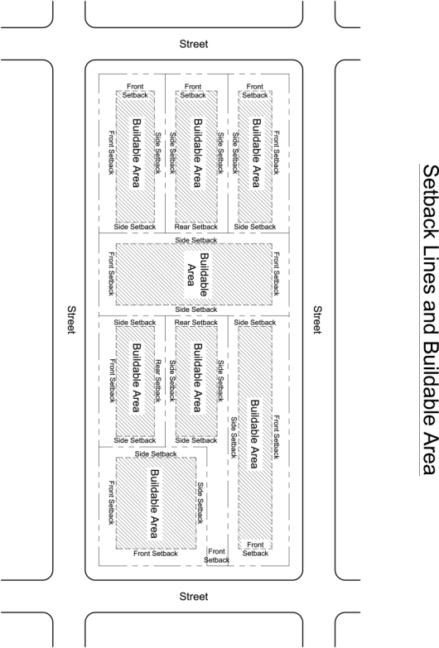

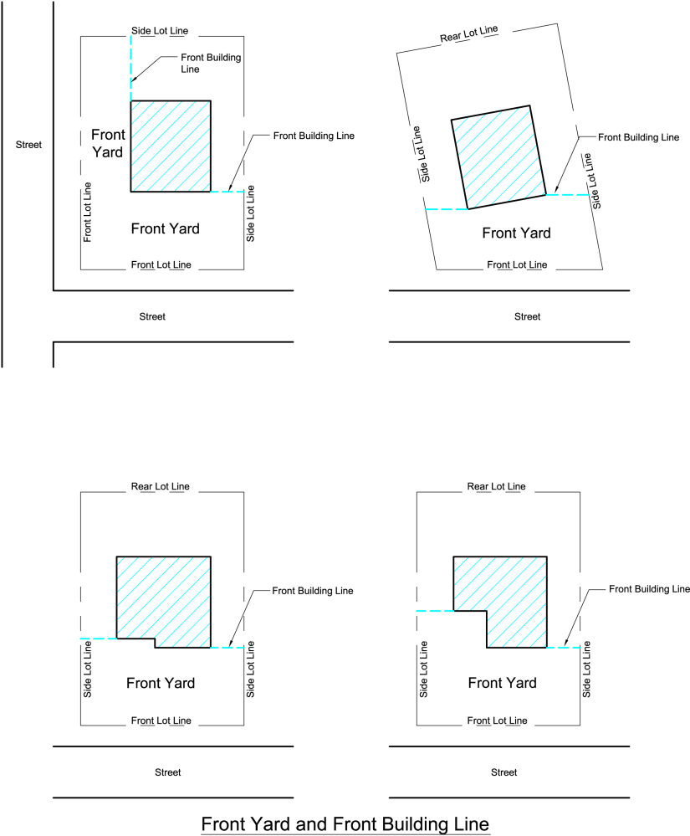
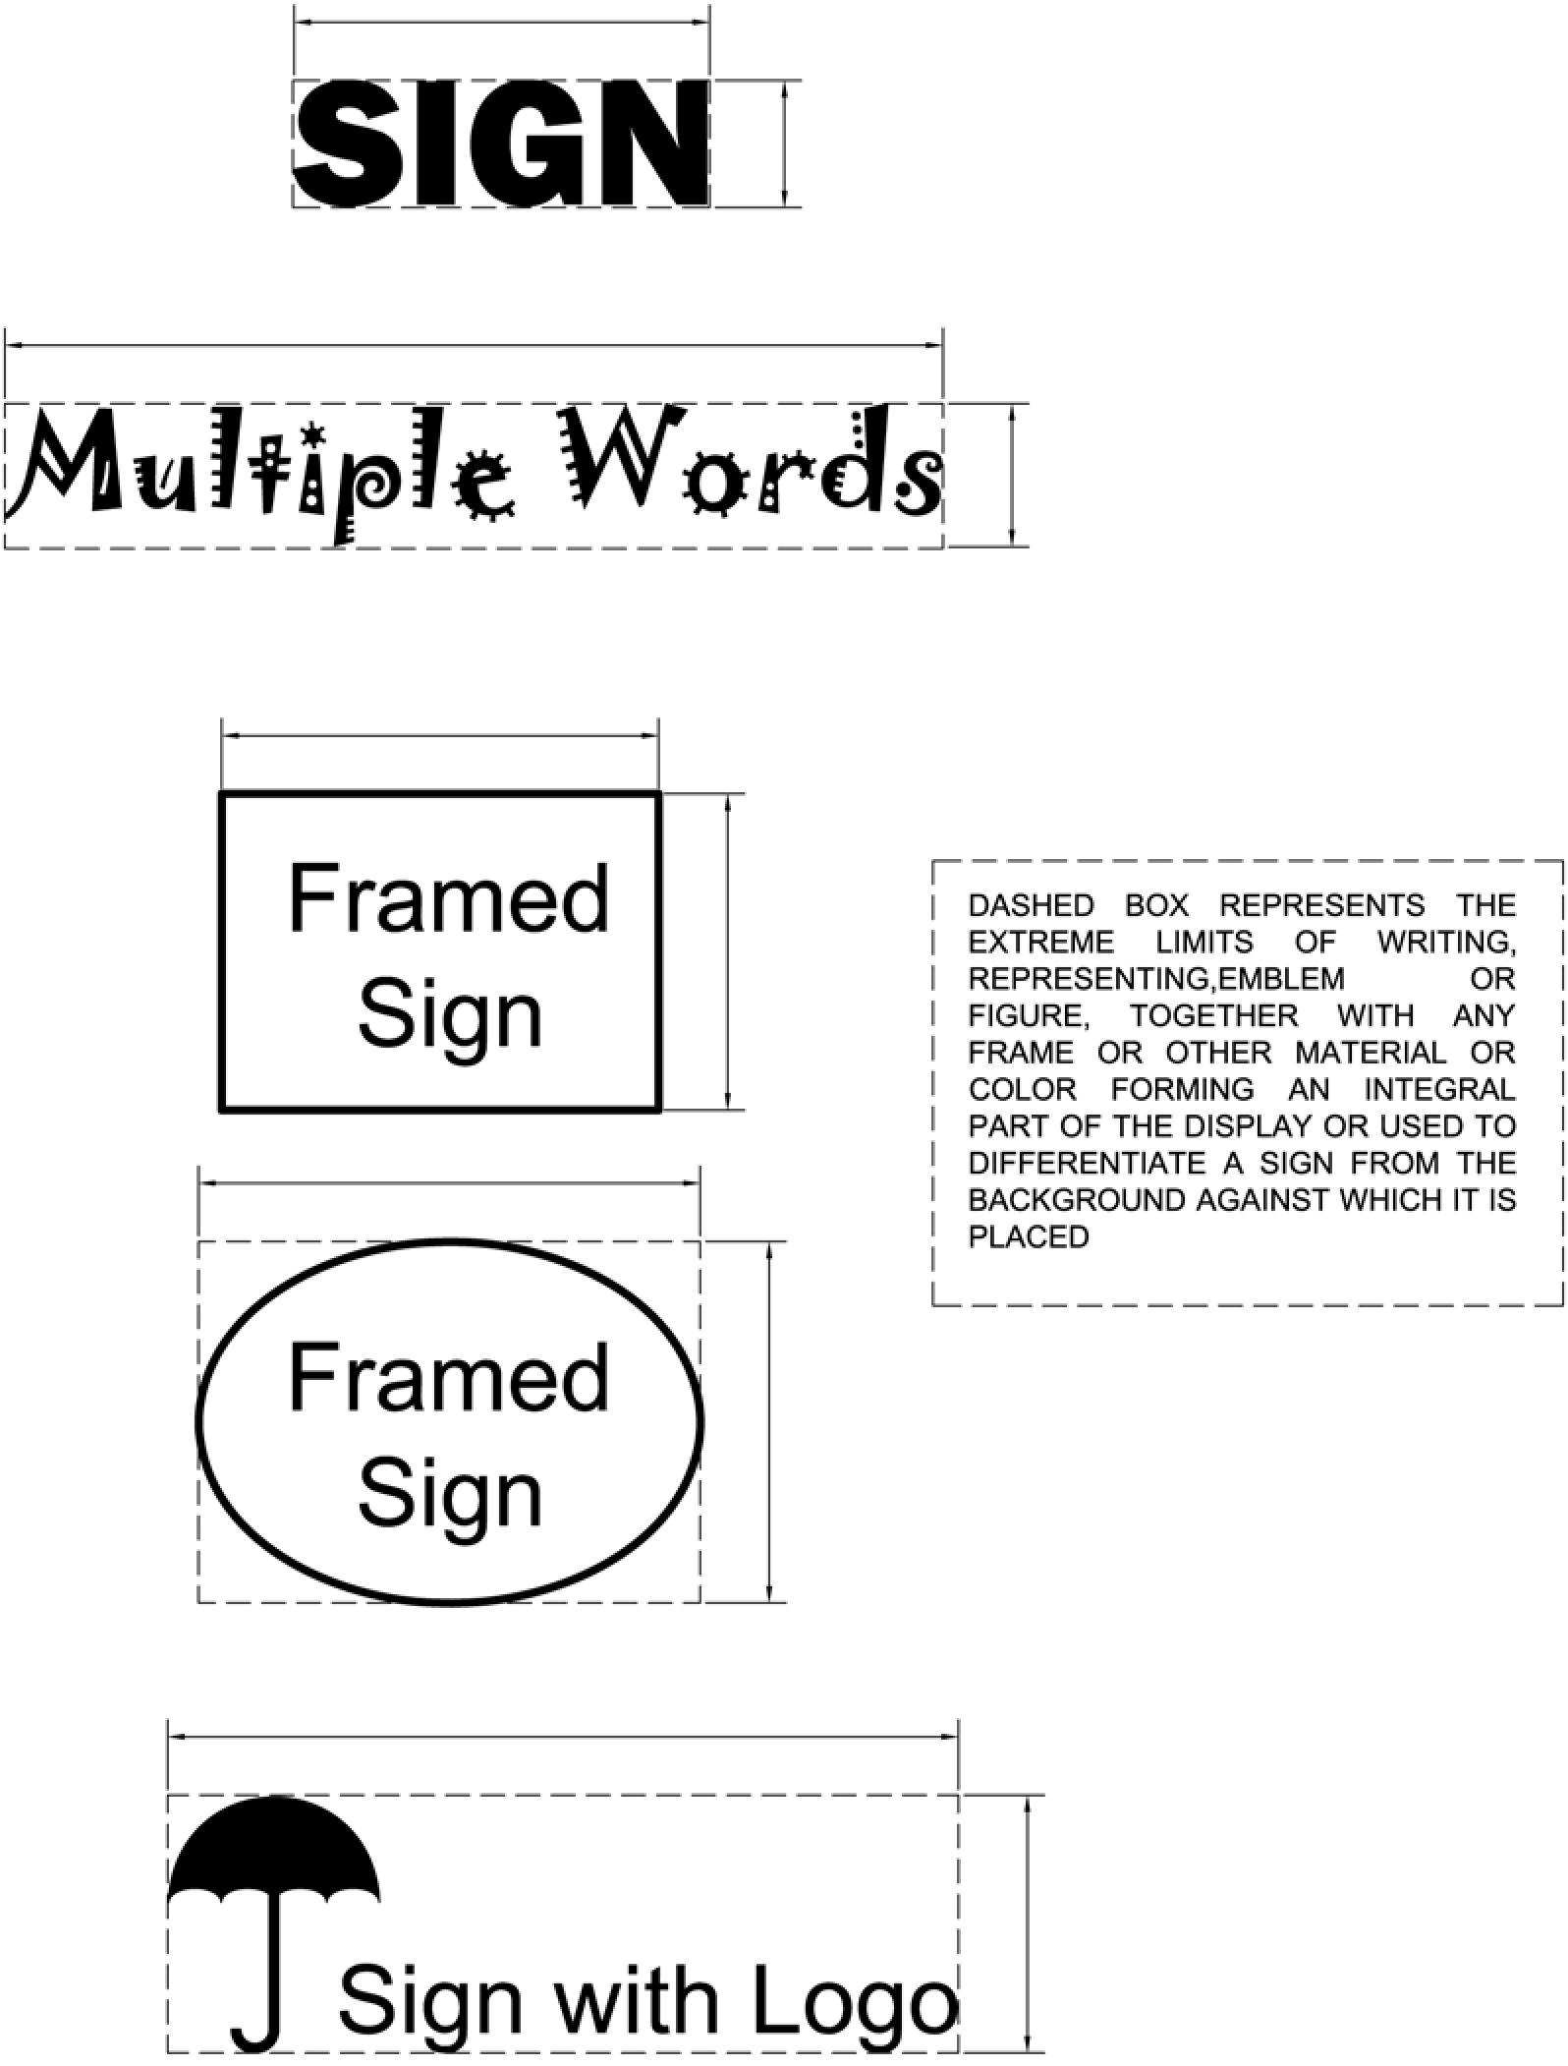
All prior ordinances, or parts of ordinances, inconsistent with this ordinance are hereby repealed to the extent of such inconsistency.
The question being on the passage of the Bill. A roll call was taken and there were; yeas –26, absent - 2, as follows:
YEAS: Burka,Burton,Clowser, Davis, Deneault, Dodrill, Ealy, Haas, Harrison, Kirk, Lane, Miller, Persinger, Reishman, Richardson, Russell, Salisbury, Sheets, Smith, Snodgrass,Stajduhar, Talkington, Ware, Weintraub,White, Mayor Jones.
ABSENT: Minardi, Nichols.

With a majority of members elected recorded thereon as voting in the affirmative the Mayor declared Bill No. 7510 passed.
STREETS AND TRAFFIC
Councillperson Joe Deneault, Chairperson of the Council Committee on Streets and Traffic, submitted the following reports.
1. Your Committee on Streets and Traffic has had under consideration Bill No. 7511, and reports the same to Council with the recommendation that the bill do pass.
Bill No. 7511 - A Bill to create A Two Hour Parking Zone on both sides of the easterly lane of Leon Sullivan Way from Smith Street to a point 284 feet south of Smith Street and on the east side of the westerly lane of Leon Sullivan Way from Smith Street to a point 306 feet south of Smith Street and amending the Traffic Control Map and Traffic Control File, established by the Code of the City of Charleston, West Virginia, two thousand and three, as amended, Traffic Law, Section 263, Division 2, Article 4, Chapter 114, to conform therewith.
Be it Ordained by the Council of the City of Charleston, West Virginia:

Section 1. A Two Hour Parking Zone on both sides of the easterly lane of Leon Sullivan Way from Smith Street to a point 284 feet south of Smith Street and on the east side of the westerly lane of Leon Sullivan Way from Smith Street to a point 306 feet south of Smith Street is hereby established.
Section 2. The Traffic Control Map and Traffic Control File, established
by the code of the City of Charleston, West Virginia, two thousand and three, as
amended, Traffic Law, Section 263, Division 2, Article 4, Chapter 114, shall be and
hereby are amended, to conform to this Ordinance.

Section 3. All prior Ordinances, inconsistent with this Ordinance are hereby repealed to the extent of said inconsistency.

The question being on the passage of the Bill. A roll call was taken and there were; yeas –26, absent - 2, as follows:
YEAS: Burka,Burton,Clowser, Davis, Deneault, Dodrill, Ealy, Haas, Harrison, Kirk, Lane, Miller, Persinger, Reishman, Richardson, Russell, Salisbury, Sheets, Smith, Snodgrass,Stajduhar, Talkington, Ware, Weintraub,White, Mayor Jones.
ABSENT: Minardi, Nichols.

With a majority of members elected recorded thereon as voting in the affirmative the Mayor declared Bill No. 7511 passed.

2. Your Committee on Streets and Traffic has had under consideration Bill No. 7512, and reports the same to Council with the recommendation that the bill do pass.
Bill No. 7512 - A Bill to amend and reenact Ordinance number 7206 passed by Council
June 19th, 2006 relating to an On Duty Magistrate Only Parking zone on the east side
of Goshorn Street from a point 92’ north of Virginia Street to a point 114’ north of
Virginia Street, and amending the Traffic Control Map and Traffic Control File,
established by the Code of the City of Charleston, West Virginia, two thousand three,
as amended, Traffic Law, Section 263,Division 2, Article 4, Chapter 114, to conform
therewith.

Be it Ordained by the Council of the City of Charleston, West Virginia:

Section 1. A Police Parking Only zone is hereby created on the east side of Goshorn Street
from a point 92’ north of Virginia Street to a point 114’ north of Virginia Street.

Section 2. The Traffic Control Map and Traffic Control File, established by the code
of the City of Charleston, West Virginia, two thousand three, as amended, Traffic Law,
Section 263, Division 2, Article 4, Chapter 114, shall be and hereby are amended, to
conform to this Ordinance.

Section 3. All prior Ordinances, inconsistent with this Ordinance are hereby repealed to the extent of said inconsistency.

The question being on the passage of the Bill. A roll call was taken and there were; yeas –26, absent - 2, as follows:
YEAS: Burka,Burton,Clowser, Davis, Deneault, Dodrill, Ealy, Haas, Harrison, Kirk, Lane, Miller, Persinger, Reishman, Richardson, Russell, Salisbury, Sheets, Smith, Snodgrass,Stajduhar, Talkington, Ware, Weintraub,White, Mayor Jones.
ABSENT: Minardi, Nichols.

With a majority of members elected recorded thereon as voting in the affirmative the Mayor declared Bill No. 7512 passed.

FINANCE

Councillperson Robert Reishman, Chairperson of the Council Committee on Finance, submitted the following reports.
1. Your Committee on Finance has had under consideration Resolution No 091-12, and reports the same to Council with the recommendation that the resolution be adopted.
Resolution No. 091-12 : “Authorizing the Mayor to receive and administer funds in the amount of $15,000 from the West Virginia State Police Commission on Drunk Driving Prevention to provide for DUI checkpoints and roving patrols during the time period of February 25, 2012 through May 27, 2012.”

Be it Resolved by the Council of the City of Charleston, West Virginia:

That the Mayor is hereby authorized and directed to receive and administer funds in the amount of $15,000 from the West Virginia State Police Commission on Drunk Driving Prevention to provide for DUI checkpoints and roving patrols during the time period of February 25, 2012 through May 27, 2012.

With a majority of members elected recorded thereon as voting in the affirmative the Mayor declared the resolution 091-12, adopted.

2. Your Committee on Finance has had under consideration Resolution No 092-12, and reports the same to Council with the recommendation that the resolution be adopted.
Resolution No. 092-12 : “Authorizing the Mayor and/or City Manager to submit a TIGER Discretionary Grant Program application to the U.S. Department of Transportation to provide funds for the Slack Plaza project as it relates to the Downtown Revitalization Program.”

Be it Resolved by the Council of the City of Charleston, West Virginia:

That the Mayor and/or City Manager is hereby authorized and directed to submit a TIGER Discretionary Grant Program application to the U.S. Department of Transportation to provide funds for the Slack Plaza project as it relates to the Downtown Revitalization Program.

With a majority of members elected recorded thereon as voting in the affirmative the Mayor declared the resolution 092-12, adopted.

3. Your Committee on Finance has had under consideration Resolution No 093-12, and reports the same to Council with the recommendation that the resolution be adopted.
Resolution No. 093-12 : “Authorizing the Finance Director to allocate funds in the amount of $61,500.00 for acquisition of one (1) HOME project located in the Loudon Heights area of Charleston.”

Be it Resolved by the Council of the City of Charleston, West Virginia:

That the Finance Director is hereby authorized and directed to allocate funds in the amount of $61,500.00 for acquisition of one (1) HOME project located in the Loudon Heights area of Charleston.

The question being on the adoption of the Resolution. A roll call was taken and there were; yeas –25, absent - 2, abstain-1 as follows:
YEAS: Burka,Burton,Clowser, Davis, Deneault, Dodrill, Ealy, Haas, Harrison, Kirk, Lane, Miller, Persinger, Richardson, Russell, Salisbury, Sheets, Smith, Snodgrass,Stajduhar, Talkington, Ware, Weintraub,White, Mayor Jones.
ABSENT: Minardi, Nichols.
ABSTAIN: Reishman

With a majority of members elected recorded thereon as voting in the affirmative the Mayor declared Resolution No. 093-12 adopted.

4. Your Committee on Finance has had under consideration Resolution No 094-12, and reports the same to Council with the recommendation that the resolution be adopted.
Resolution No. 094-12 : “Authorizing the Finance Director to allocate funds in the amount of $67,993.80 for rehabilitation of four (4) owner-occupied residences in the City of Charleston.”

Be it Resolved by the Council of the City of Charleston, West Virginia:

That the Finance Director is hereby authorized and directed to allocate funds in the amount of $67,993.80 for rehabilitation of four (4) owner-occupied residences in the locations and at the prices listed below:

West Side $17,435.40
West Side $16,200.00
West Side $19,958.40
South Side $14,400.00

The question being on the adoption of the Resolution. A roll call was taken and there were; yeas –26, absent - 2, as follows:
YEAS: Burka,Burton,Clowser, Davis, Deneault, Dodrill, Ealy, Haas, Harrison, Kirk, Lane, Miller, Persinger, Reishman, Richardson, Russell, Salisbury, Sheets, Smith, Snodgrass,Stajduhar, Talkington, Ware, Weintraub,White, Mayor Jones.
ABSENT: Minardi, Nichols.

With a majority of members elected recorded thereon as voting in the affirmative the Mayor declared Resolution No. 094-12 adopted.

5. Your Committee on Finance has had under consideration Resolution No 096-12, and reports the same to Council with the recommendation that the resolution be adopted.
Resolution No. 096-12 : “A resolution authorizing the Sanitary Board of the City of Charleston to effect any minor adjustments to easements granted by the City of Charleston which become necessary to complete the Kanawha Two Mile Sanitary Sewer Project in a safe and expeditious manner for the benefit of the public.

WHEREAS, on October 17, 2011, the Council of the City of Charleston, West Virginia, approved the conveyance of temporary construction easements and permanent easements to the Sanitary Board of the City of Charleston (the “Sanitary Board”) for the purpose of construction of the Kanawha Two Mile Sanitary Sewer Project (the “Project”) improving the sanitary sewer system within the City of Charleston; and

WHEREAS, the Sanitary Board, upon excavation pursuant to one of the easements granted by the City, has discovered that the location of a private utility’s underground infrastructure deviated slightly from the location indicated on maps used when plotting the easement; and

WHEREAS, the Sanitary Board must make a minor adjustment to the location of its intended sewer line and the corresponding easement; and

WHEREAS, the entire Project must be halted until the minor adjustments to the City’s easements are approved by the Council of the City of Charleston, leaving equipment and excavated sites open to the elements and possible injury to persons and property and incurring additional expense to the project; and

WHEREAS, there exists a possibility that additional minor adjustments may have to be made to the intended sewer line and other corresponding easements as the Project progresses to the extent any other minor variances are discovered;

Now, therefore, be it Resolved by the Council of the City of Charleston, West Virginia:

That, upon submittal of an adjusted easement area map to the City Engineer, and with the prior notice to and approval by the City Engineer and City Manager, any minor adjustment to the easements granted by the City of Charleston necessary to continue the Kanawha Two Mile Sanitary Sewer Project are hereby authorized to the extent necessary to complete the Kanawha Two Mile Project in a safe and expeditious manner for the benefit of the public. At the conclusion of the Kanawha Two Mile Sanitary Sewer Project, an ordinance containing corrective easements reflecting all minor adjustments to the easement areas shall be submitted to Council for approval and said corrected easements shall be recorded with the Clerk of Kanawha County to accurately reflect the corrected easements and location of the constructed sewer line.

With a majority of members elected recorded thereon as voting in the affirmative the Mayor declared the resolution 096-12, adopted.

6. Your Committee on Finance has had under consideration a bid submitted by West Virginia Electric Supply Company, in the amount of $25,900, for purchase of 140 Cooper PDR24408 Wall Pack Lighting Fixtures to update existing fixtures in Municipal Parking buildings. To be charged to Account No. 406-571-00-000-4-458, Parking—Capital Outlay, Major Improvements, and reports the same to Council with the recommendation that the Committee Report be adopted.

With a majority of members elected recorded thereon as voting in the affirmative the Mayor declared the committee report adopted.

7. Your Committee on Finance has had under consideration a proposal submitted by Stephens Auto Center, in the amount of $81,919, for purchase of a 2012 Ford F550 Catch Basin Truck to be used by the Street Department. To be charged to Account No. 001-977-00-750-4-459, Street—Capital Outlay, Equipment (Mears Motor Leasing, Lease Purchase Escrow Account No. 131029538 Schedule A2) , and reports the same to Council with the recommendation that the Committee Report be adopted.

With a majority of members elected recorded thereon as voting in the affirmative the Mayor declared the committee report adopted.

8. Your Committee on Finance has had under consideration a bid submitted by Old Dominion Brush Company, in the amount of $83,412, for purchase of four (4) leaf loaders ($20,853 each) to be used by the Street Department. To be charged to Account No. 001-977-00-750-4-459, Street—Capital Outlay, Equipment (Mears Motor Leasing, Lease Purchase Escrow Account No. 131029538, Schedule A2) , and reports the same to Council with the recommendation that the Committee Report be adopted.

With a majority of members elected recorded thereon as voting in the affirmative the Mayor declared the committee report adopted.

REPORTS OF OFFICERS

1. Report of the City of Charleston Payroll Variance Analysis; January 2012.
Received and Filed.

NEW BILLS

Introduced by Council member Robert Sheets on March 5, 2012:
Bill No. 7513 - A Bill to amend and reenact Ordinance number 6212 passed by Council April 15,1996 relating to a prohibition of left turns by eastbound vehicles on Kanawha Boulevard between Pennsylvania Avenue, North and Dunbar Street except at Clendenin Street and Laidley Street, and amending the Traffic Control Map and Traffic Control File, established by the Code of the City of Charleston, West Virginia, two thousand three, as amended, Traffic Law, Section 263,Division 2, Article 4, Chapter 114, to conform therewith.
Refer to Streets and Traffic Committee.

Introduced by Council members Mary Jean Davis, Jack Harrison and Joe Deneault on March 5, 2012:
Bill No. 7514 - A Bill to amend and reenact §78-212 of said code; to add language to each section.
Refer to Ordinance and Rules Committee.

Introduced by Council member Robert Reishman on March 5, 2012:
Bill No. 7515 - An ordinance approving, creating and establishing a tax increment financing district in the City of Charleston, West Virginia to be known as “the City of Charleston development district no. 1 – Charleston Convention and Civic Center Project” and approving a tax increment financing project to be known as “the City of Charleston development district no. 1 – Charleston Convention and Civic Center Project no. 1”; establishing a tax increment financing fund and providing for other matters in connection therewith; and adopting other provisions related thereto.
Refer to Finance Committee.

Introduced by Council members Mary Jean Davis, Brent Burton, Chris Dodrill, Bobby Haas, Jack Harrison, Courtney Persinger, Andy Richardson, Mike Stajduhar, Marc Weintraub on March 5, 2012:
Bill No. 7516 : A BILL to create Article VII of Chapter 102 of the Municipal Code of the City of Charleston entitled “Outdoor Dining,” creating and regulating outdoor dining on public sidewalks.
Refer to Planning Committee and Finance Committee.

ROLL CALL

YEAS: Burka,Burton,Clowser, Davis, Deneault, Dodrill, Ealy, Haas, Harrison, Kirk, Lane, Miller, Persinger, Reishman, Richardson, Russell, Salisbury, Sheets, Smith, Snodgrass,Stajduhar, Talkington, Ware, Weintraub,White, Mayor Jones.
ABSENT: Minardi, Nichols.

At 7:30 p.m., by a motion from Councilmember Harrison, Council adjourned until Monday, March 19, 2012, at 7:00 p.m.

_______________________________
Danny Jones, Honorable Mayor

_________________________________
James M. Reishman, City Clerk

