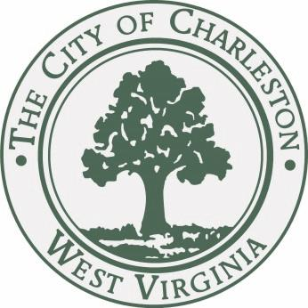

JOURNAL of the PROCEEDINGS
of the
CITY COUNCIL

CITY OF CHARLESTON, WEST VIRGINIA

Regular Meeting – Monday, September 21, 2015

at 7:00 P.M.

Council Chamber – City Hall – Charleston, West Virginia

OFFICIAL RECORD

JB Akers
City Clerk
Danny Jones
Mayor

CALL TO ORDER

The Council met in the Chambers of the City Building at 7:00 P.M., for the second meeting in the month of September on the 21st day, in the year 2015, and was called to order by the Honorable Mayor, Danny Jones. The invocation was delivered by Councilman Harrison and the Pledge of Allegiance was led by the Council lady Snodgrass. The Honorable Clerk, JB Akers, called the roll of members and it was found that there were present at the time:

BURKA BURTON CEPERLEY
CHESTNUT CLOWSER DAVIS
EALY FAEGRE HAAS
HARRISON HOOVER IRELAND LANE MILLER MINARDI OVERSTREET PERSINGER REISHMAN RICHARDSON SALISBURY SLATER SMITH SNODGRASS STEELE TALKINGTON WARE MAYOR JONES

With twenty-four members being present, the Mayor declared a quorum present.

Pending the reading of the Journal of the previous meeting, the reading thereof was dispensed with and the same duly approved.

CLAIMS

- A claim of Kristina Abdalla, 704 Jefferson Rd., South Charleston, WV; alleges personal injury.
Refer to City Solicitor.

- A claim of Andy Cook, 5 Roller Rd.,Charleston, WV; alleges damage to vehicle.
Refer to City Solicitor.

- A claim of Jonathan Jones, 804 Larchmont Drive, Charleston, WV; alleges damage to vehicle.
Refer to City Solicitor.

- A claim of Terry Potesta, 1831 Loudon Heights Rd., Charleston, WV; alleges damage to vehicle.
Refer to City Solicitor.

- A claim of Nicole Rhodes, 1506 Viewmont Drive., Charleston, WV; alleges damage to personal property.
Refer to City Solicitor.

- A claim of Sandra Sarvey, 1131 Edgewood Dr., Charleston, WV; alleges damage to vehicle.
Refer to City Solicitor.

- A claim of Chael Weems, 56 Garrison Ave., Charleston, WV; alleges damage to personal property.
Refer to City Solicitor.

PUBLIC HEARING

The Mayor called the public hearing on Bill number 7665, A Bill approving the transfer of control of the cable television franchise and cable television system now held by Cequel Corporation, the parent of Cebridge Acquisition LLC dba Suddenlink Communications to Altice S. A.
With no one from the public to speak regarding the bill, The Mayor declared the public hearing on Bill No. 7665, closed.

COMMUNICATIONS

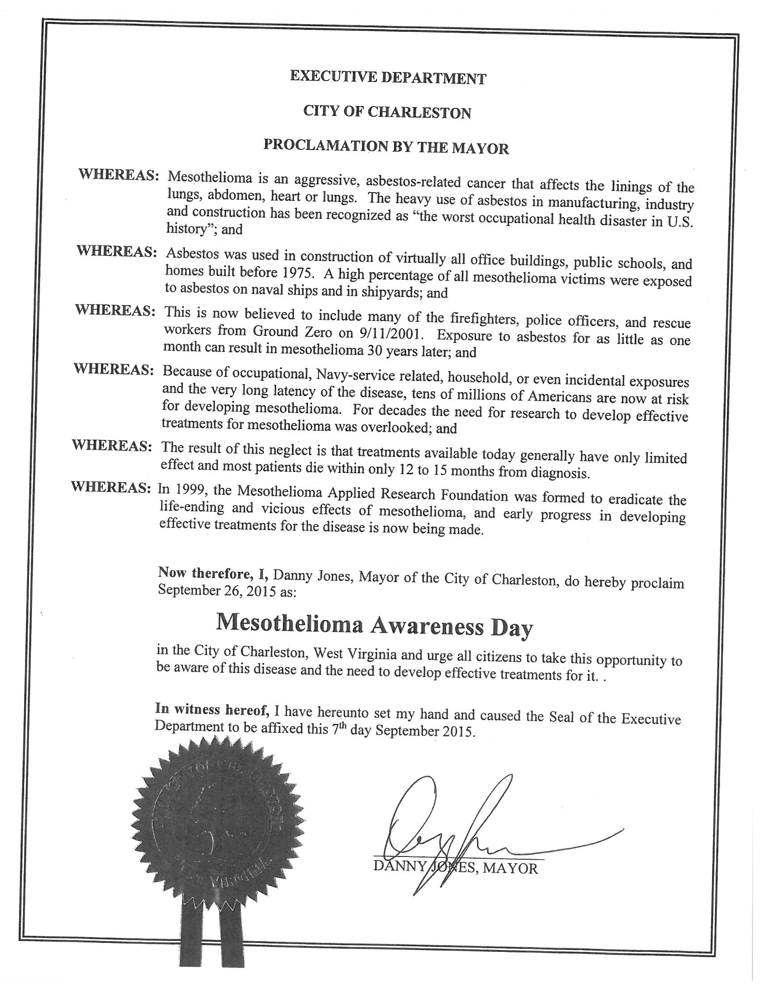
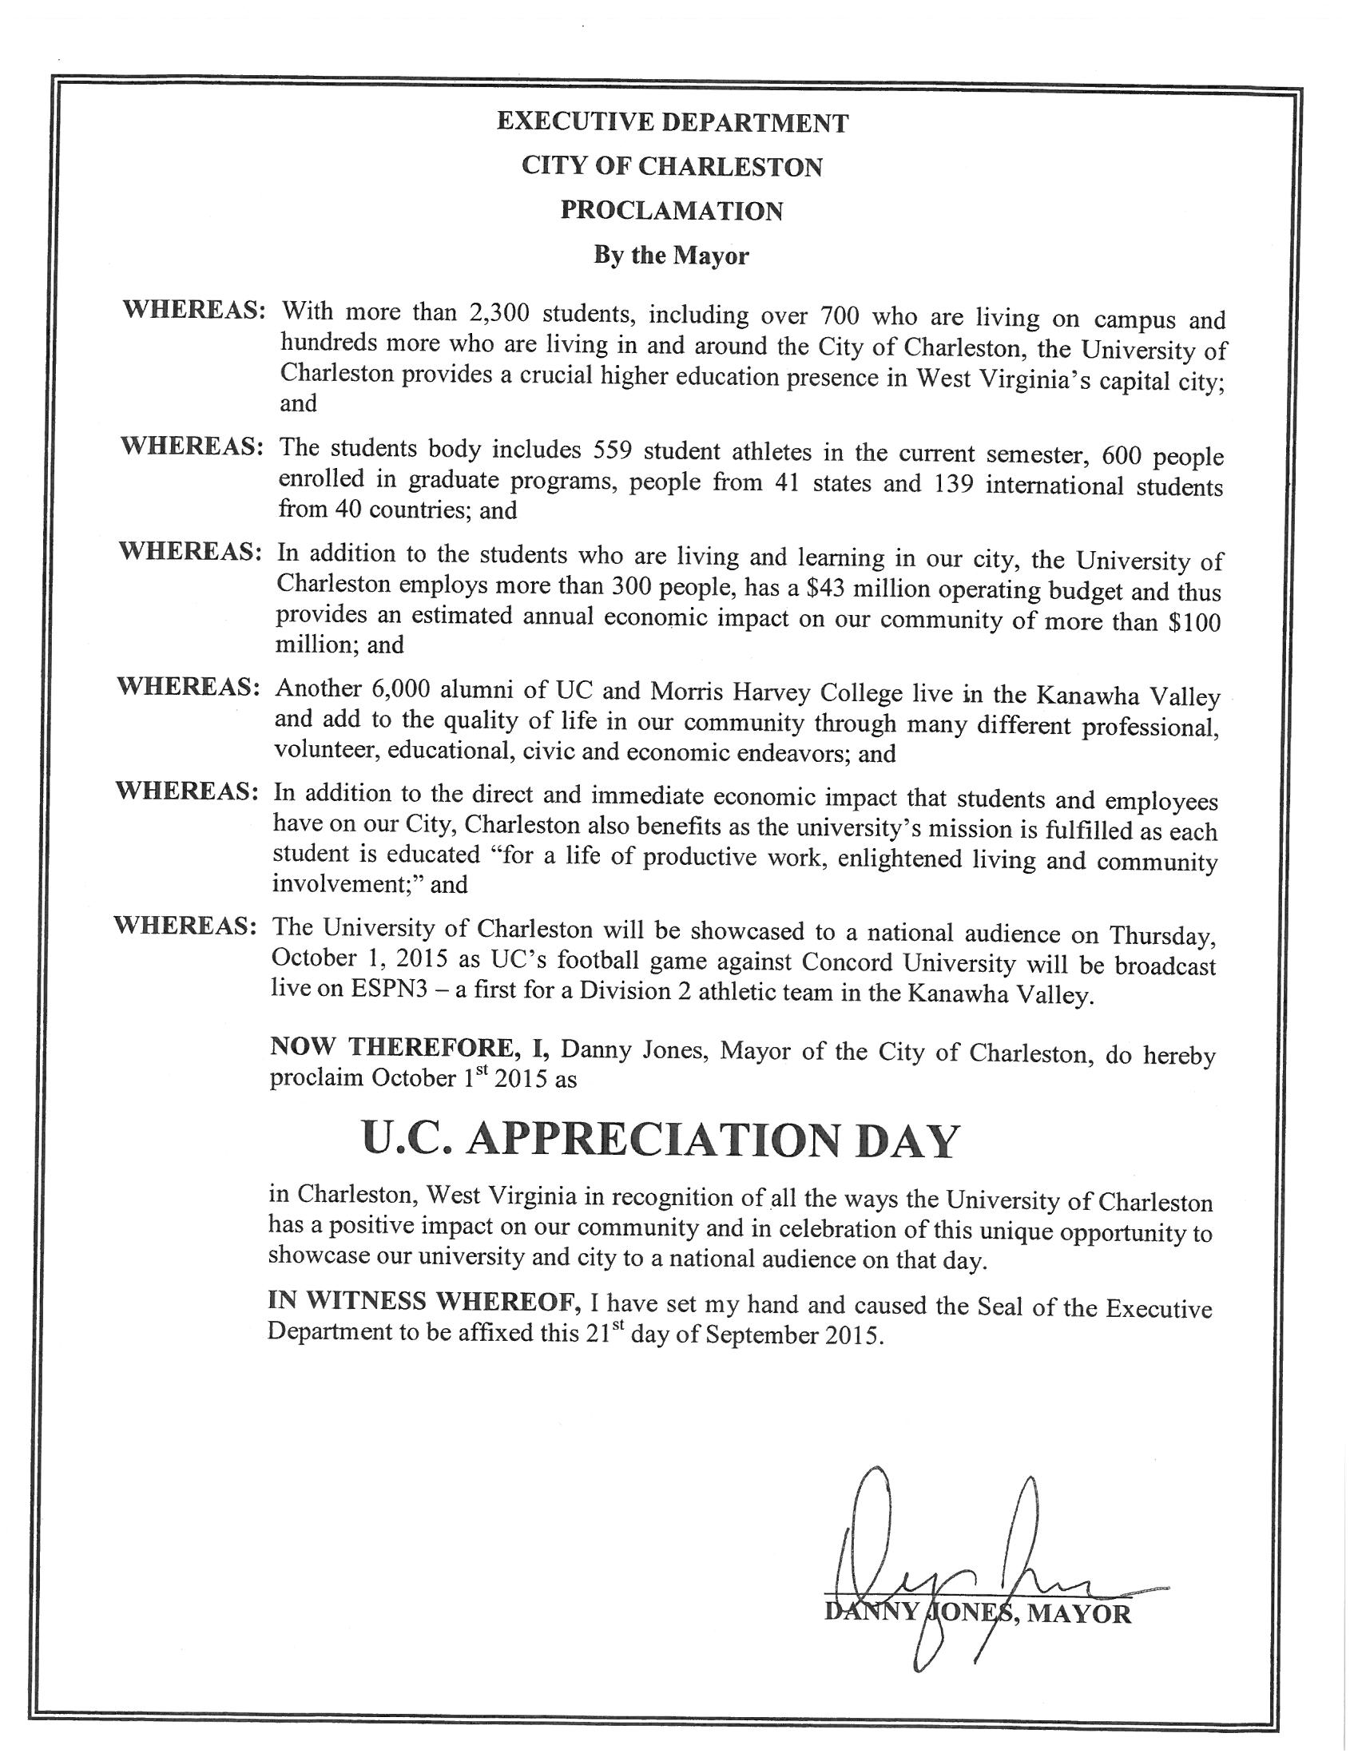

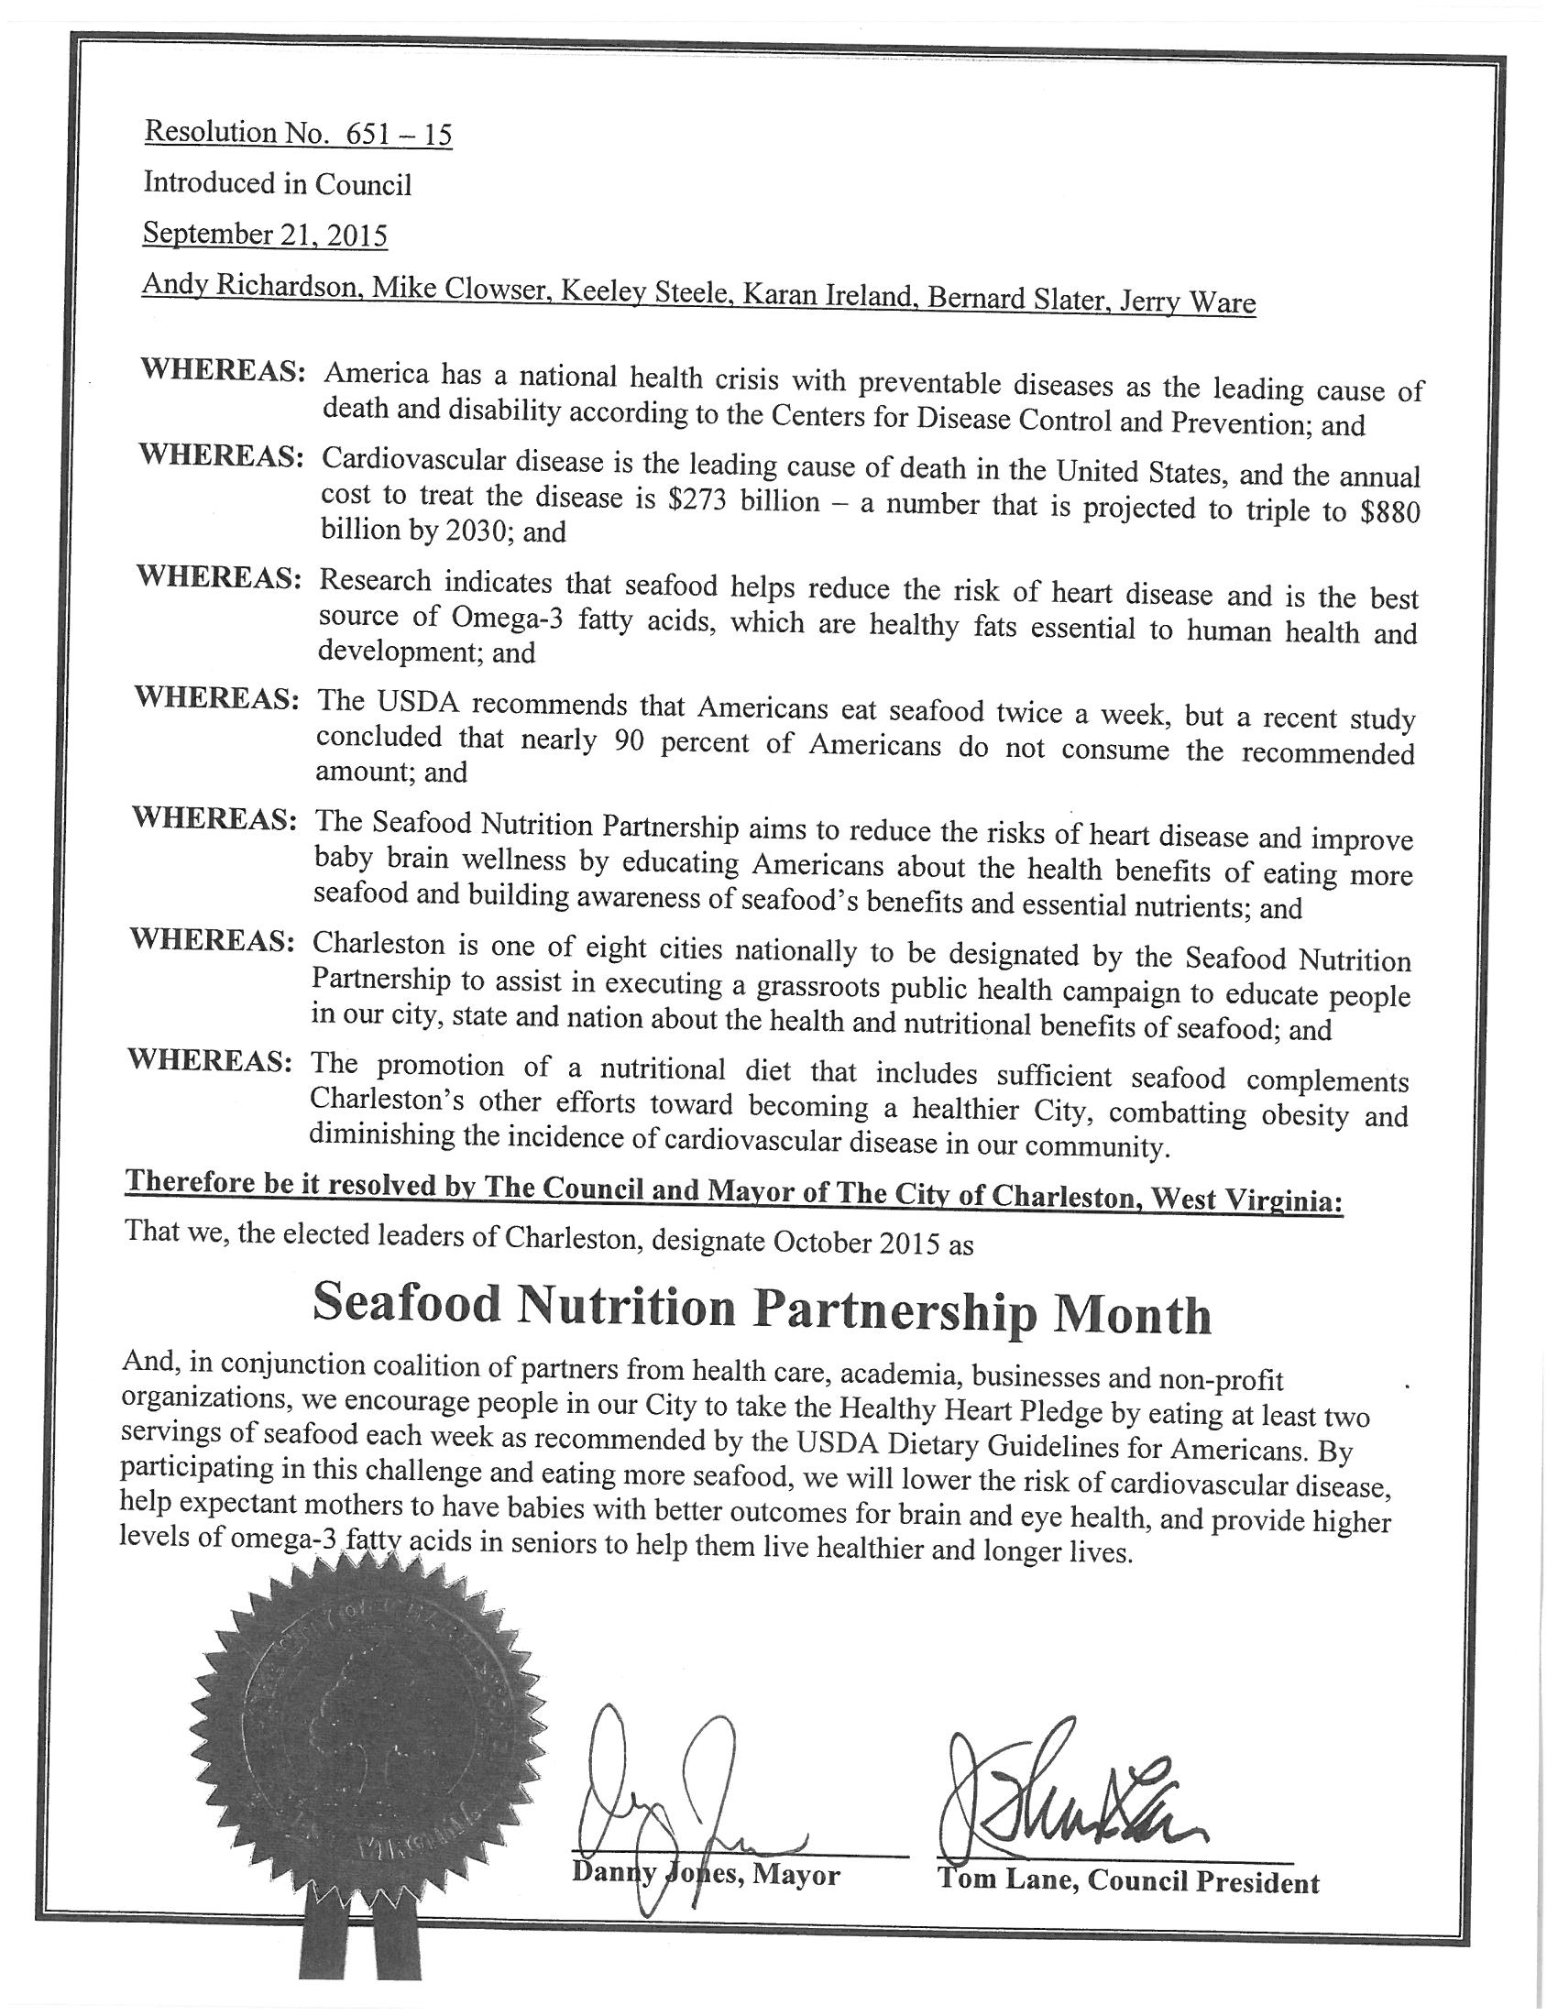

REPORTS OF COMMITTEES

COMMITTEE ON CABLE TELEVISION

Councilperson Jack Harrison, Chairperson of the Council Committee on Cable Television, submitted the following report:

- Your committee on Cable Television has had under consideration Bill No. 7665, and reports the same to Council with the recommendation that the bill do pass.
Bill No. 7665-- A Bill (a) approving the transfer of control of the cable television franchise and cable television system now held by Cequel Corporation (‘Cequel”), the parent of Cebridge Acquisition LLC dba Suddenlink Communications (“Suddenlink”) to Altice S. A. (as subsequently reorganized to become Altice N.V.) (“Altice”).

WHEREAS, Suddenlink is the present holder of a non-exclusive cable television franchise that was originally granted by the City of Charleston, WV (“City”), as set forth in Bill No. 4370, Committee substitute dated November 7, 1988, and renewed by Bill No. 6610 as Amended and adopted by Council on October 4, 1999 (the “Franchise”) and transferred to Suddenlink by Bill No. 7214 as Amended and adopted by Council on July 3, 2006. The franchise was subsequently renewed by Bill No. 7229, Committee Substitute and adopted by Council on October 2, 2006, and again renewed until October 3, 2016, by Bill No. 7501 adopted by Council on November 21, 2011. On November 19, 2012, City Council approved the transfer of control of the franchise to Nespresso Acquisition Corporation, a company that had acquired the interests of Cequel Corporation, including the Charleston Suddenlink franchise; and

WHEREAS, Cequel has entered into a Purchase and Sale Agreement (“the Agreement”) with Altice and other parties thereto, pursuant to which certain wholly-owned subsidiaries of Altice will acquire 70% of the issued and outstanding equity interests of Cequel including the cable television system (“System”) and the Franchise, (the “Transaction”); and

WHEREAS, Cequel has filed an Application for Franchise Authority Consent to Assignment or Transfer of Control of Cable Television Franchise regarding the sale of equity interests of Cequel to Altice, including the cable television system (“System”) and the Franchise, (the “Transaction”); and

WHEREAS, Cequel and Altice (collectively the “Companies”) have requested the consent of the City to the transfer of control of the Franchise and System in accordance with the requirements of the Franchise and applicable law and have filed with the City an application for consent to transfer of control of cable television franchise on FCC Form 394 that includes information concerning the Transaction and legal, technical and financial qualifications of Altice (the “Application”); and

WHEREAS, if the transfer of control is approved by the City, Altice will be the holder of the equity interests of Cequel and will have ultimate control of Suddenlink as of the date of the Transaction (“Closing Date”); and

WHEREAS, the City has reviewed the Application, and examined the legal, financial and technical qualifications of Altice that were submitted with the Application; and

WHEREAS, the City has followed all required procedures to consider and act upon the Application, and considered the comments of all interested parties at an administrative hearing held on September 15, 2015, as well as a hearing on this ordinance on September 21, 2015 (collectively, the “Public Hearings”); and

WHEREAS, Section 2-8 of Bill No. 4370, Committee Substitute, requires Council approval for transfers which approval shall not be unreasonably withheld; and

WHEREAS, it is in the public interest to maintain continuous Cable Television service within the City; and

WHEREAS, the Public Hearings did not produce substantial public opposition to the transfer of control; and

WHEREAS, the City believes it is in the interest of the community to approve the transfer of control of the Franchise and the System to Altice.

NOW THEREFORE BE IT ORDAINED;

That with respect to and in accordance with the provisions of West Virginia Code §24D-1-12, and Bill No. 4370, Committee Substitute dated November 7, 1998 and Bill No. 6610 as Amended and adopted by Council on October 4, 1999, and Bill No. 7214 as Amended and adopted by Council on July 3, 2006 (the “Ordinances”), City hereby approves the transfer of control of the Franchise and the System related thereto to Altice as follows:

SECTION 1. The City hereby approves the transfer of control of the Franchise and System to Altice without approval of the terms of the Transaction, all in accordance with the terms of the Franchise and applicable law.

SECTION 2. The City’s approval of the Application and its consent to the transfer of control of the Franchise and the System to Altice shall take effect immediately upon enactment or as otherwise required by law.

SECTION 3. Suddenlink shall notify the City of the closing of the Transaction promptly after the Closing Date; provided however, this Ordinance shall be null and void if the Transaction is not consummated.

Councilman Harrison moved to approve the Bill. Councilman Lane seconded the motion. A roll call was taken.
YEAS: Burka, Burton, Ceperley, Chestnut, Clowser, Davis, Ealy, Haas, Harrison, Hoover, Ireland, Lane, Miller, Overstreet, Persinger, Reishman, Richardson, Salisbury, Smith, Snodgrass, Slater, Talkington, Ware, Mayor Jones
NAYS: NONE
ABSENT: Faegre, Minardi, Steele
With a majority of members elected recorded thereon as voting in the affirmative the Mayor declared the bill adopted.

COMMITTEE ON ORDINANCE AND RULES

Councilperson Jack Harrison, Chairperson of the Council Committee on Ordinance and Rules, submitted the following report:

- Your committee on Ordinance and Rules has had under consideration Committee Substitute Bill No. 7666, and reports the same to Council with the recommendation that the bill do pass.
A Committee Substitute for Bill No. 7666: An ordinance repealing and reenacting Subdivision II of Division 5, Article V, Chapter 78 of the Code of the City of Charleston, and enacting Subdivision III of Division 5, Article V, Chapter 78 of the Code of the City of Charleston, all pertaining to the sale, marketing and distribution of Hypodermic Needles and Syringes.

NOW, THEREFORE, BE IT ORDAINED BY THE CITY COUNCIL OF THE CITY OF CHARLESTON THAT:

Effective September 31, 2015, Subdivision II of Division 5, Article V, Chapter 78 of the Code of the City of Charleston is hereby repealed and reenacted, and Subdivision III of Division 5, Article V, Chapter 78 of the Code of the City of Charleston is hereby enacted, all to read as follows:

Chapter 78
Article V
Division 5

Subdivision II. – Sale, Marketing, and Distribution of Hypodermic Needles and Syringes and Related Devices.

Sec. 78-381. - Sales regulated.
(a) No hypodermic needle, syringe or similar device, or disposable hypodermic needle, syringe or similar device which may be used for subcutaneous injection, or for administering any drug or other substance into the human body, shall be sold or dispensed to any person except by prescription, either written or oral, as follows:
(1) Upon a written prescription of a practitioner licensed by law to administer drugs;
(2) Upon an oral prescription of such practitioner which is reduced promptly to writing and filed by the pharmacist; or
(3) By refilling any such written or oral prescription, if such refilling is authorized by the prescriber, either in the original prescription or by oral order which is reduced to writing and filed by the pharmacist.
(b) All such pharmacists or legalized dispensers of such paraphernalia shall keep or cause to be kept accurate records of sales of such paraphernalia, including but not limited to the name of the purchaser (requiring adequate identification), the address of purchaser, date of sale, type of instrument sold and number sold. The city shall supply forms on which such information shall be recorded, and it shall be the duty of the dispenser or vendor of such devices to procure such forms.
(c) The provisions of this section shall not apply to the sale of any hypodermic syringe, needle or similar device, or disposable hypodermic needle, syringe or similar device to hospitals, physicians, dentists, pharmacists, industrial corporations and educational institutions, or embalmers, or others using such devices in the legal course of their respective business or profession; nevertheless, such vendors or legalized dispensers shall keep or cause to be kept accurate records for all such sales.

Sec. 78-382. - Possession restricted.
No person except a manufacturer of, or wholesaler, or a retail dealer in surgical instruments, apothecary, physician, dentist, hospital, veterinarian, nurse, industrial corporation, educational institution, or intern shall at any time have or possess a hypodermic syringe or needle or a disposable hypodermic syringe or needle or any instrument or implement adapted for the use of habit-forming drugs by subcutaneous injection, which is possessed for the purposes of administering habit-forming drugs, unless such possession is authorized by the prescription of a physician issued according to section 78-381.

Sec. 78-383. - Destruction of discarded hypodermic syringes or needles.
Every person who in the course of his business or for whatever reason dispenses, administers or uses hypodermic syringes or needles or disposable hypodermic syringes or needles or other similar devices, and who discards any such syringes or needles or other similar devices, whether used or not, shall cause such syringes, needles or other similar devices to be destroyed prior to discarding, whether used or not, by breaking them into at least two distinct pieces or crushing them or otherwise rendering the syringes or needles inoperable.

Sec. 78-381. - Sale, Marketing and Distribution of hypodermic needles; state license required.
It shall be unlawful for any person or persons as principal, clerk, agent or servant to sell, market, or distribute any hypodermic syringes, needles and other similar objects used or designed for injecting substances into the human body, without obtaining and having any and all licenses required under state law to do so: except that, items distributed by or exchanged at a needle exchange program sponsored or approved by the Chief of Police of the Charleston Police Department, as provided by Subdivision III herein, are thereby approved and are not unlawful.

Sec. 78-382. - Compliance with state law and regulations.
Every person licensed to sell, market, or distribute hypodermic needles shall comply with all applicable state law and regulations.

Sec. 78-383. - Penalty.
Any person violating any provision of this subdivision shall, if convicted, be guilty of a misdemeanor and be fined not less than ten dollars nor more than five hundred dollars for the first offense and succeeding offenses. Each day that such violation shall continue shall be deemed a separate and distinct offense.

Secs. 78-384—78-395. - Reserved.

Subdivision III. – Needle Exchange Program

Sec. 78-396. - Needle exchange program authorized.

The City of Charleston, by and through its Chief of Police, may sponsor, approve, or participate in a program or programs within the City of Charleston for the distribution or exchange of hypodermic syringes, needles and other similar objects used or designed for injecting substances into the human body.

Sec. 78-397. - Rules and regulations; Chief of Police authorized.

The Chief of Police of the City of Charleston Police Department is authorized to promulgate reasonable rules or regulations deemed necessary to implement and administer a program within the City of Charleston provided for in Section 78-396 for the distribution or exchange of hypodermic syringes, needles and other similar objects used or designed for injecting substances into the human body.

Secs. 78-398 -78-410. – Reserved.

Councilman Harrison moved to approve the Bill. Councilman Lane seconded the motion. A roll call was taken.
YEAS: Burka, Burton, Ceperley, Chestnut, Clowser, Davis, Ealy, Haas, Harrison, Hoover, Ireland, Lane, Miller, Overstreet, Persinger, Reishman, Richardson, Salisbury, Smith, Snodgrass, Slater, Talkington, Ware, Mayor Jones
NAYS: NONE
ABSENT: Faegre, Minardi, Steele
With a majority of members elected recorded thereon as voting in the affirmative the Mayor declared the bill adopted.

COMMITTEE ON FINANCE

Councilperson Bobby Reishman, Chairperson of the Council Committee on Finance, submitted the following reports:

- Your committee on Finance has had under consideration Resolution No. 648-15, and reports the same to Council with the recommendation that the resolution do pass.
Resolution No. 648-15 : “Authorizing the Mayor to receive and administer grant funds in the amount of $646,500.00 from the Governor’s Highway Safety Program to assist in the funding of Metro Valley Highway Safety Programs. The funds will provide partial reimbursements for the Project Coordinator’s salary, training and overtime costs for Target Red, Click It or Ticket, DUI enforcement, school safety, and aggressive driving programs in the four county area of Kanawha, Boone, Clay, and Logan counties.”

Be it Resolved by the Council of the City of Charleston, West Virginia:

That the Mayor is hereby authorized and directed to receive and administer grant funds in the amount of $646,500.00 from the Governor’s Highway Safety Program to assist in the funding of Metro Valley Highway Safety Programs. The funds will provide partial reimbursements for the Project Coordinator’s salary, training and overtime costs for Target Red, Click It or Ticket, DUI enforcement, school safety, and aggressive driving programs in the four county area of Kanawha, Boone, Clay, and Logan counties.

Councilman Reishman moved to approve the Resolution. Councilman Lane seconded the motion. With a majority of members elected recorded thereon as voting in the affirmative the Mayor declared Resolution 648-15 adopted.

- Your committee on Finance has had under consideration Resolution No. 649-15, and reports the same to Council with the recommendation that the resolution do pass.
Resolution No. 649-15 : “Authorizing the Finance Director to appropriate funds in the amount of $16,300.00 in support of the purchase and installation of netting at the City’s softball field in Kanawha City used by the University of Charleston. The netting would aid in the prevention of foul balls hitting cars parked at the Charleston Area Medical Center’s Cancer Center. The total cost of the project is $48,900.00 and the City will be sharing one-third of the cost with the University of Charleston and the Charleston Area Medical Center.”

Be it Resolved by the Council of the City of Charleston, West Virginia:

That the Finance Director is hereby authorized and directed to appropriate funds in the amount of $16,300.00 in support of the purchase and installation of netting at the City’s softball field in Kanawha City used by the University of Charleston. The netting would aid in the prevention of foul balls hitting cars parked at the Charleston Area Medical Center’s Cancer Center. The total cost of the project is $48,900.00 and the City will be sharing one-third of the cost with the University of Charleston and the Charleston Area Medical Center.

To be charged to Account No. 222-979-00-900-4-458, P&R—Capital Outlay, Facilities
Maintenance Fund

Councilman Reishman moved to approve the Resolution. Councilman Lane seconded the motion. With a majority of members elected recorded thereon as voting in the affirmative the Mayor declared Resolution 649-15 adopted.

- Your committee on Finance has had under consideration Resolution No. 650-15, and reports the same to Council with the recommendation that the resolution do pass.
Resolution No. 650-15 : “Authorizing the City Manager to execute Change Order No. 1 to the Design-Build contract with BBL Carlton, LLC, to provide for the design and relocation of a sanitary sewer main along the Elk River utilizing Bore & Jack technology in relation to the Civic Center Expansion and Renovation Project. The cost of the Change Order is a Guaranteed Maximum Price not to exceed $3,489,510.23, with the work not self-performed by the Design-Builder being competitively bid to sub-contractors through the City’s Purchasing Department. Design-Builder shall present a final accounting of the Cost of the Work to be performed pursuant to this Change Order and the amount of any resulting and/or reconciled savings shall be a credit to the City in determining the net amount to be paid by the City to the Design-Builder. The Change Order increases the contract price from $82,219,485 to an amount not to exceed $85,708,995.23.”

Be it Resolved by the Council of the City of Charleston, West Virginia:

That the City Manager is hereby authorized and directed to execute Change Order No. 1 to the Design-Build contract with BBL Carlton, LLC, to provide for the design and relocation of a sanitary sewer main along the Elk River utilizing Bore & Jack technology in relation to the Civic Center Expansion and Renovation Project. The cost of the Change Order is a Guaranteed Maximum Price not to exceed $3,489,510.23, with the work not self-performed by the Design-Builder being competitively bid to sub-contractors through the City’s Purchasing Department. Design-Builder shall present a final accounting of the Cost of the Work to be performed pursuant to this Change Order and the amount of any resulting and/or reconciled savings shall be a credit to the City in determining the net amount to be paid by the City to the Design-Builder. The Change Order increases the contract price from $82,219,485 to an amount not to exceed $85,708,995.23.

To be charged to Account No. 216-979-00-000-4-460, Civic Center Project—Capital Outlay, Construction in Progress

Councilman Reishman moved to approve the Resolution. Councilman Lane seconded the motion. With a majority of members elected recorded thereon as voting in the affirmative the Mayor declared Resolution 650-15 adopted.

REPORTS OF OFFICERS

- City Treasurer’s Report to City Council Month Ending August, 2015.
Received and Filed

NEW BILLS

Introduced by Council member Edward Talkington on September 21, 2015:
Bill No. 7667 amending the Zoning Ordinance of the City of Charleston, West Virginia, enacted the 1st day of January 2006, as amended, and the map made a part thereof, by rezoning from an I-2 district to a C-10 district, that certain parcel of land located at 910 Pennsylvania Avenue, Charleston, West Virginia.
Refer to Planning Committee and Municipal Planning Commission

Introduced by Council member Courtney Persinger on September 21, 2015:
Bill No. 7668 amending the Zoning Ordinance of the City of Charleston, West Virginia, enacted the 1st day of January 2006, as amended, and the map made a part thereof, by rezoning from an I-2 district to a C-10 district, that certain parcel of land located at 330 MacCorkle Avenue, Charleston, West Virginia.
Refer to Planning Committee and Municipal Planning Commission

ADJOURNMENT

The Clerk, JB Akers, called the closing roll call:

YEAS: Burka, Burton, Ceperley, Chestnut, Clowser, Davis, Ealy, Haas, Harrison, Hoover, Ireland, Lane, Miller, Overstreet, Persinger, Reishman, Richardson, Salisbury, Smith, Snodgrass, Slater, Talkington, Ware, Mayor Jones
ABSENT: Faegre, Minardi, Steele
At 7:25 p.m., by a motion from Councilmember Harrison, Council adjourned until Monday, October 5, 2015, at 7:00 p.m., in the Council Chamber in City Hall.

_______________________________
Danny Jones, Honorable Mayor

_______________________________
JB Akers, City Clerk

