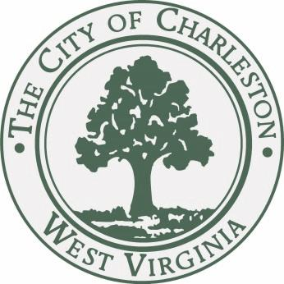

JOURNAL of the PROCEEDINGS
of the
CITY COUNCIL

CITY OF CHARLESTON, WEST VIRGINIA

Regular Meeting – Monday, March 2, 2015

at 7:00 P.M.

Council Chamber – City Hall – Charleston, West Virginia

OFFICIAL RECORD

James M. Reishman
City Clerk
Danny Jones
Mayor

CALL TO ORDER

The Council met in the Chambers of the City Building at 7:00 P.M., for the first meeting in the month of March on the 2nd day, in the year 2015, and was called to order by the Honorable Mayor, Danny Jones. The invocation was delivered by Councilman Harrison and the Pledge of Allegiance was led by Bob Sharp. The Clerk, James M. Reishman, called the roll of members and it was found that there were present at the time:

BURKA BURTON CLOWSER
DAVIS DENEAULT DODRILL
EALY HAAS HARRISON
HOOVER KIRK KNAUFF LANE MILLER MINARDI NICHOLS PERSINGER REISHMAN RICHARDSON RUSSELL SALISBURY SHEETS SMITH SNODGRASS TALKINGTON WARE WHITE
MAYOR JONES

With twenty-six members being present, the Mayor declared a quorum present.

Pending the reading of the Journal of the previous meeting, the reading thereof was dispensed with and the same duly approved.

PUBLIC SPEAKERS

- Wanda Hightower came to voice her concern on the ward/precinct changes and urged councilmembers to do as much as possible to let citizens know where they can vote in the upcoming Primary Election.
CLAIMS

- A claim of Diana Campbell, 403 Swinburn St, Charleston, WV; alleges damage to personal property.
Referred to City Solicitor.

- A claim of Nathan Rose, 5048 Weaver Drive, Colorado Springs, CO; alleges damage to person property.
Referred to City Solicitor.

COMMUNICATIONS

TO: JAMES REISHMAN
CITY CLERK

FROM: DANNY JONES
MAYOR

RE: CHARLESTON URBAN RENEWAL AUTHORITY

DATE: MARCH 2, 2015

I recommend that Jack Harrison, 1116 Shamrock Road, Charleston, WV 25314 be appointed to the Charleston Urban Renewal Authority, with an initial term to expire March 3, 2020.

I respectfully request City Council’s approval of this recommendation.

Councilman Harrison moved to approve the appointment. Councilman Lane seconded the motion. With a majority of members elected recorded thereon as voting in the affirmative the Mayor declared the appointment confirmed. (NAY: Kirk, Sheets, Smith)

TO: JAMES REISHMAN
CITY CLERK

FROM: DANNY JONES
MAYOR

RE: CHARLESTON URBAN RENEWAL AUTHORITY

DATE: MARCH 2, 2015

I recommend that Mary Jean Davis, 1527 Dogwood Rd., Charleston, WV 25314 be appointed to the Charleston Urban Renewal Authority, with an initial term to expire March 3, 2020.

I respectfully request City Council’s approval of this recommendation.

Councilman Harrison moved to approve the appointment. Councilman Lane seconded the motion. With a majority of members elected recorded thereon as voting in the affirmative the Mayor declared the appointment confirmed. (NAY: Kirk, Sheets, Smith)

TO: JAMES REISHMAN
CITY CLERK

FROM: DANNY JONES
MAYOR

RE: CHARLESTON CONVENTION & VISITORS BUREAU

DATE: MARCH 2, 2015

I recommend that Douglas J. Walters, 901 Somerset Drive, Charleston, WV 25302 be appointed to Charleston Convention & Visitors Bureau, with an initial term to expire February 17, 2018.

I respectfully request City Council’s approval of this recommendation.

Councilman Harrison moved to approve the appointment. Councilman Lane seconded the motion. With a majority of members elected recorded thereon as voting in the affirmative the Mayor declared the appointment confirmed.

TO: JAMES REISHMAN
CITY CLERK

FROM: DANNY JONES
MAYOR

RE: CHARLESTON CONVENTION & VISITORS BUREAU

DATE: MARCH 2, 2015

I recommend that Lisa McCraken, Charleston Town Center, Charleston, WV 25389 be appointed to Charleston Convention & Visitors Bureau, with an initial term to expire February 17, 2018.

I respectfully request City Council’s approval of this recommendation.

Councilman Harrison moved to approve the appointment. Councilman Lane seconded the motion. With a majority of members elected recorded thereon as voting in the affirmative the Mayor declared the appointment confirmed.

TO: JAMES REISHMAN
CITY CLERK

FROM: DANNY JONES
MAYOR

RE: CHARLESTON CONVENTION & VISITORS BUREAU

DATE: MARCH 2, 2015

I recommend that Georgette George, 400 2nd Ave., South Charleston, WV 25389 be appointed to Charleston Convention & Visitors Bureau, with an initial term to expire February 17, 2018.

I respectfully request City Council’s approval of this recommendation.

Councilman Harrison moved to approve the appointment. Councilman Lane seconded the motion. With a majority of members elected recorded thereon as voting in the affirmative the Mayor declared the appointment confirmed.

REPORTS OF COMMITTEES

COMMITTEE ON PLANNING

Councilperson Mary Jean Davis, Chairperson of the Council Committee on Finance, submitted the following reports:

- Your committee on Planning has had under consideration Bill No. 7646, and reports the same to Council with the recommendation that the bill do pass.
Bill No. 7646 amending the Zoning Ordinance for the City of Charleston, West Virginia, adopted November 21, 2005 by amending section 22-040-04 to permit gravel as a permitted driveway surface for single family and duplex dwellings provided certain conditions are met.

BE IT ORDAINED BY THE COUNCIL OF THE CITY OF CHARLESTON, WEST VIRGINIA
- The Zoning Ordinance for the City of Charleston, West Virginia, effective November 21, 2005, is hereby amended as follows:

Sec. 22-040-04 Surfacing
Areas used for off-street parking, circulation or vehicle display shall be surfaced with asphalt, concrete, masonry, or other solid paving materials with sufficient strength to support the vehicle loads imposed. Gravel driveways are permitted only for single family and duplex dwellings provided that the following conditions are met:
- A paved apron over the entire width of the right of way must connect the gravel driveway to the street, a minimum 5’ paved apron is required;
- the driveway is edged with a barrier sufficient to keep the gravel solely within the driveway;
- the gravel used is angular and interlocking; and
- the area to be graveled has a maximum grade of 5% unless otherwise approved by the City Engineer’s Office.

All off-street parking and other vehicle circulation areas shall be continuously maintained and designed to preclude free flow of storm water onto adjacent lots, properties, or public streets or ways. In addition, existing non-conforming graveled parking lots or parking spaces must be continuously maintained so that dirt, mud, and gravel shall not be tacked onto adjacent lots, properties, or public streets or ways. All land areas that are not covered with buildings or paved for off-street parking and circulation of vehicles shall be appropriately landscaped with grass or other vegetative ground cover, decorative mulch planting beds, trees or shrubs.
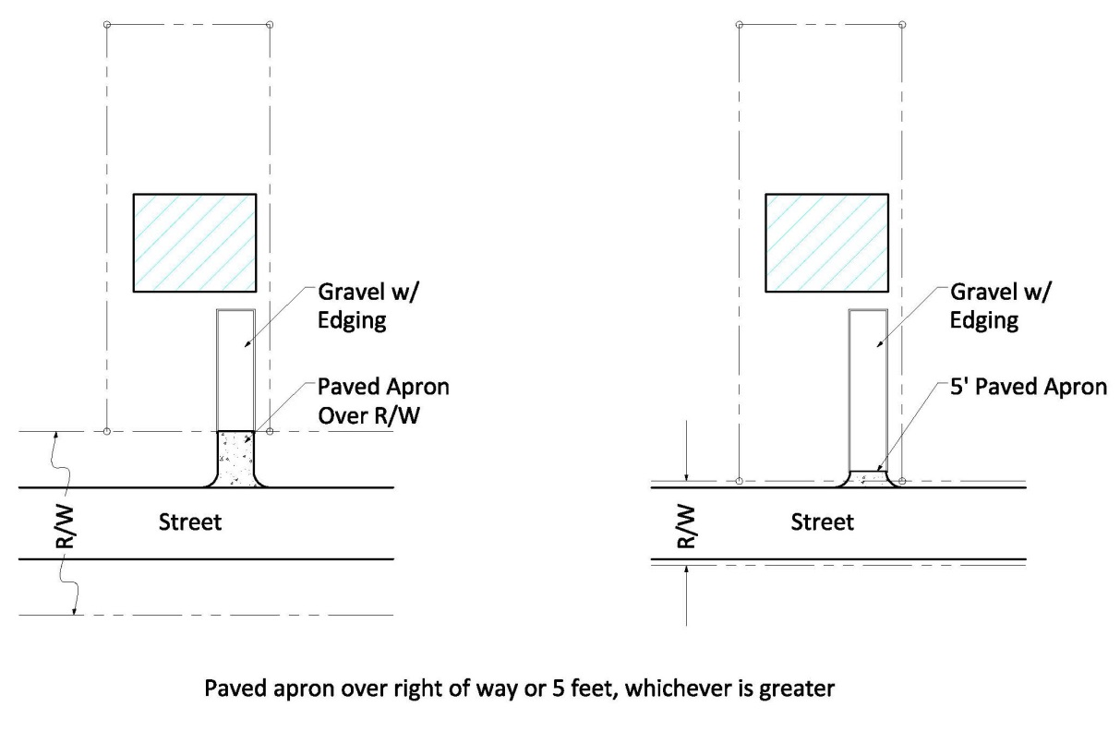
Graphic 22-40-04.01 Paved apron requirement for gravel driveways

- All prior ordinances or parts of ordinances, inconsistent with this ordinance are hereby repealed to the extent of such inconsistency.

Councilman Harrison moved to pass Bill No. 7646. Councilman Lane seconded the motion. The Mayor opened the floor for discussion of the Bill.

There was no discussion regarding the bill in question.

A roll call was taken:
YEAS: Burka, Burton, Clowser, Davis, Deneault, Dodrill, Ealy, Haas, Hoover, Kirk, Knauff, Lane, Minardi, Nichols, Persinger, Reishman, Richardson, Salisbury, Sheets, Smith, Snodgrass, Talkington, Ware, White, Jones
NAYS: None
ABSENT: Miller, Russell
With a majority vote recorded thereon as voting in the affirmative the Mayor declared Bill 7646, adopted.

COMMITTEE ON FINANCE

Councilperson Bobby Reishman, Chairperson of the Council Committee on Finance, submitted the following reports:
- Your committee on Finance has had under consideration Resolution No. 555-15, and reports the same to Council with the recommendation that the resolution do pass.
Resolution No. 555-15: “Authorizing the Mayor or City Manager, subject to final review by the City Attorney, to enter into contracts through Commercial Insurance Services and Arthur J. Gallagher Risk Management Services, Inc., at a price of $971,428, for the City’s Risk Management and Property and Casualty Insurance coverage for the period March 31, 2015 through March 31, 2016, in accordance with the costs attached, and specifically by rejecting all underinsured motorists coverage and accepting uninsured motorists coverage with statutory minimum limits of $20,000/$40,000/$10,000 only; and further authorizing the Mayor or City Manager to sign the appropriate forms rejecting the underinsured motorists coverage and accepting the uninsured motorists coverage.”

Be it Resolved by the Council of the City of Charleston, West Virginia:

That the Mayor or City Manager, subject to final review by the City Attorney, is hereby authorized and directed to enter into contracts through Commercial Insurance Services and Arthur J. Gallagher Risk Management Services, Inc., at a price of $971,428, for the City’s Risk Management and Property and Casualty Insurance coverage for the period March 31, 2015 through March 31, 2016, in accordance with the costs attached, and specifically by rejecting all underinsured motorists coverage and accepting uninsured motorists coverage with statutory minimum limits of $20,000/$40,000/$10,000 only; and further authorizing the Mayor or City Manager to sign the appropriate forms rejecting the underinsured motorists coverage and accepting the uninsured motorists coverage.

To be charged to Account No. 001-412-00-000-2-227, City Manager, Liability Insurance,
and the Civic Center, Parking system, and Sanitary Board accounts.

Councilman Reishman moved to approve the Resolution. Councilman Lane seconded the motion. With a majority of members elected recorded thereon as voting in the affirmative the Mayor declared Resolution 555-15 adopted. (ABSTAIN – Burton)

- Your committee on Finance has had under consideration Resolution No. 556-15, and reports the same to Council with the recommendation that the resolution do pass.
Resolution No. 556-15: “Authorizing the Mayor or his designee to submit a grant application to Frontier/DISH for the America’s Best Communities Grant Program. The multi-phase grant will provide for 50 applicants to receive $35,000 with a required match of $15,000, to work on planning for The EDGE project. The next phase will award $100,000 to eight (8) communities to begin implementing their plans and the final phase will award a $1million, $2 million, and $3 million grant to fully implement their plan.”

Be it Resolved by the Council of the City of Charleston, West Virginia:

That the Mayor or his designee is hereby authorized and directed to submit a grant application to Frontier/DISH for the America’s Best Communities Grant Program. The multi-phase grant will provide for 50 applicants to receive $35,000 with a required match of $15,000, to work on planning for The EDGE project. The next phase will award $100,000 to eight (8) communities to begin implementing their plans and the final phase will award a $1million, $2 million, and $3 million grant to fully implement their plan.

Councilman Reishman moved to approve the Resolution. Councilman Lane seconded the motion. With a majority of members elected recorded thereon as voting in the affirmative the Mayor declared Resolution 556-15 adopted.

- Your committee on Finance has had under consideration Resolution No. 557-15, and reports the same to Council with the recommendation that the resolution do pass.
Resolution No. 557-15: “Authorizing the Mayor or his designee to submit a grant application to the West Virginia Department of Transportation, Division of Highways, for a Transportation Alternatives Grant in the amount of $100,000 for the Gallery 64 Project, a streetscape and lighting project meant to enhance the connection between Charleston’s downtown and West Side by showcasing the 10 original Peer to Pier Murals, which were installed in 2011. The City will provide matching cash funds in the amount of $10,000 plus in-kind services in an amount to be determined. Additional matching funds will be provided by West Side Main Street and The Greater Kanawha Valley Foundation in the amount of $10,000, respectively.”

Be it Resolved by the Council of the City of Charleston, West Virginia:

That the Mayor or his designee is hereby authorized and directed to submit a grant application to the West Virginia Department of Transportation, Division of Highways, for a Transportation Alternatives Grant in the amount of $100,000 for the Gallery 64 Project, a streetscape and lighting project meant to enhance the connection between Charleston’s downtown and West Side by showcasing the 10 original Peer to Pier Murals, which were installed in 2011. The City will provide matching cash funds in the amount of $10,000 plus in-kind services in an amount to be determined. Additional matching funds will be provided by West Side Main Street and The Greater Kanawha Valley Foundation in the amount of $10,000, respectively.

Councilman Reishman moved to approve the Resolution. Councilman Lane seconded the motion. With a majority of members elected recorded thereon as voting in the affirmative the Mayor declared Resolution 557-15 adopted.

- Your committee on Finance has had under consideration Resolution No. 558-15, and reports the same to Council with the recommendation that the resolution do pass.
Resolution No. 558-15: “Authorizing the Mayor or his designee to submit a grant application to the West Virginia Department of Transportation, Division of Highways, for a Transportation Alternatives Grant in the amount of $125,000 for the Greenbrier Street Redesign and Gateway Enhancement Project, a streetscape project, in conjunction with East End Main Street and the East End Community Association, to calm vehicular traffic, accommodate pedestrian activity and create an impressive gateway to welcome visitors to the historic East End business district and residential neighborhood, as well as the State Capitol Complex. Matching funds in the amount of $25,000 will be provided by The Greater Kanawha Valley Foundation.”

Be it Resolved by the Council of the City of Charleston, West Virginia:

That the Mayor or his designee to submit a grant application to the West Virginia Department of Transportation, Division of Highways, for a Transportation Alternatives Grant in the amount of $125,000 for the Greenbrier Street Redesign and Gateway Enhancement Project, a streetscape project, in conjunction with East End Main Street and the East End Community Association, to calm vehicular traffic, accommodate pedestrian activity and create an impressive gateway to welcome visitors to the historic East End business district and residential neighborhood, as well as the State Capitol Complex. Matching funds in the amount of $25,000 will be provided by The Greater Kanawha Valley Foundation.

Councilman Reishman moved to approve the Resolution. Councilman Lane seconded the motion. With a majority of members elected recorded thereon as voting in the affirmative the Mayor declared Resolution 558-15 adopted.

REPORTS OF OFFICERS

- Report of the City of Charleston Payroll Variance Analysis; October 2014.
Received and Filed.

- Report of the City of Charleston Payroll Variance Analysis; November 2014.
Received and Filed.

- Report of the City of Charleston Payroll Variance Analysis; December 2014.
Received and Filed.

NEW BILLS

- Introduced by Council member Joe Deneault on March 2, 2015:
Bill No. 7648- A BILL to enact Division 1 of Article VIII, Chapter 102 of the Municipal Code of the City of Charleston, as amended, to be known as the “City of Charleston Illicit Discharge Detection and Elimination Ordinance”.
Referred to Streets and Traffic Committee.

ADJOURNMENT

The Clerk, James M. Reishman, called the closing roll call:

YEAS: Burka, Burton, Clowser, Davis, Deneault, Dodrill, Ealy, Haas, Hoover, Kirk, Knauff, Lane, Minardi, Nichols, Persinger, Reishman, Richardson, Salisbury, Sheets, Smith, Snodgrass, Talkington, Ware, White, Jones
ABSENT: Miller, Russell
At 7:40 p.m., by a motion from Councilmember Harrison, Council adjourned until Monday, March 16, 2015, at 7:00 p.m., in the Council Chamber in City Hall.

_______________________________
Danny Jones, Honorable Mayor

_______________________________
James M. Reishman, City Clerk

