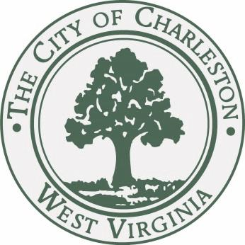

JOURNAL of the PROCEEDINGS
of the
CITY COUNCIL

CITY OF CHARLESTON, WEST VIRGINIA

Regular Meeting – Monday, February 2, 2014

at 7:00 P.M.

Council Chamber – City Hall – Charleston, West Virginia

OFFICIAL RECORD

James M. Reishman
City Clerk
Danny Jones
Mayor

CALL TO ORDER

The Council met in the Chambers of the City Building at 7:00 P.M., for the first meeting in the month of February on the 2nd day, in the year 2015, and was called to order by the Honorable Mayor, Danny Jones. The invocation was delivered by Councilman Richardson and the Pledge of Allegiance was led by Lewisburg Mayor John Manchester. The Clerk, James M. Reishman, called the roll of members and it was found that there were present at the time:

BURKA BURTON CLOWSER
DAVIS DENEAULT DODRILL
EALY HAAS HARRISON
HOOVER KIRK KNAUFF LANE MILLER MINARDI NICHOLS PERSINGER REISHMAN RICHARDSON RUSSELL SALISBURY SHEETS SMITH SNODGRASS TALKINGTON WARE WHITE
MAYOR JONES

With twenty-three members being present, the Mayor declared a quorum present.

Pending the reading of the Journal of the previous meeting, the reading thereof was dispensed with and the same duly approved.

PUBLIC SPEAKERS

- Lewisburg, WV Mayor John Manchester came to thank the Mayor and Council members for sending a truckload of bottled water to their city earlier that week.

COMMUNICATIONS

TO: JAMES REISHMAN
CITY CLERK

FROM: DANNY JONES
MAYOR

RE: CHARLESTON URBAN RENEWAL AUTHORITY

DATE: FEBRUARY 2, 2015

I recommend that Karen Haddad, 3011 Kanawha Avenue, Charleston, WV 25304, be reappointed to the Charleston Urban Renewal Authority, with a said term to expire March 3, 2020.

I respectfully request City Council’s approval of this recommendation.

Councilman Harrison moved to approve the appointment. Councilman Lane seconded the motion. The Mayor opened the floor for discussion of the appointment.
Councilman Sheets suggested that they find someone else who can represent a different section of the city, as in someone from his ward. The Mayor asked for a roll call.
A roll call was taken:
YEAS: Burka, Burton, Davis, Dodrill, Ealy, Haas, Hoover, Knauff, Lane, Nichols, Persinger, Reishman, Richardson, Russell, Salisbury, Snodgrass, Talkington, Ware, White, Jones
NAYS: Sheets, Smith
ABSENT: Clowser, Deneault, Kirk, Miller, Minardi
With a majority vote recorded thereon as voting in the affirmative the Mayor confirmed the appointment.

TO: JAMES REISHMAN
CITY CLERK

FROM: DANNY JONES
MAYOR

RE: BOARD OF ZONING APPEALS

DATE: FEBRUARY 2, 2015

I recommend that Charles Roskovensky, 2304 Oakridge Drive, Charleston, WV 25311, be reappointed to the Board of Zoning Appeals, with a said term to expire January 1, 2018.

I respectfully request City Council’s approval of this recommendation.

Councilman Harrison moved to approve the appointment. Councilman Lane seconded the motion. The Mayor opened the floor for discussion of the appointment.
A voice vote was taken and the appointment was confirmed unanimously.

TO: JAMES REISHMAN
CITY CLERK

FROM: DANNY JONES
MAYOR

RE: CHARLESTON-KANAWHA HOUSING AUTHORITY

DATE: FEBRUARY 2, 2015

I recommend that Virginia D. Nesmith, 905 Griffin Drive, Charleston, WV 25387, be reappointed to the Charleston-Kanawha Housing Authority, with a said term to expire December 1, 2019.

I respectfully request City Council’s approval of this recommendation.

Councilman Harrison moved to approve the appointment. Councilman Lane seconded the motion. The Mayor opened the floor for discussion of the appointment.
A voice vote was taken and the appointment was confirmed unanimously.

TO: JAMES REISHMAN
CITY CLERK

FROM: DANNY JONES
MAYOR

RE: MUNICIPAL PLANNING COMMISSION

DATE: FEBRUARY 2, 2015

I recommend that David C. Callaghan, 1713 Loudon Heights Road, Charleston, WV 25314, be appointed to the Municipal Planning Commission, with an initial term to expire July 1, 2016. He is replacing Danny Scalise.

I respectfully request City Council’s approval of this recommendation.

Councilman Harrison moved to approve the appointment. Councilman Lane seconded the motion. The Mayor opened the floor for discussion of the appointment.
A voice vote was taken and the appointment was confirmed unanimously.

TO: JAMES REISHMAN
CITY CLERK

FROM: DANNY JONES
MAYOR

RE: CHARLESTON HISTORIC LANDMARKS COMMISSION

DATE: FEBRUARY 2, 2015

I recommend that Paul W. Tennant, 318 Lee Street, West, Charleston, WV 25304, be reappointed to the Charleston Historic Landmarks Commission, with a said term to expire September 1, 2016.

I respectfully request City Council’s approval of this recommendation.

Councilman Harrison moved to approve the appointment. Councilman Lane seconded the motion. The Mayor opened the floor for discussion of the appointment.
A voice vote was taken and the appointment was confirmed unanimously.

TO: JAMES REISHMAN
CITY CLERK

FROM: DANNY JONES
MAYOR

RE: CHARLESTON BUILDING COMISSION

DATE: FEBRUARY 2, 2015

I recommend that Christopher Morris, 1505 Coventry Lane, Charleston, WV 25314, be appointed to the Charleston Building Commission, with an initial term to expire July 20, 2019. He is replacing Paula Butterfield.

I respectfully request City Council’s approval of this recommendation.

Councilman Harrison moved to approve the appointment. Councilman Lane seconded the motion. The Mayor opened the floor for discussion of the appointment.
A voice vote was taken and the appointment was confirmed unanimously.

REPORTS OF COMMITTEES

COMMITTEE ON PLANNING

Councilperson Mary Jean Davis, Chairperson of the Council Committee on Planning, submitted the following report:
- Your committee on Planning has had under consideration Bill No. 7645, and reports the same to Council with the recommendation that the bill do pass.
Bill No. 7645 - A Bill closing, abandoning and discontinuing as a public right of way, a 50 foot by 60 foot section of the unimproved portion of 3405 Kanawha Avenue, SE, in the City of Charleston, West Virginia.

BE IT ORDAINED BY THE CITY COUNCIL OF CHARLESTON, WEST VIRGINIA

1. The unimproved portion of the public right-of-way commonly known as Kanawha Avenue, SE, situate in Block 22 of Kanawha City. The right of way to be closed is described below and depicted on that plat titled “Plat of Survey, Showing Property Owned by, the Estate of Olga H. Cassis, No. 3405 Kanawha Ave. SE, Tax Parcels 11 and 49 and A, 3,000 sq. ft. Unimproved Area of Kanawha Ave. SE, to be Abandoned, Prepared for the Estate of Olga H. Cassis” by Garcelon Surveying, Inc. Professional Surveyor, WV License No. 861, dated September 14, 2014 and attached hereto as Exhibit A:

Beginning at a 1” iron pipe found marking the southwest corner of the herein described parcel and the northwest corner of Lot 3; thence N.15°-12’-37”E. 60.00 feet to a point in the northerly line of the aforesaid unimproved right of way; thence with said line. S.74°-52’-39”E. 50.00 feet to a point; thence crossing said right of way, S15°-12’-37”W. 60.00 feet to a point marking the northeast corner of Lot 3; thence with the northerly line of said Lot, N.74°-52’-39”W. 50.00 feet to the point of the beginning containing 3000 square feet.

2. The Mayor of the City of Charleston be, and is hereby authorized and directed to execute, acknowledge and deliver a proper deed conveying to Dianna Lee Shdeed, Dr. Daniel Lee Cassis, David Lee Cassis and Dede Lee Cassis and their successors in office, all rights, title and interest in and to said property as described in Section 1 above, for the consideration of Three Thousand dollars and no cents ($3000.00).

3. All prior ordinances, or parts of ordinances, inconsistent with this ordinance are hereby repealed to the extent of such inconsistency.

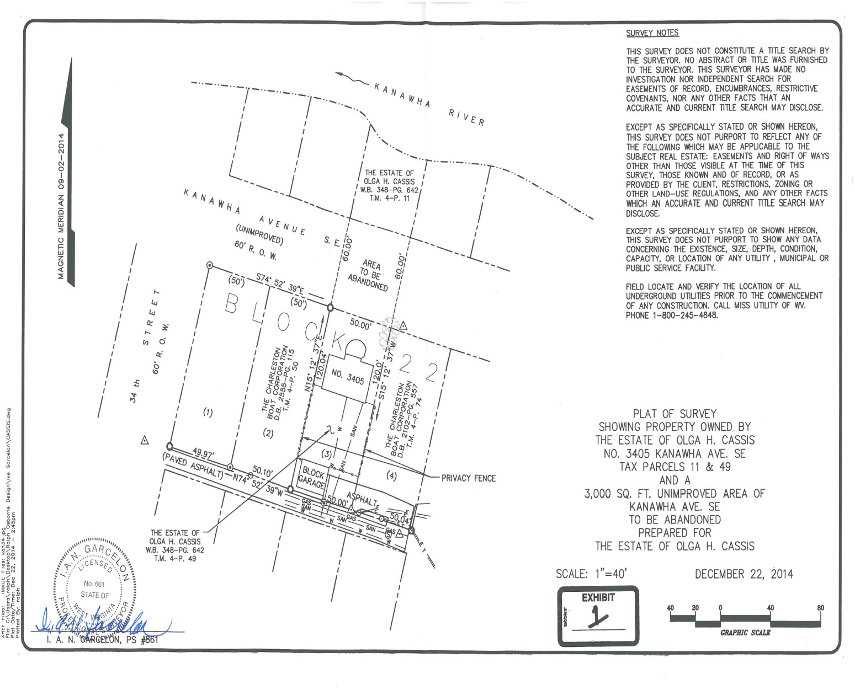

Council lady Davis moved that the bill be voted on under the Finance section of the meeting. Received and Filed.
COMMITTEE ON HOME RULE

Councilperson Jack Harrison, Chairperson of the Council Committee on Home Rule, submitted the following reports:
- Your committee on Home Rule has had under consideration Bill No. 7643, and reports the same to Council with the recommendation that the bill do pass.
Bill No. 7643: “A BILL authorizing the City of Charleston to submit to the Municipal Home Rule Board a proposed amendment, attached hereto as Exhibit A, to the City of Charleston Municipal Home Rule Plan consistent with W. Va. State Code Section
8-1-5a, requesting approval to increase the number of commissioners serving on the Charleston Urban Renewal Authority Board of Commissioners from seven to nine by adding two permanent seats to be filled by Charleston City Council members;

WHEREAS, W. Va. State Code Section 16-18-4(e) sets forth the number of commissioners that may serve on a municipality’s urban renewal authority board at no fewer than five and no more than seven; a number arbitrarily assigned to all municipalities within the state regardless of size, scope of projects, or area of a municipality’s urban renewal zone(s); and

WHEREAS, historically the City of Charleston has maintained a Charleston Urban Renewal Authority (“CURA”) Board of Commissioners with seven members, the maximum allowed by state law, even though the renewal zones have more than tripled in size since the City’s creation of its urban renewal authority; and

WHEREAS, the expansion of the CURA zones within the city combined with the recent variety and complexity of proposed essential economic and revitalization projects in the City require further active participation, cooperation, and continuity between the City and CURA; and

WHEREAS, although city council members could be appointed to the CURA Board of Commissioners to fill future vacancies, those appointments would reduce the participation of the community and business leaders whose independent experience and perspective have been beneficial to the City; and

WHEREAS, adding two additional permanent seats to the CURA Board to be filled by city council members without reducing the members of the community and business leaders who have traditionally provided helpful and independent insight and guidance to the City is the most effective resolution to successfully coordinate and complete the economic and revitalization projects currently being undertaken in Charleston;

Now, therefore, be it Ordained by the Council of the City of Charleston, West Virginia:

That, on behalf of the City of Charleston, the Mayor and the City Administration are hereby authorized and requested to submit to the Municipal Home Rule Board a proposed amendment, attached hereto as Exhibit A, to the City of Charleston Municipal Home Rule Plan consistent with W. Va. State Code Section 8-1-5a, requesting approval to increase the number of commissioners serving on the Charleston Urban Renewal Authority Board of Commissioners from seven to nine by adding two permanent seats to be filled by Charleston City Council members.

Councilman Harrison moved to approve the bill. Councilman Lane seconded the motion. The Mayor opened the floor for discussion of the bill.
Councilman Sheets suggested that they find someone else who can represent a different section of the city, as in someone from his ward. The Mayor asked for a roll call.
A roll call was taken:
YEAS: Burka, Burton, Davis, Dodrill, Ealy, Haas, Hoover, Knauff, Lane, Nichols, Persinger, Reishman, Richardson, Russell, Salisbury, Sheets, Snodgrass, Talkington, Ware, White, Jones
NAYS: Smith
ABSENT: Clowser, Deneault, Kirk, Miller, Minardi
With a majority vote recorded thereon as voting in the affirmative the Mayor declared Bill No. 7643, adopted.

COMMITTEE ON FINANCE

Councilperson Bobby Reishman, Chairperson of the Council Committee on Finance, submitted the following reports:
- Your committee on Finance has had under consideration Resolution No. 544-15, and reports the same to Council with the recommendation that the resolution do pass.
Resolution No. 544-15: “Appointing election officials, establishing voting places, and authorizing payment of a rental fee for voting places and payment for certain voting place personnel necessary for conducting the City of Charleston Primary Election on the 7th day of March 2015, and the City of Charleston General Election on the 16th day of May 2015.”

Be it Resolved by the Council of the City of Charleston, West Virginia:

That the Council of the City of Charleston does hereby appoint the following persons (set forth in Attachment A hereto) to serve as election officials and establishes the following voting places (set forth in Attachment B hereto) City of Charleston Primary Election on the 7th day of March 2015, and the City of Charleston General Election on the 16th day of May 2015.”

That the Council of the City of Charleston authorizes payment of a reasonable rental fee, not to exceed $35.00, to certain voting places and further authorizes payment of a reasonable fee, not to exceed $250.00, to precinct personnel who are required to open and close certain non-city owned voting places.

To be charged to Account No. 001-438-00-000-2-230, Elections—Contracted Services

Councilman Reishman moved to approve the Resolution. Councilman Lane seconded the motion. With a majority of members elected recorded thereon as voting in the affirmative the Mayor declared Resolution 544-15 adopted.

- Your committee on Finance has had under consideration Resolution No. 547-15, and reports the same to Council with the recommendation that the resolution do pass.
Resolution No. 547-15: “Authorizing the Mayor or his designee to sign and submit an application to the West Virginia Division of Justice and Community Services (DJCS) for a Justice Assistance Grant (JAG) requesting funds in the amount of $336,000.00 to provide for MDENT officers. A 25% match for this grant is comprised of supplemental salary and benefit costs incurred by each participating agency.”

Be it Resolved by the Council of the City of Charleston, West Virginia:

That the Mayor or his designee is hereby authorized and directed to sign and submit an application to the West Virginia Division of Justice and Community Services (DJCS) for a Justice Assistance Grant (JAG) requesting funds in the amount of $336,000.00 to provide for MDENT officers. A 25% match for this grant is comprised of supplemental salary and benefit costs incurred by each participating agency.

Councilman Reishman moved to approve the Resolution. Councilman Lane seconded the motion. With a majority of members elected recorded thereon as voting in the affirmative the Mayor declared Resolution 547-15 adopted.

- Your committee on Finance has had under consideration Resolution No. 548-15, and reports the same to Council with the recommendation that the resolution do pass.
Resolution No. 548-15: “Authorizing the Mayor or his designee to sign and submit an application to the West Virginia Division of Justice and Community Services (DJCS) for a Justice Assistance Grant (JAG) in the amount of $84,000.00 for salary, benefits and training for a Prevention Resource Officer (PRO) at Stonewall Jackson Middle School, Capital High School, and George Washington High School. The City is required to provide a 25% match to supplement the grant funds requested for the PRO positions.”

Be it Resolved by the Council of the City of Charleston, West Virginia:

That the Mayor or his designee is hereby authorized and directed to sign and submit an application to the West Virginia Division of Justice and Community Services (DJCS) for a Justice Assistance Grant (JAG) in the amount of $84,000.00 for salary, benefits and training for a Prevention Resource Officer (PRO) at Stonewall Jackson Middle School, Capital High School, and George Washington High School. The City is required to provide a 25% match to supplement the grant funds requested for the PRO positions.

Councilman Reishman moved to approve the Resolution. Councilman Lane seconded the motion. With a majority of members elected recorded thereon as voting in the affirmative the Mayor declared Resolution 548-15 adopted.

- Your committee on Finance has had under consideration Resolution No. 549-15, and reports the same to Council with the recommendation that the resolution do pass.
Resolution No. 549-15: “Authorizing the Mayor or his designee to submit a grant application to the West Virginia Homeland Security/Division of Military Affairs and Public Safety for a grant in the amount of $21,000.00 to provide for purchase of equipment to be used by the Neighborhood Assistance Officers (NAO). Matching funds are not required for this grant.”

Be it Resolved by the Council of the City of Charleston, West Virginia:

That the Mayor or his designee is hereby authorized and directed to submit a grant application to the West Virginia Homeland Security/Division of Military Affairs and Public Safety for a grant in the amount of $21,000.00 to provide for purchase of equipment to include radios with chargers, LED flashlights with chargers, color wands, tiger safety road flares, jump boxes, and raincoats to be used by Neighborhood Assistance Officers (NAO). Matching funds are not required for this grant.

Councilman Reishman moved to approve the Resolution. Councilman Lane seconded the motion. With a majority of members elected recorded thereon as voting in the affirmative the Mayor declared Resolution 549-15 adopted.

- Your committee on Finance has had under consideration Resolution No. 550-15, and reports the same to Council with the recommendation that the resolution do pass.
Resolution No. 550-15: “Authorizing the Finance Director to amend the FY 2014-2015 General Fund budget as indicated on the attached list of accounts.”

Be it Resolved by the Council of the City of Charleston, West Virginia:

That the Finance Director is hereby authorized and directed to amend the FY 2014-2015 General Fund budget as indicated on the attached list of accounts.

Councilman Reishman moved to approve the Resolution. Councilman Lane seconded the motion. With a majority of members elected recorded thereon as voting in the affirmative the Mayor declared Resolution 550-15 adopted.

- Your committee on Finance has had under consideration the following committee report, and reports the same to Council with the recommendation that the committee report do pass.
A bid submitted by Stephens Auto Center, in the total amount of $221,525, for purchase of nine (9) Model 2015 vehicles for various City Departments, as listed on Attachment A.

To be charged to the following accounts:
$23,997 - 001-980-00-952-4-459, Spring Hill Cemetery—Capital Outlay, Equipment
$24,140 - 001-975-00-412-4-459, City Manager/Construction—C/O, Equipment
$24,140 - 001-977-00-750-4-459, Street—Capital Outlay, Equipment
$23,697 - 001-978-00-800-4-459, Refuse Collection & Recycling—C/O, Equipment
$74,733 - 001-976-00-706-4-459, Fire—Capital Outlay, Equipment
$50,818 - 001-975-00-567-4-459, Public Grounds—Capital Outlay, Equipment
(PNC Equipment Finance, Lease Purchase Schedule No. 187583000 for the nine (9) vehicles)

Councilman Reishman moved to approve the committee report. Councilman Lane seconded the motion. With a majority of members elected recorded thereon as voting in the affirmative the Mayor declared the committee report adopted.

- Your committee on Finance has had under consideration the following committee report, and reports the same to Council with the recommendation that the committee report do pass.
A bid submitted by Bob Robinson Chevrolet, in the total amount of $127,808, for purchase of six (6) Model 2015 vehicles for various City departments, as listed on Attachment A.
To be charged to the following accounts:
$58,431 - 001-975-00-436-4-459, Building Commission—Capital Outlay, Equipment
$19,477 - 001-975-00-437-4-459, Planning—Capital Outlay, Equipment
$25,724 - 001-975-00-420-4-459, Engineering—Capital Outlay, Equipment
$24,176 - 001-975-00-439-4-459, IS Department—Capital Outlay, Equipment
(PNC Equipment Finance, Lease Purchase Schedule No. 187583000 for the six (6) vehicles)

Councilman Reishman moved to approve the committee report. Councilman Lane seconded the motion. With a majority of members elected recorded thereon as voting in the affirmative the Mayor declared the committee report adopted.

- Your committee on Finance has had under consideration the following committee report, and reports the same to Council with the recommendation that the committee report do pass.
A bid submitted by Stephens Auto Center, in the total amount of $413,043, for purchase of nine (9) Model 2015 Ford Police Sedan Interceptors ($241,119), and six (6) Model 2015 Ford Police Utility Interceptors ($171,924) to be used by the Charleston Police Department.

To be charged to Account No. 001-976-00-700-4-459, Police—Capital Outlay, Equipment
(PNC Equipment Finance, Lease Purchase Schedule No. 187582000)

Councilman Reishman moved to approve the committee report. Councilman Lane seconded the motion. With a majority of members elected recorded thereon as voting in the affirmative the Mayor declared the committee report adopted.

- Your committee on Finance has had under consideration the following committee report, and reports the same to Council with the recommendation that the committee report do pass.
A bid submitted by Electronic Communications, in the amount of $26,062.50, for purchase and installation of emergency equipment and light bars onto the new vehicles being purchased for the Charleston Police Department.
To be charged to Account No. 001-976-00-700-4-459 Police—Capital Outlay, Equipment
Councilman Reishman moved to approve the committee report. Councilman Lane seconded the motion. With a majority of members elected recorded thereon as voting in the affirmative the Mayor declared the committee report adopted.

- Your committee on Planning has had under consideration Bill No. 7645, and reports the same to Council with the recommendation that the bill do pass.

Bill No. 7645 - A Bill closing, abandoning and discontinuing as a public right of way, a 50 foot by 60 foot section of the unimproved portion of 3405 Kanawha Avenue, SE, in the City of Charleston, West Virginia.

BE IT ORDAINED BY THE CITY COUNCIL OF CHARLESTON, WEST VIRGINIA

1. The unimproved portion of the public right-of-way commonly known as Kanawha Avenue, SE, situate in Block 22 of Kanawha City. The right of way to be closed is described below and depicted on that plat titled “Plat of Survey, Showing Property Owned by, the Estate of Olga H. Cassis, No. 3405 Kanawha Ave. SE, Tax Parcels 11 and 49 and A, 3,000 sq. ft. Unimproved Area of Kanawha Ave. SE, to be Abandoned, Prepared for the Estate of Olga H. Cassis” by Garcelon Surveying, Inc. Professional Surveyor, WV License No. 861, dated September 14, 2014 and attached hereto as Exhibit A:

Beginning at a 1” iron pipe found marking the southwest corner of the herein described parcel and the northwest corner of Lot 3; thence N.15°-12’-37”E. 60.00 feet to a point in the northerly line of the aforesaid unimproved right of way; thence with said line. S.74°-52’-39”E. 50.00 feet to a point; thence crossing said right of way, S15°-12’-37”W. 60.00 feet to a point marking the northeast corner of Lot 3; thence with the northerly line of said Lot, N.74°-52’-39”W. 50.00 feet to the point of the beginning containing 3000 square feet.

2. The Mayor of the City of Charleston be, and is hereby authorized and directed to execute, acknowledge and deliver a proper deed conveying to Dianna Lee Shdeed, Dr. Daniel Lee Cassis, David Lee Cassis and Dede Lee Cassis and their successors in office, all rights, title and interest in and to said property as described in Section 1 above, for the consideration of Three Thousand dollars and no cents ($3000.00).

3. All prior ordinances, or parts of ordinances, inconsistent with this ordinance are hereby repealed to the extent of such inconsistency.

Councilman Reishman moved to approve the bill. Councilman Lane seconded the motion. The Mayor opened the floor for discussion of the bill.
A roll call was taken:
YEAS: Burka, Burton, Davis, Dodrill, Ealy, Haas, Hoover, Knauff, Lane, Nichols, Persinger, Reishman, Richardson, Russell, Salisbury, Sheets, Snodgrass, Smith Talkington, Ware, White, Jones
ABSENT: Clowser, Deneault, Kirk, Miller, Minardi
With a majority vote recorded thereon as voting in the affirmative the Mayor confirmed Bill No. 7645, adopted.

REPORTS OF OFFICERS

1 . Municipal Court Report to City Council Month Ending December 2014.
Received and Filed.

NEW BILLS

Introduced by Council members Davis, Persinger, Dodrill, Harrison, Richardson, Knauff, Burton, Haas, and Hoover on February 2, 2015:
Bill No. 7646 – A Bill amending the Zoning Ordinance for the City of Charleston, West Virginia, adopted November 21, 2005 by amending section 22-040-04 to permit gravel as a permitted driveway surface for single family and duplex dwellings provided certain conditions are met.
Refer to Municipal Planning Commission, Planning Committee.

Introduced by Council member Bob White on February 2, 2015:
Bill No. 7647 – A Bill closing, abandoning and discontinuing as a public right of way, a 10 foot wide by 80 foot long public right located between Lots 9, 10, 20, and 21, Block 7, J. Brisben Walker Addition, situate in Charleston West District, Kanawha County, West Virginia.
Refer to Municipal Planning Commission, Planning Committee and Finance Committee.

ADJOURNMENT

The Clerk, James M. Reishman, called the closing roll call:

YEAS: Burka, Burton, Davis, Dodrill, Ealy, Haas, Hoover, Knauff, Lane, Nichols, Persinger, Reishman, Richardson, Russell, Salisbury, Sheets, Snodgrass, Smith Talkington, Ware, White, Jones
ABSENT: Clowser, Deneault, Kirk, Miller, Minardi
At 7:35 p.m., by a motion from Councilmember Harrison, Council adjourned until Monday, February 17, 2015, at 7:00 p.m., in the Council Chamber in City Hall.

_______________________________
Danny Jones, Honorable Mayor

_______________________________
James M. Reishman, City Clerk

